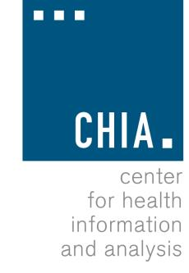Oversight Council
CHIA, 88 Newbury Street
December 17, 2015

Welcome 09:00 AM Approval of Prior Meeting Minutes 09:05 AM Executive Director’s Report 09:10 AM Proposed Council Bylaws & Calendar 09:40 AM CHIA Data Assets: Overview and Outlook 10:10 AM Adjourn 11:00 AM
Please remember to bring your ID for building security, and enter at the 88 Newbury Street entrance.

