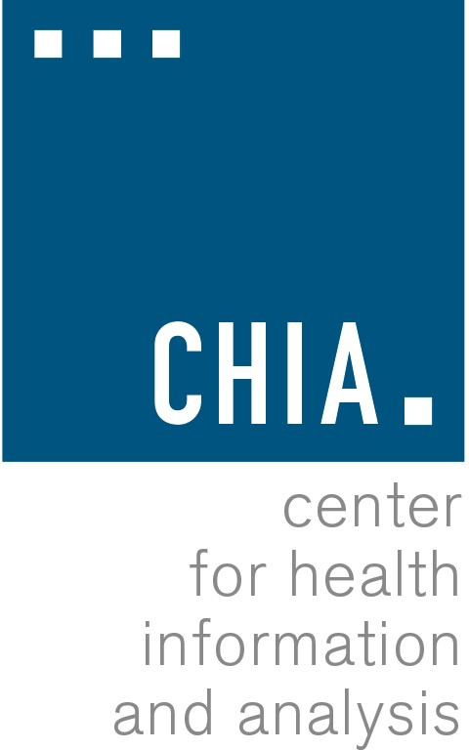
Health Information and Analysis Oversight Council Administration & Finance Committee

Executive Office for Administration and Finance State House Room 373, Boston, MA
November 16, 2016 4:15 PM
MEETING MINUTES

The meeting began at 4:20 p.m.
Present were Secretary Kristen Lepore, Undersecretary Alice Moore (designee of Secretary Marylou Sudders), Health Policy Commission Executive Director David Seltz, Fay Donohue, Lauren Peters, and CHIA Executive Director Ray Campbell.
A motion to approve the Committee’s meeting minutes from September 13 was requested. Undersecretary Moore moved to approve the minutes. Ms. Donohue duly seconded the motion. The Committee unanimously voted to approve the minutes.
Mr. Campbell proceeded to summarize CHIA’s efforts to create a budget for FY18. He walked through CHIA’s exercises to both prioritize projects as well as minimize costs. Specifically, Mr. Campbell discussed the zero-based budget exercise performed with Accenture to help prioritize projects. He discussed the diminishing size of agency staff due to voluntary attrition, and efforts to reduce IT and administrative spending. The efforts to apply for the Commonwealth’s IT capital fund were also mentioned. A discussion followed regarding how much money CHIA could save with its efforts.
Secretary Lepore noted that MassIT will look closely at the scope of capitalization projects proposed and determine if there are more efficient ways for work to be done at CHIA. Executive Director David Seltz arrived at 4:28 p.m.
Mr. Campbell then moved to discuss the development of the MA APCD strategy. He explained to the committee the difficulties around normalizing the data that is submitted to CHIA, which requires necessary enhancements. He also reiterated the value of the MA APCD and its unique ability to provide an individual-focused insight into the Commonwealth’s health care system. Mr. Campbell concluded his remarks by stating that CHIA will spend as little as possible while still maintaining the value of the MA APCD; however, further discussion both internally and with the Oversight Council will determine how much effort and cost should be spent on the data set. A discussion ensued regarding the Gobeille v. Liberty Mutual Supreme Court decision, and how it impacts the value of the MA APCD. Secretary Lepore asked about the functionality of the MA APCD with the planned upgrades and enhancements; Ms. Peters added that she wants to understand precisely what questions the data can answer as a result of the planned enhancements that it could not answer before. Mr.

Campbell noted that much of the expected cost will be one-time only to complete the intended goals for the MA APCD. The secretary stated that the full council will likely have follow-up questions about the capital funding request and the intended use of the funds. She also asked for another committee meeting prior to CHIA submitting its capital funding request.
Ms. Donahue asked about CHIA’s transparency initiative and whether it involves the creation of a health care transparency website. Mr. Campbell walked the committee through CHIA’s transparency efforts, and stated that a website will indeed be created to emulate New Hampshire’s website. A brief conversation followed about the usefulness of existing consumer-facing transparency websites. Mr. Campbell noted that CHIA plans to create a website that does more than just compares health care costs.
Mr. Campbell concluded his presentation by discussing in further detail the development of the strategic plan at CHIA. He noted that CHIA will be developing a roadmap for the agency’s health data assets.
Secretary Lepore asked about funding for the MA APCD, and whether it will source form the capital fund. Mr. Campbell replied that CHIA needs around $400,000 to complete the MA APCD. He noted that if CHIA does not receive the capital funding then the agency’s capabilities will be severely limited—adding that cuts to non-essential agency functions have already occurred. The secretary asked for further detail on CHIA’s budget request, as well for more information on what additional funding sources CHIA is counting on in order to make up the budget shortfall. A discussion ensued about what funds CHIA needs and what the funding will be used for. Mr. Campbell noted that while CHIA can survive without some of the requested funds, many agency efforts, including the opioid study, will not occur. He concluded by stating that CHIA previously had operated based on its assessment funding rather than capital funding, and that going forward the agency will operate differently. Mr. Seltz reiterated to the committee that the Legislature is unlikely to increase CHIA’s assessment in order to counteract the transfer of money to the Community Hospital Reinvestment Trust Fund. CHIA’s budget, as a result, is expected to remain at its current level. The committee then briefly discussed the merits of CHIA receiving capital funding. Secretary Lepore departed the meeting at 5:06 p.m.
Ms. Peters explained that MassIT is revamping their application process for the capital funding, and that CHIA will evaluated based on this new method. She also noted that both the Secretary of Health and Human Services and the Secretary of Administration & Finance will be contacted regarding CHIA’s application, so they both should have a deep understanding of CHIA’s needs and request.
Ms. Peters called for the motion to approve CHIA’s budget request, which Mr. Seltz duly seconded. The committee voted to approve the budget request. Ms. Donahue concluded by asking whether a national model existed for a health care data agency, and requested that the executive director provide an update on what other states are doing.
There being no other business to discuss, Undersecretary Moore moved to adjourn the meeting which Ms. Donahue seconded. The meeting adjourned at 5:19 p.m.

