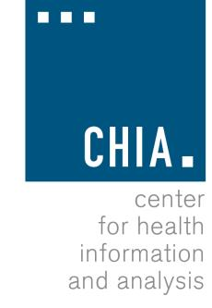Health Information and Analysis Oversight Council
Administration & Finance Committee

Executive Office for Administration and Finance
State House, Room 373, Boston, MA June 13, 2016 1:00-2:00 PM

Meeting Notice and Agenda

Approval of Prior Meeting Minutes (VOTE) Check-in on CHIA’s FY16 Budget Discussion of CHIA’s FY17 Budget

