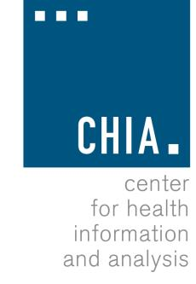
Health Information and Analysis Oversight Council
Administration & Finance Committee

Executive Office for Administration and Finance State House, Room 373, Boston, MA November 16, 2016 4:15 PM

Approval of Prior Meeting Minutes
Discussion of the results of CHIA’s zero-based budget planning engagement with Accenture

Discussion of CHIA’s FY18 maintenance budget request

