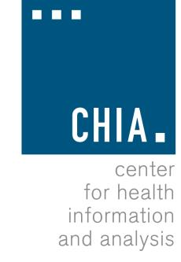
Health Information and Analysis Oversight Council
Administration & Finance Committee

Executive Office for Administration and Finance State House, Room 373, Boston, MA
November 15, 2017 1:30 PM

MEETING NOTICE AND AGENDA

- Approval of Prior Meeting Minutes (VOTE)
- Fiscal Year 2018 Update

