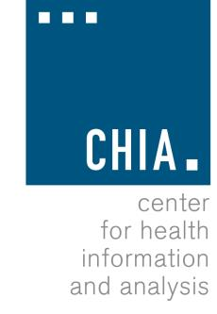
Health Information and Analysis Oversight Council

Center for Health Information and Analysis
Remote Meeting Available for Viewing on YouTube
September 23, 2020 10:30 AM

AGENDA

- Approval of Prior Meeting Minutes

- Executive Director’s Report
  - CHIA’s Work for the Command Center
  - Review CHIA-related Legislation
  - NAHDO’s 35th Annual Conference & AcademyHealth’s
Annual Research Meeting
  - CHIA Accomplishments and Look Ahead
- Hospital Financial Performance During COVID-19
- CHIA Linkage Service
- Presentation of 2019 MA Health Insurance Survey (MHIS) Results

