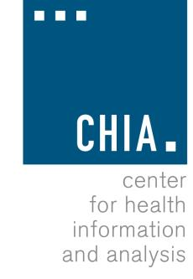Oversight Council
CHIA, 501 Boylston Street
March 3, 2016

Welcome
Approval of Prior Meeting Minutes (VOTE) 9:00 AM

Executive Director’s Report 9:05 AM Review of HPC Recommendations 9:30 AM CHIA’s 2016 Analytic Agenda 9:45 AM Adjourn 11:00 AM

Please remember to bring your ID for building security.

