CENTER FOR HEALTH INFORMATION AND ANALYSIS

CHIA SUBMISSIONS USER GUIDE:

nUrsing services cost REPORT

April 2022

Table of Contents
Reminders for the FY2021 Nursing Services Cost Report (NSR) 3
PURPOSE 3
ACCESSING AND FILLING OUT THE ONLINE COST REPORT 3
Logging into “CHIA Submissions”: 4
Home Screen: 4
Cost Report Year Selection: 4
Saving: 5
Color coding: 5
User-defined fields: 5
FREQUENTLY ASKED QUESTIONS (FAQ) 6
ADDITIONAL INFORMATION: 7

Reminders for the FY2021 Nursing Services Cost Report (NSR)
- Providers are required to submit completed cost reports through CHIA's online submission portal, CHIA Submissions. Please note, CHIA Submissions works best in Google Chrome.
- Financial statements must be emailed to data@chiamass.gov, not uploaded through CHIA Submissions.

PURPOSE
The Center for Health Information and Analysis (Center or CHIA), in accordance with its statutory authority under M.G.L. c. 12C, collects cost reports in furtherance of its mission to monitor the health care system in Massachusetts and to provide reliable information and meaningful analysis for those seeking to improve health care quality, affordability, access and outcomes. The data the Center collects through the Nursing Services Cost Report (NSR) is used, among other items, to support the rate-setting obligations of the Executive Office of Health and Human Services (EOHHS) which uses the data to establish rates for continuous skilled nursing providers (CSN), home health agencies (HHA), and temporary nursing services agencies (TNS). Once filed with the Center, these reports become public documents and will be provided upon request to any interested party.
This document contains step-by-step instructions on how to retrieve and navigate the online cost report. It also contains the steps to properly save and submit the online cost report to CHIA Submissions. “Frequently Asked Questions” are included at the end of the document for additional information.

ACCESSING AND FILLING OUT THE ONLINE COST REPORT

If you have not registered with CHIA through CHIA Submissions, please follow the following instructions:

- If you are a new user with CHIA, please fill out the CHIA INET User Agreement. Once this form has been received and processed by CHIA, the registered user will receive a Login ID via email or phone. This may take several days; please plan accordingly.
- If the agency is new to the filing process, the agency must also submit the Business Partner Security Agreement. Please allow up to several days for CHIA to process this information.

The completed and signed forms can be submitted to CHIA by email to: DL-Data-Submitter-HelpDesk@chiamass.gov.

Once these forms are processed, you will be able to Log into CHIA Submissions at https://chiasubmissions.chia.state.ma.us/ using the Login ID provided to you by CHIA in step 1 above.

Logging into “CHIA Submissions”:
Providers can access the CHIA Submissions page through this link: https://chiasubmissions.chia.state.ma.us. Once logged in, select “LAUNCH” under the Nursing Services Cost Report icon. Below is an example of this screen:
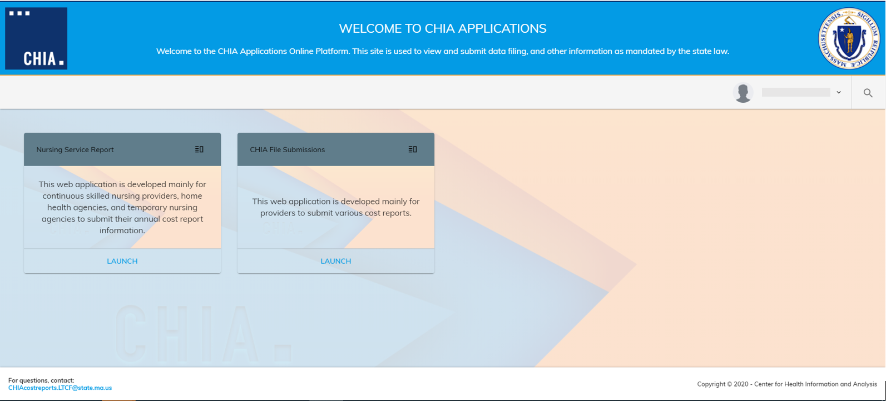

Please note: CHIA Submissions works best with Google Chrome.

Home Screen:
The list of providers or facilities for which a user has access is located on the far-left side of the screen. By clicking on the provider name on the list, the system will activate that account and display the information entered in Schedule #1 for the Reporting Year selected. Below is an example of a list of providers on the left-hand panel.
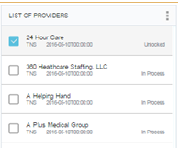

Cost Report Year Selection:
Once you have selected the correct provider, select the dropdown menu on the right for the correct cost report year you wish to file. Below is an example of this dropdown menu:

Saving:
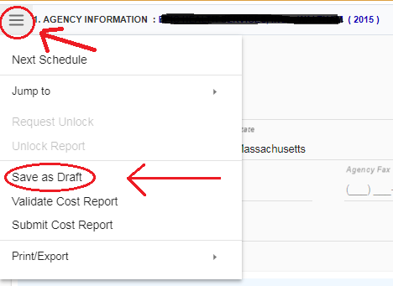
Please save the report often as you move from schedule to schedule. The “Save as Draft” command is located in the button pictured below. Once you select this button, a drop down menu will appear. Please select the “Save as Draft” option to save the cost report at that time. Please ensure that you have saved the report before printing.

Color coding:
Cells in the cost report have different colors, based on the type of value the cell contains. Below is a description of what each color signifies. 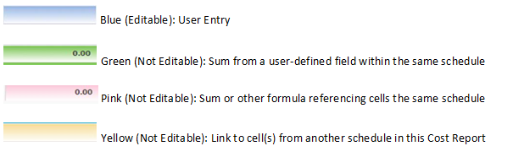

User-defined fields:
Cells in the cost report that are shaded green reference user-defined fields. To most effectively interact with user-defined fields, (1) use the Google Chrome browser, (2) hover over the gear icon in the middle of the screen, (3) and click on the three horizontal lines for “Single column view”, as circled below. This will expand the labels of the user-defined fields.
Hover over gear icon

Data for user-defined fields is entered on the right side of the screen. User-defined fields are labeled with an “A” after the line number that references the user-defined field. Below is an example of where to enter data in user-defined fields. As an example, for line 4, “Parent/Management Company Allocation”, enter information in the user-defined field labeled “Line 4A – Administrative Personnel: Parent/Management Company Allocation”.
In order to create an entry in the user-defined field, click the blue plus sign, as circled below.

FREQUENTLY ASKED QUESTIONS (FAQ)

- How can I register to get into the NSR in CHIA Submissions?
You will need to complete the following two forms and email them to dl-data-submitter-helpdesk@chiamass.gov.

- Business Partner Security Agreement:
http://www.chiamass.gov/assets/docs/p/inet/confidential-business-partner-agreement-2018.pdf
- CHIA User Agreement: http://www.chiamass.gov/assets/docs/p/inetuseragreementotherprovider.pdf

- What are my system requirements?
CHIA Submissions is fully supported on Google Chrome.

- I’ve completed the report, but it’s giving me a validation error when I try to submit, something about an invalid date on schedule 1?
Please make sure you are accessing the report in Google Chrome. Some parts of the report are not compatible with Internet Explorer, particularly the date fields on schedule 1. Once you switch to Google Chrome, make sure that you have filled out the Fiscal Year End date (top right), as well as the Office Signed Date, and Preparer Signed Date, if applicable.

- I’ve completed the report, but it’s giving me a validation error when I try to submit, something about schedule 9?
Schedule 9 requires all fields to be completed. If you do not have a parent agency or these questions otherwise do not apply to you, enter information in Schedule 9 to explain that these questions do not apply to your agency. For example, enter “NA” in any text fields that do not apply to your agency, and enter “000-000-0000” in fields asking about phone numbers that do not apply to your agency.

- How do I update information in a submitted report?
If a provider needs to update information in an already submitted report, users should email data@chiamass.gov to inform CHIA of the intent to resubmit and provide good cause for resubmission. Users should make the appropriate changes to the cost report and resubmit the report once completed.

- I already submitted the report, but I got an email/letter that I have not completed the requirements.
Please make sure you submitted all supplemental documents via email to data@chiamass.gov. In addition to the cost report submitted via CHIA Submissions, we require financial statements, and for HHA agencies a copy of your Medicare cost report.

In addition, if your agency performs continuous skilled nursing (CSN) services, sometimes called “private duty nursing”, CHIA requires agencies to submit separate cost reports for CSN services and all other HHA services. For the purpose of this report, CSN services are considered to be private duty nursing provided by RNs or LPNs. Information regarding CSN should not be reported in the “HHA” version of the NSR. Instead, we ask providers to separate this information and report it on a slightly different, CSN-specific version of the NSR. Look on the left-hand side of the CHIA submissions page. In the search bar, type in “CSN”, and search for your agency name. The format for the CSN report will be “Your Facility Name (CSN)”, with “CSN” underneath in small gray letters. See below for an example:

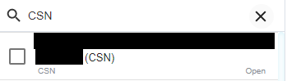

If you do not already have access to the CSN report, you will need to register to gain access (see FAQ 1).

ADDITIONAL INFORMATION:
If you have any additional questions regards to this filing, please email DL-Data-Submitter-HelpDesk@chiamass.gov.

