CENTER FOR HEALTH INFORMATION AND ANALYSIS

COST REPORT INSTRUCTIONS:
cOMMUNITY hEALTH cENTERS
cost REPORT

April 2025


TABLE OF CONTENTS
PURPOSE 3
WHO MUST FILE 3
WHAT TO FILE 4
WHEN TO FILE 4
RETRIEVING AND POPULATING THE TEMPLATE 4
GENERAL COST REPORT INSTRUCTIONS 5
FUNCTIONAL REVENUE AND COST CENTERS 6
Cost Centers: 7
Tab 1: Agency Information 7
Tab 2. Revenue 8
Tab 3 and 4. Providers and Non-Providers 10
Tab 5. Cost Information 11
Tab 6. Reclassification 11
Tab 7. Adjustments 12
Tab 8. Other Information: Facility Square Footage 12
Cost Breakdown 13
Forms 1 through 5 13
Form 6A and 6B – Reclassifications and Adjustments 13
Form 7 – Visits by FTE 13
Form A – Allocations 13
Form B – Cost per Visit 13
Tab 9. Reconciliation 13
Tab 10. Accuracy of Report 14
QUESTIONS 16

About the Community Health Center (CHC) Cost Report:
- Providers are now required to submit completed cost reports through CHIA’s online submission portal, CHIA Submissions.
  - Please note, CHIA Submissions works best in Google Chrome.
  - The same login credentials previously used in INET can be used for CHIA Submissions. If you need login credentials, please follow the instructions on page 6.
- Please read all Cost Report Instructions and the CHIA Submissions User Guide thoroughly prior to beginning the cost report.
- The Community Health Center cost report is available as an Excel template. Complete cost reports will be submitted via CHIA Submissions. Financial statements should be emailed to data@chiamass.gov, not uploaded through CHIA Submissions.
- Data must be keyed in. Please do not insert formulas or references to other spreadsheets as this may prevent the data from calculating accurately.
- All numbers must be whole numbers without decimals, except for the FTEs on Tabs 3 and 4.
- The ‘Certification by Provider’ section, in the yellow cells on Tab 10, must be filled in to save successfully.
- All submissions must be saved using the “Save Submission File” button on Tab 10, Accuracy of Report, which will only work if all errors are cleared on the tab. Submissions that are not saved by using this button cannot be read by CHIA’s system and will not successfully upload.

PURPOSE
The Center for Health Information and Analysis (CHIA), in accordance with its statutory authority under M.G.L. c. 12C, collects cost reports in furtherance of its mission to monitor the health care system in Massachusetts and to provide reliable information and meaningful analysis for those seeking to improve health care quality, affordability, access and outcomes. The data CHIA collects through Community Health Center Cost Report is used, among other things, to support the rate-setting obligations of the Executive Office of Health and Human Services (EOHHS), which uses the data to establish rates for community health center providers, and to complete additional analyses to inform policy-making. Once filed with CHIA, these cost reports and financial statements become public documents and will be provided upon request to any interested party.
This document contains step-by-step instructions on how to retrieve and fill out the Excel cost report. Detailed steps for uploading and submitting a completed cost report can be found in the CHIA Submissions User Guide.

WHO MUST FILE
Pursuant to Regulation 957 CMR 6.00: Cost Reporting Requirements: Clinics that provide comprehensive community health center services and are not financially or physically an integral part of a hospital are required to report financial and statistical data to the Center for Health Information and Analysis on an annual basis. Such data must reflect activity for the twelve months of a community health center’s fiscal year.

PLEASE NOTE
The Community Health Center cost report filing will NOT be considered complete until all relevant financial data and all additional documentation requested by CHIA staff has been provided to the satisfaction of CHIA staff.

Providers that fail to file required data with CHIA will be subject to penalties in accordance with CHIA regulation, 957 CMR 6.00, and EOHHS regulation, 101 CMR 304.00.

WHAT TO FILE
- Cost Report. Agencies must file the cost report with CHIA for the fiscal year 2024 based on the provider’s fiscal year end. The report is available to download on CHIA’s website.

The reporting period shall be consistent with financial statements. The cost report shall be completed on the basis of the total program costs.

- Financial Statements. Agencies must submit copies of financial statements and other external documentation supporting the accuracy of the data reported on the cost report.

Agencies must file one of the following forms of acceptable documentation (in descending order of preference):
- A financial statement certified by a certified public accountant;
- In the absence of certified statements, the agency may submit uncertified statements or a Balance Sheet and Operating Statement prepared by the health center.
Email financial statement documents to data@chiamass.gov.
Label all PDF files with the CHC provider’s name and document type. For example, financial statements can be labeled as AgencyName_CHCFS_FY24.pdf.

WHEN TO FILE
All Community Health Center providers have the same due date. Providers must file the CHC cost report and financial statements no later than late June 24, 2025.

NOTE: If you would like to be added to CHIA’s email list to receive cost report alerts, including deployment and due dates, please request that your email address be added by emailing CostReports.Pricing@chiamass.gov.

Extensions
Providers may request a filing extension. The extension request must be submitted via email to data@chiamass.gov. The request must demonstrate a good cause or circumstances for the filing extension.

RETRIEVING AND POPULATING THE TEMPLATE

Download the Excel Template
All Community Health Center providers can download the cost report template by visiting the following URL:https://www.chiamass.gov/community-health-center-cost-reports-2/

Open and View Tabs
Upon opening the template, select “Enable Editing” at the top of the screen, above the formula bar, to be able to work on the report. You must also select “Enable Content”. Failure to select Enable Content will result in an inability to successfully use the template and save.

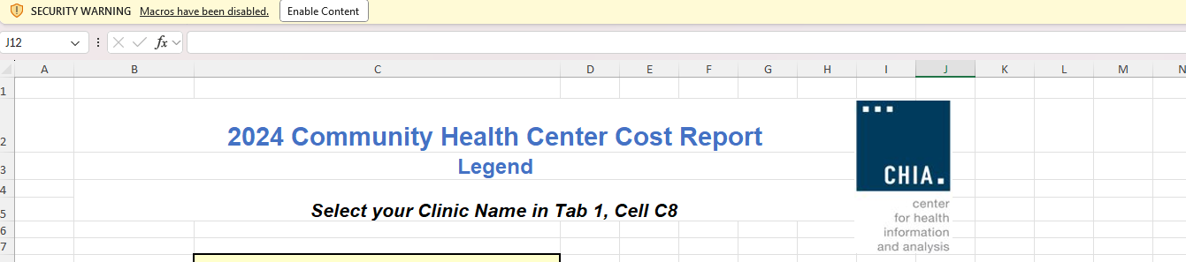

If after clicking Enable Content you receive the below error, please visit the Microsoft support page linked here to trust the template and unblock the macros. Failure to do this will result in an inability to successfully submit the cost report. Please email CostReports.Pricing@chiamass.gov if you need additional assistance.

If you do not see this error, you can proceed in filling out the cost report with no additional action required.

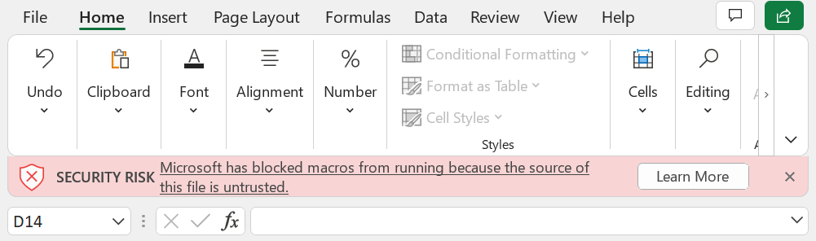

The cost report contains the following sections, to be completed by the provider and certified by an authorized individual.

The schedules should be completed in the order listed above.

GENERAL COST REPORT INSTRUCTIONS
Please be sure to check that your provider name is in the drop down list in Tab 1 PRIOR to initiating work on the cost report.
If your provider name does not appear in the drop down list in Tab 1 of the cost report or you are a new filer with CHIA, you MUST fill out, scan, and send a User Agreement and a Business Partner Security Agreement form to CostReports.Pricing@chiamass.gov BEFORE you begin working on the cost report and attempt to submit a completed cost report.

After submitting the forms, you will receive notification and an updated cost report template that will include your provider name in the drop down. Please wait to fill out the cost report until you receive the updated template.

Agencies should use the accrual basis of accounting. All numbers must be whole numbers without decimals, except for the FTE values on Tabs 3 and 4.

You may paste data into the cost report template from existing worksheets. Please paste as VALUES. If you fail to paste as values, you will not be able to save and submit successfully. Please check that pasted values are WHOLE numbers, aside from the FTE values on Tabs 3 and 4 where decimals are allowed.
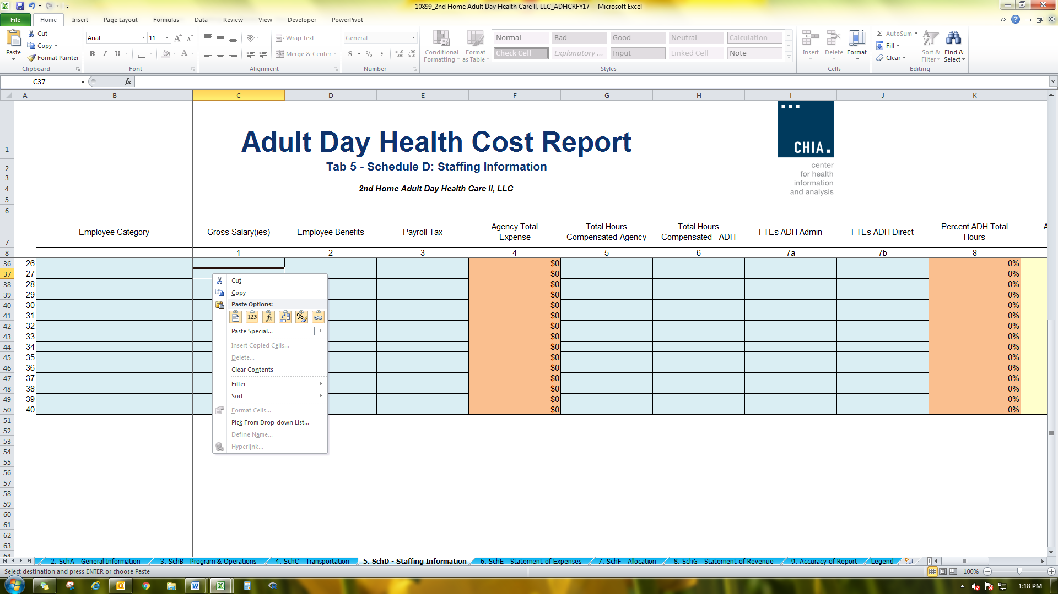
SAVE ENTERED DATA OFTEN. You may save a draft of the template at any time by using the “Save As” or “Save” options under the File menu in Excel.
You may navigate the schedules of the cost report by clicking the tabs at the bottom of the workbook.

The cost report has four different kinds of cells, designated by two different colors. The table below explains what each color means. Providers are only responsible for entering data into the blue cells.

FUNCTIONAL REVENUE AND COST CENTERS
Directly assign each expense category to the relevant cost centers whenever possible: Medical, Behavioral Health & Substance Abuse, Dental, Vision, Laboratory, X-Ray, Pharmacy, Enabling, Admin, Facility. Expenses that you cannot assign directly should be allocated.

Please reference the below regulations for definitions of the following cost centers:

Cost Centers:

A cost center is a specific program, service, or activity which can be separated from others within the organization based on its unique staffing, equipment, or facility needs. This separation permits the segregation or allocation of costs to one area or another.

Medical: Expenditures incurred in the provision of direct care services for the prevention, diagnosis, and treatment of physical illness, including routine family health care such as internal medicine, family medicine, pediatrics and OB/GYN, and the cost of medical specialists.
Behavioral Health & Substance Abuse: Expenditures for any mental health services certified for reimbursement under Regulation 101 CMR 306 should go under this cost center. Noncertified mental health programs should report only Psychiatrists costs and associated costs for support personnel. Psychologists, LICSW and associated indirect costs working for centers uncertified for mental health should appear under Enabling.
Dental: Expenditures for providing dental services, including laboratory and X-ray.
Vision: Expenditures for providing vision services.
Laboratory: Expenditures for all laboratory services (excluding dental lab services).
X-Ray: Expenditures for X-ray diagnosis and treatment services (excluding dental X-ray services).
Pharmacy: Expenditures for a 340B pharmacy operating on-site within a CHC or off-site by a contractual agreement with a retail pharmacy.
Enabling: Expenditures for a wide range of services that support and assist primary care and facilitate patient access to care. These services include case management, transportation, outreach, patient and community education, eligibility assistance, translation/interpretation services, community health workers, and other.
Administration: Expenditure for administration salaries, benefits, and Other Than Personnel Services (OTPS) expenses. Also includes expenditures for administrative services of professional provider staff that spend less than 100% of their time performing administrative services provided that such services apply to the total community health center program. The Reclassification schedule should be used to record the portion of a provider’s salary that is attributed to administrative functions (See Reclassification instructions on page 15).
Facility: Expenditures for the maintenance and oversight of facility development, maintenance, security, and operations.
Non-Allowable: Expenditures that are not directly related to the provision of CHC services, such as WIC (Women, Infants, & Children), Non- Federally Qualified Health Center (FQHC) Sites, PACE Program (Program of All-Inclusive Care for the Elderly), and SCO (Senior Care Options). These expenses are not included in the Total Expense figure.

Tab 1: Agency Information
Line 1: Provider Name:
Select your provider name from the drop-down list. Please see the instructions on page 6 if your provider name is not in the dropdown. You will need to register with CHIA and receive an updated template.

Line 2: Federal Employee ID Number (FEIN)
Enter your agency’s 9-digit FEIN.

Line 3: MassHealth Provider ID and Service Location (PIDSL)
Enter your agency’s MassHealth PIDSL. The PIDSL is 10 characters consisting of 9 numbers and 1 letter suffix.

Line 4: Medicare Provider number
Enter your agency’s 6-digit Medicare Provider Number.

Lines 5, 6, 7, 8: Mailing Address, City, State, Zip Code
Enter your agency’s mailing address.

Line 9: Main Phone Number
Enter your agency’s main phone number.

Line 10: Fiscal Year Ending
Select from the drop-down the month in which your fiscal year ends.

Lines 11 and 12: Report Contact’s Name and Title
Enter the name and title of the individual that CHIA should contact with questions about the report.

Lines 13 and 14: Contact’s Phone and Extension
Enter the telephone number and/or extension of the individual that CHIA should contact with questions about the report.

Line 15: Email
Enter the e-mail address of the individual CHIA should contact with questions about the report.

Line 16: Executive Director
Enter the name of your Executive Director.

Line 17: Medical Director
Enter the name of your Medicare Director.

Line 18: Financial Manager
Enter the name of your Financial Manager.

Tab 2. Revenue

Total revenue reported on Tab 2 should equal the total revenue in the company’s financial statements. If the amounts do not match, you will be asked to explain the reason for the differences on “Tab 9. Reconciliation”. All revenue earned during the specified fiscal year should be listed on this schedule.

Third Party Revenue:

On Schedule 2, under Third Party Revenues, report Net Patient Service Revenue by payer. Total Net Patient Service Revenue must agree with the Financial Statement.

The sum of the Restricted Grants, the Unrestricted Grants and the Contract Revenue must tie to the total Grant and Contract Revenue reported on the Financial Statements.

Total Revenue MUST agree with the Financial Statements.

Below are clarifications for some of the main Third Party Revenue categories:

Line 2: MassHealth – Fee-For-Service (FFS) / Primary Care Clinician (PCC) Plan
Claims revenue for PCC Plan members and other MassHealth FFS members paid directly by MassHealth.

Line 3: MassHealth – MCO
WellSense Essential MCO, Tufts Health Together.

Line 4: MassHealth - ACO
Fallon Health – Atrius Health Care Collaborative, Berkshire Fallon Health Collaborative, Fallon 365 Care, Be Healthy Partnership Plan, WellSense Beth Israel Lahey Health (BILH), Performance Network ACO, WellSense Community Alliance, WellSense Boston Children’s ACO, East Boston Neighborhood Health WellSense Alliance, WellSense Mercy Alliance, WellSense Signature Alliance, WellSense Southcoast Alliance, WellSense Care Alliance, Mass General Brigham Health Plan with Mass General Brigham ACO, Tufts Health Together with Cambridge Health Alliance (CHA), Tufts Health Together with UMass Memorial Health. Primary Care ACOs- Steward, Community Care Cooperative (C3).

Line 11: Commercial / Private Third Parties
Neighborhood Health Plan (COMMERCIAL MEMBERS ONLY), Blue Cross / Blue Shield, Tufts Health Plan, etc. Funding reported, on FY24 CHC cost reports and earlier versions, as OTHER THIRD PARTIES –GOVERNMENT, including out-of-state Medicaid, should be included here.

Line 12: Patient Fees / Self Pay
All bills paid for by the patient and all co-payments for third party payers paid for by the patient. It also includes any patient payments towards partial free care.

Grants, Gifts, & Donations:

Report revenue from both restricted and unrestricted grants, gifts, and donations. Sub-categories for restricted and unrestricted grants, gifts, and donations include:
• Federal
• State – Cost Reimbursement Contracts
• State – Unit Rate Contracts
• Local
• Private
• Donated

Unrestricted Grants, Gifts, & Donations: Income is considered to be UNRESTRICTED if it has NOT been designated for a specific purpose or program or time period by the GRANTOR and it cannot be used for purposes and programs or time periods other than those designated.

Restricted Grants, Gifts, & Donations: Income is considered to be RESTRICTED if it has been designated for a specific purpose or program or time period by the GRANTOR and it cannot be used for purposes and programs or time periods other than those designated.

Lines 16-21: Unrestricted Grants, Gifts, and Donations:

Report Unrestricted Grants, Gifts, Contributions, or any income used to defray allowable costs, not including Operating costs.

Line 22: Total Unrestricted Grants, Gifts, and Donations
Do not manually enter. This amount will be calculated automatically.

Lines 23-28: Restricted Grant Funding:

Report Restricted Grants, Gifts, Contributions, Bequests, Fund Principal, or Endowment Balances, or any income used to defray allowable operating costs. Cost reimbursement and negotiated rate contracts are included, NO Capital Grants.

Line 29: Total Restricted Grants, Gifts, and Donations
Do not manually enter. This amount will be calculated automatically.

Other Income:

Lines 36-41: Other
Enter descriptions for Other Income in column B/C/D and enter Other Income amounts in column E. Report losses other than bad debt, such as loss on investments, as a negative amount.

Lines 42-43: Total Other Income and Total Revenue
Do not manually enter. These amounts will be calculated automatically.

Tab 3 and 4. Providers and Non-Providers

In the Provider and Non-Provider tabs, report salary/contractor expense and FTEs and billable visits for any applicable positions type.

Salary/Contractor Expenses:

For all personnel, please report the total annual salary expense for all employees included in the position category listed that were incurred during the 12-month period. Include all salary paid, including base salary, incentive pay, bonuses, and paid leave time. For example, if there are a total of 2.4 FTEs (Full-Time Equivalents) of Family Physicians and they were paid a total combined amount of $300,000, then $300,000 is the amount which should be entered into the employee column. The salary total must exclude fringe benefits.

All contracted provider costs during the 12-month period should be entered in the Contracted column by position type. This refers to 1099 personnel, as opposed to non-1099 contractual services which will be entered on Tab 5 with Other Than Personnel Services (OTPS) expenses.

Note: If your health center utilizes a provider/non-provider type that is not listed, please indicate in one of the ‘Other Specify’ lines. Please add the staff position to the appropriate cost center:
• Medical,
• Behavioral Health & Substance Abuse,
• Dental,
• Vision,
• Laboratory,
• X-Ray,
• Pharmacy,
• Enabling,
• Administration,
• Facility, and
• Non-Allowable.

Salary/Contractor FTEs:

In the Full Time Employees (FTE) columns, please indicate the aggregate number of FTEs for all providers in each category. FTEs for direct employees should be entered under the employee column, and FTEs for contracted providers (1099 personnel) should be entered under the contracted column. For example, during the 12-month period the organization had a total of 2.40 FTEs of directly employed Family Physicians. This total amount of 2.40 should be entered on the Family Physician line for employee FTEs. Or, if the facility had a total of 2.40 FTE OB/GYN contracted providers, 2.40 FTEs should be entered on the OB-GYN line for contracted FTEs.

When calculating FTEs, please base this figure on hours “paid.” These hours should be divided by the number of hours in a standard work week to arrive at the FTE calculation. This will allow for a more accurate representation of baseline salary costs per FTE at your organization and can inform your projections related to Suppressed Salary costs.

Billable Visits:

Enter the aggregate number of billable visits provided by each provider type. These are all billable visits eligible for reimbursement by a third-party payer. Visits generated by residents should be captured under the Licensed Residents line for each service grouping.

Tab 5. Cost Information

Fringe Benefits:

Please provide information on the total annual cost of fringe benefits (lines 1 – 11), by type, provided to the employees for the reporting period.

OTPS Cost Information:

Please enter the following expense information consistent with financial statements. Please allocate to the appropriate cost center based on the available information. If this is not readily identifiable, please allocate to the best of your abilities given reasonable allocation methodologies.

Please make sure to EXCLUDE clinical and non-clinical personnel within the ‘Contracted Services’ line if these expenses were reported under contracted personnel in Tabs 3 and 4.
Below the table is a calculation of all expenses entered in Tabs 3 and 4. Please confirm that total expenses reported in the Cost Report Template agree to total expenses per the financial statement.

Tab 6. Reclassification
This worksheet provides for the reclassification of certain costs from cost centers per the financial statement to effect proper cost allocation. For each reclassification adjustment, indicate an explanation of the reclassification, and indicate which cost center will be increased by the reclassification and which cost center will be decreased by the reclassification.

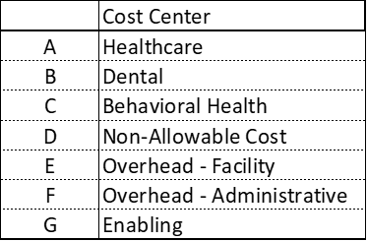

The amounts entered in the Increases and Decreases columns will automatically be transferred to the appropriate cost report line on Forms 1 through 5. It is important that the actual line #s on the cost report Forms 1 through 5 are entered in this Reclassifications tab, not the Excel row numbers. Also, please note that both Increases and Decreases in costs should be entered as positive numbers in this tab. The Cost Report will add those amounts reported in the Increases column and decrease costs for those amounts reported in the Decreases column.

Please verify that the total amount reported in the Increases column agrees to the total amount reported in the Decreases column. A common reclassification entry occurs if the medical director’s full salary cost is reported in the Physician line in the Healthcare cost center and the portion attributed to administrative functions are reclassed to Office Salaries in the Administrative cost center.

Tab 7. Adjustments
This worksheet provides for the opportunity to remove costs. Please remove any non-reimbursable expenses or add allowable. Adjustments that reduce costs should be entered as a negative number and those that add costs should be entered as a positive number.

Any bad debt expense is to be entered in Line 1 under “Amount”. Bad Debt should be reflected as a positive dollar value so it is included in the overall expense figure.

Similar to Reclassifications, the appropriate cost center and cost report line numbers per Forms 1 through 6 should be entered in Tab 7. The Cost Report Template will automatically post the adjustments to Forms 1 through 6.

Common adjustments might include but are not limited to:
- Investment income offsets
- Rental of building/office space – income offset versus cost allocation
- Related party transactions – reduced to the actual cost to the related party
- Donated space
- Outside contracted ancillary services

Tab 8. Other Information: Facility Square Footage

Please indicate the total amount of square footage utilized by your Health Center by cost center. This information will be utilized to allocate facility costs in the Medicaid rate calculation.

The following schedules in the Template, from Cost Breakdown through Form B – Cost Per visit, are password protected and formula-based so they will auto populate with results based on your data entries in Tabs 1 – 8. Projected rates can be found in Form B.

Cost Breakdown

This tab pulls in costs, square footage, and total visits from the expense tabs and allocating the costs by service. Total expenses are summed across all cost centers. Facility costs are allocated across cost centers based on how Square Footage is entered in Tab 8. Other Information. Enabling Services costs are allocated across cost centers based on how Billable Visits are entered in Tab 3. Providers. Note: The total allocated amounts and total expenses on this tab are prior to any reclassifications or adjustments. These values will not match those of Form A – Allocations. This is because Form A allocated expenses after reclassifications and adjustments are applied.

Note: Forms 1 through 7 and Forms A and B are all locked for editing, as they are entirely formula-based and pull from information in other tabs.

Forms 1 through 5

Form 1 (Direct Medical Cost), Form 2 (Direct Dental Cost), and Form 3 (Direct BH Cost) sum direct staff costs as well as other direct costs. Form 4 (Non-Allowable) sums non-allowable direct other service costs. Form 5 (Overhead & Enabling) sums facility, administrative, and enabling costs, all categorized as “Overhead”. These costs include salaries, benefits, other costs, and any reclassified or adjusted expenses.

Form 6A and 6B – Reclassifications and Adjustments

These forms pull from information in Tabs 6 and 7.

Form 7 – Visits by FTE

Total Visits and Total FTEs are pulled in by practitioner for Medical, Dental, and Behavioral Health providers.

Form A – Allocations

This tab allocates Non-Provider & Other Direct Costs between In-Bundle and Out-of-bundle FTEs across the cost centers, allocates costs based on Square Footage across the cost centers, and allocates administrative costs across the cost centers.

Form B – Cost per Visit

Cost per Visit is calculated for the combined Medical and Behavioral Health, as well as Dental. Total Adjusted Allowable Costs are divided by visits to get a Cost per visit for Medical/Behavioral Health and Dental.

Tab 9. Reconciliation
The purpose of this tab is to show and explain any difference in total revenue and expenses as reported on the cost report compared to what is on your organization’s financial statements.

Line 1: Total Cost Report Revenue
Do not manually enter. This line will be imported from Tab 2, line 45.

Line 2: Total Cost Report Expenses
Do not manually enter. This line will sum the values imported from Form A, Line 18 and Tab 7, Line 19.

Line 3: Net Income (Loss) Cost Report
Do not manually enter. This line will calculate the difference between Line 1 and Line 2.

Line 4: Profitability
Do not manually enter. This line will be calculated based on Line 1 and Line 2.

Line 5: Total Financial Statement Revenue
Enter the total revenue amount for the fiscal year on your financial statement that will be submitted with your cost report.

Line 6: Total Financial Statement Expenses
Enter the total expense amount for the fiscal year on your financial statement that will be submitted with your cost report.

Line 7: Net Income (Loss) Financial Statement
Do not manually enter. This line will calculate the difference between Line 1 and Line 2.

Line 8: Variance Between Cost Report and Financial Statements: Revenue
Do not manually enter. This line will calculate the difference between Line 1 and Line 5

Line 9: Variance Between Cost Report and Financial Statements: Expenses
Do not manually enter. This line will calculate the difference between Line 2 and Line 6

Line 10: Variance Between Cost Report and Financial Statements: Net Income
Do not manually enter. This line will calculate the difference between Line 3 and Line 7.
If your variance in Line 10 is $0, no further work is required on this tab.

If the variance is not $0, in the chart in Lines 11-15 explain the reason for the variance. Please enter all dollar amounts as positive numbers. Use as many Item numbers as needed.

See example below:
Reconciling Items
 | Description | Amount ($)
Reconciling Item #1 | The financial statement includes data for a service line that is separate from our CHC, so there is a difference between the cost report and financial statement. | $150,000

Line 16: Difference Between Total Reconciling Items and Variance Between Cost Report and Financial Statements: Net Income
Do not manually enter. This line will automatically calculate the difference between the total of all reconciling items and the variance between the net income of the cost report and financial statement. This should be zero. The variance in net income should be accounted for by the reconciling items. If it does not, please fix the reconciling item amounts in lines 10-15 to account for all variances between the cost report and financial statements.

Tab 10. Accuracy of Report
This schedule contains an overview of the agency’s revenue, expense, and profitability. The submitter must complete the provider certification by entering their electronic signature, the date, and their name in the blue cells in order to submit.

Below the filer’s acknowledgement is a list of requirements that must be met in order to successfully submit. If any of the items have an error, you must go back to that item and fix it.

When finished, click the “Save Submission” button in the bottom right of the tab. This button will only work if all of the above errors are cleared. An error is cleared when the error message is highlighted in green and reads “No Action Required.” If successful, the button automatically creates a pop-up box so you can save your template under the standard naming convention of “Org ID_Provider Name_CHCCRFY24”. Do NOT rename the file; it will not successfully upload in CHIA Submissions.

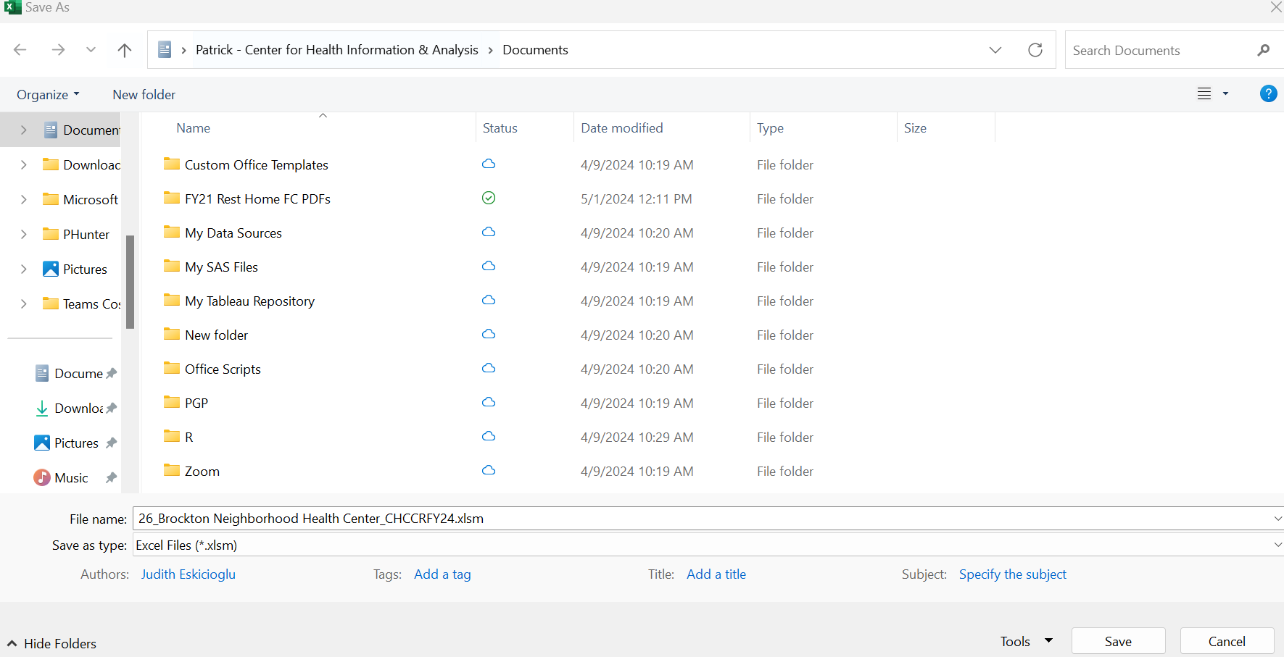

Save the file in a location you will remember when it is time to upload the cost report for submission.
You are now ready to visit the CHIA Submissions webpage to upload and submit the report by Fiscal Year.
Detailed instructions for submitting a saved cost report can be found in the CHIA Submissions User Guide.

QUESTIONS
If your agency has not registered with CHIA, you must do so to file the cost report. See page 6 for detailed steps on registering with CHIA.
If you have questions related to the CHIA Submissions portal, please email dl-data-submitter-helpdesk@chiamass.gov.
If you have any questions, please email CostReports.Pricing@chiamass.gov with the following information in the subject line of your email:
- Name of your agency with MassHealth ID #
- Name of the cost report you are asking about
- Cost report reporting year

Subject Line Example: Question on FY2024 Community Health Center Cost Report – ABC agency, ID# 123456789A

