CENTER FOR HEALTH INFORMATION AND ANALYSIS

CHIA SUBMISSIONS USER GUIDE:

Community Health Center
cost REPORT

April 2025


Table of Contents
A Few Reminders About the Process for Community Health Center Cost Report Submissions: 3
PURPOSE 3
RETRIEVING AND POPULATING THE TEMPLATE 3
Download the Excel Template 3
Open and View Tabs 3
Required Field Population 4
Saving the File 4
SUBMITTING THE EXCEL FILE 5
Community Health Center User Access: CHIA Submissions 5
Cost Report File Selection and Upload 8
FREQUENTLY ASKED QUESTIONS (FAQ) 10

A Few Reminders About the Process for Community Health Center (CHC) Cost Report Submissions:

- Community Health Center providers are required to submit completed cost reports through the Center for Health Information and Analysis’ (CHIA) online submission portal, CHIA Submissions.
- Providers will log into CHIA Submissions and upload complete CHC Cost Reports.
- All submissions must be saved using the “Save Submission File” button on Tab 10: Accuracy of Report. Submissions that are not saved by using this button cannot be read by CHIA’s system and will not successfully upload.

PURPOSE
The Center for Health Information and Analysis (CHIA), in accordance with its statutory authority under M.G.L. c. 12C, collects cost reports in furtherance of its mission to monitor the health care system in Massachusetts and to provide reliable information and meaningful analysis for those seeking to improve health care quality, affordability, access and outcomes. The data CHIA collects through the CHC Cost Report is used, among other things, to support the rate-setting obligations of the Executive Office of Health and Human Services (EOHHS), which uses the data to establish rates for CHC providers, and to complete additional analyses to inform policy-making. Once filed with CHIA, these reports become public documents and will be provided upon request to any interested party.
This document contains step-by-step instructions on how to retrieve and navigate the Excel cost report. It also contains the steps to properly save and upload the file to CHIA Submissions. “Frequently Asked Questions” are included at the end of the document for additional information.

RETRIEVING AND POPULATING THE TEMPLATE

Download the Excel Template
All CHC providers can download the cost report template by visiting the following URL: https://www.chiamass.gov/community-health-center-cost-reports-2/

Open and View Tabs

The cost report contains the following sections, which must be completed by the provider and certified by an authorized individual:
- 1. Agency Information
- 2. Revenue
- 3. Providers
- 4. Non-Providers
- 5. Cost Information
- 6. Reclass Template
- 7. Adjustment Template
- 8. Other Information
- Cost Breakdown
- Form 1 – Direct Medical Cost
- Form 2 – Direct Dental Cost
- Form 3 – Direct BH Cost
- Form 4 – NonAllowable
- Form 5 – Overhead & Enabling
- Form 6A – Reclassification
- Form 6B – Adjustments
- Form 7 – Visits by FTE
- Form A – Allocations
- Form B – Cost per Visit
- 9. Reconciliation
- 10. Accuracy of Report

Required Field Population
The Accuracy of Report tab, tab 10, details which fields must be populated in order to save and submit a completed report. If all fields in the table on Tab 10 say “No Action Required”, you have correctly populated all required fields. Upon hitting the Save Submission File button, any outstanding errors will be shown.

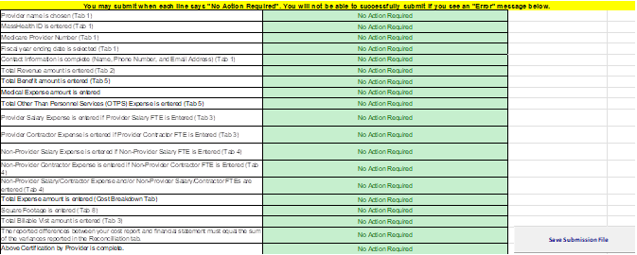

NOTE: The “Save Submission File” button is located in the lower right corner of the required fields in Tab 10. This button will automatically name your file in the required format that CHIA will accept. This is important when you submit your spreadsheet. Do NOT rename the file; it will not successfully upload in CHIA Submissions.

Saving the File
You may save a draft of the template at any time by using the “Save As” or “Save” options under the File menu in Excel.

PLEASE NOTE: Submissions to CHIA must be saved using the “Save Submission File” button. Do not submit using another file name, as CHIA will not be able to process the submission.
SAVING THE FILE FOR SUBMISSION TO CHIA:
After completing the Excel spreadsheet, providers must save the report using the “Save Submission File” box located in the bottom right-hand side of the Accuracy of Report tab. This will automatically open your workstation’s Save functionality. Please use the pre-formatted naming convention that is designed to work in CHIA’s upload system. This pre-formatted name will be auto-populated in the Save As box that appears when you click the “Save Submission File” button.
It will be formatted as follows: ‘OrgID_FacilityName_CHCCRFYXX’ The file name’s fiscal year should reflect the fiscal year for which the cost report is being submitted. See example below:
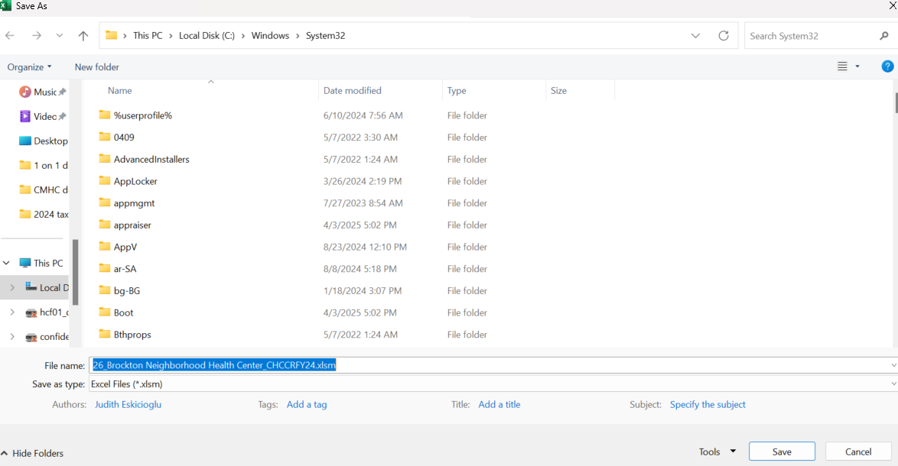

You are now ready to visit the CHIA Submissions webpage to upload and submit the report.

SUBMITTING THE EXCEL FILE

Community Health Center User Access: CHIA Submissions
- Access CHIA’s online submission platform at https://chiasubmissions.chia.state.ma.us. Then log-in with a valid username and password. The login credentials will be the same as the ones used for INET submissions.
  - If you are new user for a facility that is registered with CHIA, please complete a User Agreement and email the completed form to CostReports.Pricing@chiamass.gov.
  - If you are a new user for a new facility that is not registered with CHIA you must also submit a Business Partner Security Form to CostReports.Pricing@chiamass.gov in order to submit a complete cost report through CHIA Submissions.
  - Please refer to the Cost Report Instructions for more detailed steps on submitting these forms. For technical issues with CHIA Submissions, please email dl-data-submitter-helpdesk@chiamass.gov.

Please Note: CHIA Submissions works best with Google Chrome.
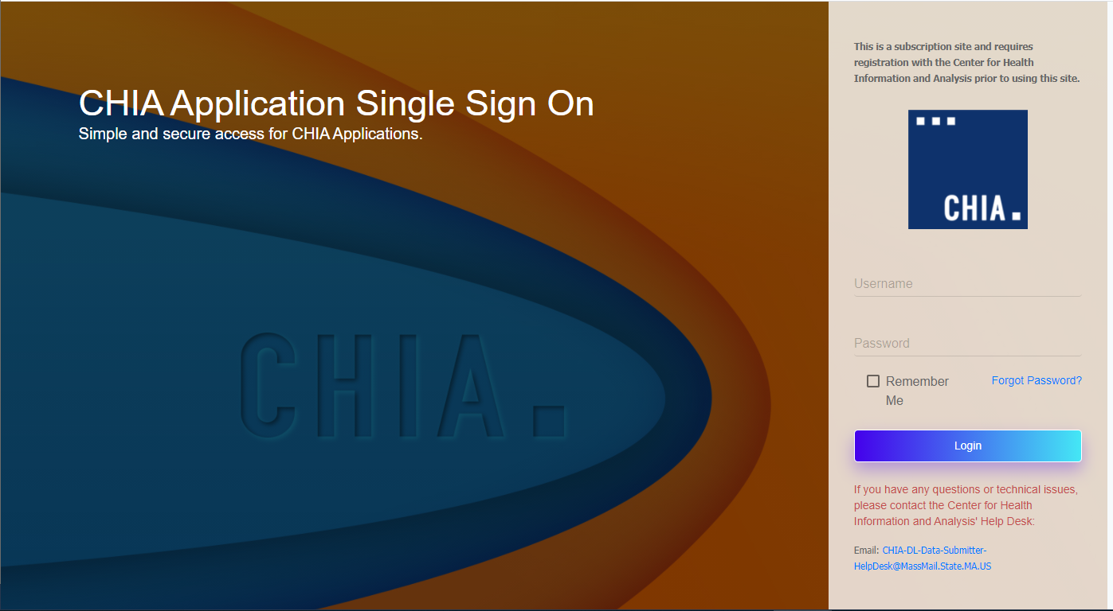

- Successful access brings you to the Main Menu page. Choose the selection box titled ‘CHIA File Submissions’. You may have access to more than one box depending on other projects for which you have applied.
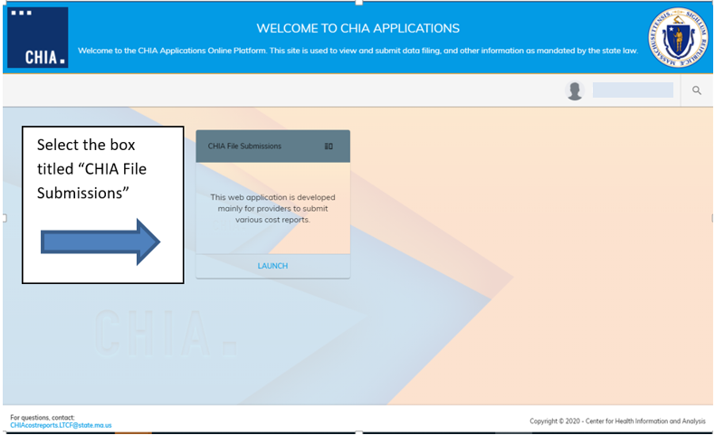

- If you submit other cost reports, aside from the Community Health Center Cost Report, you will see a drop down list containing all the possible reports you can submit. Select “Community Health Center Cost Report” from the drop down menu.

- If you are the designated user for multiple facilities, you will see them listed under the “Agency Name” column on the left hand side. If you are affiliated with only one facility, the “Agency Name” column will not be displayed. Your Agency name will be displayed at the top, above the Save and Upload button.

- If you see more than one facility, select the facility you are submitting for by clicking the check mark next to the facility name. If you do not see agency names, this does not pertain to you.

Cost Report File Selection and Upload
- Choose the correct ‘Fiscal Year’ via the available dropdown boxes on the right. The Fiscal Year chosen should match the fiscal year on the cost report you are submitting

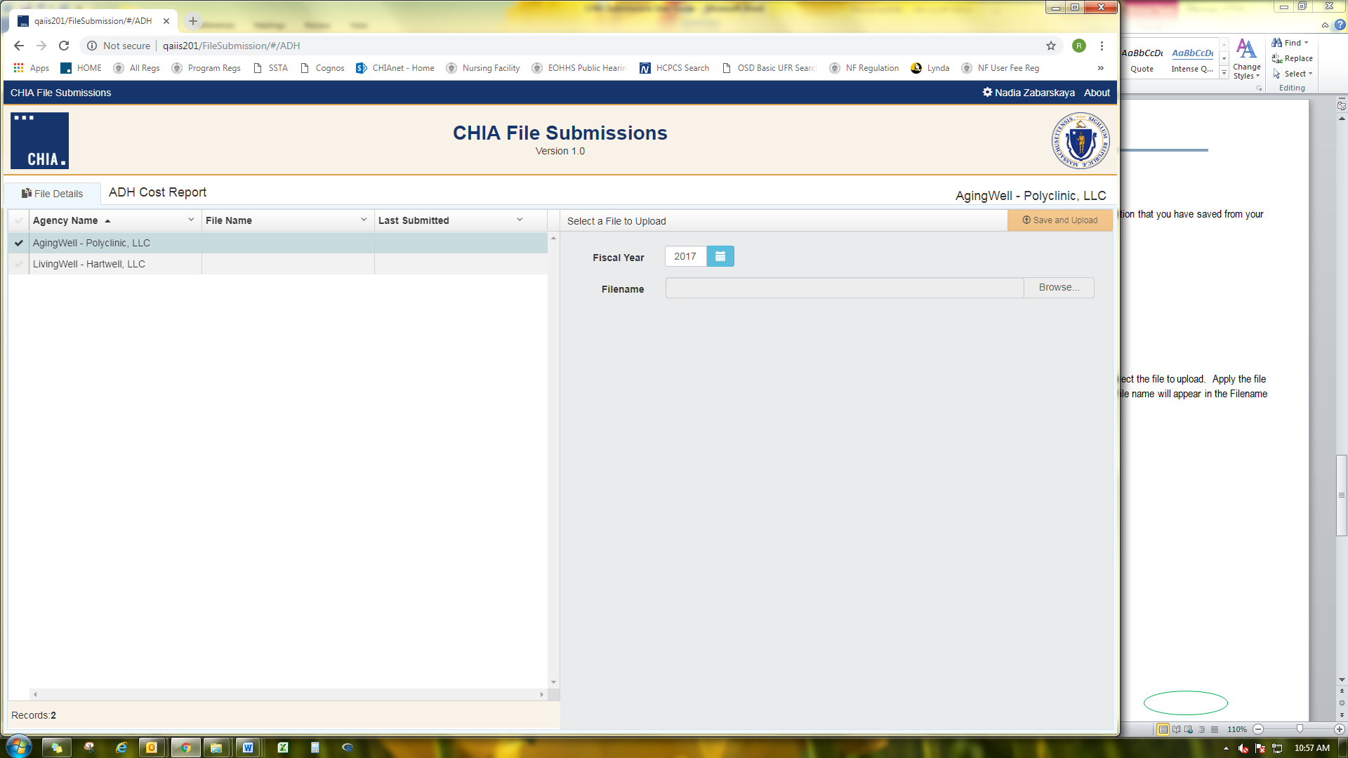
20XX

- Once selected, hit the ‘Browse’ button to choose the final file with the CHIA naming convention that you have saved from your own computer workstation.

- Browse your File Manager or your Windows Explorer on your computer workstation and select the file saved using the “Save Submission File” button from the Excel cost report template. Apply the file to CHIA Submissions by using the ‘Open’ key in the lower right corner of the screen. Your file name will appear in the Filename line.
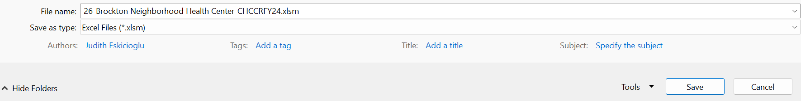

- To upload the File, to the CHIA Submissions application, hit the Save and Upload button.

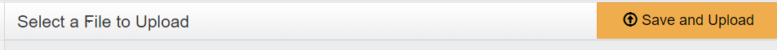

- When the progress bar shows 100%, you will see your Filename is uploaded successfully.
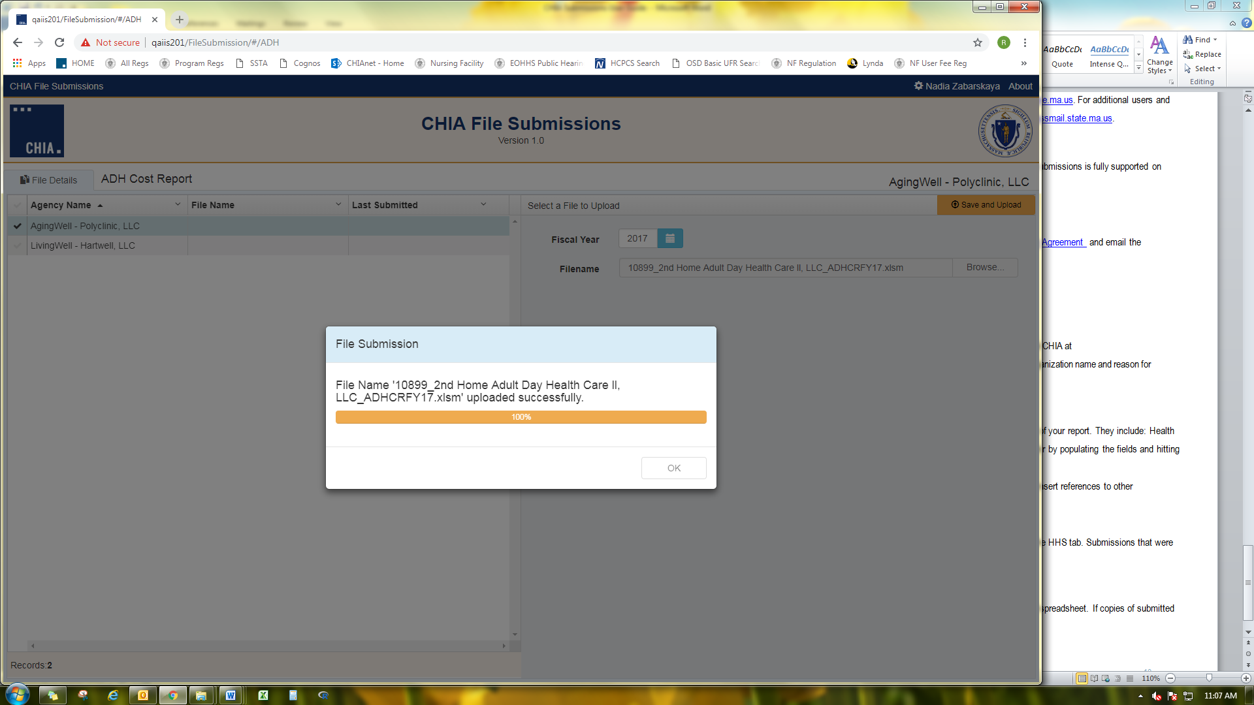

FREQUENTLY ASKED QUESTIONS (FAQ)
- Who can access the web application?
Users who are registered with CHIA to submit the Community Health Center Cost Report will be able to access the application located at https://chiasubmissions.chia.state.ma.us. For additional users, follow the instructions under FAQ #3.

- What are my system requirements?
The Microsoft (MS) Excel template is fully supported with MS Excel 2010 or higher. CHIA Submissions is fully supported on Google Chrome.

- How can I request to add new user(s)?
- If you are new user for a facility that is registered with CHIA, please complete a User Agreement and email the completed form to CostReports.Pricing@chiamass.gov.
- If you are a new user for a new facility that is not registered with CHIA you must also submit a Business Partner Security Form to CostReports.Pricing@chiamass.gov in order to submit a complete cost report through CHIA Submissions.
- Please refer to the Cost Report Instructions for more detailed steps on submitting these forms. For technical issues with CHIA Submissions, please email dl-data-submitter-helpdesk@chiamass.gov.

- Can one provider have multiple submitters?
User access can be granted for multiple individuals.

- How do I update information in a submitted report?
If a provider needs to update information in an already submitted report, users should email data@chiamass.gov to inform CHIA of the intent to resubmit and provide good cause for resubmission. Users should make the appropriate changes to the cost report in the local workstation and resubmit it by following the steps detailed in this user guide.

- What are the different types of errors and how do I avoid them?
- All errors on Tab 10: Accuracy of Report must be cleared to submit. If there is an error, please follow the description of the error to go to the relevant tab and correct it.
- All submissions must be saved using the “Save Submission File” button on Tab 10. You will be unable to save if all errors are not cleared. Submissions that were not saved by using this button cannot be read by CHIA’s system.
- Data can be pasted in. Please paste as values and refrain from attempting to re-format the cost report template. If you choose to paste values, please ensure that numbers entered are whole numbers, unless it is stated that decimals are allowed. Please consult the cost report instructions for detailed information on where decimals are allowed in the cost report.

- Can I view submitted reports?
The provider that submitted the report has the original copy of the Excel spreadsheet. If copies of submitted data are needed from CHIA, please contact data@chiamass.gov.

- Who can I contact with questions?
If you have any questions, please email CostReports.Pricing@chiamass.gov with the following information in the subject line of your email:
- Name of the agency with MassHealth ID #
- Name of the cost report you are asking about
- Cost report reporting year

Subject Line Example: Question on FY2024 Community Health Center Cost Report – ABC agency, ID# 123456789A

