Monthly APCD User Workgroup Webinar
February 25, 2014
Agenda
- APCD / Case Mix Website Tour
- Frequently Asked Questions from Current APCD Users
- SME Office Hours
Website Tour – APCD
www.mass.gov/chia/apcd
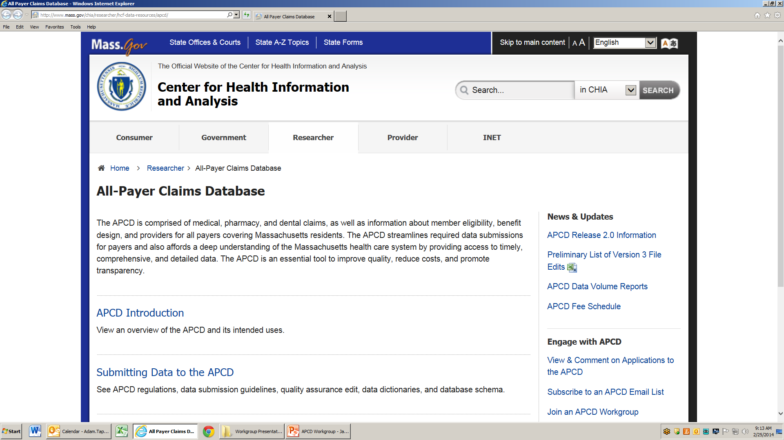

Website Tour – APCD
http://www.mass.gov/chia/researcher/hcf-data-resources/apcd/accessing-the-apcd.html
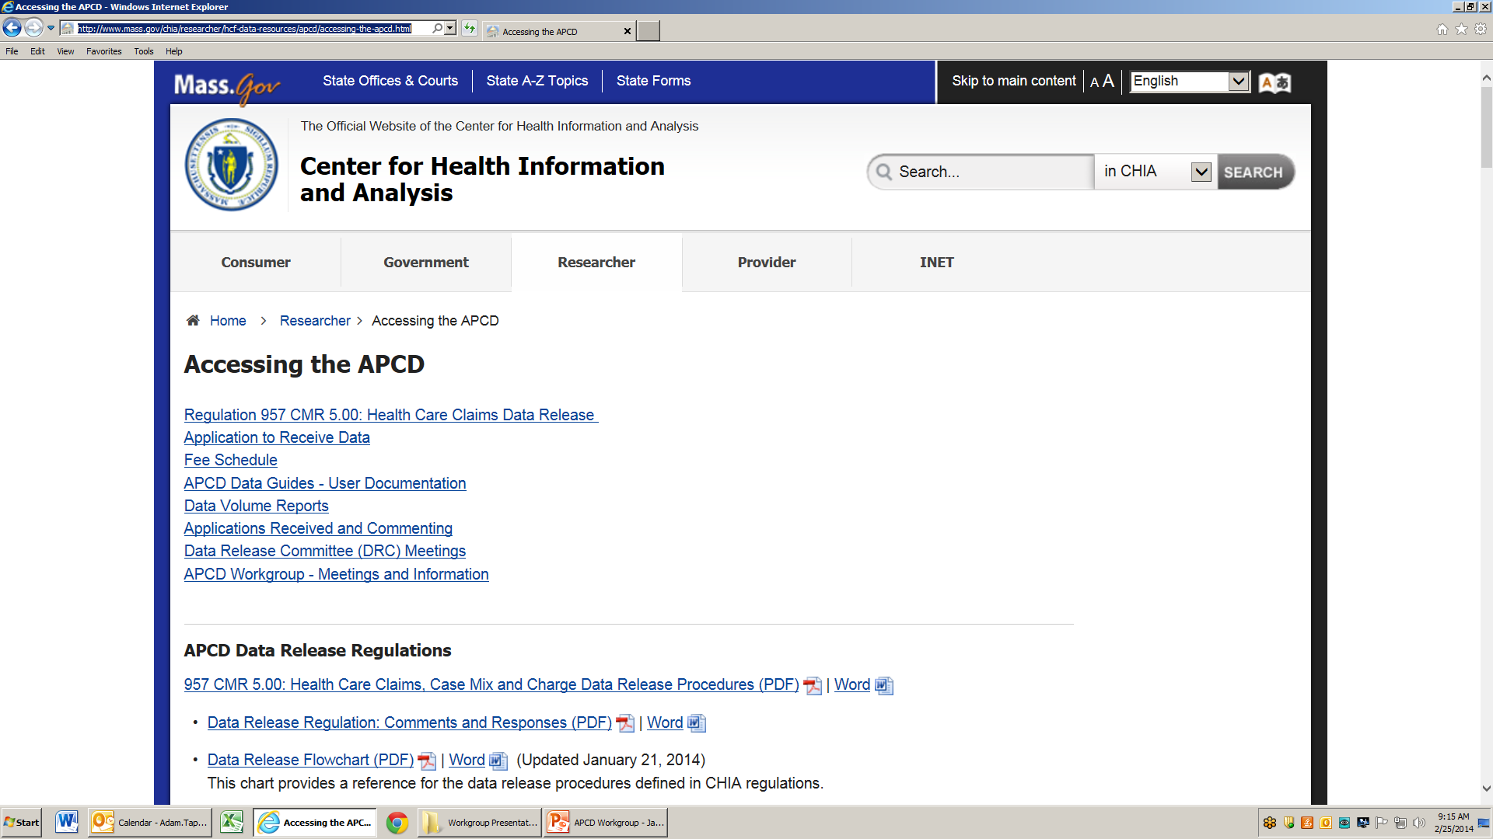

Website Tour – APCD
Application Materials and Fee Schedule
See: http://www.mass.gov/chia/researcher/hcf-data-resources/apcd/accessing-the-apcd.html#fee_schedule
APCD Release 2.0 Data Guides
See: http://www.mass.gov/chia/researcher/hcf-data-resources/apcd/accessing-the-apcd.html
Website Tour – Case Mix
See: http://www.mass.gov/chia/researcher/hcf-data-resources/case-mix/
FAQs from Current Users
Question: We received [Element X], but it is incompletely populated or not populated.
Answer: Consult the APCD Data Guides before requesting an element. Note edit levels and thresholds. In the coming months, we plan to publish data profiles on the largest carriers.
Question: We realized there are some additional elements we need, but did not request.
Answer: To request an amendment, please send an email to APCD.data@state.ma.us
Question: We need to link/define members across the files we received (e.g,. Medical Claims, Member Eligibility, Pharmacy), but we are not sure how to do this. Are there variables that allow us to do this?
Answer: Records between claims files and eligibility files should be linked via the OrgID and the Hashed Carrier Specific Unique Member ID. This may not always work, due to variation in submission by the carriers. The anticipated Master Member Index, to be release in mid-2014, may alleviate this issue.
Question: How do we determine “final” paid adjudicated status claim. Do we use the version identity of the claim? Do we use the fact that a “former” version of the claim is populated?
Answer: CHIA has a standard version logic that’s based on the APCD submission guide. This logic may need to be modified depending on how each carrier submits their data to APCD. In Release 2.0, CHIA included a “highest version” flag for seven of the largest carriers. For more details on this, please see relevant sections of APCD Release 2.0 Documentation Guides
Question: Some Plans submitted lookup tables for medical specialties and some did not. How do we determine medical specialties for those Plans that did not submit lookup tables? Can we assume that they use some form of national taxonomy?
Answer:
- For descriptions of Specialty data element codes, users should first link orgid + data_element_code to TlkpCarrierSpecificCodes_All_Redacted. Then, the unmatched should be linked to the standard provider specialty codes as described in the relevant Data Documentation Guide.
- For description codes of PV029, users should link orgid + data_element_code to TlkpCarrierSpecificCodes_All_Redacted.
**We will be publishing a note related to this issue in the near future**
SME Office Hours
Every Meeting!
- Our subject matter experts are available to answer your technical questions about APCD and Case Mix data.
- Please submit your questions in advance when possible.
  - Examples:
    - “How stale is the data we would get from the Dental file?”
    - “Are mental health and substance abuse claims contained within the APCD?
    - “Can you explain discharge dispositions as they relate to Case Mix data?”
Questions?
- General questions about the APCD:
(CHIA-APCD@state.ma.us)
- Questions related to APCD applications: (apcd.data@state.ma.us)
- Questions related to Casemix: (casemix.data@state.ma.us)
Calendar
- 2/27 – February Data Release Committee Meeting
- 3/11 – Monthly APCD Technical Assistance Group Meeting
- 3/25 – Monthly APCD User Workgroup Webinar
- 3/27 – March Data Release Committee Meeting

