CENTER FOR HEALTH INFORMATION AND ANALYSIS

COST REPORT INSTRUCTIONS:
Adult Day Health (ADH) cost REPORT

April 2025


TABLE OF CONTENTS

REMINDERS ABOUT THE ADH COST REPORT 3
PURPOSE 3
WHO MUST FILE 3
WHAT TO FILE 4
WHEN TO FILE 4
RETRIEVING AND POPULATING THE TEMPLATE 5
Download the Excel Template 5
Open and View Tabs 5
Required Field Population 6
6
GENERAL COST REPORT INSTRUCTIONS 6
Tab 1: Agency Information 7
Tab 2: Schedule A - General Information 8
Tab 3: Schedule B – Program Unit Information/Operations Information 9
Tab 4: Schedule C - Direct Client Transportation 9
Tab 5: Schedule D - Staffing Information 11
Tab 6: Schedule E - Statement of Expenses 14
Tab 7: Schedule F - Calculation of Allocation Bases 16
Tab 8: Schedule G - Statement of Revenue 16
Tab 9: Accuracy of Report 16
SAVING THE FILE 17
QUESTIONS 18
Appendix A: Allocation Examples 18
Case I: Direct Expense Allocation 19
Case II: Other than Direct Expense Allocations 19
Case III: Schedule F, Part 3 20

REMINDERS ABOUT THE ADH COST REPORT
- Providers are required to submit completed cost reports through CHIA’s online submission portal, CHIA Submissions. Please note, CHIA Submissions works best in Google Chrome.
- Please read all Cost Report Instructions and the CHIA Submissions User Guide thoroughly prior to beginning the cost report.
- The ADH cost report is available as an Excel template. Complete cost reports will be submitted via CHIA Submissions. Financial statements should be emailed to data@chiamass.gov, not uploaded through CHIA Submissions.
- Providers will log into CHIA Submissions and upload complete ADH Cost Reports.
- Data must be keyed in. Please do not insert formulas or references to other spreadsheets as this may prevent the data from calculating accurately.
- All numbers must be whole numbers without decimals, except for Tab 3, Schedule B: Program Information, Hours per week, and Tab 5, Schedule D: Staffing Information, columns 5, Total Hours Compensated – Agency, 6, Total Hours Compensated – ADH, 7a, FTEs ADH Admin and 7b, FTES ADH Direct.
- In Schedule D, if ADH hours are entered in Column 6, Agency hours should be entered in Column 5 for each staffing type. If you have no information to report for a given staff type, leave the cell blank.
- The ‘Certification by Provider’ section, in the blue cells in Tab 9, must be filled in to save successfully.
- All submissions must be saved using the “Save Submission File” button on Tab 9, Accuracy of Report. Submissions that are not saved using this button cannot be read by CHIA’s system and will not successfully upload.

PURPOSE
The Center for Health Information and Analysis (CHIA), in accordance with its statutory authority under M.G.L. c. 12C, collects cost reports in furtherance of its mission to monitor the health care system in Massachusetts and to provide reliable information and meaningful analysis for those seeking to improve health care quality, affordability, access and outcomes. The data CHIA collects through the ADH Cost Report is used, among other things, to support the rate-setting obligations of the Executive Office of Health and Human Services (EOHHS), which uses the data to establish rates for Adult Day Health providers, and to complete additional analyses to inform policy-making. Once filed with CHIA, these reports become public documents and will be provided upon request to any interested party.
This document contains step-by-step instructions on how to retrieve and fill out the Excel cost report. Detailed steps for uploading and submitting a completed cost report can be found in the CHIA Submissions User Guide.

WHO MUST FILE
Adult Day Health providers that participated in the MassHealth (Medicaid) program for the reporting year must file unless they meet the exemption criteria.
The term “provider” will be used throughout these instructions to refer to all filers.
PLEASE NOTE
The ADH cost report filing will NOT be considered complete until all relevant financial data and all additional documentation requested by CHIA staff has been provided to the satisfaction of CHIA staff.

Please refer to 957 CMR 6.00: Cost Reporting Requirements for information on penalties for non-compliance.
Exemptions
An agency may request an exemption if it meets one of the following criteria:
1) The agency is hospital-owned;
2) The agency was in business for less than 6 months during its FY2024;
3) The agency was owned by the current owner for less than 6 months during its FY2024;
4) The agency did not participate in the MassHealth program during its FY2024; or
5) The agency received less than $50,000 in MassHealth revenue in its FY2024.
An agency claiming an exemption on any of the above grounds must notify CHIA of the reason for its exemption by emailing the ADH Exemption Request form available on the CHIA website to data@chiamass.gov. Please save the file as Provider Name_MassHealth ID_ Exemption Request_FY2024.

WHAT TO FILE

- Cost Report. Agencies must file the cost report annually with CHIA for the fiscal year that ended in the year prior to the filing date. The report is available for downloading on CHIA’s website.

The reporting period shall be consistent with financial statements. The cost report shall be completed on the basis of the total program costs.

- Financial Statements. Agencies must submit copies of financial statements and other external documentation supporting the accuracy of the data reported on the cost report.

Agencies must file one of the following forms of acceptable documentation (in descending order of preference):
- Audited, reviewed, or compiled financial statements prepared by a Certified Public Accountant (CPA), preferably completed using generally accepted accounting principles (GAAP);
- For unaudited financial statements, a certification from a CPA attesting to the accuracy and validity of the data reported on the cost report is recommended. A certification form can be found on the CHIA website. The CPA must not be a related party to the principal owners or partners of the agency;
- Copies of tax returns filed with the Internal Revenue Service (IRS) for the reporting year;
- Unaudited financial statements for the reporting year.
Email financial statement documents to the following email address data@chiamass.gov.
Label all PDF files with the ADH provider’s name, MassHealth ID, document type, and year. For example, financial statements can be labeled as AgencyName_MassHealth ID_FS_FY24.pdf.

WHEN TO FILE
All ADH providers have the same due date. Agencies must file the ADH cost report and financial statements no later than June 2, 2025.

NOTE: If you would like to be added to CHIA’s email list to receive cost report alerts, including deployment and due dates, please request that your email address be added by emailing CostReports.Pricing@chiamass.gov.

Extensions

Agencies may request a filing extension for a period of two weeks if the following criteria are met:
- The extension request must be submitted in writing to the attention of “ADH Cost Report Submission.”
- E-mail is an acceptable method to request an extension. Please send your request to data@chiamass.gov.
- The request must demonstrate a good cause or circumstances for the filing extension.

RETRIEVING AND POPULATING THE TEMPLATE

Download the Excel Template
All Adult Day Health providers can download the cost report template by visiting the following URL: http://www.chiamass.gov/adult-day-health-cost-reports-2/

Open and View Tabs
Upon opening the template, select Enable Editing at the top of the screen, above the formula bar, to be able to work on the report. You must also select ‘Enable Content’. Failure to select Enable Content will result in an inability to successfully use the template and save.
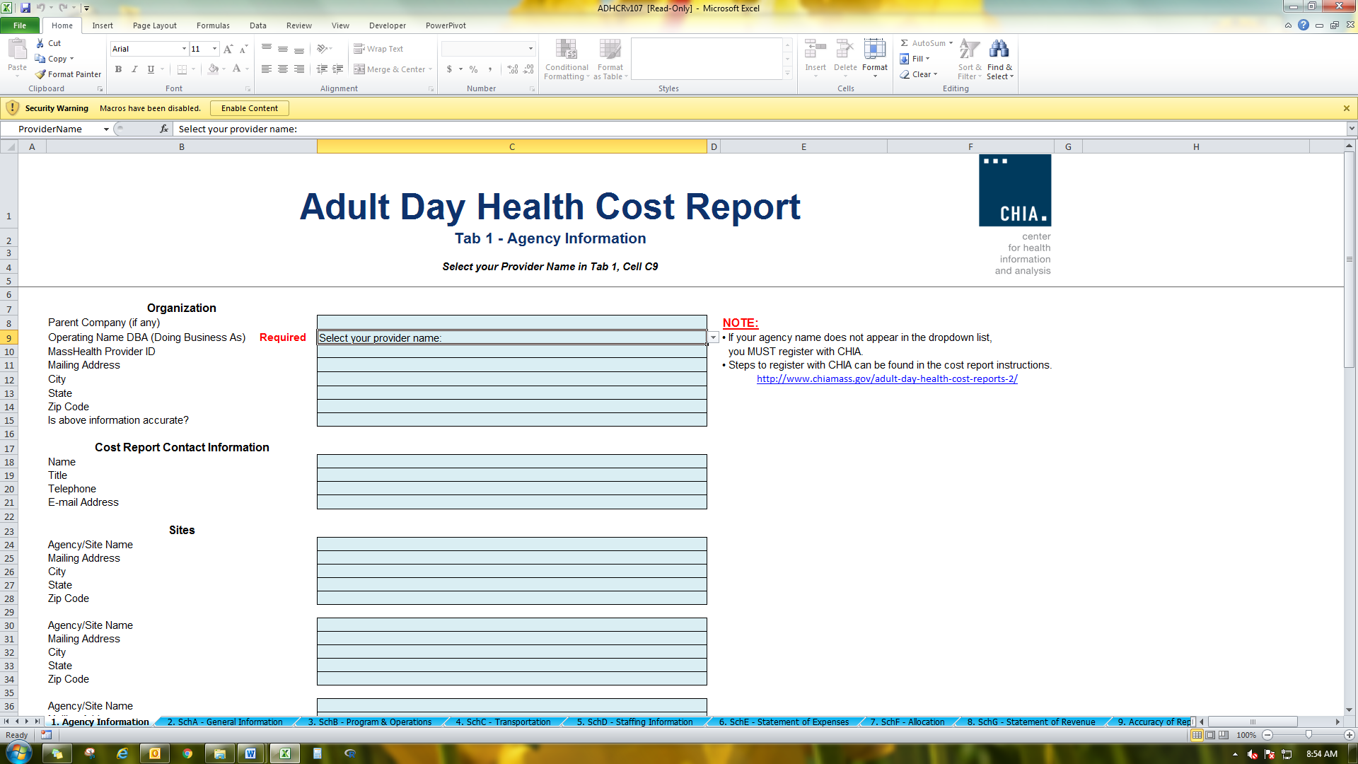

The Excel template contains 10 tabs, including 7 schedules:
- Agency Information
- Schedule A – General Information
- Schedule B – Program and Operations
- Schedule C – Direct Client Transportation
- Schedule D – Staffing Information
- Schedule E – Statement of Expenses
- Schedule F – Statement of Basis of Allocated Expenses
- Schedule G – Statement of Revenue
- Accuracy of Report – contains the file Save Submission File button
- Legend

NOTE
Please be sure to check that your agency name is in the drop down list in Tab 1 PRIOR to initiating work on the cost report.
If your agency name does not appear in the drop down list in Tab 1 of the cost report or you are a new filer with CHIA, you MUST fill out, scan, and send a User Agreement and a Business Partner Security Agreement form to dl-data-submitter-helpdesk@chiamass.gov BEFORE you begin working on the cost report and attempt to submit a completed cost report.

Required Field Population
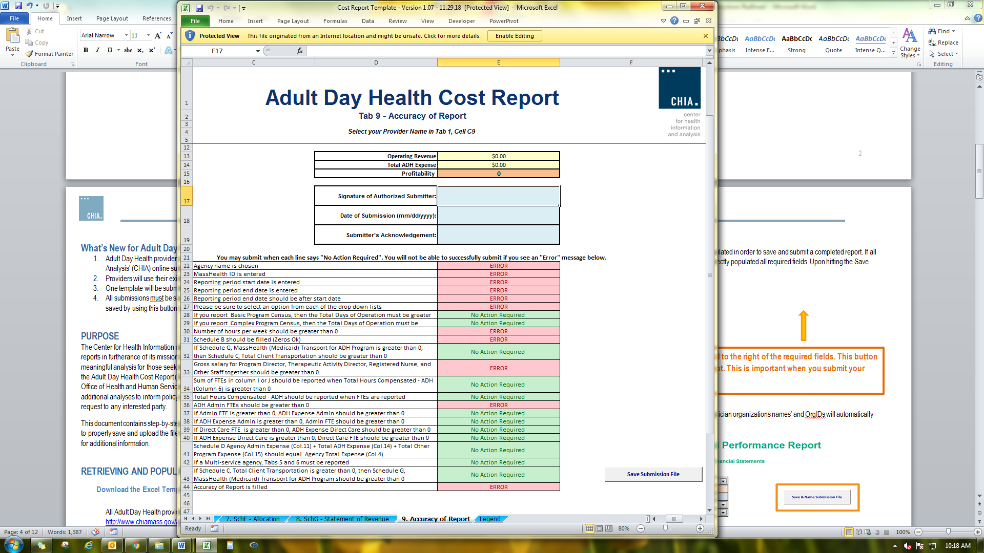
The Accuracy of Report tab, Tab 9, details which fields must be populated in order to save and submit a completed report. If all fields in the table on Tab 9 say “No Action Required”, you have correctly populated all required fields. Upon hitting the Save Submission File button, any outstanding errors will be shown.

NOTE: The “Save Submission File” button is located in the lower right corner of the required fields table in Tab 9. This button will automatically name the file in the required format. This is important when you submit your spreadsheet. Do NOT rename the file; it will not successfully upload in CHIA Submissions.

GENERAL COST REPORT INSTRUCTIONS

Agencies should use the accrual basis of accounting. All numbers must be whole numbers without decimals, except for Tab 3, Schedule B: Program Information, Hours per week, and Tab 5, Schedule D: Staffing Information, columns 5, Total Hours Compensated – Agency, 6, Total Hours Compensated – ADH, 7a, FTEs ADH Admin and 7b, FTES ADH Direct.

You may navigate among the schedules of the ADH cost report by clicking the tabs at the bottom of the workbook, which allow you to select the schedule to which you wish to go.
You may paste data into the cost report template from existing worksheets. Please paste as VALUES. If you fail to paste as values, you will not be able to save and submit successfully. Please check that pasted values are WHOLE numbers, aside from those fields where decimals are allowed. Upon clicking the “Save Submission File” button, you will be alerted to any errors due to incorrect pasting.
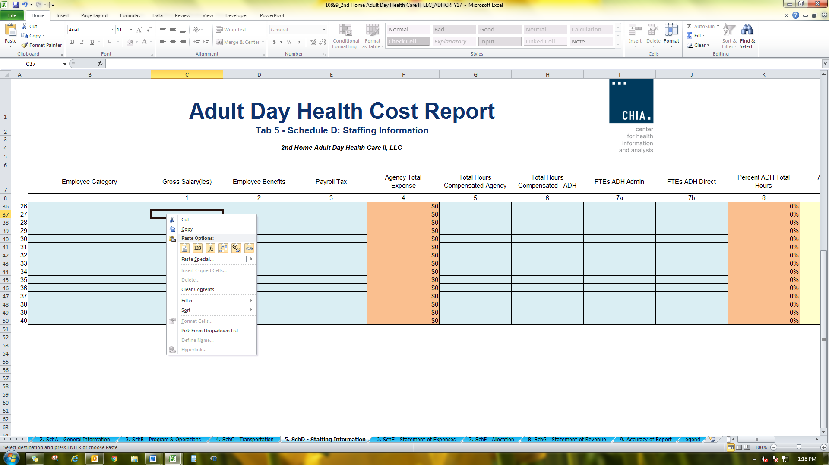
SAVE ENTERED DATA OFTEN. You may save a draft of the template at any time by using the “Save As” or “Save” options under the File menu in Excel.
The cost report has three different kinds of cells, designated by three different colors. The table below explains what each color means. Providers are only responsible for entering data into the blue cells.

PLEASE NOTE

Submissions to CHIA must be saved using the “Save Submission File” button. Please save the file using the auto-populated file name that is designed to work in CHIA’s upload system. Do not rename the file, as CHIA will not be able to process the submission. This process is detailed in the CHIA Submissions User Guide.

Tab 1: Agency Information

There are three sections of the Agency Information schedule:

- The first section, “Organization”, includes Operating Name (Doing Business As), Parent Company (if any), Mass Health Provider ID (This consists of 9 numbers for the provider ID# and 1 letter for the location. Ex: 123456789A) and Mailing Address.

The following are definitions for terms used in the Agency Information schedule:

Parent Company – Some organizations’ structure includes an entity that operates and controls all its affiliates.

For example, a company called “ADH Centers of Massachusetts” owns and operates two ADH centers called “Plainville ADH” and “Centerville ADH”. In this example, the parent company would be “ADH Centers of Massachusetts”.

Operating Name DBA (Doing Business As) – The name of a stand-alone ADH program or a subsidiary of a parent company.

For example, a company called ADH Centers of Massachusetts owns and operates an ADH center called “Plainville ADH”. In this example, the subsidiary or Operating Name of the ADH would be “Plainville ADH”. For our purposes, the Operating Name is also the name of an independently owned ADH with no other affiliations/parent company.

All agencies that are in CHIA’s database can be found in the dropdown list. If your agency is not in the drop-down list, you are not registered with CHIA’s database.

    - You must register with CHIA in order to have your Agency name added to the list.
    - To register with CHIA, please fill out the following forms and submit them to dl-data-submitter-helpdesk@chiamass.gov.
      - User Agreement form: http://www.chiamass.gov/assets/docs/p/inetuseragreementotherprovider.pdf
      - Business Partner Security form: http://www.chiamass.gov/assets/docs/p/inet/confidential-business-partner-agreement-2018.pdf
    - You will be added to CHIA’s database and will receive an updated template, via email, 2-3 days after submitting your agreement form.

- The second section, “Cost Report Contact Information”, must be completed in its entirety. ADH providers must fill in the primary contact’s Name, Title, Telephone and Email address line items.

- The third section, “Sites”, asks for all agency site addresses that an ADH provider has. To complete this section, fill in the Location Name, Mailing Address, City, State and Zip Code for each location the ADH agency has. You may enter up to 10 additional sites.

Tab 2: Schedule A - General Information

- Reporting Period
Enter the dates for the filing year’s fiscal year for which data is reported. Please enter the dates as mm/dd/yyyy.

- Legal and Financial Information.
Choose the appropriate legal and financial affiliations in the drop down lists.

NOTE: If you choose Multi-service agency, those that offer other services in addition to Adult Day Health services, as your legal affiliation, you must complete Schedule D, Column 15, Total Other Program Expense, and Schedule E, Column 5, Total Other Agency Expense.

- Program Type
Choose the program type or the types of clients or services the agency bills for from the drop down list. The options are Basic, Complex, or a case mix of Basic and Complex.

- Other Cost Reports
Please specify if you file any additional cost reports with CHIA or the Operational Services Division (OSD) in the drop down list. If you do not submit the HCF-1 or UFR, please select “Neither HCF-1 nor UFR.”

Tab 3: Schedule B – Program Unit Information/Operations Information

Program Units

All cells must be filled in; if there is nothing to report, please put a zero.

- Program Unit Count: Enter both full day and 15 minute units for each service level (basic and complex) for the fiscal year.
Lines 1, 3, 10, and 12 – Total Program Unit Count (MassHealth ONLY) - should only contain units billed to MassHealth.
Lines 2, 4, 11, and 13 – Total Program Unit Count (NON-MassHealth ONLY) – should contain all non-MassHealth units billed. For example, services billed to the Veteran’s Administration (VA), private insurance, or Senior Care Options (SCOs).

NOTE: The full day unit count includes only 6 full hour visits. If a visit is less than 6 hours, the unit count would be the number of 15 min units equal to the time spent in the visit. If the unit count is greater than zero, then the total days of operation should be greater than zero. There are 4 (four) 15-minute units in 1 (one) hour. If you are converting hours to 15-minute units, multiply the number of hours by 4 (four).

- Total Days of Operation: Enter the number of days of the year for which the agency was scheduled to be open for service. If you report any unit count then you must have a total days of operation that is greater than zero.

NOTE: Low attendance days, such as days when only two participants were present, should be still counted towards the total days of operation for the year. These days should not be included anywhere else.

- Total Number of Absences: Enter the difference between the total number of clients booked and the total number of clients that physically arrived at the agency for both full day and 15 minute units.
Lines 6, 8, 15, and 17 – Total Number of Absences for the Year (MassHealth ONLY) - should only contain the number of Mass Health absences.
Lines 7, 9, 16, and 18 – Total Number of Absences for the Year (NON-MassHealth ONLY) – should contain all of the NON-MassHealth absences.

- Total Unplanned Closings: Enter the number of days that the agency cancelled operations due to snow days or other conditions that were beyond the control of the agency.

Operations Information

- Hours per week: Enter the number of hours per week that constitutes full-time employment at the agency. This is typically 40 hours or less.
- Hours per year: This will automatically calculate the number of hours/years which corresponds to the answer for hours/week.
- Hours of service: Enter the hours that the agency operates in the “From” and “To” boxes. Enter time in hh:mm am/pm format.
Please be sure to have a space between the last minute and “am/pm.” For example: 8:00(space)AM
Monday From To
08:00 AM | 04:00 PM

Tab 4: Schedule C - Direct Client Transportation

Direct Client Transportation

These are the travel expenses incurred by transporting clients to and from the agency; including expenses incurred transporting private pay clients. Only direct client transportation expense should be recorded on Schedule C.

THE Direct Client Transportation EXPENSES SHOULD NOT BE ENTERED ON SCHEDULES D AND E.

Other transportation expenses, such as mileage paid to administrative staff, or wages paid to staff for other transportation needs of the agency should be included in the transportation related line items on Schedules D and E.

Total Client Transportation Billed to MassHealth: Enter the total amount billed to MassHealth for direct client transportation.

NOTE: If an expense is recorded on Schedule C “Total Client Transportation”, then MassHealth transportation revenue on Schedule G Statement of Revenue, Part 1, Direct Third Party Revenues, next to “MassHealth (Medicaid) Transport”, must be recorded. If it is not, an error message will appear when attempting to submit.

Agency Provided Expense (Line 3) is equal to the sum of lines 5 through 10.

Total Direct Client Transportation (Line 4) is equal to the sum of lines 2 and 3.

Agency-Provided Expense Breakdown

These are the transportation expenses incurred when the agency itself provides the transport (i.e., use of an agency van). This must be reported in detail by category of expense.

Total of Other List Expense (Line 10) is equal to the sum of lines 11 through 19.

Expense Information (Schedules D, E, F)

This section of the cost report consists of Schedule D “Staffing Information”, Schedule E “Statement of Expenses”, and Schedule F “Statement of Basis of Allocated Cost”. These schedules request cost information for both the Adult Day Health center, and, if applicable, the overall parent organization. The information for the entire agency will facilitate the accurate allocation of costs that cannot be allocated on a direct basis to the Adult Day program.

Basis of Allocation

CHIA provides the following acceptable methods to allocate general ledger expenses to the three potential cost centers of a parent agency (Agency Administration, Adult Day Program, and Other Programs).

Schedules D (Staffing Information) and E (Statement of Expense) contain drop-down buttons indicating each method with a capital letter-designation, as noted below.

Wherever possible, the Direct Expense basis should be used as a primary allocation method.

The following section describes each method and provides the identifying letter.

D - Direct Expense Basis: Any cost that can be identified as applying only to the Adult Day Health program, or only to other programs, should be entered directly into that cost center.

H - Hours of Service Basis: Compensation expense that cannot be charged directly is allocated by the percentage of time spent in each cost center. (Applies to Schedule D).

S - Square Footage Occupancy Basis: Space occupancy costs and maintenance and housekeeping salaries that cannot be charged directly are allocated on the basis of the percentage of square footage occupied by each cost center. If the Adult Day health program cost can be charged on a direct basis (e.g., rent for a separate building), the balance of the cost is allocated between the other two cost centers (if it applies to both) based on the percentage of square footage occupied by each remaining cost center out of the total. The square footage percentages for both cases are calculated in Schedule F, Part 1.

O - Operating Expense Basis: In cases where expenses apply only to the agency as a whole, or cannot be charged directly, allocate on the basis of the percentage of each cost center's operating expense of the total agency's operating expense. These percentages are calculated in Schedule F, Part 3.

NOTE: each applicable expense would appear in Column 3, Schedule E, “Agency Administrative
Expense”, and would be auto-summed in line 26. On the basis of Schedule F, Part 3, an automatic
allocation would occur to Columns 4 and 5.

C - Compensation Expense: Use this method in cases where an expense applies to all three cost centers, but the costs of the Adult Day program can be charged directly. Allocate the balance of that expense between Agency Administration and Other Programs, based upon the percentage of compensation expense of each remaining cost center out of the total of the two. Schedule F, Part 2 will provide these percentages.

Please contact CHIA if the agency has another method that more accurately depicts how its resources should be allocated. An allocation example appears at the end of these instructions, in appendix A.

Tab 5: Schedule D - Staffing Information

Complete Schedule D for all categories of staff that worked at the agency during the reporting period. This includes:

- Staff on the Adult Day payroll
- Staff on the parent agency payroll
- Staff on other agency program payroll
- Purchased direct-care staff (i.e., staff from outside vendors or agencies not employed by the Adult Day program or the parent agency)
- Donated personnel, i.e. volunteers who worked in positions that would normally be occupied by paid personnel. Each non-paid worker's qualifications must be comparable to those of paid workers.

Please group employees by job title. If a position has split responsibilities between direct care and administrative function, the salaries and FTEs must be reported appropriately on Schedule D.

Reporting ADH and Non-ADH Positions on Schedule D

ADH Positions:
If you have a position title that is not included in the staffing line items, use lines 16 through 40 “Other Staffing List”. You can write in the staff title in the “Employee Category” column and corresponding staffing expenses associated with it.

NOTE: Staff who are “social workers”, but are not L.S.W.s, L.C.S.Ws, or L.I.C.S.Ws, may best fit in the “Program Assistants” category rather than in the “Other” category.

Non-ADH Positions:
CHIA prefers that multi-service agencies use the “Other Staffing List” to describe all staff not involved at all in ADH.

NOTE: Remember that those positions not involved in ADH should not be represented in the actual ADH portion of Schedule D.

Reconciliation to the Financial Statements

If the numbers on the cost report cannot be traced directly to the financial statements, please submit a reconciliation of the numbers in the financials. The reconciliation can be submitted as a PDF or Excel file to data@chiamass.gov.

Instructions for each column of Schedule D

- Columns 1 – 5: Total Agency - All Programs
These columns are for compensation expenses and hours for staff in all the programs of the parent agency, including Adult Day. If the Adult Day program is independent of any parent organization, the information in these columns would be simply that of the Adult Day program.

Gross salaries: Salaries for the agency staff

Employee Benefits: Expenses for items such as health insurance, retirement plans, and life insurance.

Payroll Taxes: Taxes on paid wages; e.g. FICA, Massachusetts Unemployment and Federal Unemployment Taxes.

If data is pasted as values in these columns, please ensure that all numbers are all whole numbers.

NOTE: If applicable, workers’ compensation should be reported on Schedule E, under “Specify Other Information,” not on schedule D.

- Column 4: Agency Total Expense
This column will automatically sum Columns 1, 2, and 3.

- Column 5: Total Hours Compensated - Agency
Enter the total hours (including total ADH hours) paid for each position for all programs in the fiscal year. Include hours worked as well as hours for paid time off.

- Column 6: Total Hours Compensated - ADH
This column should be completed in a similar manner to Column 5 but only compensated ADH hours should be recorded.

Enter the total compensated hours in the reporting year for Adult Day Health services only.

If 100% of an employee's time is in Adult Day Health, the hours in column 5 and 6 will be equal. If this is not the case, the hours should be allocated among the programs based on a time study or on the program director's knowledge of how many hours per year the employee spends in the Adult Day Health program. If the employee works with other programs besides ADH, the hours in Column 5 should be greater than the hours in Column 6 to capture all programs that the employee works with.

NOTE: If ADH hours are entered in Column 6, Agency hours should be entered in Column 5 for each staffing type.

For example, if total hours paid for Registered Nurses are 5,000 hours, including 3,000 hours for ADH and 2,000 hours for other programs during this reporting period, please enter 5,000 hours in Column 5, Row 3, and 3,000 hours in Column 6, Row 3. If your agency runs only the ADH program and total hours paid for Registered Nurses are 5,000 hours, please enter 5,000 hours both in Column 5, Row 3 and in Column 6, Row 3.

NOTE: If Compensated ADH Hours are reported, Admin or Direct FTEs must be reported.

- Columns 7a and 7b: FTEs ADH Admin and Direct
Calculate full-time equivalents in the Adult Day program for each employee category by dividing Column 6, “Total Hours Compensated”, by the number of full-time hours reported in Schedule B, “Hours Per Year”.

Up to TWO decimals are allowed in these two columns.

For example, if a person is compensated for 1040 hours in Adult Day health, and full time is considered to be 2080 hours (40 hours per week x 52 weeks), then the person represents 0.5 FTE. The FTE then must be classified in the correct column or columns, as an administrative or direct care FTE. In some cases providers split the FTE proportionally among the staff member’s various functions.

CHIA expects every program to show some FTE administrative time in Column 7a for program direction and oversight. This would most likely be for “Program Director(s)”, but other positions may fulfill this role.

NOTE: If Admin or Direct FTEs are reported, ADH Expense Admin (column 12) and ADH Expense Direct Care (Column 13) must be reported, respectively. If you do not have any FTEs to report, leave the cell blank.

- Column 8: Percent ADH Total Hours
This column calculates this percentage by dividing Column 6 “Total Hours Compensated” (in ADH) by Column 5 “Total Hours Compensated” (total agency) and multiplying by 100. This figure is designed to assist in the allocation of compensation of employees who split their time between Adult Day and other agency programs.

- Column 9: Agency Total Expense
This column automatically carries over the entry from Column 4, “Agency Total Expense”, for each employee type.

- Column 10: Basis of Allocation (Method)
Enter the method to be used to allocate the compensation expense in Column 9 to Columns 11, 12, and 13. Basis of allocation includes direct expense; hours of service, square footage occupied and operating expense (see Bases of Allocation section beginning on page 8).

- Column 11: Agency Admin Expense
Enter the compensation of executive staff (Executive Director, Assistant Director, Medical Director, Clinical Director, and Controller) and clerical and support staff (secretaries, medical records personnel, billing clerks, and drivers) whose services benefit the entire agency.

Do not include administrative staff of individual programs whose compensation can be charged directly to those programs. For those administrators who spend a portion of their time in direct client care, only the portion of the employee's salary corresponding to the time spent in the management position should be included in this column.

If the administrative employee’s time is 100% administrative, then the compensation should be entered in Column 11. If the employee splits time between the agency and Adult Day program, the expense should be allocated on the basis of hours of service in each.

All of the costs in Column 11 will be summed and further allocated to Adult Day and Other Programs on Schedule E, line 27, on the basis of operating expense. Case III in Appendix A details how these costs are allocated.

- Column 12: ADH Admin Expense
Enter the compensation expense of executive, clerical, and support staff that spend 100% of their time in the Adult Day Health program. If employees split their time between Adult Day administration and Adult Day direct care, agency administration, or other programs, allocate on the basis of hours of service. Do not allocate agency administrative salaries from Column 11 to Adult Day, as they will be allocated in Schedule E on the basis of operating expense.

Maintenance and housekeeping staff that provided services only to Adult Day are also included in this column. Otherwise they should be allocated on the basis of percent of square footage occupied by the Adult Day program relative to the total agency. This percentage is derived from Schedule F Part 1, “Square Footage Basis of Allocation”.

- Column 13: ADH Direct Care Expense
This includes the compensation expense of direct care staff. If they spend 100% of their time in the Adult Day program, their expense should be charged directly. If they split their time between direct care in Adult Day and time in other programs, the basis is the percentage of hours from Column 8.

- Column 14: Total ADH Compensation
This column automatically sums Columns 12 and 13.

- Column 15: Total Other Program Expense
Enter compensation expense of all staff in other programs. Include those who split their time between these programs and Adult Day Health or agency administration, allocating their expense on the basis of hours of service.

- Columns 16a and 16b: ADH Expense Paid and Donated
These columns split the amount in Column 14 into compensation actually paid by the Adult Day Health program or total agency, and expense which is donated by some other source (e.g., volunteer services). Please note: if you have “donated staff”, include only those who provide 20 hours or more per week.

- Column 17: ADH Donation Source
Enter the source of the donation (e.g. DMH, EOEA, or some other source).

Tab 6: Schedule E - Statement of Expenses

Schedule E requests cost information for the agency as a whole, with apportionment to the Adult Day Health program, other programs, and, in cases where there are other programs, “Agency Administrative Expense”. Instructions follow for each column, in addition to definitions for each line item expense.

- Column 1: G. L. Parent Agency
This column is populated automatically by summing the data entered in columns 3, 4, and 5.

- Column 2: Basis of Allocation (See examples in Appendix A)
Enter the method of the basis for allocating the general ledger expenses to the three cost centers - Agency Administration, Adult Day Program, and Other Programs (Columns 3, 4 and 5).

- Column 3: Agency Admin. Expense
Enter administrative compensation, other direct administrative costs and general overhead costs that apply to the agency as a whole. This includes expenses that cannot be allocated to the three cost centers on either the direct, hours of service, or square footage basis.

- Column 4: Total Adult Day Expense
This includes all costs that apply to Adult Day. These costs are allocated from Column 1, General Ledger on a direct, hours-of-service, or square footage basis.

(Agency administrative costs are summed and allocated to the Adult Day program and other programs on the basis of operating expense, on line 27 of Schedule E. Note: This line will not be computed until Schedule F Part 3 has automatically populated.)

- Column 5: Total Other Agency Expense
This includes all costs that apply to programs other than Adult Day Health; allocated from Column 1 on the appropriate basis.

- Column 6: Total Outside Entity(ies)
Occasionally a provider will render services to entities outside of the parent agency. These entities are not part of the parent agency ledger. They might be programs such as outpatient mental health, or something very different like real estate development, or development work for specialized schools.

Please note: Only the total operating expense for any outside entity(ies) is required. You will not be able to enter data in lines 1-25.

We require the operating expenses of the entity(ies) to appear on Schedule E, line 26, “Total Operating Expense.” As a result, the administrative allocation for the ADH program and any “Other Programs” of the parent agency will be affected because part of the administrative allocation will include apportionment of expenses to these outside activities. Schedule F of the cost report details the allocations of administrative expenses.

The following expense definitions apply to line items on Schedule E.

- Staff Expense: Totals from Schedule D, Columns 9, 11, 14, and 15 are automatically carried to columns 1, 3, 4, and 5, respectively, of Schedule E.

- Legal and Accounting: necessary and reasonable legal and accounting expenses including computer processing, license application fees, and auditing services.

- Purchased Services: all direct purchased services including but not limited to restorative services, such as MassHealth required consultative services.

- Advertising and Recruiting: newspaper, radio or other advertisement used to recruit personnel.

- Telephone, Internet expenses

- Office Supplies: administrative supplies, including postage, that are consumable items. Rental or lease of office equipment should be specified under Indirect Purchase Service.

- Interest (Mort. only): interest on a mortgage payable for buildings used for the Adult Day program. This interest may not exceed the amount that would be allowable depreciation. Mortgage principal payment is not an allowable expense.

- Interest Other: necessary and proper interest on both current and capital indebtedness. This does not include mortgage interest.

- Rent - facilities-only rent: rental and leasehold expenses should be included as reasonable operating cost to the extent of prevailing rents for comparable properties in the area. The expenses should not exceed the amount that would be allowable if the provider owned the facilities and claimed the allowable depreciation.

- Maintenance Expense: supplies for maintenance and housekeeping functions. Contract cleaning services should be recorded under Indirect Purchased Services.

- Utilities: items such as gas, electricity, heating fuel, and water.

- Depreciation Auto (not direct client): depreciation of transportation vehicles, using the straight-line method in conformity with the useful lives stated in the American Hospital Association Estimated Lives of Depreciable Hospital Assets.

If the vehicle is used exclusively for patient transportation service, do not include the expense on this line: include it in Schedule C.
If the vehicle(s) are used part of the time for direct client transportation, please include only the amount applicable to other administrative tasks on this line.

- Depreciation Building: depreciation of buildings based upon accepted accounting principles using the original acquisition cost and/or donated value, if title is held by the facility. The straight-line method should be applied in conformity with the useful lives stated in the American Hospital Association Estimated Lives of Depreciable Hospital Assets. Include any necessary capital renovations as a result of the Department of Public Health Licensure requirements.

- Depreciation Other: all other depreciation (use the same standards as previously described).

- Recreational Supplies: the expense of recreational supplies that are needed to fulfill the program requirements.

- Other supplies: supplies not accounted for in previous lines.

- Food Supplies: food supplied to patients at the expense of the Adult Day Health program.

- Indirect Purchased Service: services other than direct Adult Day Health services (such as housekeeping, security, etc.) purchased from outside vendors.

- Insurance Expense: premiums for worker's compensation, fire, liability, bonding and malpractice insurance, etc., purchased by the agency. [Note: health insurance should be included in benefits on Schedule D]

- Vehicle Expense (not direct client): administrative transportation expenses. Exceptions: Depreciation of vehicles owned by the agency or program should be recorded in line 12 Depreciation - Auto. Direct Client Transportation expense should be recorded on Schedule C.

- Management Fees: fees paid to a parent or outside management firm.

- Donated Space (Imputed): the imputed fair market value of donated space determined by the valuation per square-foot that reflects comparable costs in the area where the facility is located.

- Other Donations: fair market value of in-kind contributions of goods or services by benefactors of the agency. (Donated salaried positions are accounted for in Schedule D.) Valuation of donations must be at fair market value.

- Bad Debt: accounts receivable written off as uncollectable. This is not the provision for bad debts.

- Other (Specify): this line automatically sums the data entered for each additional line item after line 31

- Total Operating Expense: this line automatically sums lines 1 through 25

- Administrative Allocation: the administrative allocation for the Adult Day Health program and other programs is calculated in Schedule F, Part 3. This line is automatically populated with the data from Schedule F.

- Total Expense: this line automatically sums lines 26 and 27.

- Total Direct Client Transportation: this line automatically fills in the data entered in Schedule C, line 1.

- Total ADH Expense: this line automatically sums lines 28 and 29.

Tab 7: Schedule F - Calculation of Allocation Bases

The allocation basis of square footage, compensation expense and operating expense are calculated in Schedule F, “Statement of Basis of Allocated Costs”. In the case of the operating expense basis (Part 3), the allocation itself is also calculated. Instructions are provided on the schedule. Note: Examples are in Appendix A.

Tab 8: Schedule G - Statement of Revenue

The final Schedule in the cost report is the Statement of Revenue. Part 1 is for direct third party revenues; Part 2 is for unrestricted grants, gifts and donations; Part 3 is for restricted grants, gifts and donations; Part 4 is for other revenue.

Tab 9: Accuracy of Report

This schedule contains an overview of the agency’s operating revenue, expense, and profitability.

In the Reconciliation of Cost Report Net Income to Financial Statement (Book) Net Income section, filers must enter the Total Financial Statement Revenue and Total Financial Statement Expenses that are reported on the financial statements being submitted starting in row 16. Based on the revenue and expenses calculated in the cost report, the variance in revenue, expenses, and net income between the cost report and financial statements is calculated. If the variance is not zero, meaning the reported net incomes do not match in cell 23D, filers need to complete the Reconciling Items table to describe what accounts for the variance, and how much of the variance that item accounts for starting in row 27.

The Total Reconciling Items amount in cell 32E should equal the variance in net income between the financial statements and cost report, shown in cell 23D. The remaining variance, shown in cell 35D, should therefore be $0.

The submitter must then complete the Certification by Provider section by entering their electronic signature, the date, and their name in the blue cells in order to submit. Below the filer’s acknowledgement is a list of requirements that must be met in order to successfully submit.

SAVING THE FILE

After completing the Excel spreadsheet, providers must save the Report using the “Save Submission File” box located in the bottom right-hand side of the Accuracy of Report tab.

Any outstanding errors will be shown in the table below the “Submitter’s Acknowledgement” box. All errors, due to entered or pasted data, will be shown upon clicking the “Save Submission File” button.

If there are no errors, clicking the button will automatically open your workstation’s Save functionality.

Please use the pre-formatted naming convention that is designed to work in CHIA’s upload system. This pre-formatted name will be auto-populated in the Save As box that appears when you click the “Save Submission File” button.

It will be formatted as follows: ‘OrgID_FacilityName_ADHCRFY24’
(e.g., 18803_Anew Health LLC_ADHCRFY24)
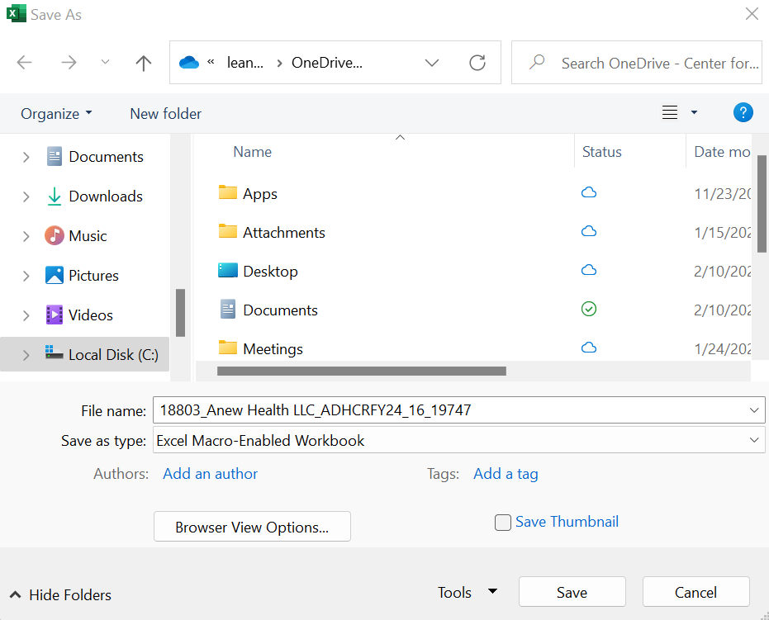

Save the file in a location you will remember when it is time to upload the cost report for submission.

You are now ready to visit the CHIA Submissions webpage to upload and submit the report by Fiscal Year.

Detailed instructions for submitting a saved cost report can be found in the CHIA Submissions User Guide.

QUESTIONS
If your agency has not registered with CHIA, you must do so to file the cost report. See the CHIA Submissions User Guide for detailed steps on registering with CHIA.
If you have questions related to the CHIA Submissions portal and registering your agency, please email dl-data-submitter-helpdesk@chiamass.gov.
For all other questions, please email CostReports.Pricing@chiamass.gov with the following information in the subject line of your email:
- Name of your agency with MassHealth ID #
- Name of the cost report you are asking about
- Cost report reporting year
Subject Line Example: Question on FY2024 ADH Cost Report – ABC agency, ID# 123456789A

Appendix A: Allocation Examples

The following is an overview of the allocation methods to be used in the Adult Day Health Cost Report.

The Adult Day Health Cost Report is formatted so that all of the costs of the entire agency (including donations) are reported in Schedule E, “Statement of Expenses”, under Column 1 - G. L. Parent Agency, in Lines 1–25. Each of these line items must be allocated, as applicable, to the cost centers of Agency Administrative Expense, Total Adult Day Expense, and/or Total Other Programs Expense [Columns 3, 4, and 5, respectively]. The bases for allocating the costs are:

D - Direct Expense
H - Hours of Service
S - Square Footage Occupied
O - Operating Expense
C - Compensation (Staff) Expense

Determination of an allocation method depends upon the type of expense, and to which cost center that expense is applied. Specific examples are provided below.

Case I: Direct Expense Allocation
Whenever a portion of a general ledger expense can be identified and documented as applying only to the Adult Day Health program, it should be charged directly (“D” basis) to the Adult Day Expense column. The allocation of the balance of that expense depends on which of the following cases apply.

- If the balance of the expense can be identified as applying to Agency Administrative or Other Programs, it should be charged to them directly. Medical supplies and travel represent costs that might be allocated in this way. The “D” in the drop-down for column 2 on Schedule E would indicate this allocation example.

- If the balance cannot be charged directly, follow the direction below.

- Space Occupancy Cost. The Square Footage basis, “S”, should be used if the cost represents space occupancy (building, utilities, etc.) or maintenance/housekeeping staff cost. These percentages are calculated in Schedule F, Part 1. Since this allocation is only between Agency Administrative and Other Programs, use the “Allocation between Two Cost Centers” percentages in Schedule F, Part 1.

- Compensation Expense. The Compensation Expense basis, “C”, should be used (e.g., telephone expense). These percentages are derived in Schedule F, Part 2.

In both of these cases, multiply the percentages by the difference between the General Ledger amount and the Adult Day Health amount, and enter the resulting allocation to Columns 3 and 5 in Schedule E.

Case II: Other than Direct Expense Allocations
If the Adult Day Health program expense has not been charged directly, the allocations should be as follows:

Basis | Source | Costs
H – Hours of Service | Schedule F, Part 2,  Time study or best estimate  Schedule F, Part 2 is pre-populated as data is entered into the cost report | All staff except maintenance and housekeeping (see Schedule D)
S – Square Footage Occupied | Schedule F, Part 1  This section is not auto-populated and must be filled out. | Space occupancy costs, including donated space, maintenance, and housekeeping staff expense
O – Operating Expense | Schedule F, Part 3  Schedule F, Part 3 is pre-populated as data is entered into the cost report | All other costs

These allocation methods are identified for each line item in the drop-down for Schedule E, Column 2, but the direct expense basis takes precedence when applicable.

If you are allocating costs based on Operating Expense basis of allocation, enter the costs in Column 3, Agency Administration, in Schedule E, only. Do not further allocate to Columns 4 and 5, as this will be done automatically at line 27.

Case III: Schedule F, Part 3
The pre-populated calculations in Schedule F, Part 3 are as follows:

Cost Center | Total Operating Expense (Schedule E, Line 26) | Percentage | Administrative Allocation
Total Adult Day Program | Total Adult Day Operating Expense  (Sch E, Line 26, Column 4)
Total Direct Client Transportation | Total Direct Client Transportation  (Sch C, Line 4)
Total ADH Expense for Allocation of Administration Costs | Total Adult Day Operating Expense  + Total Direct Client Transportation | The percentages in this column are derived from dividing the program operating expense by the Total Agency Operating Expense. They are used to allocate the administrative expenses back to the corresponding program | The ADH amount below is the administrative expense allocated to the ADH program based on the percent of Total Operating Expense represented by the ADH program.  The numbers in this column will appear in Schedule E, line 27.
Other Programs | Total Other Program Operating Expense  (Sch E, Line 26, Column 5)
Outside Entities | Total Outside Entities  (Sch E, Line 26, Column 6)
TOTAL | Total Adult Day Operating Expense  + Total Direct Client Transportation  + Total Other Program Operating Expense  + Total Outside Entities | Sum of all percentages | Total Agency Admin Operating Expense  (Sch E, Line 26, Column 3)

