CENTER FOR HEALTH INFORMATION AND ANALYSIS

CHIA SUBMISSIONS USER GUIDE:

Adult Day Health cost REPORT

March 2024

Table of Contents
REMINDERS FOR ADULT DAY HEALTH COST REPORT SUBMISSIONS 3
PURPOSE 3
RETRIEVING AND POPULATING THE TEMPLATE 3
Download the Excel Template 3
Open and View Tabs 3
Required Field Population 4
Saving the File 4
SUBMITTING THE EXCEL FILE 5
Adult Day Health User Access: CHIA Submissions 5
Cost Report File Selection and Upload 7
FREQUENTLY ASKED QUESTIONS (FAQ) 9

REMINDERS FOR ADULT DAY HEALTH COST REPORT SUBMISSIONS

- Adult Day Health (ADH) providers are required to submit completed cost reports through the Center for Health Information and Analysis’ (CHIA) online submission portal, CHIA Submissions.
- Providers will log into CHIA Submissions and upload complete ADH Cost Reports.
- All submissions must be saved using the “Save Submission File” button on Tab 9, “Accuracy of Report”. Submissions that are not saved using this button cannot be read by CHIA’s system and will not successfully upload.

PURPOSE
The Center for Health Information and Analysis (CHIA), in accordance with its statutory authority under M.G.L. c. 12C, collects cost reports in furtherance of its mission to monitor the health care system in Massachusetts and to provide reliable information and meaningful analysis for those seeking to improve health care quality, affordability, access and outcomes. The data CHIA collects through the ADH Cost Report is used, among other things, to support the rate-setting obligations of the Executive Office of Health and Human Services (EOHHS), which uses the data to establish rates for Adult Day Health providers, and to complete additional analyses to inform policy-making. Once filed with CHIA, these reports become public documents and will be provided upon request to any interested party.
This document contains step-by-step instructions on how to retrieve and navigate the Excel cost report. It also contains the steps to properly save and upload the file to CHIA Submissions. “Frequently Asked Questions” are included at the end of the document for additional information.

RETRIEVING AND POPULATING THE TEMPLATE

Download the Excel Template
All ADH providers can download the cost report template by visiting the following URL: http://www.chiamass.gov/adult-day-health-cost-reports-2/

Open and View Tabs
The Excel template contains 10 tabs, including 7 schedules:
- Agency Information
- Schedule A – General Information
- Schedule B – Program and Operations
- Schedule C – Direct Client Transportation
- Schedule D – Staffing Information
- Schedule E – Statement of Expenses
- Schedule F – Statement of Basis of Allocated Expenses
- Schedule G – Statement of Revenue
- Accuracy of Report – contains the Provider Certification and file Save Submission File button
- Legend

Required Field Population
Tab 9, “Accuracy of Report”, details which fields must be populated in order to save and submit a completed report. If all fields in the table on Tab 9 say “No Action Required”, all required fields have been properly populated and you are ready to submit the cost report. Upon clicking the Save Submission File button, any outstanding errors will be shown.

NOTE: The “Save Submission File” button is located in the lower right corner of the required fields in Tab 9. This button will automatically name the file in the required format. Do NOT rename the file; it will not successfully upload in CHIA Submissions.

Saving the File
You may save a draft of the template at any time by using the “Save As” or “Save” options under the File menu in Excel.

PLEASE NOTE: Submissions to CHIA must be saved using the “Save Submission File” button. Do not submit using another file name, as CHIA will not be able to process the submission.
SAVING THE FILE FOR SUBMISSION TO CHIA:
After completing the Excel spreadsheet, providers must save the report using the “Save Submission File” box located in the bottom right-hand side of the “Accuracy of Report” tab. This will automatically open your workstation’s Save functionality. Please use the pre-formatted naming convention that is designed to work in CHIA’s upload system. This pre-formatted name will be auto-populated in the Save As box that appears when you click the “Save Submission File” button.
It will be formatted as follows: ‘OrgID_FacilityName_ADHCRFYXX’ The file name’s fiscal year should reflect the fiscal year for which the cost report is being submitted.
(e.g., 18803_Anew Health LLC_ADHCRFY23)
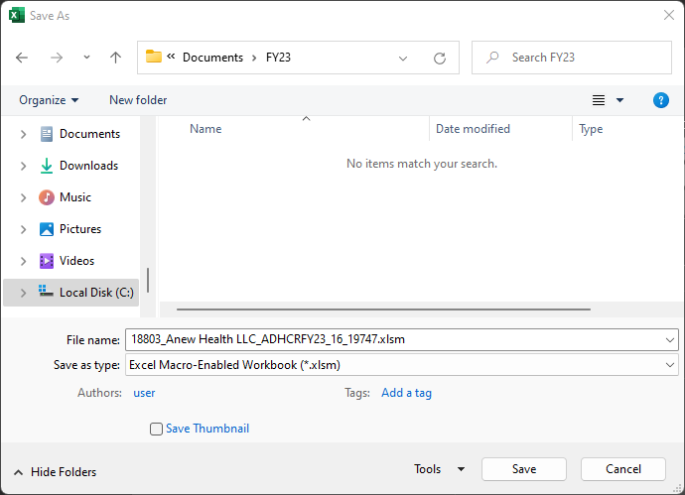

You are now ready to visit the CHIA Submissions webpage to upload and submit the report.

SUBMITTING THE EXCEL FILE

Adult Day Health User Access: CHIA Submissions
- Access CHIA’s online submission platform at https://chiasubmissions.chia.state.ma.us. Then log-in with a valid username and password. The credentials will be the same as the ones used for INET submissions.
  - If you are new user for a facility that is registered with CHIA, please complete a User Agreement and email the completed form to dl-data-submitter-helpdesk@chiamass.gov.
  - If you are a new user for a new facility that is not registered with CHIA you must submit both the User Agreement and the Business Partner Security Form to dl-data-submitter-helpdesk@chiamass.gov. Please refer to the Cost Report Instructions for more detailed steps on submitting these forms.
  - For technical issues, please email dl-data-submitter-helpdesk@chiamass.gov.
Please Note: CHIA Submissions works best with Google Chrome.

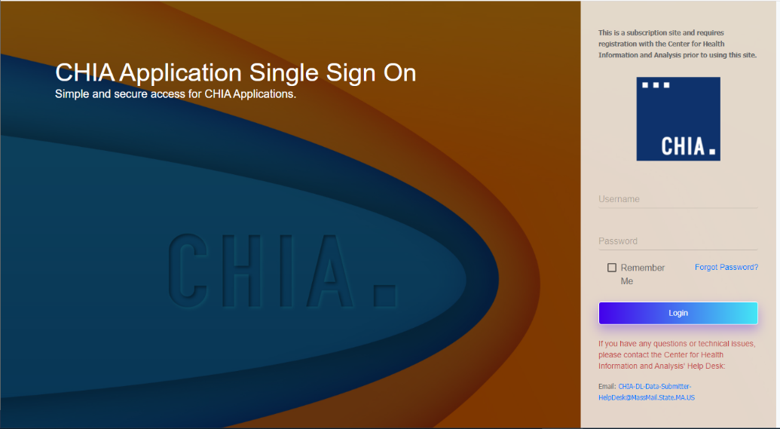

Successful access brings you to the Main Menu page. Choose the selection box titled ‘CHIA File Submissions’. You may have access to more than one box depending on other projects for which you have applied.
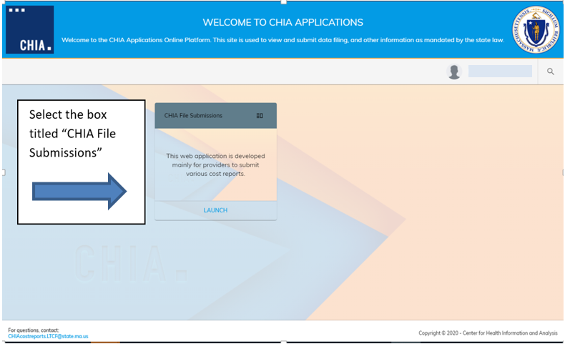

- If you submit other cost reports, aside from the Adult Day Health Cost Report, you will see a drop down list containing all the possible reports you can access. Select “Adult Day Health” from the drop-down menu.

- If you are the designated user for multiple facilities, you will see them listed under the “Agency Name” column on the left-hand side. If you are affiliated with only one facility, the “Agency Name” column will not be displayed. Your agency name will be displayed at the top, above the Save and Upload button.

- If you see more than one facility, select the facility you are submitting for by clicking the check mark next to the facility name. If you do not see agency names, this does not pertain to you.

Cost Report File Selection and Upload
- Choose the correct ‘Fiscal Year’ via the available dropdown boxes on the right. The Fiscal Year chosen should match the fiscal year on the cost report you are submitting.
20XX

- Once selected, hit the ‘Browse’ button to choose the final file with the CHIA naming convention that you have saved from your own computer workstation.

- Browse your File Manager or your Windows Explorer on your computer workstation and select the file saved using the “Save Submission File” button. Apply the file to CHIA Submissions by using the ‘Open’ key in the lower right corner of the screen. Your file name will appear in the Filename line.
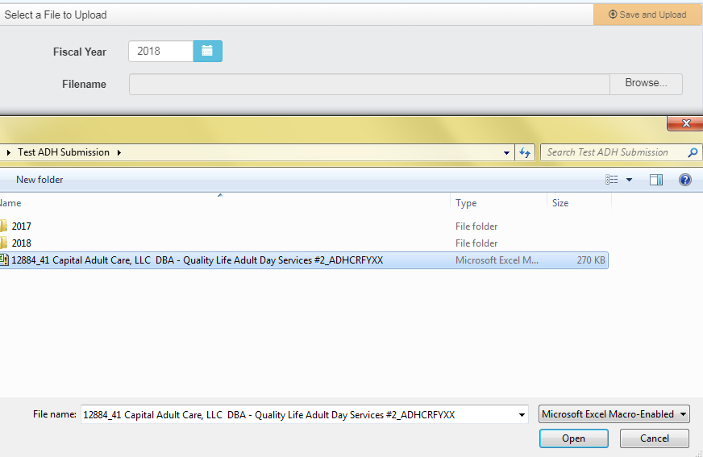
20XX

- To upload the file to the CHIA Submissions application, hit the Save and Upload button.

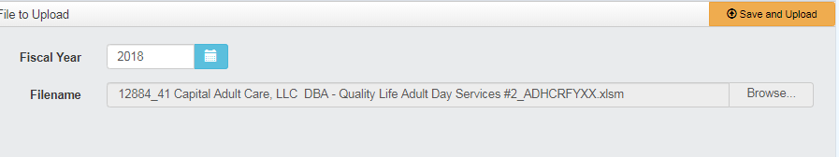
20XX

- When the progress bar shows 100%, you will see your Filename is uploaded successfully.

FREQUENTLY ASKED QUESTIONS (FAQ)
- Who can access the web application?
Users who are registered with CHIA to submit the Adult Day Health (ADH) Cost Report will be able to access the application located at https://chiasubmissions.chia.state.ma.us. For additional users and technical issues, please email dl-data-submitter-helpdesk@chiamass.gov.

- What are my system requirements?
The Microsoft (MS) Excel template is fully supported with MS Excel 2010 or higher. CHIA Submissions is fully supported on Google Chrome.

- How can I request to add new user(s)?
ADH Providers needing to change users or request additional users should complete an Other Providers User Agreement and email the completed form to dl-data-submitter-helpdesk@chiamass.gov.
If your facility is new or is not registered with CHIA you must also submit a Business Partner Security Form to dl-data-submitter-helpdesk@chiamass.gov in order to submit a complete cost report through CHIA Submissions. Please refer to the Cost Report Instructions for more detailed steps on submitting these forms.
- Can one Adult Day Health facility have multiple submitters?
User access can be granted for multiple individuals.

- How do I update information in a submitted report?
If an ADH provider needs to update information in an already submitted report, users should email costreports.pricing@chiamass.gov to inform CHIA of the intent to resubmit and provide good cause for resubmission. Users should make the appropriate changes to the cost report in the local workstation and resubmit it by following the steps detailed in this user guide.

- What are the different types of errors and how do I avoid them?
- Lines shown as “Required” which are omitted will prevent the ability to save and submit your report. All outstanding errors will appear upon clicking the “Save Submission File” button in Tab 9, “Accuracy of Report”.
- Data can be pasted in. Please paste as values and refrain from attempting to re-format the cost report template. If you choose to paste values, please ensure that numbers entered are whole numbers, unless it is stated that decimals are allowed. Please consult the cost report instructions for detailed information on where decimals are allowed in the cost report.
- All submissions must be saved using the “Save Submission File” button on Tab 9, “Accuracy of Report”. Submissions that were not saved by using this button cannot be read by CHIA’s system.

- Can I view submitted reports?
The ADH provider that submitted the report has the original copy of the Excel spreadsheet. If copies of submitted data are needed from CHIA, please contact data@chiamass.gov.

