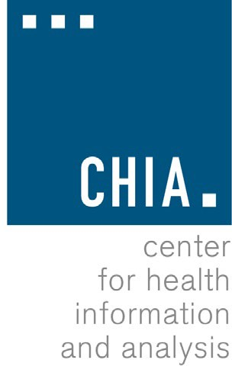

NOTICE OF PUBLIC HEARING
Pursuant to the provisions of M.G.L. c. 12C and in accordance with M.G.L. c. 30A, the Center for Health Information and Analysis (CHIA) will hold a remote public hearing on Thursday, February 26, 2026 at 10:00 A.M. relative to the emergency adoption of amendments to the following regulation:

957 CMR 3.00 – ASSESSMENT ON CERTAIN HEALTH CARE PROVIDERS AND SURCHARGE PAYORS

The proposed amendments to 957 CMR 3.00 reflect changes made to CHIA’s assessments by Chapter 140 of the Acts of 2024 and Chapters 342 and 343 of the Acts of 2025. The amendments remove references to the Surcharge Payor Assessment, which is now collected pursuant to M.G.L. c. 118E § 64 due to statutory changes made by Chapter 140 of the Acts of 2024. The amendments also add a new Pharmacy Benefit Manager Assessment, consistent with M.G.L. c. 12C § 7, as amended by Chapters 342 and 343 of the Acts of 2025. Finally, the amendments update data submission procedures to make 957 CMR 3.00 consistent with other CHIA regulations.

The amended regulation went into effect on January 16, 2026. The amended regulation will have no fiscal impact on cities and towns and is not anticipated to have any fiscal impact on small businesses.

If you plan to testify at the hearing, CHIA strongly encourages you to register in advance by emailing regulations@chiamass.gov. Individuals may also submit written testimony to the same email address. Please include the name of the regulation in the subject line of your email. All submissions must include the sender’s full name, mailing address, and organization or affiliation (if applicable). Individuals who are unable to submit testimony by email should mail written testimony to the Center for Health Information and Analysis, 501 Boylston Street, Suite 5100, Boston, MA 02116. Written testimony must be submitted by 5:00 P.M. on Monday, March 9, 2026. This notice and copies of the proposed regulations may be viewed on CHIA’s website at www.chiamass.gov/regulations.
To join the remote hearing online, go to: https://us02web.zoom.us/j/81965706019?pwd=3HwUAmNfURlbDBGEPPFv81GHM3FhUd.1, and enter Meeting ID: 819 6570 6019 and Passcode: 456165.

To join the remote hearing by phone, call 1-646-518-9805 or 1-646-558-8656, and enter Meeting ID: 819 6570 6019 and Passcode: 456165 when prompted.

501 BOYLSTON STREET
BOSTON, MA 02116

