CENTER FOR HEALTH INFORMATION AND ANALYSIS

CHIA SUBMISSIONS USER GUIDE:
MANAGEMENT/CENTRAL
OFFICE COST REPORT (MGT-CR)

JUNE 2019

CHIA

Table of Contents

Summary of Changes .........................................................................................................................3

Purpose .............................................................................................................................................3

Accessing and Submitting the Cost Report ..........................................................................................4

User Access: CHIA Submissions................................................................................................................. 4

Main Menu................................................................................................................................................ 5

Home Screen ............................................................................................................................................. 5

Cost Report Year Selection ....................................................................................................................... 6

Navigating the Tool ................................................................................................................................... 7

Cell Colors ................................................................................................................................................. 8

Schedule 1 Legal Status............................................................................................................................. 8

Dynamic Tables ......................................................................................................................................... 9

Data Validations ........................................................................................................................................ 9

Submitting the Cost Report ...................................................................................................................... 9

Frequently Asked Questions (FAQ) ...................................................................................................13
Summary of Changes
• Nursing Facility Management Companies are now required to complete the management company/central office cost report (MGT-CR) through the Center for Health Information and
Analysis’ (CHIA) online submission portal: CHIA Submissions.

• Providers will use their registered Username and Password to log into CHIA Submissions and input their data. (If you forget your Username and Password, please contact the CHIA Help Desk at (617) 701-8297.)

• This application allows users to electronically submit and save the MGT-CR intermittently, and may be closed at any time prior to the final submission.

• CHIA has consolidated some accounts where possible to streamline the cost report process. A document labeled “Account Crosswalk: Prior HCF-3 Cost Report to MGT-CR” can be found in Appendix A of the MGT-CR Technical User Manual.

• When completed, all submissions must be certified by the preapproved Owner, Partner, or
Officer (“Owner”) using the “Submit” button on Schedule 8.

Purpose
The Center for Health Information and Analysis (CHIA), in accordance with its statutory authority under M.G.L. c. 12C, collects cost reports in furtherance of its mission to monitor the health care system in Massachusetts and to provide reliable information and meaningful analysis for those seeking to improve health care quality, affordability, access and outcomes. The data CHIA collects through the MGT-CR Cost Report is used, among other things, to support the rate-setting obligations of the Executive Office of Health and Human Services (EOHHS), which uses the data to establish rates for nursing and residential care facility providers, and to complete additional analyses to inform policy-making. Once filed with
CHIA, these reports become public documents and will be provided upon request to any interested
party.

This document contains step-by-step instructions on how to access, navigate, and submit the cost report through CHIA Submissions portal. “Frequently Asked Questions” are included at the end of the
document for additional information on completing the electronic MGT-CR.

Moreover, the data CHIA collects from your MGT-CR is combined with data you report to us on other cost reports (Forms HCF-1, HCF-2, and HCF-4). This supports the calculation of per diem rates of payment for Long-Term Care facilities that care for publicly-aided residents and for informational purposes in various databases. It is extremely important that reports are prepared by persons who are familiar with Section
6.00 of Title 957 of the Code of Massachusetts Regulations (CMR), Cost Reporting Requirements, 957 CMR
7.00 Nursing Facility Cost Reporting Requirements; 101 CMR 206.00 Standard Payments to Nursing
Facilities; and/or 101 CMR 204.00 Rates of Payment to Resident Care Facilities. Copies of these regulations may be obtained on our website at www.chiamass.gov or from the Secretary of State's Office, Public Document Division, Room 116, State House, Boston, MA 02133, for a nominal charge. Their telephone number is (617) 727-2834.

This application has a printable Technical User Manual which provides detailed instructions on how to use and file an MGT-CR, located at http://www.chiamass.gov/nursing-facility-cost-report-forms-and-
instructions.

Accessing and Submitting the Cost Report

User Access: CHIA Submissions
• Access CHIA’s online submission platform at https://chiasubmissions.chia.state.ma.us.

• Log-in with the Username and Password created during the registration process for the user’s appropriate access level (Data Submitter, Preparer, or Owner).

o If you do not have a CHIA Submissions Username and Password, you will need to obtain one using the following steps:
  If you are a new user and your facility is currently registered with CHIA, please complete a User Agreement and email it to CHIA-DL-Data-Submitter- HelpDesk@state.ma.us.

  If you are a new user and your facility has NOT submitted any cost reports to CHIA, you must first complete a Non-Confidential Data Security Agreement to CHIA and email it to CHIA-DL-Data-Submitter-HelpDesk@state.ma.us. Once this has been completed and approved, you will need to complete a User Agreement and email it to CHIA-DL-Data-Submitter-HelpDesk@state.ma.us.

• For assistance in completing this cost report, contact the CHIA Help Desk at (617) 701-8297 or at
CHIAcostreports.LTCF@State.MA.US.

• For technical issues, please call 617-701-8217 or email CHIA-DL-Data-Submitter- HelpDesk@state.ma.us.

PLEASE NOTE: For optimal performance, CHIA recommends users access CHIA Submissions and the MGT-CR using Google Chrome©.
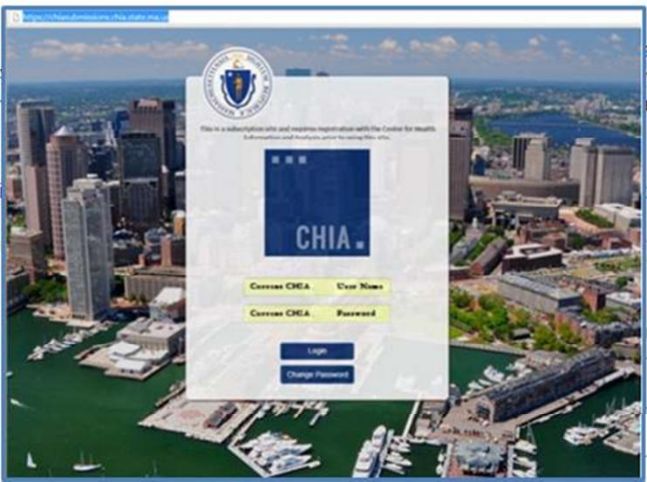

Main Menu
• Users will log in using their Username and Password, which is linked to all cost reports and filings registered with the Username and organization.

• Choose the selection box titled LTC Management Company Cost Report (HCF-3).

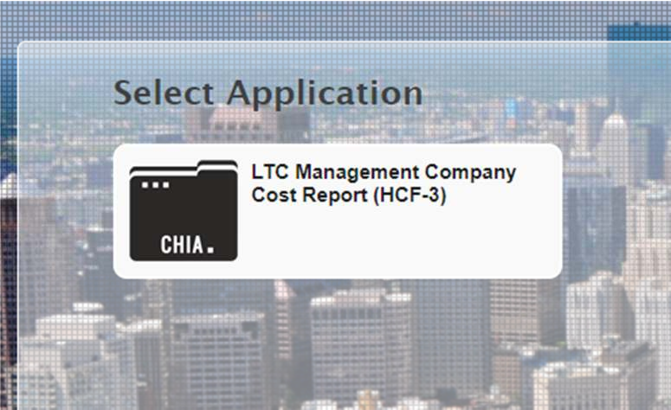

Home Screen
• The far left side of the screen lists all organizations or provider names and facilities that are registered with your Username.
• Clicking on an organization’s name will activate that account and display the information entered in Schedule 1 for the Reporting Year selected. Below is an example of a list of providers on the left hand panel.
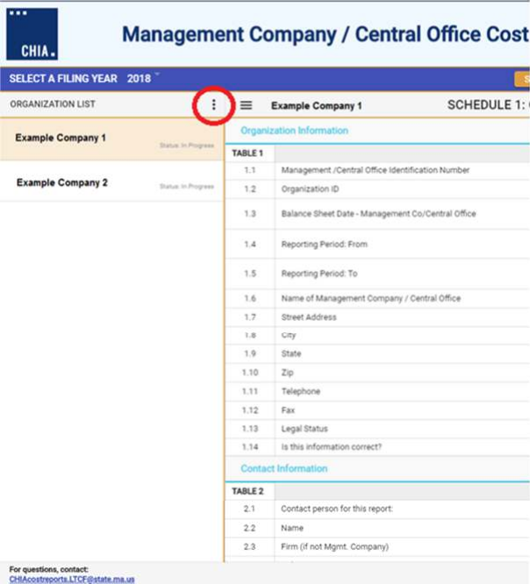• The Organization List may be expanded and collapsed by selecting the ellipsis icon (circled on the screenshot below). You may then use the search, sort, and collapse menu functions.

Cost Report Year Selection
• Once an organization is selected, ensure the appropriate filing year is selected in the drop-down menu on the top of the screen under “Select a Filing Year”:

• NOTE: Since this is the first year the MGT-CR is on this platform, only 2018 is available.
Navigating the Tool
• Users are strongly recommended to save reports early and often when moving through each of the schedules. This will temporarily save your work, so you may navigate away from the cost report and not lose progress, while not officially submitting your cost report.
• To save a draft, click the “Save as Draft” button, located in the top right hand corner, and as pictured
below.
• To navigate between schedules, use the right-hand panel as shown below:

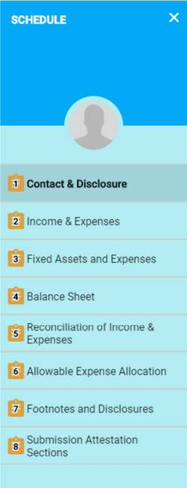

Users can also use the drop-down menu box; option labeled “Jump to Schedule”, as illustrated below:
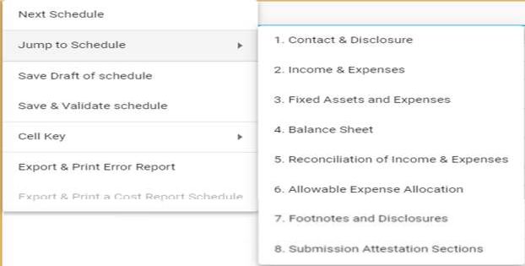

Cell Colors
• Throughout the report, you will note that each cell is color coded. Each color provides guidance as to how you should proceed. For example, light blue color filled cells indicate that the cell requires you to input a response. Also, yellow cells indicate the cell is linked to another cell and does not require your input. To access the key for all cell colors, click on the hamburger menu button and select the “Cell Key” option to display the cell key, as shown below:

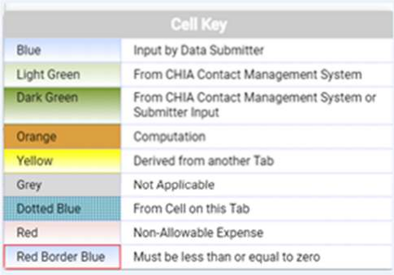

Detailed Instructions

For line-by-line instructions detailing the each cell in each schedule, please refer to the CHIA Submissions
Technical User Manual for the Management Company /Central Office Report (MGT-CR) located at http://www.chiamass.gov/nursing-facility-cost-report-forms-and-instructions.

Schedule 1 Legal Status
• Schedule 1 Table 1 Legal Status. Please refer to the chart below to confirm that CHIA has the correct legal status for your management company on file.

Legal Code | Description | Profit / Non-Profit
1 | MA Corp (Chapter 156B) | Profit
2 | MA Corp (Chapter 156B with 501c(3)  exemption) | Non-Profit
3 | MA Non-Profit Corp (Chapter 180) | Non-Profit
4 | Partnership, Limited Liability  Corporation (LLC) | Profit
5 | Sole Proprietorship | Profit
6 | Governmental Entity | Non-Profit
7 | Other For-Profit | Profit
8 | Other Non-Profit | Non-Profit
9 | Non-MA Corporation | Profit

Dynamic Tables
• Throughout the cost report, some tables are expandable to accept new rows of data.
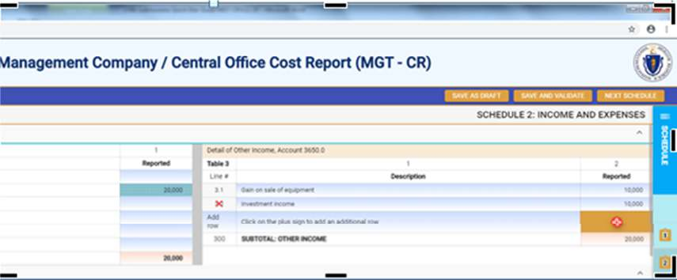• Click the red plus sign to expand the table, and click the red ‘x’ on the individual line number to delete a row.

Data Validations

The MGT-CR includes a number of edits or checks within each of the eight schedules which need to be managed through the validation process described below. Preparers and submitters will not be able to lock reports for review or submit their cost report unless all schedules have been validated and the errors fixed.

Users will note that there is a “Save and Validate” button at the top right corner of each schedule. Upon completing a schedule users must click the Save and Validate button to progress through the report. When this button is selected, users will encounter the following:
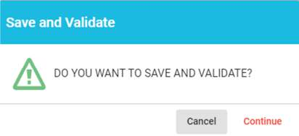

To launch the validation process, users will select “Continue”. Once this is done, there will be two results.

o If there are validation errors, users will need to select the method they would like to view their validation errors, as shown below:

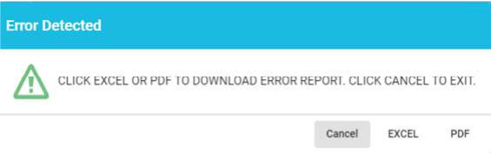

o If there are no validation errors, users are notified that their schedule saved and successfully validated as shown below:

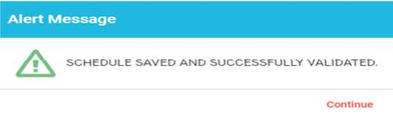

Additionally, users can launch the validation reports two additional ways.

First, users can click on the hamburger menu button to open the menu options on the top left corner as follows:
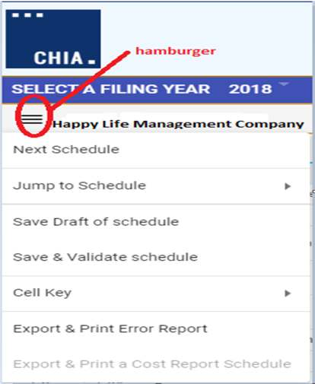

Then users will select the “Save & Validate schedule” option. This option validates only the current schedule in your view.

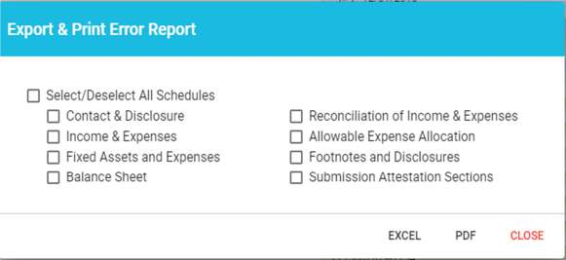Finally, users can launch the “Export & Print Error Report” from the hamburger menu button. Next, users will be prompted to select which schedule(s) they would like to validate, as follows:

Submitting the Cost Report
• All validation errors must be resolved before users can attest and submit their cost reports.
• The submission process is designed with the following process based on access privileges:
o Users with Owner, Partner, or Officer (referred to as “Owner”) privileges can certify and submit their cost reports.
o Users with Preparer privileges can complete and lock the report for Owner review.
o Those users with Data Submitter privileges can only prepare the report.
• CHIA recommends that management companies use the following process to successfully complete and submit the MGT-CR.

• As illustrated above, Data Submitters and Preparers may prepare the cost report. Once complete, a Preparer locks the report for the Owner’s final review. Only users with “Owner” privileges can certify and submit the cost report, which is managed on Schedule 8 of the report.
• NOTE: Users who have Data Submitter privileges cannot access Schedule 8.

Preparers:
• Complete Section A containing contact information.
• Select the checkbox on Schedule 8 Line 1.14 certifying the report.
• Select “Lock for Owner Review”:

Owner/Partner/Officer:
• Owners/partners/officers cannot submit until the preparer has locked the cost report for review.
o An exception to this is when an Owner is the sole individual completing the cost report without any other user , which must be indicated at the beginning of the report on Schedule 1, Line 3.1.
• Complete Section B containing contact information.
• Select the checkbox on Line 2.7 certifying the report.
• Click the “Submit” button:

Frequently Asked Questions (FAQ)

1. Who can access the web application?
Users who are registered with CHIA to submit the Management Company Cost Report (MGT-CR) will be able to access the application located at https://chiasubmissions.chia.state.ma.us. To add additional users and for assitance with technical issues, please call 617-701-8297, or email CHIA-DL-
Data-Submitter-HelpDesk@state.ma.us.

2. What are my system requirements?
CHIA Submissions works best on Google Chrome©.

3. How can I request to add new user(s)?
Management company providers needing to change users or request additional users should complete a User Agreement and email the completed form to CHIA-DL-Data-Submitter-HelpDesk@state.ma.us.

If your management company is new or is not registered with CHIA, you must also submit a Non- Confidential Data Security Agreement to CHIA in order to gain access to CHIA Submissions and cost reports. Please refer to the Cost Report Instructions for more detailed steps on submitting these forms.

4. Can one Management Company have multiple submitters?
User access can be granted for one or multiple individuals. For changes to user access please contact the
CHIA Help Desk.

5. How do I update information in a submitted report?
If the preparer has locked for owner review and needs to change something in the report, the preparer should simply uncheck the attestation box on Line 1.14, click the “Save and Validate” button, to access the schedules to make revisions. Then, re-lock the report for review.

If the Owner, Partner, or Officer has clicked the Submit button, the cost report can only be reopened by contacting CHIA and submitting a request.

Please submit all requests to CHIAcostreports.LTCF@state.ma.us along with the following information:
• User Name
• User E-Mail Address
• Organization Name
• Applicable Filing Year
• Reason for request
6. When is the MGT CR due?
The report is due sixty (60) days after CHIA electronically releases it on the CHIA Submissions platform. Reports not received 60 days after the release will be subject to sanctions per 101 CMR 206.08 or 101
CMR 204.07. No additional extensions will be granted beyond this date.

