

Skilled Nursing Facility Cost Report
XML Schema
User Guide
February 2025
Version 2024.1

Contents
General Instructions 3
General Format Requirements 4
Filing Submission Instructions 4
Appendix A: XML Schema for Intake 8
Appendix B: Exceptions 11

General Instructions

This document includes instructions on creating an XML schema for the Skilled Nursing Facility Cost Report (SNF-CR) effective for filings beginning calendar year 2024.

If you have questions or need assistance, please contact CostReports.LTCF@chiamass.gov

The SNF-CR includes 13 schedules. Much of the data requested in the following 11 schedules is eligible to be submitted as an XML file through the CHIA Submissions portal. Not all fields in the 11 eligible schedules may be submitted in an XML file. Consult the accompanying excel spreadsheet labeled SNF-CR XML DD CY2024 for the specific data elements in these schedules that can be submitted via XML.

- Schedule 1: General and Ownership Information
- Schedule 2: Revenue
- Schedule 3: Expenses
- Schedule 4: Other Business Revenues and Expenses
- Schedule 5: Statement of Operations and Reconciliation of Financial to Cost Reported Net Income
- Schedule 6: Balance Sheet and Reconciliation of Owner's Equity
- Schedule 7: Detail of Fixed Assets and Depreciation
- Schedule 8: Statement of Cash Flows
- Schedule 9: Licensure & Patient Statistics
- Schedule 10: Detail of Facility Compensation and Purchased Nursing Services
- Schedule 11: Notes Payable and Working Capital Debt

The following 2 schedules must be filed through the CHIA Submissions website using the SNF-CR application.

- Schedule 12: Footnotes and Financial Statements
- Schedule 13: Submission and Attestation

If you want to submit an XML file, you are required to submit a full XML schema for all fields identified in SNF-CR XML DD CY2024. However, you are not required to provide values for all fields. Completed XML files must be submitted through the CHIA Submissions portal.

NOTE: Please be sure that the values for each field in your XML file adhere to the specific data types, usages, and formats as detailed in the SNF-CR XML DD CY2024 document. If it does not, your entire file may be rejected or certain submitted values with invalid data types, usages, and formats may be rejected and replaced with a NULL (blank) value.

CHIA can provide an XML Error Report Log at your request. This error report provides the errors that caused your file to be rejected or details on why certain data was not uploaded due to incorrect data type, usage, or format submitted.

Instructions for using the CHIA Submissions portal to submit your XML file are listed below. Submitted files will appear in the SNF-CR application approximately one hour after upload.

To submit your annual cost report, you will need to log in to the SNF-CR application to complete the remaining fields that are not permitted to be submitted via XML. Additionally, you will need to review and validate all schedules before you can submit your cost report. See the SNF-CR Technical Instructions and User Guide on how to complete the cost report using the SNF-CR application.

Data elements that were included in version 2021.1 but are now obsolete are identified in SNF-CR XML DD CY2024. This document also identifies new data elements that were added for version 2024.1.

General Format Requirements

Please ensure that you are following the data types, usages, and formats that are in the SNF-CR XML DD CY2024 document.

Listed below are several general format requirements that are provided for in the SNF-CR XML DD CY2024 document:

Date Fields: Use the format YYYY-MM-DD.

Percent Values: You must not include the % sign. The decimal is optional. Consult the SNF-CR XML DD CY2024 for the proper percentage value that will be accepted in the field (i.e., XX.X%, or XX.XXX%, or XX.XXX%).
  - Any of the following formats are acceptable:
- 25.00 will be recognized by the system as 25%
- 25 will be recognized by the system as 25%
- 0.125 will be recognized by the system as 0.125%
Numeric Values:
  - Negative numbers must include the negative sign (-). Example: -100
  - Do not submit negative numbers in fields that accept positive only numbers. Consult the SNF-CR XML DD CY 2024 document for correct usage. If you do, your file may be rejected.
  - Do not submit positive numbers in fields that accept negative only numbers. Consult the SNF-CR XML DD CY 2024 document for correct usage. If you do, your file may be rejected.
Fields with Dropdown Options:
- As detailed in the SNF-CR XML DD CY2024 document, only provide the value if the dropdown option accepts one of the following:
  - Yes/No
  - Direct/Indirect
- For all other fields that have dropdown options, your XML file must include the structure for the field but leave the value blank. You will need to complete this field using the application dropdown option tools once your XML file has been accepted.

Filing Submission Instructions

Steps-by-Step Instructions to Submit an XML File

- Prior to submitting a file to CHIA for processing, you must submit a test file as detailed in step 9.

- Create an XML file based on the requirements noted in Appendix A: XML Schema for Intake and Appendix B: Exceptions.

- The file name convention should match the following:

{OrganizationID} + "_" + {FilingTypeID} + "_" + {FilingYear} + "_" + {Submission Date TimeStamp}
Example: 22_5_2024_20250505141000

- OrganizationID – This is the CHIA assigned Organization ID for the facility that is filing the cost report.
- FilingTypeID – This is a fixed value of “5”.
- FilingYear – Enter the cost report filing year using YYYY format.
- Submission DateTime – Enter today’s date and current time without hyphens (-) or solidus (/).

- Use the following URL to submit your XML file: https://chiasubmissions.chia.state.ma.us/.

- Log in to CHIA Submissions using your current CHIA username and password. If you need assistance with your username and password, please contact DL-Data-Submitter-HelpDesk@chiamass.gov.

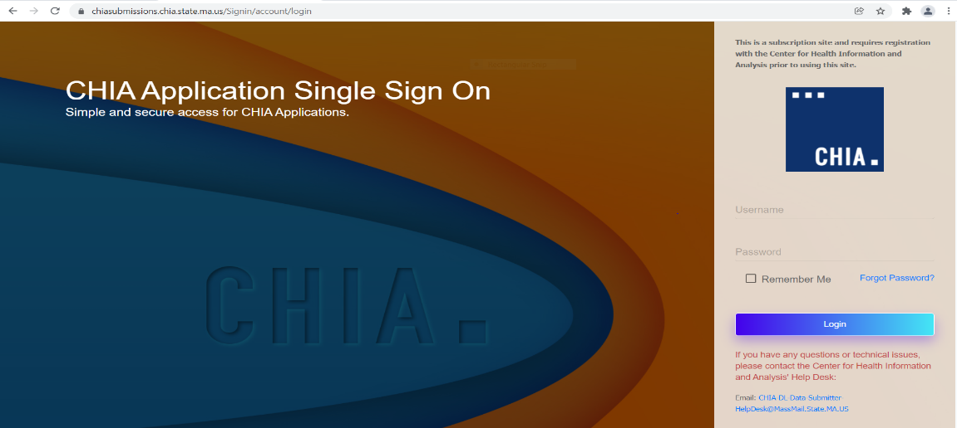

- On the Welcome page, you will see an application labeled “CHIA File Submissions”. Click on the “Launch” button.
Note: Depending on your access privileges, you may see applications for other CHIA applications.

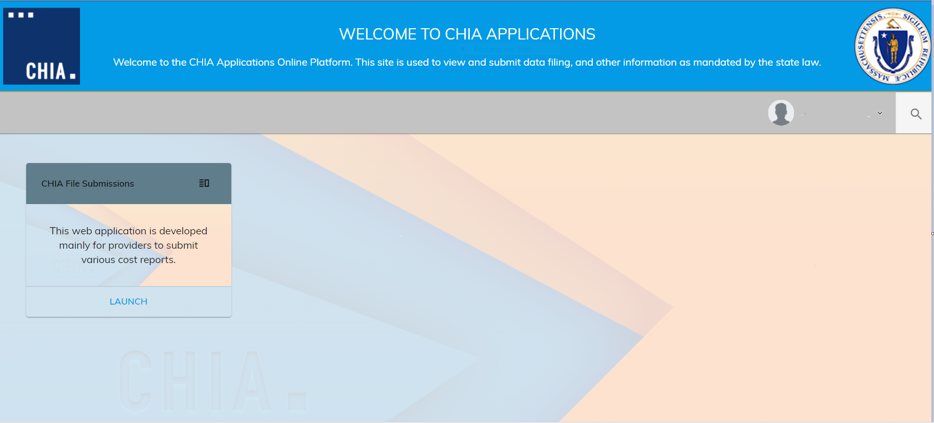

- To submit a file:
- Locate the nursing facility name in the box on the left side of the screen and click on the check box.
- Select the Fiscal year.
- Click on the “Browse” button to locate the file on your computer that you would like to upload.

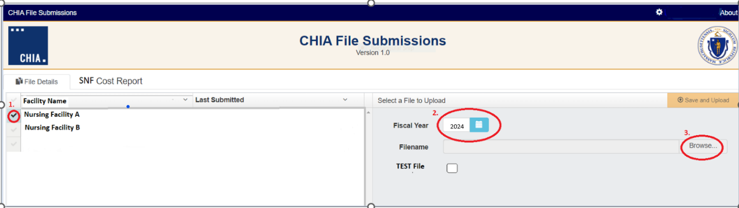
- Once the name of your file appears in the Filename field, click on the “Save and Upload” button at the upper right side of the screen to submit your file for CHIA processing.

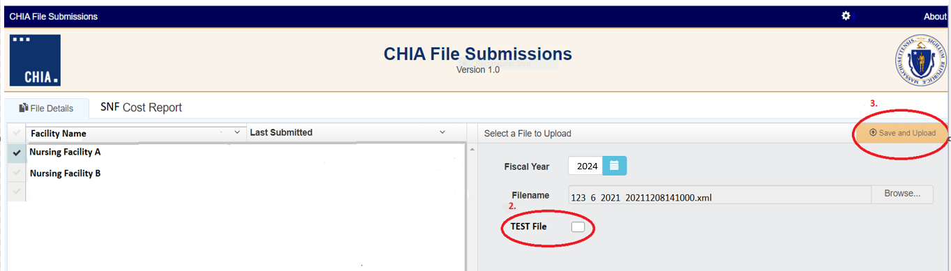

- You are required to submit a test file before you submit your initial file to CHIA for processing. You may also submit a test file at any time if you would like to validate the file structure and format. To submit a test file:
- Complete the steps detailed above in number 7.
- Click in the TEST File checkbox.
- Click on the “Save and Upload” button to submit your file for processing.

Appendix A: XML Schema for Intake

Nursing Facility Identification and Filing Year

Each submitted XML file may only contain information for one nursing facility. Each file must include the version control number (Customer Application Version). The current version control number is 2024.1. CHIA will notify you if the control number changes.

Each XML submission must include the information below about the filing.
- Customer Application Version (Version Control Number)
- Organization ID
- Nursing Facility Name
- Filing Year

Cost Report Schedule Numbers and Names – Standard Structure

Each cost report schedule number and name is delimited by <Tab TabID>………</TabName> tags. The tab number represents the schedule number, and the tab name represents the schedule name. Both are required for the start of each tab. TabIDs and TabNames for all schedules that can be submitted via XML can be found in the SNF-CR XML DD CY2024 excel document.

Example: Schedule 2 – Revenue 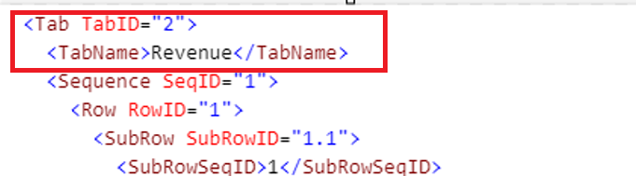

Cost Report Table Numbers – Standard Structure

Each cost report table number is delimited by <Sequence SeqID ="#">……</Sequence> tags. The SeqID number represents the specific table number of each schedule. The SeqID follows TabIDs and TabNames and precedes the SubRowIDs and SubRowSeqIDs. The SeqID and RowID are the same for all tables displayed on the left side of a cost report schedule in the application. Refer to SNF-CR Wireframe for CY2024 – XML Version.xlsx for the location of the table (left or right side of a schedule). All SeqIDs for all tables that can be submitted via XML can be found in the SNF-CR XML DD CY2024 excel document. Refer to the “Altered Structure” Section below for proper tags for tables displayed on the right side of the cost report schedule in the application.

Example: Schedule 2, Table 1
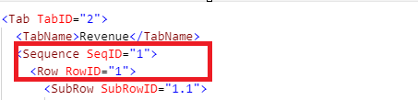

Cost Report Lines and Columns – Standard Structure

Each cost report line number is delimited by <SubRowID ="#">……</SubRowID> and <SubRowSeqID = #>….< SubRowSeqID> tags. Each column number is delimited by <ColumnID ="#">……</ColumnID> tags. The RowID represents the numerical order of the line number for all cost report tables displayed on the left side of a cost report schedule. Refer to SNF-CR Wireframe for CY2024 – XML Version.xlsx for the location of the table (left or right side of a schedule). All SubRowIDs for all tables that can be submitted via XML can be found in the SNF-CR XML DD CY2024 excel document. Refer to the “Altered Structure” Section below for proper tags for lines in tables that are displayed on the right side of the cost report schedule in the application.

Example: Schedule 2, Table 1, Line 1.1 Columns 1 and 2
and Line 1.2 Columns 1 and 2
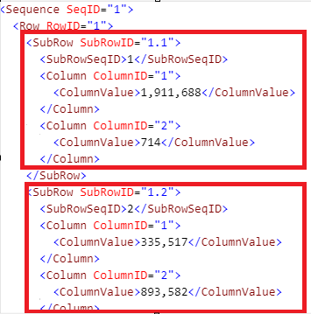

Altered Structures

Cost Report Tables Displayed on the Right Side of a Cost Report Schedule

There are 8 cost report tables displayed on the right side of a cost report schedule in the application that require an altered structure. These table numbers and the order for the SeqID tags are listed in the table below. These tables require altered XML structures and tags as explained below.

Schedule Number | Table Number | Table Name | Order (SeqID)
3 | 2A | Detail of Other A&G Expenses | 1
3 | 2B | Detail of Non-Allowable A & G Expenses | 2
5 | 1C | Detail of Extraordinary Items | 1
5 | 1D | Detail of Changes in Accounting Principles | 2
6 | 1A | Detail of Other Current Assets | 1
6 | 3A | Detail of Other Deferred Changes and Non-Current Assets | 2
6 | 5A | Detail of Other Current Liabilities | 3
6 | 8D | Prior Period Adjustments | 4

Table Number and Table Names – Altered Structure

For the cost report tables that are displayed on the right side of a cost report schedule in the application, the XML structure requires the following additional tags to identify the Table Number and Names:
- SubTabIDs
- SubTabNames

All SubTabNames and SubTabIDs for all tables that are displayed on the right side of a cost report schedule can be found in the SNF-CR XML DD CY2024 excel document.

Example: Schedule 6 Table 3A
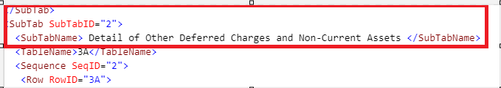

Table Order – Altered Structure

The SeqID tags that identify the table number in the standard structure are used to identify the table order in the altered structure. Refer to the table above for the table order number for each of the 8 tables with altered structures.

Example: Schedule 6, Table 3A, Table Order # 2
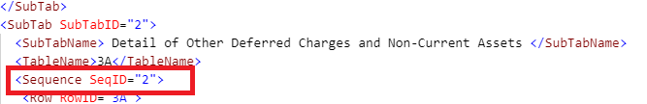

Line and Column Numbers – Altered Structure

The RowID tag identification differs from the standard structure. This tag restates the table number. Additionally, the SubRowID and the SubRowSeqID are the same number; any reference to the alphanumeric table number is dropped from these tags. All RowIDs, SubRowIDs, and SubRowSeqIDs for all tables that are displayed to the right side of a cost report schedule can be found in the SNF-CR XML DD CY2024 excel document.
Example: Schedule 6, Table 3A, Line 3A.1

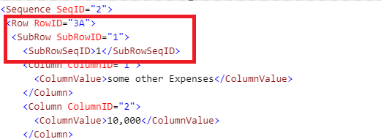

Dynamic Table Schedule 3 Table 2A – Altered Structure

A dynamic table is any table to which the user can add a line. The dynamic Table 2A in Schedule 3A is a table that is also located on the right side of the cost report schedule and requires a similar structure to what was described above. Because this table is dynamic, only one SubRowID is required for the file to pass submission. Additional SubRowIDs can be added as needed to submit additional data.

Schedule 3, Table 2A – Dynamic Table Altered Structure
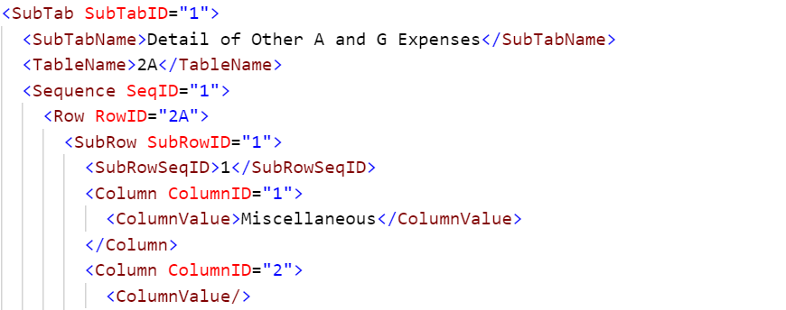

Appendix B: Exceptions

- Fields with Dropdown Options: There are several fields in the cost report that allow the user to select a value from available dropdown options. When submitting data via an XML file, some fields with dropdown options can be submitted via XML file, others cannot.
  - Fields with dropdown options that are permitted in XML file submission: Certain fields with dropdown options of either Yes/No options or Direct/Indirect options can be submitted with the exact text. For example, if the response to Schedule 4, Line 1.1 is Yes, either include the structure with a blank value, or include the structure and populate with Yes. Do not include any other value such as 1.
  - Fields not permitted in XML submission file: The following fields in the following schedules must be completed using the SNF-CR application. Include the structure in the XML file for each of the following fields but leave the value blank.

Schedule 1:

Line Number | Column Name | Column Number
4.1 | Service Type | 1
4.2 | Service Type | 1
4.3 | Service Type | 1
4.4 | Service Type | 1
4.5 | Service Type | 1
4.6 | Service Type | 1
4.7 | Service Type | 1
4.8 | Service Type | 1
4.9 | Service Type | 1
4.10 | Service Type | 1
4.11 | Service Type | 1
4.12 | Service Type | 1
4.13 | Service Type | 1
4.14 | Service Type | 1
4.15 | Service Type | 1

Schedule 7:

Line Number | Column Name | Column Number
4.1 | Type of Ownership Change | 1
4.2 | Type of Ownership Change | 1
4.3 | Type of Ownership Change | 1

Schedule 10:

Line Number | Column Name | Column Number
5.1 | Primary Expense Category | 4
5.2 | Primary Expense Category | 4
5.3 | Primary Expense Category | 4
5.4 | Primary Expense Category | 4
5.5 | Primary Expense Category | 4
6A.1 | Primary Expense Category | 4
6B.1 | Primary Expense Category | 4
6B.2 | Primary Expense Category | 4
6B.3 | Primary Expense Category | 4
6B.4 | Primary Expense Category | 4
6B.5 | Primary Expense Category | 4
6C.1 | Primary Expense Category | 4
6C.2 | Primary Expense Category | 4
6C.3 | Primary Expense Category | 4
6C.4 | Primary Expense Category | 4
6C.5 | Primary Expense Category | 4

Schedule 11:

Line Number | Column Name | Column Number
1.1 | Type of Notes Payable | 1
1.2 | Type of Notes Payable | 1
1.3 | Type of Notes Payable | 1
1.4 | Type of Notes Payable | 1
1.5 | Type of Notes Payable | 1
1.6 | Type of Notes Payable | 1
1.7 | Type of Notes Payable | 1
1.8 | Type of Notes Payable | 1
1.9 | Type of Notes Payable | 1
1.10 | Type of Notes Payable | 1
1.11 | Type of Notes Payable | 1
1.12 | Type of Notes Payable | 1
1.13 | Type of Notes Payable | 1
1.14 | Type of Notes Payable | 1
1.15 | Type of Notes Payable | 1
1.16 | Type of Notes Payable | 1
1.17 | Type of Notes Payable | 1
1.18 | Type of Notes Payable | 1
1.19 | Type of Notes Payable | 1
1.20 | Type of Notes Payable | 1

- Legal Status: There are several tables in the cost report that are based on the Legal Status provided in Schedule 1, line 1.17. Include the structure in the XML file for all fields. Include data for lines associated with the applicable legal status as instructed in SNF-CR XML DD CY2024. For example, if legal status = 1, complete lines associated with legal status 1. Leave the remaining lines blank.

  - Schedule 5: Complete when Legal Status is 1, 4, 5, 7, 9 or 10.

Line Number | Line Description | Column Number
1A.1 | Net Patient Service Revenue | 1
1A.2 | Other Revenue | 1
1A.3 | Net Assets Released from Restriction | 1
1A.4 | Salaries and Wages | 1
1A.5 | Employee Benefits | 1
1A.6 | Supplies and Other (including Payroll Taxes) | 1
1A.7 | Interest Expense | 1
1A.8 | Provision for Bad Debt | 1
1A.9 | Depreciation and Amortization Expenses | 1
1A.10 | Interest Income | 1
1A.11 | Investment Income | 1
1A.12 | Realized Gain(Loss) from Investments | 1
1A.13 | Realized Gain(Loss) from Sale or Disposal of Equipment | 1
1A.14 | Other Non-Operating Income(Expense) | 1
1A.15 | Provision for Income Tax | 1

  - Schedule 5: Complete when Legal Status is 2, 3, 6, or 8.

Line Number | Line Description | Column Number
1B.1 | Net Patient Service Revenue | 1
1B.2 | Other Revenue | 1
1B.3 | Net Assets Released from Restriction | 1
1B.4 | Salaries and Wages | 1
1B.5 | Employee Benefits | 1
1B.6 | Supplies and Other (including Payroll Taxes) | 1
1B.7 | Interest Expense | 1
1B.8 | Provision for Bad Debt | 1
1B.9 | Depreciation and Amortization Expense | 1
1B.10 | Interest Income | 1
1B.11 | Investment Income | 1
1B.12 | Realized Gain(Loss) from Investments | 1
1B.13 | Realized Gain(Loss) from Sale or Disposal of Equipment | 1
1B.14 | Other Non-Operating Revenue and Expenses | 1
1B.15 | Contributions, Gifts, and Other | 1
1B.18 | Change in Beneficial Interest in Net Assets Without Donor Restrictions | 1
1B.19 | Unrealized Gain(Loss) on Investments from Net Assets Without Donor Restrictions | 1
1B.20 | Other Changes in Net Assets Without Donor Restrictions | 1

  - Schedule 6: Complete when Legal Status is 2, 3, 6, or 8.

Line Number | Line Description | Column Number
8A.1 | Net Assets Balance: Prior Year | 1 and 2
8A.2 | Prior Period Adjustment(s) | 2
8A.4 | Gain/(Loss) Realized on Investments | 2
8A.5 | Contributions, Gifts and Other | 2
8A.6 | Change in Unrealized Gains/(Losses) on Investments | 2
8A.7 | Net Assets Released from Donor Restriction | 1 and 2
8A.8 | Net Assets - Other | 1 and 2

  - Schedule 6: Complete when Legal Status is 4, 5, or 10.

Line Number | Line Description | Column Number
8B.1 | Owner's Equity Balance: Prior Year | 1
8B.3 | Capital Contributions During the Year | 1
8B.5 | Proprietor/Partner Drawings | 1

  - Schedule 6: Complete when Legal Status is 1, 7, or 9.

Line Number | Line Description | Column Number
8C.1 | Owner's Equity Balance: Prior Year | 1- 4
8C.3 | Sale of Capital Stock | 1
8C.4 | Purchase or Sale Treasury Stock | 2
8C.5 | Additional Paid-in Capital | 3
8C.7 | Dividends Paid | 4

  - Schedule 10: Complete when Legal Status is 5.

Line Number | Column Number
6A.1 | 1-5, 7

  - Schedule 10: Complete when Legal Status is 4 or 10.

Line Number | Column Number
6B.1 | 1-8
6B.2 | 1-8
6B.3 | 1-8
6B.4 | 1-8
6B.5 | 1-8

  - Schedule 10: Complete when Legal Status is 1, 2, 3, 6, 7, 8 or 9.

Line Number | Column Number
6C.1 | 1-8
6C.2 | 1-8
6C.3 | 1-8
6C.4 | 1-8
6C.5 | 1-8

- Special Consideration for Schedule 7 Line 3.11: Include the structure in the XML file for all fields in Schedule 7 identified in SNF-CR XML DD CY2024. If the response to Schedule 7, Line 3.11, Column 1 is “Yes”, you must report data in the following fields. If the response is “No”, include the structure and leave the following fields blank.

Line Number | Line Description | Column Number
5.1 | List the DON project #. | 1
5.2 | Please briefly describe the DON project. | 1
5.3 | What is the date of the original DON approval? | 1
5.4 | What is the approved Maximum Capital Expenditure of the original DON? | 1
5.5 | Has this facility received a letter from the DPH Office of Determination of Need approving any significant change in the capital project resulting in an increase in the Maximum Capital Expenditure? | 1
5.11 | Do you have more than 2 DON Projects? | 1

- Special Consideration for Schedule 7 Line 5.5: Include the structure in the XML file for all fields in Schedule 7 identified in SNF-CR XML DD CY2024. If the response to Schedule 7, Line 5.5, Column 1 is “Yes”, you must report data in the following fields. If the response is “No”, leave the following fields blank.

Line Number | Line Description | Column Number
5.6 | What is the date of the significant change letter received from DPH? | 1
5.7 | What is the revised Maximum Capital Expenditure resulting from the approved significant change? | 1

- Dynamic Tables: Dynamic tables are for submitting itemized account details. There is one dynamic table that you may include up to ten lines of data for when submitting an XML file. However, you are not required to include the structure for this dynamic table. If included each line in the XML file must contain a line description.

The following list includes the dynamic tables in the cost report and whether data can be submitted via XML file:

Schedule Number | Table Number | Table Name | Can be submitted with XML file (up to 10 lines) Yes/No
3 | Table 2A | Detail of Other A&G Expenses | Yes
10 | Table 4* | Detail of Purchased Nursing Services | No

*Data for this table was permitted to be submitted via XML file in version 2021.1, but no longer allowed to be submitted via XML in the current version 2024.1.

