Version 3/18/2022sh
02/2025
INSTRUCTIONS FOR THE COMMONWEALTH OF MASSACHUSETTS NURSING FACILITY COST REPORT (SNF-CR)

Contents
INTRODUCTION 3
IMPORTANT: Please Clear your Cache! 3
CHANGES TO THE NURSING FACILITY COST REPORT AND FILING TIPS FOR CY2024 3
WHO MUST FILE? 4
WHEN TO FILE 5
HOW TO FILE 5
WHAT FORMS TO FILe 5
GUIDANCE ON COVID-19 ANTIVIRAL TREATMENTS, COSTS, AND EXPENSES 6
SUBMITTING DATA USING XML FILES 6
GENERAL and ownership INFORMATION 6
FACILITIES WITH MANAGEMENT AND REALTY COMPANIES 7
MANAGEMENT COMPANY COST REPORT (MGT-CR) 7
REALTY COMPANY Cost REPORT (REA-CR) 8
OTHER BUSINESS ACTIVITIES 8
COST SPLITTING 9
GENERAL USER INSTRUCTIONS 9
Home Screen 11
Cost Report Year Selections 11
Navigating the SNF-CR 11
Saving Your Work 12
Entering Data 12
Understanding Cell Colors 12
Hover Messaging 13
Legal Status 13
Dynamic Tables 14
Data Validations 14
Submitting Your Cost Report 16
DETAILED INSTRUCTIONS BY SCHEDULE 18
SCHEDULE 1 – GENERAL AND OWNERSHIP INFORMATION 18
SCHEDULE 2 – REVENUE 22
SCHEDULE 3 - EXPENSES 25
SCHEDULE 4 – OTHER BUSINESS REVENUES AND EXPENSES 41
SCHEDULE 5 – STATEMENT OF OPERATIONS AND RECONCILIATION OF FINANCIAL TO COST REPORTED Net INCOME 43
SCHEDULE 6 – BALANCE SHEET AND RECONCILIATION OF OWNER’S EQUITY 47
SCHEDULE 7 – DETAIL OF FIXED ASSETS AND DEPRECIATION 54
SCHEDULE 8 – STATEMENT OF CASH FLOWS 60
SCHEDULE 9 – LICENSURE AND PATIENT STATISTICS 61
SCHEDULE 10 – DETAIL OF FACILITY COMPENSATION AND PURCHASED NURSING SERVICES 63
SCHEDULE 11 – NOTES PAYABLE AND WORKING CAPITAL DEBT 66
SCHEDULE 12 – FOOTNOTES AND FINANCIAL STATEMENTS 68
SCHEDULE 13 – SUBMISSION AND ATTESTATION 69

INTRODUCTION

The Center for Health Information and Analysis (the Center) uses Forms SNF-CR, REA-CR and MGT-CR as the basis for computing per diem rates of payment for nursing facilities that care for publicly aided patients. In addition, the Center uses this data for informational purposes to support public policy and transparency initiatives. It is extremely important that these reports are prepared by people who understand regulation 101 Code of Massachusetts Regulation (CMR) 206.00: Standard Payments to Nursing Facilities. Copies of this regulation may be obtained on the Executive Office of Health and Human Services’ (EOHHS) website at https://www.mass.gov/lists/provider-payment- rates-hospitals nursing-facilities-and-rest-homes. All three cost reports will be filed electronically via CHIA Submissions for the calendar year 2024.

IMPORTANT: Please Clear your Cache!
As part of continuous improvement of the Nursing Facility Cost Reports, changes and upgrades have been implemented. In order for the system to function properly, users should clear their web browser cache. If you do not clear your cache it may cause your browser to display older versions of SNF/MGT/REA Cost Reports and generate error messages.
Instructions on how to clear your cache can be found here: https://www.mass.gov/guides/clear-your-browser-cache

CHANGES TO THE NURSING FACILITY COST REPORT AND FILING TIPS FOR CY2024
In an effort to improve cost report data quality and promote a more efficient user experience, listed below are some changes and cost report filing tips for users when filing the SNF/MGT/REA Cost Reports:
- Save and Validate: CHIA has instituted a loading screen for the SNF-CR when selecting “save and validate” for each schedule.

  - Please wait until the “save and validate” process is completed before moving to another schedule or exiting the application.

  - As a reminder, in order to “lock for review” on the Submission and Attestation schedules, users must “save and validate” each schedule sequentially starting with Schedule 1 of each cost report.

- Realty Company and Management Company Information: Schedule 1 of the SNF-CR will now automatically populate with the name(s) of your facility’s realty and/or management company.

  - You must confirm whether this pre-populated data is accurate. If it is not correct for the CY2024 period, contact CHIA at Costreports.LTCF@chiamass.gov. Please notify us as soon as possible of any needed corrections or updates.

- Reported Expenses, Non-allowable Expenses, and Add-backs: This year’s SNF-CR, Schedule 3 has split the reporting of non-allowable expenses and add-backs from one column into two.
  - As an improvement to the SNF-CR, reported expenses and certain other fields throughout the report which used to be restricted to positive entries only will now accept positive or negative values.
  - Add-backs should be entered as positive values, as applicable.
  - Non-allowable expenses must be entered as negative values.
  - The total allowable expenses column is the sum of reported expenses, add-backs, and non-allowable expenses.
- Uploads: Previously, users needed to upload files related to other disclosures. This year’s SNF-CR has incorporated data that was previously uploaded into fixed tables throughout the report and no longer requires these uploads. Note that uploads are still required in the REA-CR and MGT-CR.
  - Financial statements are still required as part of the SNF/MGT/REA Cost Reports. Note that “Financial Statements Unavailable” is no longer an option. Instead of uploading these files, they must be sent to data@chiamass.gov.
- As in prior years, please remember to pay close attention to two key areas of the cost report when preparing the SNF-CR.
  - Review the payer category for patient days recorded on the SNF-CR under Schedule 9, Table 2 (Patient Statistics – Days). This table, along with the rest of the cost report, is used to aid rate analysis for CHIA and EOHHS and accuracy in reporting is crucial to the rate building process.
  - Ensure that you are following the instructions for reporting add-backs from the REA-CR and MGT-CR, where applicable.

WHO MUST FILE?
All nursing facilities that provide care to publicly aided residents must file the SNF-CR for calendar year 2024. If a provider closed on or before November 30, the provider is not required to file. For closures that take place in December, the report should be filed for the period of time that the facility was in operation.
If a provider changed ownership on or before November 30, the seller is not required to file, and it is the responsibly of the buyer to file the cost report. The buyer should file the report for the period of time that they had ownership of the facility, i.e., the period beginning at the time of the change of ownership and through the end of the calendar year.
For changes of ownership which occurred in December, the report should be filed by the seller for the period of time prior to the sale.
For any reports which do not contain information for the entirety of the calendar year, please make sure that Schedule 1, Lines 1.8 and 1.9 (“Reporting Period From” and “Reporting Period To”), accurately reflect the reporting period of the data within the report.

WHEN TO FILE

The SNF-CR is a calendar year cost report. All nursing facilities will receive an advanced email notification of the cost report deployment date, that will indicate the filing deadline for the current year SNF-CR. Additionally, the filing deadline will be posted on CHIA’s webpage located at Information for Data Submitters: Nursing Facility Cost Reports.
Providers who fail to submit timely reports and required data may be subject to penalties in accordance with 957 CMR 7.07. Additionally, in accordance with 101 CMR 206.08(7), EOHHS may reduce the provider’s rates for current services by 5% on the day following the date the submission is due and 5% for each month of noncompliance thereafter.

HOW TO FILE
The SNF-CR is filed via CHIA Submissions at https://chiasubmissions.chia.state.ma.us. To register for CHIA Submissions, each nursing facility must complete and sign a Non-Confidential Data Security Agreement on behalf of the entity, and each user who will be using CHIA Submissions for the organization must complete a Nursing Facility User Agreement. The forms are located at http://www.chiamass.gov/information-for-data-submitters/#inetinfo.

Please note that the CHIA Submissions web application works best in Google Chrome.

All data submitters, preparers, and signatories will use their existing INET credentials to log into CHIA Submissions. If you are a new owner or new user, please complete the nursing facility information form, the nursing facility user agreement, and the non-confidential data security agreement to ensure that you and your facility have proper permissions to access CHIA Submissions. If you do not submit the correct forms in a timely manner, you will not be able to access CHIA Submissions and submit your required cost report.

WHAT FORMS TO FILe
Nursing Facility Cost Report (SNF-CR)- Each nursing facility must complete a SNF-CR each
calendar year and file with the Center. The SNF-CR is filed electronically.
Realty Company Cost Report (REA-CR) – A nursing facility that does not own the real property of the facility and pays rent to an affiliated or non-affiliated realty trust or other business entity must file or cause to be filed an REA-CR with the Center.
Management Company Cost Report (MGT-CR) - A management company must file a separate Management Company Cost Report with the Center if its nursing facilities report management or central office expenses related to the care of Massachusetts publicly aided residents.
Pediatric and Special Contract Supplemental Form (PSCSF) – A nursing facility that received a Pediatric or Special Contract rate during the reporting year is required to file a SNF-CR Pediatric and Special Contract Supplemental Form (PSCSF). The PSCSF must be emailed as an attachment to Costreports.LTCF@chiamass.gov.

GUIDANCE ON COVID-19 ANTIVIRAL TREATMENTS, COSTS, AND EXPENSES

Expenses Associated with Administration of Monoclonal Antibody and COVID-19 Antiviral Treatments

In accordance with 101 CMR 206.10(8)(b), the costs of services for administering COVID-19 monoclonal and COVID-19 antiviral antibody treatments must be reported as a nonallowable expense since MassHealth is making separate fee-for-service payments for such services. The following options for reporting these expenses are:
- Self-disallow the associated costs by entering these amounts in Schedule 3, column 3 of the appropriate expense line,
- Report these amounts in line 2B.16 Other Non-Allowable A&G Expenses, or
- Report these amounts in lines 3.90 House Supplies Resold to Private Residents and 3.91 House Supplies Resold to Public Residents and these amounts will be automatically disallowed.

COVID-19 Costs and Receipts
Cost report preparers are required to report additional costs associated with COVID-19 using the existing cost report lines. For example, when reporting the costs for additional PPE or staffing, providers are to report these costs on the lines they normally use, such as “Supplies” or “RN/LPN salaries”.
Cost report preparers are to report COVID-19 receipts pursuant to certain Administrative and Nursing Facility Bulletins. These COVID-19 receipts are to be reported as revenues in Schedule 2, Table 4 (Detail of Endowment and Non-Recoverable Revenue). Please use one line in the detail table to report the total of all COVID-19 receipts and use the description “Total COVID-19 Receipts”.

SUBMITTING DATA USING XML FILES

If you are a data submitter that plans to submit your cost report using XML files, you will need to build XML files that match the SNF-CR schema. You will also need to seek re-approval of your new schema from CHIA so that you can transmit data via XML for the 2024 cost report period. CHIA is now accepting XML test file submissions for the SNF-CR.

If you are interested in learning about the process that you need to follow to build and submit new XML files for approval, please follow the link here.

GENERAL and ownership INFORMATION
The SNF-CR must be completed using the accrual basis of accounting. These cost report schedules are financial statement reports, including balance sheets and income statements, and must accurately reflect the complete financial condition of the facility. It is essential that each schedule of this cost report be prepared to accurately reflect the complete financial condition of the reporting entity (partial reporting is not acceptable). There is a minor exception to this requirement; certain timing differences between the books of the provider and the claim for payment requirements may occur which may result in modest variances between the report and the provider’s books. When this occurs, Schedule 5, “Reconciliation Between Financial Statement and Cost Report Net Income”, must identify any such timing differences.
In addition to being a complete financial statement, these cost report schedules also constitute a claim for payment. On the SNF-CR, the conversion from a financial statement to a claim for payment begins with reporting total expenses, subtracting all non-allowable expenses, and adding back any allowable expenses from realty or management companies.
Only whole dollars should be entered and rounding to the nearest dollar should be done carefully to ensure that all totals balance precisely.
Footnotes that reveal specific information are required whenever the cost report indicates “Explain.” All explanations and addenda must be detailed on Schedule 12, “Footnotes and Explanations”.

FACILITIES WITH MANAGEMENT AND REALTY COMPANIES
Facilities with management and realty companies must also complete a management company cost report (MGT-CR) and/or a realty company cost report (REA-CR). These cost reports are separate and distinct reports from the SNF-CR.

MANAGEMENT COMPANY COST REPORT (MGT-CR)
In accordance with 101 CMR 206.08 (1)(c), a nursing facility must file or cause to be filed a management company cost report (MGT-CR). A management fee is the cost related to a second party overseeing the ongoing operation of all or part of the facility. Whenever management fees are incurred, a Management and/or Central Office Report, Form MGT-CR, must be filed. The actual management fees should be reported in Schedule 3, line 2B.8. If more than one Management Company or central office provides services to the facility, additional MGT-CRs must be filed. The management fee will be disallowed, but the allowable management company/central office costs allocated over the managed entities are allowed and can be added to the claimed expenses through the MGT-CR add-back lines in Schedule 3 (1.6, 2.6, 2.25, 2.26, 3.12, 3.17, 3.35, and 3.63). The MGT-CR should reflect all the costs of the management company/central office and should not be reported as net costs after adjustments. If expenses of the management company/central office have been reported directly on the SNF-CR, this should be disclosed in the Footnotes and Explanations section on both the SNF-CR and the MGT-CR.
Management consulting expense is the cost of a specific identifiable project or task done by an outside vendor and should be reported in line 2B.9 Management Consultants. A separate MGT-CR is not required for these types of management consulting service fees.

REALTY COMPANY Cost REPORT (REA-CR)
If the operating company incurs rent expense or if a value is reported on the SNF-CR in Real Property Rent Expense, Schedule 3, line 4.14, a Realty Company Cost Report (REA-CR) must also be filed. Real property rent expense will be disallowed but the allowable fixed cost expenses of the realty company will be added to the SNF-CR as allowable expenses. The REA-CR is required whether or not the realty company is owned by a related party.
Additionally, whenever a nursing facility pays rent or its realty company allocates its expenses or allowances to it, it must also report the financial activities and financial condition of the entire realty company entity. The REA-CR allows for this reporting in the same realty company cost report that a nursing facility must file.
For example, if a realty trust owns a nursing facility in Athol, parking garage in Orange and apartments in Greenfield, the nursing facility must file the REA-CR. This REA-CR is used to report the financial condition and realty activities of the following entities:
- The REA-CR is used to report the financial condition and realty activities related to the nursing facility.
- Section 1 of Schedule 7 of the REA-CR includes a downloadable Excel template. This template would be used to report the following:
  - the financial condition and realty company activities related to other non-nursing facility entities (the Greenfield apartments and the parking garage in Orange); and
  - The financial condition and realty company activities related to the entire realty company, which includes the nursing facility, the apartments, and the parking garage.

If the realty company of a nursing facility incurred other expenses or utility and plant operation expenses that relate directly to the nursing facility, these values should be entered on Schedule 3 as add-backs on the applicable expense line.

OTHER BUSINESS ACTIVITIES
The SNF-CR includes sections in Schedule 4 labeled Other Business Revenues and Expenses for facilities to report all other business activities and the revenues and expenses associated with these activities. Other business activities include:
- Adult Day Health
- Child Day Care
- Assisted Living
- Outpatient Services
- Chapter 766 Education Programs
- Ventilator Programs
- Acquired Brain Injury Unit
- MS/ALS Program
- Hospital – Other Business
- Residential Care

Any facility that provides Adult Day Health must file a separate cost report called the Adult Day Health cost report. Amounts reported on the Adult Day Health cost report must match the amounts reported on the SNF-CR.
All expenses incurred by the facility for other business activities are non-allowable expenses and must be individually reported on Schedule 4, Table 3. Additionally, any depreciation expense and other fixed asset expenses (i.e., building insurance and real estate taxes) associated with the other business activities must be reported either as non-allowable expenses on Schedule 3 Table 4 or other business expenses on Schedule 4 Table 3. These accounts have been established to collect all the relevant non-nursing facility costs, including fixed asset expenses. Any asset addition, unless specifically identified and recorded as contributing only to one cost center, will be treated as shared by all activities.
Specific identifications of assets or other costs must be explained and documented in Schedule 12 “Footnotes and Explanations”.

COST SPLITTING
Any cost that is split across two or more accounts on the cost report(s) must be supported by adequate documentation. Each account affected by such cost splitting must be identified and the cost splitting fully explained in Schedule 12 “Footnotes and Explanations”.

GENERAL USER INSTRUCTIONS
Logging in and Getting Started
Users will log-in to CHIA Submissions at https://chiasubmissions.chia.state.ma.us using their unique Username and Password, as follows:

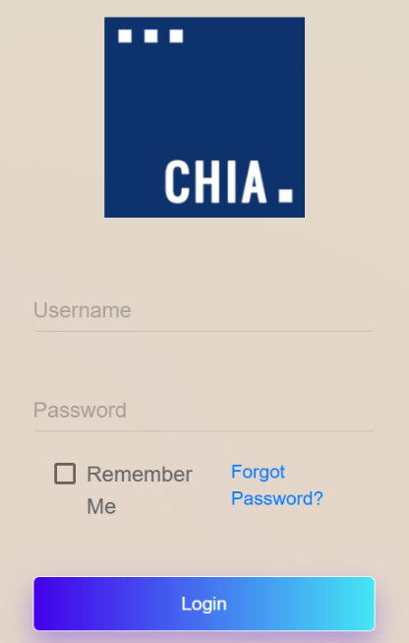

Next users will select the “Launch” button under the Skilled Nursing Facility Cost Report (SNF-CR) application module Users may have access to more than one application, such as the REA-CR or MGT-CR.

Starting with CY2024 reporting, you may see two separate tiles for the SNF-CR. The one marked (2021-2023) is only for those historical years. Please launch the report from the other tile in order to report 2024 data.

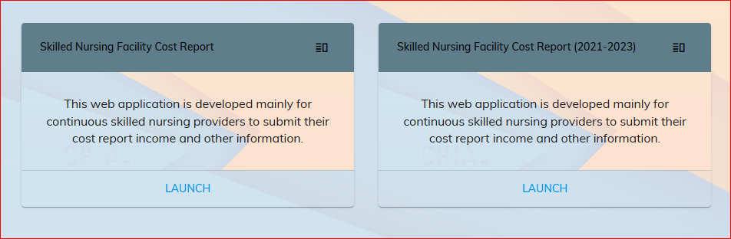

This will bring the user to the home screen of the SNF-CR.
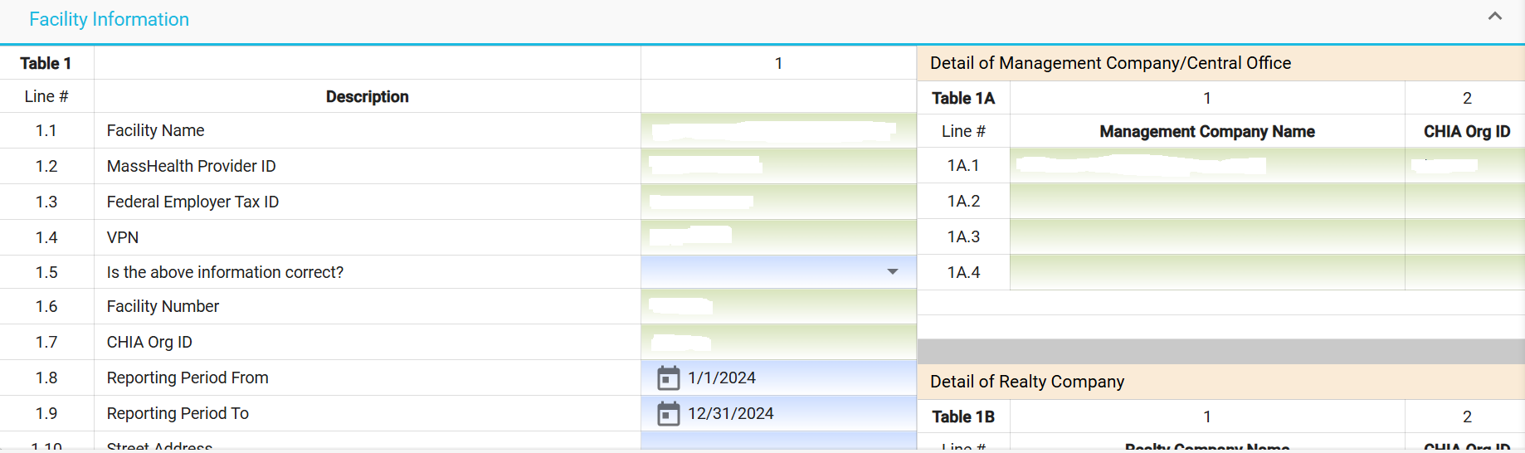

Home Screen
The far-left side of the screen lists all facilities that are registered to your username.

Clicking on a facility name will activate that account and display the information entered in Schedule 1 for the Reporting Year selected.

By clicking on the facility name in the organization list, the system will highlight that facility and activate the cost report schedules for the reporting year selected.

Users with access privileges to only one nursing facility’s cost report will not have an organization list in their view.

By clicking on the ellipses, you can collapse the Organization List.

Cost Report Year Selections
A user may change the reporting year by using the dropdown menu at the top of the screen labeled “Select a Filing Year.”


Navigating the SNF-CR
To move between schedules in the report, users can use the Schedule number listing to the right, select the “Jump To” menu option in the top left, or use the “Next Schedule” button in the top right.

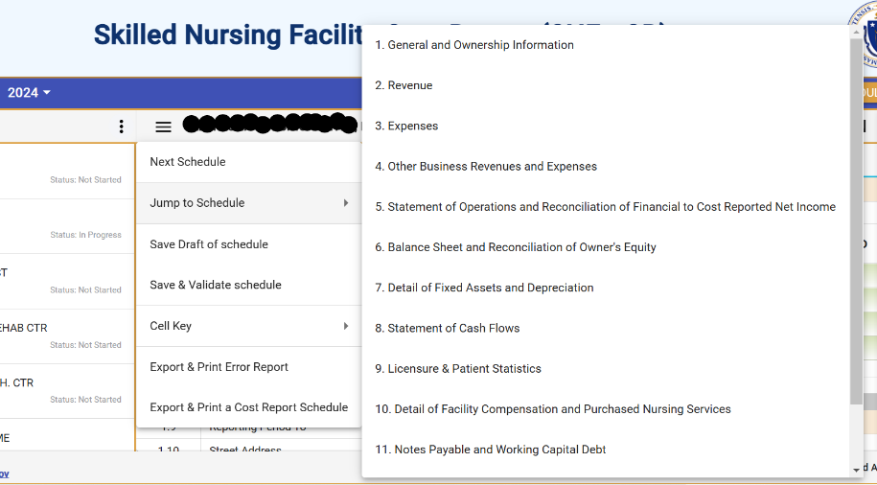

Saving Your Work
CHIA suggests that you save your reported data at frequent intervals as you move through each schedule of the cost report. To save your work, you can select the “Save as Draft” button which is located at the top right-hand corner of each schedule.
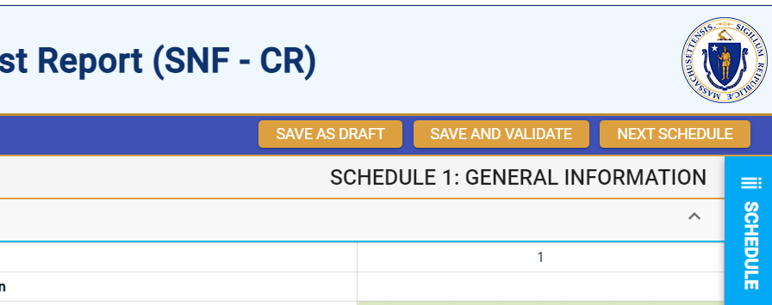

A screen will appear to “Cancel” or “Continue.” Select “Continue” to save. A screen confirming that the information is saved will appear. Select “Continue” again to return to the report.

Entering Data
Many of the data fields in the cost report have been formatted to accept data as text, whole dollars, and percentages. Some of the data fields will allow users to enter decimals and those fields are specifically indicated in the application.
When entering negative figures, users need to enter a negative sign (“- “) AFTER the figure as follows:
123,456-

Understanding Cell Colors
Each cell in the electronic cost report has been color shaded. The Cell Color Legend, illustrated below, provides an explanation of each color for how the cost report can be completed. Users are only able to enter information in the cells colored light blue or dark green. Cells with any other color will be either prepopulated from CHIA’s own system or from other cells in the cost report.
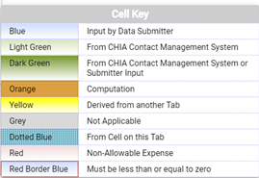
Note: Cells with red borders will automatically be shown as negative numbers.

Hover Messaging
Throughout the cost report, you will encounter hover messages when your mouse “hovers” over cells. These hover messages are designed to help in the following ways:
- Assist in providing information on the cell usage, i.e., percentage, number of decimal places permitted in a certain cell, etc.
- Assist with the location of the cell where data comes from. This is for cells colored yellow and dotted blue.
- Assist with what information should be reported in the cell.
An example of a hover message is illustrated in the picture below. This hover message explains that employee benefits consist of group life/health insurance, pensions, and other benefits for line 1.8 “Registered Nurses: Employee Benefits.”
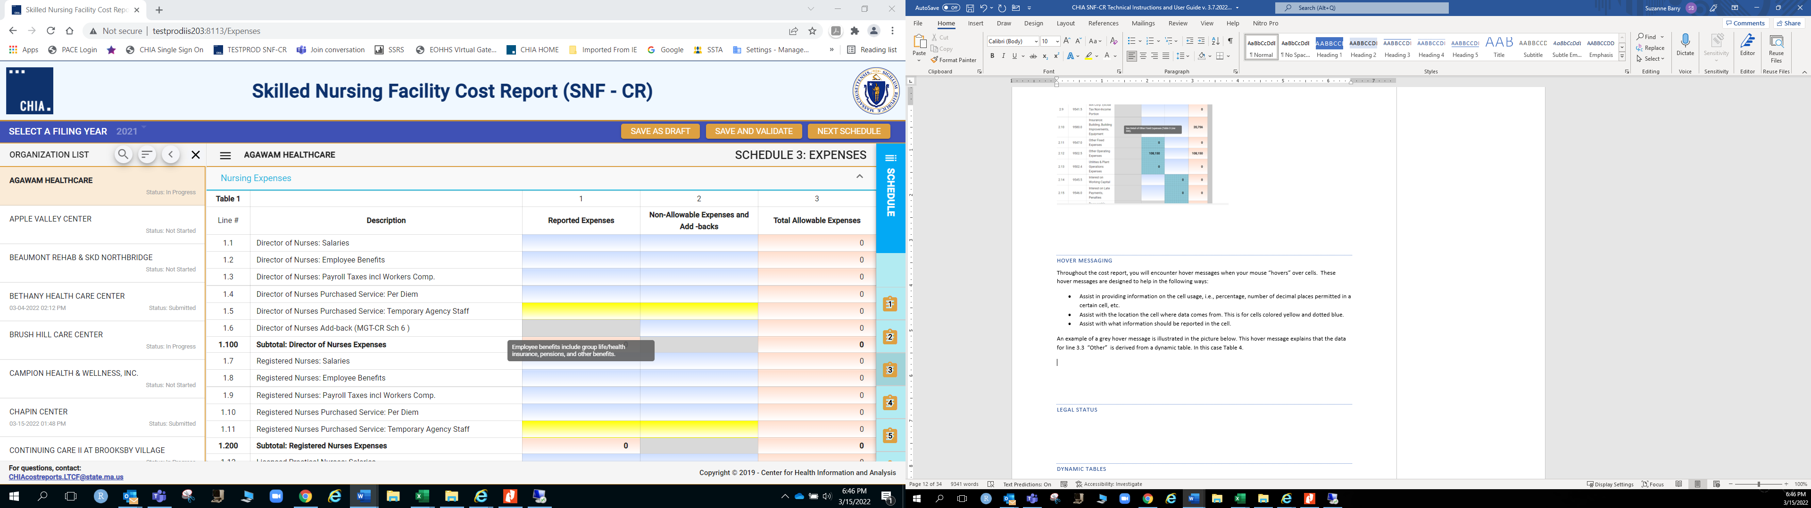

Legal Status
The legal status options that you can select in Schedule 1 line 1.17 are listed below. The legal status you select will determine which type of owner’s equity table and cash flow table will be populated in your cost report. Please refer to additional instructions on Schedules 6 and 8 for which tables are populated based on your selection.
Legal Code | Description | Profit / Non-Profit
1 | MA Corp (Chapter 156B) | Profit
2 | MA Corp (Chapter 156B with 501c(3) exemption) | Non-Profit
3 | MA Non-Profit Corp (Chapter 180) | Non-Profit
4 | Partnership, Limited Liability Corporation (LLC) | Profit
5 | Sole Proprietorship | Profit
6 | Governmental Entity | Non-Profit
7 | Other For-Profit | Profit
8 | Other Non-Profit | Non-Profit
9 | Non-MA Corporation | Profit
10 | Limited Liability Corporation | Profit

Dynamic Tables
This cost report uses dynamic tables that can be expanded to allow for flexible entry of additional detailed cost information. These tables will appear to the right of the main schedule tables and require users to enter information in these tables that will be automatically carried over to the main tables. Users can select the + button to add a line or hover over any added line number and click the red X to remove that line. An example of a dynamic table is illustrated below:
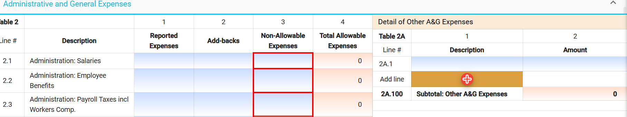

Data Validations
The SNF-CR includes several edits or checks within each of the schedules which need to be managed through the validation process described below. Preparers and submitters will not be able to lock the SNF-CR for review or submit the cost report unless all schedules have been validated and the errors fixed.
To ease this process, CHIA has created a validation report listing all validation errors. To access the validation report, you will select the “Save and Validate” Button on the top right corner of each schedule.



When this button is selected, users will encounter the following:
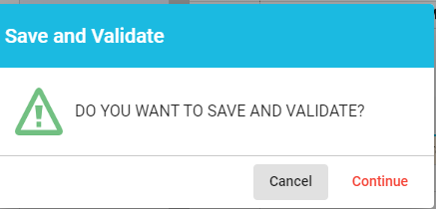

Users will select “Continue.” Once this is done, there will be two results. If there are validation errors, users will need to select the method they would like to view the validation report, as shown below:

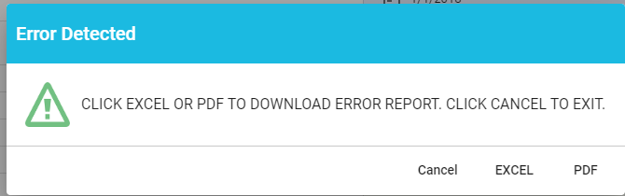

The validation report will provide users with the schedule number and line number of the error along with a description of what the problem is.
- If there are no validation errors, users will be notified that their schedule saved successfully and can continue completing the cost report.

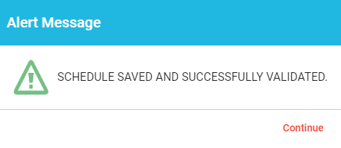
Additionally, users can launch the validation reports two additional ways. First, users can click on the hamburger menu button to pull down the menu options on the top left corner as follows:
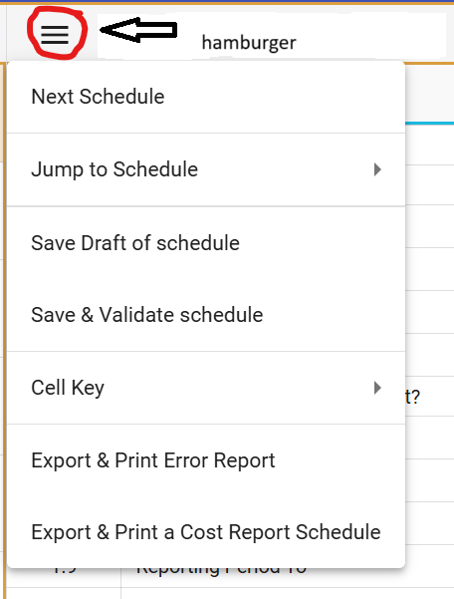
Then users will select the “Save & Validate schedule” option. This option validates only the current schedule in your view.
Finally, users can launch the “Export & Print Error Report” from the hamburger icon. Users should check each box for each Schedule an error report is desired. Please only use this option if you have already saved and validated the current schedule.
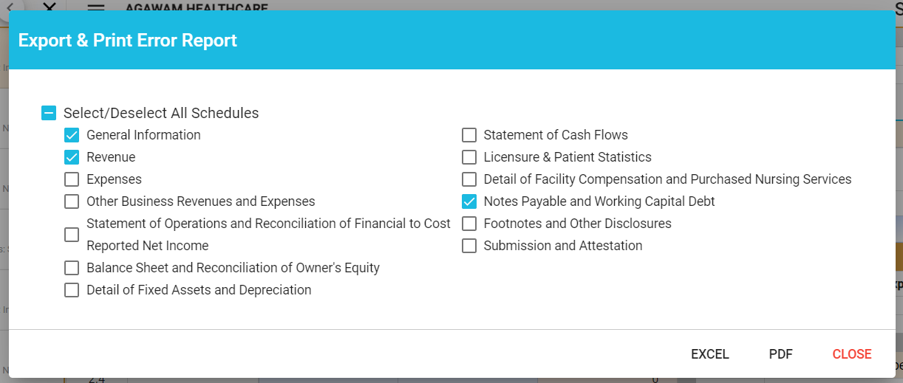

Submitting Your Cost Report
All validation errors must be resolved before users can attest and submit their cost reports. The submission process is designed with the following process based on access privileges. Those users with data access privileges can only prepare the report. Users with owner, partner, or officer privileges can certify and submit their cost reports. CHIA recommends that nursing facilities use the following process to successfully complete and submit the SNF-CR.

As illustrated above, users with data access only privileges, enter data in the cost report. Next, preparers, who also have the same privileges as data submitters, can continue to enter data in the cost report and, once complete, lock the report for owner review. Only users with owner, partner, or officer privileges can certify and submit the cost report, which is managed on Schedule 13 of the report. NOTE: Users who have data access only privileges will not have Schedule 13.

Preparers:
- Check Line 1.11 certifying the report. Owners, who are also preparers, have this privilege too.
- Select “Lock for Owner Review”

Owner/Partner/Officer:
- Owners/partners/officers cannot submit until the preparer has locked for owner review.
- Check Line 2.1 certifying the report.
- Click the “Submit” button

DETAILED INSTRUCTIONS BY SCHEDULE

SCHEDULE 1 – GENERAL AND OWNERSHIP INFORMATION
In Table 1, line 1.17, you must select the legal status of your facility. This selection will determine the format of four tables in this cost report in Schedules 5, 6, 8, and 10. The table below provides a summary of the options and the format of the tables. Refer to the specific line instructions and the drop-down menu for each legal status option.
Table Format | Legal Status Options
Not-for-profit | 2, 3, 6, 8
Proprietorship or partnership | 4, 5, 10
Corporation | 1, 7, 9

Table 1 – Facility Information
This table requires you report certain general facility information, as listed below.
Line | Line Description | Usage | Instructions
1.1 | Facility Name | Text | This field is pre-populated from CMS2.
1.2 | MassHealth Provider ID | Text | This field is pre-populated from CMS2.
1.3 | Federal Employer Tax ID | Text | This field is pre-populated from CMS2.
1.4 | VPN | Text | This field is pre-populated from CMS2.
1.5 | Is the above information, correct? | Drop down menu | Select from a drop-down list: Yes, No.
1.6 | Facility Number | Text | This field is pre-populated from CMS2.
1.7 | CHIA Org ID | Text | This field is pre-populated from CMS2.
1.8 | Reporting Period From | MM-DD-YYYY | Enter reporting period beginning date which is either 1/1/20XX or the date of purchase.
1.9 | Reporting Period To | MM-DD-YYYY | Enter reporting period ending date which is either 12/31/20XX or the date of sale.
1.10 | Street Address | Text | Enter the street address of facility.
1.11 | City | Text | Enter the city where the facility is located.
1.12 | Zip | ZIP + 4 | Enter zip code where facility is located.
1.13 | Telephone | (XXX) XXX-XXXX | Enter facility phone number.
1.14 | Is this a hospital-based nursing facility? | Drop down menu | Select from a drop-down list: Yes, No.
1.15 | Does the provider have pediatric beds? | Drop down menu | Select from a drop-down list: Yes, No.
1.16 | Does the provider have an executed special contract with MassHealth (e.g., ventilator unit, acquired brain injury, etc.)? | Drop down menu | Select from a drop-down list: Yes, No. NOTE: If you answer “YES”, you must complete a Pediatric Special Contract Supplemental Form (PSCSF) available on CHIA’s nursing facility webpage Information for Data Submitters: Nursing Facility Cost Reports.
1.17 | Legal Status | Drop down menu | Select from a drop-down list: (1) MA Corp (Chapter 156B) (2) MA Corp (Chapter 156B and 501c(3) exemption) (3) MA Non-Profit Corp (Chapter 180) (4) Partnership/Limited Liability Partnership (LLP)(5) Sole Proprietorship (6) Governmental Entity (7) Other For-Profit (8) Other Non-Profit (9) Non-MA Corp (10) Limited Liability Corporation (LLC). NOTE: your selection will determine the presentation of other tables in this cost report: Schedule 5, table 1; Schedule 6, table 8; and Schedule 10, table 6.
1.18 | Is the Management Company/Central Office information correct in Table 1A? | Drop down menu | Select from a drop-down list: Yes, No.
1.19 | List the name of the entity that holds the nursing facility license. | Text | Enter the name of the licensee who was issued the bed license.
1.20 | Is the Realty Company information correct in Table 1B? | Drop down menu | Select from a drop-down list: Yes, No.
1.21 | Do the direct and indirect owners of this facility operate any other Massachusetts public payer programs that are provided to facility residents? | Text | Select from a drop-down list: Yes, No.

Table 1A – DETAIL OF MANAGEMENT COMPANY/CENTRAL OFFICE
This table will pre-populate information from CMS2. If any of this information is incorrect, please email CHIA at Costreports.LTCF@chiamass.gov with the correct information. CHIA will make the appropriate corrections for this table.
Line | Col | Line Description | Usage | Instructions
1A.1+ | 1 | Management Company Name | Text | This field is pre-populated from CMS2.
1A.1+ | 2 | CHIA Org ID | Text | This field is pre-populated from CMS2.

Table 1B – DETAIL OF REALTY COMPANY
This table will pre-populate information from CMS2. If any of this information is incorrect, please email CHIA at Costreports.LTCF@chiamass.gov with the correct information. CHIA will make the appropriate corrections for this table.
Line | Col | Line Description | Usage | Instructions
1A.1+ | 1 | Realty Company Name | Text | This field is pre-populated from CMS2.
1A.1+ | 2 | CHIA Org ID | Text | This field is pre-populated from CMS2.

TABLE 2 – DETAIL OF DIRECT AND INDIRECT OWNERS
List all names of direct and indirect owners in this table, including their address, type of ownership, and % share of ownership.
Line | Col | Line Description | Usage | Instructions
2.1+ | 1 | Owner Name | Text | Enter the name of the owner.
2.1+ | 2 | Owner Address | Text | Enter the address of the owner.
2.1+ | 3 | Direct or Indirect | Drop down menu | Select from a drop-down list: direct or indirect ownership type.
2.1+ | 4 | % Share | XX.XXX% | Enter the % share of ownership.

TABLE 3 – DETAIL OF OTHER FACILITY INFORMATION
List the name(s) of any Massachusetts and non-Massachusetts nursing or residential care facilities owned, directly or indirectly, with an interest of 5% or more, by the nursing facility owners listed in Table 2.
Line | Col | Line Description | Usage | Instructions
3.1+ | 1 | Nursing or Residential Care Facility Name | Text | Enter the name of the nursing or residential care facility.
3.1+ | 2 | Is this facility in Massachusetts? | Drop down menu | Select from a drop-down list: yes or no.
3.1+ | 3 | MassHealth Provider ID # | Text | Enter the facility’s 9-digit MassHealth Provider ID number if applicable.
3.1+ | 4 | DPH License Number | Text | Enter the facility’s DPH license number that is found on the DPH license.
3.1+ | 5 | Name of Owner(s) | Text | List the name(s) of owner(s) for this facility.
3.1+ | 6 | Direct or Indirect | Drop down menu | Select from a drop-down list: direct or indirect ownership type.
3.1+ | 7 | Facility Address | Text | Enter the address of the facility.
3.1+ | 8 | % Share | XX.XXX% | Enter the % share of ownership.

TABLE 4 – OWNER BUSINESS INFORMATION
Use this table to provide information on any other Massachusetts public payer programs that the direct and/or indirect owners of this facility operate. If there are additional rows needed, please provide details in Schedule 12, Footnotes and Explanations.
Line | Col | Line Description | Usage | Instructions
4.1+ | 1 | Service Type | Drop-down menu | Select the service type from the drop-down menu.
4.1+ | 2 | Company Name | Text | Enter the name of the company doing business with the Commonwealth of Massachusetts.
4.1+ | 3 | MassHealth Provider ID | Text | Enter the facility’s 9-digit MassHealth Provider ID number if applicable.
4.1+ | 4 | Direct Owner/Partner Names | Text | Enter each of the direct owners’ names of the business that also own the nursing facility.
4.1+ | 5 | Indirect Owner/Partner Names | Text | Enter each of the indirect owners’ names of the business that also own the nursing facility.
4.1+ | 6 | Parent Organization Names | Text | Enter the names of the parent organization.

Table 5 – COntact Information
This table requires you to report information on the facility’s main contact, as listed below.
Line | Line Description | Usage | Instructions
5.1 | Contact Person Name | Text | Enter the name of the facility’s main contact. This is the person that will receive emails and rate notifications.
5.2 | Nursing Facility or Firm Name | Text | Enter nursing facility name if the contact person is an employee of the nursing facility or enter the firm name of the main contact person.
5.3 | Title | Text | Enter the title of the main contact.
5.4 | Street Address | Text | Enter the street address.
5.5 | City | Text | Enter the city.
5.6 | State | Text | Enter the state.
5.7 | Zip Code | XXXXX | Enter the zip code.
5.8 | Phone Number | (XXX) XXX-XXXX | Enter the main contact’s phone number.
5.9 | Email Address | Text | Enter the main contact’s email address.

Table 6 – Preparer Information
This table requires you to report information on the facility’s cost report preparer, as listed below.
Line | Line Description |  | Usage |  | Instructions
6.1 | I am the sole individual completing the cost report as an Owner, Partner, of Officer, and do not have a Preparer formally attesting to the information. | Checkbox |  | By checking this box, you indicate that you are both the owner and the cost report preparer.
6.2 | Preparer Person Name | Text |  | Enter the name of the cost report preparer or leave the entry that was prepopulated from CHIA’s system.
6.3 | Nursing Facility or Firm Name | Text |  | Enter the nursing facility name if the preparer is an employee of the nursing facility or enter the firm name of cost report preparer or leave the entry that was prepopulated from CHIA’s system.
6.4 | Title | Text |  | Enter the title of the preparer.
6.5 | Street Address | Text |  | Enter the preparer’s street address or leave the entry that was prepopulated from CHIA’s system.
6.6 | City | Text |  | Enter the city or leave the entry that was prepopulated from CHIA’s system.
6.7 | State | Text |  | Enter the state or leave the entry that was prepopulated from CHIA’s system.
6.8 | Zip Code | ZIP + 4 |  | Enter the zip code or leave the entry that was prepopulated from CHIA’s system.
6.9 | Phone Number | (XXX) XXX-XXXX |  | Enter the phone number or leave the entry that was prepopulated from CHIA’s system.
6.10 | Email Address | Text |  | Enter the email address or leave the entry that was prepopulated from CHIA’s system.
6.11 | Type of Accounting Service Performed. | Drop down menu |  | Select one of the following from the drop-down menu: Audit, Compilation, Review, Other (Explain in Footnotes).

SCHEDULE 2 – REVENUE
This schedule requires you to enter all types of revenue earned by your facility.

Table 1 – Nursing Facility Revenue
This table has payer descriptions that correspond with the payer descriptions for reporting patient day information on Schedule 9. Please use the following definitions when reporting revenues by payer.
Private Pay: Includes any payments made directly to the facility from a patient or his or her family. Does not include any payments made from commercial or government insurance programs.
Commercial Managed Care: Includes Health Maintenance Organizations (HMOs) and Preferred
Provider Organizations (PPOs) that are not Medicare+ Choice plans or Medicaid.
Commercial Non-Managed Care: Includes commercial indemnity products and long-term care insurance payments made directly to facilities, excluding HMOs, PPOs, and Medicare+ Choice plans or Medicaid.
Medicare Fee-For-Service: Includes Medicare Parts A & B.
Medicare Managed Care (Part C): A health plan, such as a Medicare managed care plan or Private Fee-for-Service plan offered by a private company and approved by Medicare. Includes Medicare+ Choice plans.
MassHealth Fee-For-Service: Includes fee-for-service MassHealth, Massachusetts Commission for the Blind, and other fee-for-service Title XIX days associated with the Massachusetts Medicaid Program, excluding Senior Care Options, OneCare, or PACE days.
MassHealth Managed Care: Includes days associated with beneficiaries enrolled in a MassHealth managed care organization, excluding Senior Care Options, OneCare, or PACE days.
Senior Care Options: Includes residents participating in the Senior Care Options (SCO) program sponsored by the Massachusetts Executive Office of Health and Human Services.
OneCare: Includes residents participating in the OneCare program sponsored by the Massachusetts Executive Office of Health and Human Services.
PACE: Includes residents participating in the Programs of All-inclusive Care for the Elderly (PACE).
Medicaid Out-of-State: Includes any other state Medicaid program except Massachusetts.
Veteran’s Affairs and Other Public: Includes patient days for Veteran’s Administration or other non-Title XIX state or federal payments, such as the TriCare program for military employees or retirees.
DTA & EAEDC: Includes Department of Transitional Assistance (DTA) days for DTA or Emergency Aid for the Elderly and Disabled (EAEDC) patients in Resident care beds (Level IV).
Other: Includes any other product not categorized above.

Line | Col | Line Description | Column | Usage | Instructions
1.1 | 1 | Private Pay | Routine Revenue | XX,XXX OR (XX,XXX) | Enter total private pay routine revenue.
1.1 | 2 | Private Pay | Ancillary Revenue | XX,XXX OR (XX,XXX) | Enter total private pay ancillary revenue.
1.2 | 1 | Commercial Managed Care | Routine Revenue | XX,XXX OR (XX,XXX) | Enter total commercial managed care routine revenue.
1.2 | 2 | Commercial Managed Care | Ancillary Revenue | XX,XXX OR (XX,XXX) | Enter total commercial managed care ancillary revenue.
1.3 | 1 | Commercial Non-Managed Care | Routine Revenue | XX,XXX OR (XX,XXX) | Enter total commercial non-managed care routine revenue.
1.3 | 2 | Commercial Non-Managed Care | Ancillary Revenue | XX,XXX OR (XX,XXX) | Enter total commercial non-managed care ancillary revenue.
1.4 | 1 | Medicare Fee-For-Service | Routine Revenue | XX,XXX OR (XX,XXX) | Enter total Medicare FFS routine revenue.
1.4 | 2 | Medicare Fee-For-Service | Ancillary Revenue | XX,XXX OR (XX,XXX) | Enter total Medicare FFS ancillary revenue.
1.5 | 1 | Medicare Managed Care (Part C) | Routine Revenue | XX,XXX OR (XX,XXX) | Enter total Medicare managed care (Part C) routine revenue.
1.5 | 2 | Medicare Managed Care (Part C) | Ancillary Revenue | XX,XXX OR (XX,XXX) | Enter total Medicare managed care (Part C) ancillary revenue.
1.6 | 1 | MassHealth Fee-for-Service | Routine Revenue | XX,XXX OR (XX,XXX) | Enter total MassHealth (Medicaid) FFS routine revenue.
1.6 | 2 | MassHealth Fee-for-Service | Ancillary Revenue | XX,XXX OR (XX,XXX) | Enter total MassHealth (Medicaid) FFS ancillary revenue.
1.7 | 1 | MassHealth Managed Care | Routine Revenue | XX,XXX OR (XX,XXX) | Enter total MassHealth (Medicaid) managed care routine revenue.
1.7 | 2 | MassHealth Managed Care | Ancillary Revenue | XX,XXX OR (XX,XXX) | Enter total MassHealth (Medicaid) managed care ancillary revenue.
1.8 | 1 | Senior Care Options | Routine Revenue | XX,XXX OR (XX,XXX) | Enter total Senior Care Options (SCO) managed care routine revenue.
1.8 | 2 | Senior Care Options | Ancillary Revenue | XX,XXX OR (XX,XXX) | Enter total Senior Care Options (SCO) managed care ancillary revenue.
1.9 | 1 | OneCare | Routine Revenue | XX,XXX OR (XX,XXX) | Enter total OneCare routine revenue.
1.9 | 2 | OneCare | Ancillary Revenue | XX,XXX OR (XX,XXX) | Enter total OneCare ancillary revenue.
1.10 | 1 | PACE | Routine Revenue | XX,XXX OR (XX,XXX) | Enter total PACE routine revenue.
1.10 | 2 | PACE | Ancillary Revenue | XX,XXX OR (XX,XXX) | Enter total PACE ancillary revenue.
1.11 | 1 | Medicaid Out-of-State | Routine Revenue | XX,XXX OR (XX,XXX) | Enter total Medicaid out of state routine revenue.
1.11 | 2 | Medicaid Out-of-State | Ancillary Revenue | XX,XXX OR (XX,XXX) | Enter total Medicaid out of state ancillary revenue.
1.12 | 1 | Medicaid Patient Paid Amount | Routine Revenue | XX,XXX OR (XX,XXX) | Enter total Medicaid patient paid routine revenue.
1.12 | 2 | Medicaid Patient Paid Amount | Ancillary Revenue | XX,XXX OR (XX,XXX) | Enter total Medicaid patient paid ancillary revenue.
1.13 | 1 | DTA & EAEDC | Routine Revenue | XX,XXX OR (XX,XXX) | Enter total DTA & EAEDC routine revenue.
1.13 | 2 | DTA & EAEDC | Ancillary Revenue | XX,XXX OR (XX,XXX) | Enter total DTA & EAEDC ancillary revenue.
1.14 | 1 | Veteran's Affairs & Other Public | Routine Revenue | XX,XXX OR (XX,XXX) | Enter total VA and other public routine revenue.
1.14 | 2 | Veteran's Affairs & Other Public | Ancillary Revenue | XX,XXX OR (XX,XXX) | Enter total VA and other public ancillary revenue.
1.15 | 1 | Other Payer Revenue | Routine Revenue | XX,XXX OR (XX,XXX) | Enter total other payer routine revenue.
1.15 | 2 | Other Payer Revenue | Ancillary Revenue | XX,XXX OR (XX,XXX) | Enter total other payer ancillary revenue.

Table 2 Other Nursing Facility Revenue
This table requires you to enter all other nursing facility revenues. This table and other schedules replace the Non-Nursing Facility Revenue and Expenses Schedules on the predecessor cost report (HCF-1).
Line | Line Description | Usage | Instructions
2.1 | Total Other Business Revenue | XX,XXX OR (XX,XXX) | No entry is allowed in this line. This line is linked to schedule 4, table 2, line 200.
2.2 | Endowment and Other Non-Recoverable Revenue | XX,XXX OR (XX,XXX) | No entry is allowed in this line. This line is linked to schedule 2, table 3, line 300.
2.3 | Laundry Revenue | XX,XXX OR (XX,XXX) | Enter revenue from other special laundry services provided to nursing residents for a fee.
2.4 | Vending Machine Revenue | XX,XXX OR (XX,XXX) | Enter revenue from vending machines available for nursing facility residents. If the vending machine is located where other business activities occur, e.g., Outpatient Services, then the revenues should be entered in Schedule 4.
2.5 | Recovery of Bad Debts | XX,XXX OR (XX,XXX) | Enter amount recovered from receivables from nursing facility residents that were previously written off.
2.6 | Prior Year Retroactive Revenue | XX,XXX OR (XX,XXX) | Enter the amount of any prior year revenue for nursing facility services.
2.7 | Interest Income | XX,XXX OR (XX,XXX) | Enter the amount of interest income earned on investments used for nursing facility purposes.
2.8 | Nurses' Aid Training Revenue | XX,XXX OR (XX,XXX) | Enter the amount of revenue generated from nurses’ aid training programs. This account represents the amount received directly from the Department of Public Health for the administrative component of the Nurses’ Aide Training Program.
2.9 | Administrative and General Recoverable Revenue | XX,XXX OR (XX,XXX) | Enter the amount of any administrative and general recoverable revenues.
2.10 | Nursing Recoverable Revenue | XX,XXX OR (XX,XXX) | Enter the amount of any nursing cost recoverable revenue.
2.11 | Variable Recoverable Revenue | XX,XXX OR (XX,XXX) | Enter the amount of any variable cost recoverable revenue.
2.12 | Fixed Cost Recoverable Revenue | XX,XXX OR (XX,XXX) | Enter the amount of any fixed asset cost recoverable revenue.

Table 3 – Detail of Endowment and Non-Recoverable Revenue
To report other endowment and non-recoverable revenues on table 1 of schedule 2, users must enter the details of the type and amount of this revenue on this table.
Cost report preparers are to report COVID-19 receipts pursuant to certain Administrative and Nursing Facility Bulletins. These COVID-19 receipts are to be reported as revenues in Schedule 2, Table 3 (Detail of Endowment and Non-Recoverable Revenue). Please use one line in the detail table to report the total of all COVID-19 receipts and use the description “Total COVID-19 Receipts”.
Line | Line Description | Type | Usage | Instructions
3.1 | Other Endowment and Non-Recoverable Revenue | Enter the type | XX,XXX or (XX,XXX) | Enter the type and amount of any endowment and non-recoverable revenue.
3.2 | Other Endowment and Non-Recoverable Revenue | Enter the type | XX,XXX or (XX,XXX) | Enter the type and amount of any endowment and non-recoverable revenue.
3.3 | Other Endowment and Non-Recoverable Revenue | Enter the type | XX,XXX or (XX,XXX) | Enter the type and amount of any endowment and non-recoverable revenue.
3.4 | Other Endowment and Non-Recoverable Revenue | Enter the type | XX,XXX or (XX,XXX) | Enter the type and amount of any endowment and non-recoverable revenue.
3.5 | Other Endowment and Non-Recoverable Revenue | Enter the type | XX,XXX or (XX,XXX) | Enter the remaining amount of any endowment and non-recoverable revenue.

SCHEDULE 3 - EXPENSES
Please note that the CY2024 SNF-CR has many changes and improvements as compared to prior years, including updates to Schedule 3. The layout of this schedule has changed in how to report add-backs and non-allowable expenses. There are 3 columns for user entry: 1) reported expenses,2) add-backs, and 3) non-allowable expenses. You must report all facility expenses in column 1. Column 2 is for reporting add back expenses, which should be entered as positive values, as applicable. Column 3 is for reporting self-disallowed expenses, which must be entered as negative values, to arrive at allowable expenses automatically calculated in column 4. If an expense is entirely non-allowable according to state regulations, the amount is automatically populated in column 3 upon entry in column 1. Cost report preparers must be familiar with 101 CMR 206.05 for capital and fixed cost expenses and 101 CMR 206.08(3) for other allowable and non-allowable costs when completing this schedule.
The expenses are categorized in the following four main (4) tables:
- Nursing Expenses
- Administrative and General Expenses
- Variable Expenses
- Capital and Fixed Cost Expenses.
There are two (2) additional detail tables that link to the main Administrative and General table. These are Table 2A for reporting details of other administrative and general costs, and Table 2B for reporting all non-allowable A&G costs. Please refer to the General User Instruction section of this manual to further understand how dynamic tables function.
In addition, Detail of Related Party Transactions, which used to be uploaded information, is now located in Table 7 of Schedule 3.

Table 1 – Nursing Expenses
You will not be allowed to enter data in the lines for Purchased Service Nursing Services Temporary Agency Staff; lines 1.5, 1.11, 1.16, and 1.21. You will need to enter these amounts first in Schedule 10 Table 4.
When entering values in the Purchased Service: Per Diem lines (Lines 1.4, 1.10, 1.15, 1.20), use the following definition of per diem staff:
Per Diem Staff: Per diem staff includes an individual who provides his/her own services on a temporary basis to the nursing facility. Such an individual is generally self-employed and is not employed by a temporary nursing agency (“nursing pool”) or other staffing organization. The facility contracts directly with the individual for the services provided.
Line | Line Description | Usage | Instructions
1.1 | Director of Nurses: Salaries | XX,XXX or (XX,XXX) | Enter the director(s) of nursing salaries.
1.2 | Director of Nurses: Employee Benefits | XX,XXX or (XX,XXX) | Enter employee benefits provided to the directors of nursing. Employee benefits include group health/life, pensions, and other benefits.
1.3 | Director of Nurses: Payroll Taxes incl Workers Comp. | XX,XXX or (XX,XXX) | Enter payroll and workers comp. associated with the directors of nursing salaries.
1.4 | Director of Nurses Purchased Service: Per Diem | XX,XXX or (XX,XXX) | Enter the cost of director of nursing per diem purchased services.
1.5 | Director of Nurses Purchased Service: Temporary Agency Staff | XX,XXX or (XX,XXX) | Entry is not permitted in this field. You must report director of nursing costs from temporary nursing service agencies on schedule 10 table 4 first.
1.6 | Director of Nurses Add-back (MGT-CR Sch 6 ) | XX,XXX or (XX,XXX) | Enter the allocated cost of director of nursing services from the management company cost report (MGT-CR) Schedule 6. Entry allowed in column 2 only.
1.7 | Registered Nurses: Salaries | XX,XXX or (XX,XXX) | Enter RN salaries.
1.8 | Registered Nurses: Employee Benefits | XX,XXX or (XX,XXX) | Enter employee benefits provided to RNs. Employee benefits include group health/life, pensions, and other benefits.
1.9 | Registered Nurses: Payroll Taxes incl Workers Comp. | XX,XXX or (XX,XXX) | Enter payroll and workers comp. associated with RN salaries.
1.10 | Registered Nurses Purchased Service: Per Diem | XX,XXX or (XX,XXX) | Enter the cost of RN per diem purchased services.
1.11 | Registered Nurses Purchased Service: Temporary Agency Staff | XX,XXX or (XX,XXX) | Entry is not permitted in this field. You must report RN costs from temporary nursing service agencies on schedule 10 table 4 first.
1.12 | Licensed Practical Nurses: Salaries | XX,XXX or (XX,XXX) | Enter LPN salaries.
1.13 | Licensed Practical Nurses: Employee Benefits | XX,XXX or (XX,XXX) | Enter employee benefits provided to LPNs. Employee benefits include group health/life, pensions, and other benefits.
1.14 | Licensed Practical Nurses: Payroll Taxes incl Workers Comp. | XX,XXX or (XX,XXX) | Enter payroll and workers comp. associated with LPN salaries.
1.15 | Licensed Practical Nurses Purchased Service: Per Diem | XX,XXX or (XX,XXX) | Enter the cost of LPN per diem purchased services.
1.16 | Licensed Practical Nurses Purchased Service: Temporary Agency Staff | XX,XXX or (XX,XXX) | Entry is not permitted in this field. You must report LPN costs from temporary nursing service agencies on schedule 10 table 4 first.
1.17 | Certified Nurse Aides: Salaries | XX,XXX or (XX,XXX) | Enter CNA salaries.
1.18 | Certified Nurse Aides: Employee Benefits | XX,XXX or (XX,XXX) | Enter employee benefits provided to CNAs. Employee benefits include group health/life, pensions, and other benefits.
1.19 | Certified Nurse Aides: Payroll Taxes incl Workers Comp. | XX,XXX or (XX,XXX) | Enter payroll and workers comp. associated with CNA salaries.
1.20 | Certified Nurse Aides Purchased Service: Per Diem | XX,XXX or (XX,XXX) | Enter the cost of CNA per diem purchased services.
1.21 | Certified Nurse Aides Purchased Service: Temporary Agency Staff | XX,XXX or (XX,XXX) | Entry is not permitted in this field. You must report CNA costs from temporary nursing service agencies on schedule 10 table 4 first.
1.22 | Nurse's Aide Training Administration | XX,XXX or (XX,XXX) | Enter the cost associated with training nurse aides, in accordance with the requirements set forth by the Department of Public Health, includes the instructor, books, and space rental, if necessary. The wages paid to the aide during the training program should be reported under nurse aide salaries.
1.23 | Nursing Education and Training | XX,XXX or (XX,XXX) | Enter the cost of other required or non-required continuing education and training for nursing staff for non-required training, the training must be job related and generally available to all nursing staff.
1.24 | This line description is intentionally left blank | N/A | No entry permitted.
1.25 | This line description is intentionally left blank | N/A | No entry permitted.
1.26 | Nursing & Director of Nursing Recoverable Revenue | N/A | Entry is not permitted in this field. You must enter nursing and DON recoverable income on schedule 2 line 2.10.
1.27 | Nurses' Aide Training Recoverable Revenue | N/A | Entry is not permitted in this field. You must enter nurses’ aide training recoverable income on schedule 2 line 2.8.

Table 2 – Administrative and General Expenses
Line | Line Description | Usage | Instructions
2.1 | Administration: Salaries | XX,XXX or (XX,XXX) | Enter administrator and administrator in training salaries. Do not include the balance of any “Draw” accounts.
2.2 | Administration: Employee Benefits | XX,XXX or (XX,XXX) | Enter employee benefits provided to the administrator and administrator in training. Employee benefits include group health/life, pensions, and other benefits.
2.3 | Administration: Payroll Taxes incl Workers Comp. | XX,XXX or (XX,XXX) | Enter payroll and workers comp. associated with administrator and administrator in training salaries.
2.4 | Administration: Purchased Service | XX,XXX or (XX,XXX) | Enter administrator and administrator in training purchased services costs.
2.5 | Officers: Total Compensation | XX,XXX or (XX,XXX) | Enter total officer compensation. Officer salaries are presumed to be for non-active officers. If the officer performs an active role in the facility’s operation, the salary and related benefits and taxes should be posted to the account representing the type of work done. For example, if the officer works in the nursing department, the salary and related expenses should be reported in nursing salaries and nursing benefit, taxes, and workers compensation accounts.
2.6 | Management Company Administration Add-Back (MGT-CR Sch. 6) | XX,XXX or (XX,XXX) | Enter the amount of management company allocated administrative costs from the amount reported on schedule 6 of the MGT-CR. Entry allowed in column 2 only as an add-back.
2.7 | Clerical Staff: Salaries | XX,XXX or (XX,XXX) | Enter clerical staff salaries.
2.8 | Clerical Staff: Employee Benefits | XX,XXX or (XX,XXX) | Enter employee benefits provided to clerical staff. Employee benefits include group health/life, pensions, and other benefits.
2.9 | Clerical Staff: Payroll Taxes incl Workers Comp. | XX,XXX or (XX,XXX) | Enter payroll and workers comp. associated with clerical staff salaries.
2.10 | Clerical Staff: Purchased Service | XX,XXX or (XX,XXX) | Enter clerical staff purchased services costs.
2.11 | Electronic Data Processing, Payroll, and Bookkeeping Services | XX,XXX or (XX,XXX) | Enter EDP, payroll, and bookkeeping services costs.
2.12 | Office Supplies | XX,XXX or (XX,XXX) | Enter the cost of officer supplies.
2.13 | Telecommunications (e.g., Internet, Phone) | XX,XXX or (XX,XXX) | Enter the cost of telecommunications.
2.14 | Other Telecommunications (e.g., tablets to support family and resident communications) | XX,XXX or (XX,XXX) | Enter other telecommunications costs. This is a line available for other nursing facility resident care telecommunications costs.
2.15 | Travel: Conventions & Meetings | XX,XXX or (XX,XXX) | Enter travel costs associated with resident care. Travel costs not associated with resident care must be reported separately on table 2B.
2.16 | Advertising: Help Wanted | XX,XXX or (XX,XXX) | Enter advertising associated with resident care. Other advertising costs, such as those associated with promotion of the facility for new admissions, must reported separately on table 2B.
2.17 | Licenses and Dues: Patient Care Related Portion | XX,XXX or (XX,XXX) | Enter the cost of licenses and dues associated with patient care. Any licenses and dues not related to patient care must be reported separately on table 2B.
2.18 | Continuing Professional Education / Training and Development | XX,XXX or (XX,XXX) | Enter the cost of continuing professional education and training. Any continuing professional education and training not related to patient care must be reported separately on table 2B.
2.19 | Accounting Services (Not related to appeals) | XX,XXX or (XX,XXX) | Enter the cost of accounting services. Accounting services associated with appeals or other legal matters and not associated with resident care must be reported separately on Table 2B.
2.20 | Insurance: Malpractice & General Liability | XX,XXX or (XX,XXX) | Enter the cost of malpractice and general insurance. Building insurance must be reported separately on Table 4 as a fixed asset expense. Insurance costs associated with other business activities (e.g., adult day health services or outpatient services) must be reported separately on Schedule 4, table 3.
2.21 | Insurance: Department of Unemployment Assistance (DUA) Claims - A & G Portion | XX,XXX or (XX,XXX) | Enter the administrative and general portion of DUA claims.
2.22 | Other A & G Expenses | XX,XXX or (XX,XXX) | Entry is not permitted in this field. You must enter the details of all other administrative and general costs on table 2A.
2.23 | Non-Allowable A & G Expenses | N/A | Entry is not permitted in this field. You must complete table 2B non-allowable A&G expenses. These are non-allowable costs and the amount entered in column 1 will automatically be populated in column 3.
2.24 | Realty Company Other Expenses Add-back (REA-CR, Sch. 2) | XX,XXX or (XX,XXX) | Enter the amount of realty company allocated administrative costs from the amount reported on schedule 2 of the REA-CR. Entry allowed in column 2 only as an add-back.
2.25 | Management Company Allocated A & G Expenses (MGT-CR, Sch. 6) | XX,XXX or (XX,XXX) | Enter the amount of management company allocated administrative and general expenses from the amount reported on schedule 6 of the MGT-CR. This line should reflect the expenses associated with an administrator that is employed by a management company or central office but works at the facility. Entry allowed in column 2 only as an add-back.
2.26 | Management Company Allocated Fixed Cost Expenses (MGT-CR, Sch. 6) | XX,XXX or (XX,XXX) | Enter the amount of management company allocated fixed cost expenses from the amount reported on schedule 6 of the MGT-CR. Entry allowed in column 2 only as an add-back.
2.27 | This line description is intentionally left blank | N/A | No entry permitted.
2.28 | This line description is intentionally left blank | N/A | No entry permitted.
2.29 | A & G Recoverable Revenue | N/A | Entry is not permitted in this field. You must enter A&G recoverable income on schedule 2 line 2.9.

Table 2A – Detail of Other A&G Expenses
This table is a dynamic table. For additional instructions on how to use dynamic tables, refer to the General User Instructions section of this user manual.
Line | Column 1 | Column 2 | Usage | Instructions
2A.1+ | Enter Description | Enter Amount | Col 1 – text  Col 2 – XX,XXX or (XX,XXX) | This is a dynamic table that allows the user to manipulate the number of rows by clicking the “+.” This table is designed to report details of other A&G costs. Do not enter a description of “Other” or “Misc.” in this table.

Table 2B – Detail of Non-Allowable A&G Expenses
Line | Line Description | Usage | Instructions
2B.1 | Advertising: Marketing | XX,XXX or (XX,XXX) | Enter non-allowable advertising marketing and promotions costs
2B.2 | Licenses and Dues: Not Related to Resident Care | XX,XXX or (XX,XXX) | Enter non-allowable licenses and dues that are not related to patient care.
2B.3 | Accounting: Appeal Service | XX,XXX or (XX,XXX) | Enter accounting costs associated with appeal services.
2B.4 | Legal: Appeal Service and DALA Filing Fees | XX,XXX or (XX,XXX) | Enter costs and fees associated with legal appeal services.
2B.5 | Legal: Resident care | XX,XXX or (XX,XXX) | Report only legal expenses that are related to obtaining guardianships or other legal services related to the protection of residents.
2B.6 | Legal: Other | XX,XXX or (XX,XXX) | Report all other legal costs not reported in lines 2B.4 and 2B.5.
2B.7 | Key Person insurance | XX,XXX or (XX,XXX) | Enter the costs associated with key person insurance. This is a non-allowable expense because this benefit is not available to all staff.
2B.8 | Management Company Fees | XX,XXX or (XX,XXX) | If the nursing facility had a management company or central office during the year, then it must file or cause to be filed the MGT-CR (management company/central office report). Amounts reported as management company income reported on the MGT-CR for this facility must match amounts paid on this line.
2B.9 | Management Consultants | XX,XXX or (XX,XXX) | Enter the cost of management consultants. Management consultant expense is the cost of outside expertise assisting or advising the facility’s staff with an identifiable project or task. Examples of consulting expense include public relations development, recruiting through personnel agencies, reorganization of medical records by outside vendors, and management minutes questionnaire consulting (excluding the actual cost to complete the MMQ).
2B.10 | Interest on Working Capital | XX,XXX or (XX,XXX) | Enter the amount of interest incurred on working capital. All interest expense is non-allowable unless the interest is for fixed asset additions.
2B.11 | Fines, Late Fees, Penalties, including Interest | XX,XXX or (XX,XXX) | Enter all fines, late fees, penalties, and interest related to past due payments.
2B.12 | State and Federal Income Taxes | XX,XXX or (XX,XXX) | Enter state and federal income taxes.
2B.13 | Pre-Opening Expenses | XX,XXX or (XX,XXX) | This line must be used to report pre-opening costs and the amortization expense of any pre-opening costs that were capitalized. Examples of such costs, which are sometimes called start-up costs, would include the salaries and related expenses of an administrator and other staff who were hired prior to the date of licensure and the arrival of the first patient. Because new facilities benefit from other special provisions, the amortization expense related to these capitalized pre-opening costs must be reported here because they are automatically disallowed.
2B.14 | Bad Debt Expense | XX,XXX or (XX,XXX) | Enter amount of bad debt reserved for this year.
2B.15 | User Fee Assessment | XX,XXX or (XX,XXX) | Enter all 4 quarterly user fee payments.
2B.16 | Other Non-Allowable A&G Expenses | XX,XXX or (XX,XXX) | Enter any other non-allowable non-nursing facility expenses.
2B.17 | This line description is intentionally left blank | N/A | No entry permitted.
2B.18 | This line description is intentionally left blank | N/A | No entry permitted.

Table 3 - Variable Expenses
Line | Line Description | Usage | Instructions
3.1 | Staff Development Coordinator: Salaries | XX,XXX or (XX,XXX) | Enter staff development coordinator salaries.
3.2 | Staff Dev. Coord.: Employee Benefits | XX,XXX or (XX,XXX) | Enter staff development coordinator employee benefits. Employee benefits include group health/life, pensions, and other benefits.
3.3 | Staff Dev. Coord.: Payroll Taxes incl Workers Comp. | XX,XXX or (XX,XXX) | Enter staff development coordinator payroll taxes and worker’s comp.
3.4 | Staff Dev. Coord.: Purchased Service | XX,XXX or (XX,XXX) | Enter cost of purchased services for staff development coordinators.
3.5 | Plant Operation: Salaries | XX,XXX or (XX,XXX) | Enter plant operations salaries.
3.6 | Plant Operation: Employee Benefits | XX,XXX or (XX,XXX) | Enter plant operations employee benefits. Employee benefits include group health/life, pensions, and other benefits.
3.7 | Plant Operation: Payroll Taxes incl Workers Comp. | XX,XXX or (XX,XXX) | Enter plant operations payroll taxes and worker’s comp.
3.8 | Plant Operation: Purchased Service | XX,XXX or (XX,XXX) | Enter cost of purchased services for staff development coordinators.
3.9 | Plant Operation: Supplies and Expenses | XX,XXX or (XX,XXX) | Enter cost of plant operations supplies.
3.10 | Plant Operation: Utilities | XX,XXX or (XX,XXX) | Enter utilities expenses.
3.11 | Plant Operation: Repairs | XX,XXX or (XX,XXX) | Enter cost of plant repairs.
3.12 | REA-CR Utilities/Plant Operations Add-back (REA-CR, Schedule 2) | XX,XXX or (XX,XXX) | Enter the cost of utilities and plant operations expenses from the amount reported on schedule 2 of the REA-CR. Entry allowed in column 2 only as an add-back.
3.13 | Dietician: Salaries | XX,XXX or (XX,XXX) | Enter dietician salaries. Note: do not report dietician salary as part of the “Dietary” staff category, even if the dietician and dietary staff are all purchased services.
3.14 | Dietician: Employee Benefits | XX,XXX or (XX,XXX) | Enter dietician employee benefits. Employee benefits include group health/life, pensions, and other benefits.
3.15 | Dietician: Payroll Taxes incl Workers Comp. | XX,XXX or (XX,XXX) | Enter dietician payroll taxes and worker’s comp.
3.16 | Dietician: Purchased Service | XX,XXX or (XX,XXX) | Enter the cost of purchased services for the dietician.
3.17 | Dietician Add-back (MGT-CR, Sch. 6 col 11) | XX,XXX or (XX,XXX) | Enter the cost of dietician from the amount reported on schedule 6 of the MGT-CR. Entry allowed in column 2 only as an add-back.
3.18 | Dietary: Salaries | XX,XXX or (XX,XXX) | Enter dietary salaries.
3.19 | Dietary: Employee Benefits | XX,XXX or (XX,XXX) | Enter dietary employee benefits. Employee benefits include group health/life, pensions, and other benefits.
3.20 | Dietary: Payroll Taxes incl Workers Comp. | XX,XXX or (XX,XXX) | Enter dietary payroll taxes and worker’s comp.
3.21 | Dietary: Food | XX,XXX or (XX,XXX) | Enter the cost of food.
3.22 | Dietary: Purchased Service | XX,XXX or (XX,XXX) | Enter the cost of purchased services for dietary staff. Note: Do not include the cost of purchased services for a dietician on this line. Report that cost on line 3.16.
3.23 | Dietary: Supplies and Expenses | XX,XXX or (XX,XXX) | Enter the cost of other dietary supplies.
3.24 | Housekeeping/Laundry: Salaries | XX,XXX or (XX,XXX) | Enter housekeeping and laundry salaries.
3.25 | Housekeeping/Laundry: Employee Benefits | XX,XXX or (XX,XXX) | Enter housekeeping and laundry employee benefits. Employee benefits include group health/life, pensions, and other benefits.
3.26 | Housekeeping/Laundry: Payroll Taxes incl Workers Comp. | XX,XXX or (XX,XXX) | Enter housekeeping and laundry payroll taxes and worker’s comp.
3.27 | Housekeeping/Laundry: Purchased Service | XX,XXX or (XX,XXX) | Enter the cost of purchased services for housekeeping and laundry staff.
3.28 | Housekeeping/Laundry: Supplies and Expenses | XX,XXX or (XX,XXX) | Enter the cost of housekeeping and laundry supplies.
3.29 | Housekeeping/Laundry: Linen and Bedding | XX,XXX or (XX,XXX) | Enter the cost of linen and bedding.
3.30 | Housekeeping/Laundry: Special Cleaning | XX,XXX or (XX,XXX) | Enter the cost of special cleaning due to COVID or other contagions.
3.31 | Quality Assurance (QA) Professional: Salaries | XX,XXX or (XX,XXX) | Enter QA salaries. This line should be used to report the salaries of quality assurance professionals who may or may not be licensed nurses. Quality assurance professionals are those who are primarily engaged in oversight functions which provide nursing facility management with assurances of compliance with company policy and governmental requirements.
3.32 | QA Professional: Employee Benefits | XX,XXX or (XX,XXX) | Enter QA employee benefits. Employee benefits include group health/life, pensions, and other benefits.
3.33 | QA Professional: Payroll Taxes incl Workers Comp. | XX,XXX or (XX,XXX) | Enter QA payroll taxes and worker’s comp.
3.34 | QA Professional: Purchased Service | XX,XXX or (XX,XXX) | Enter the cost of purchased services for QA professional staff.
3.35 | QA Professional Add-back (MGT-CR, Sch. 6 col 13) | XX,XXX or (XX,XXX) | Enter the cost of QA professional services allocated from the amount reported on schedule 6 of the MGT-CR. Entry allowed in column 2 only as an add-back.
3.36 | Unit Clerk & Medical Records: Salaries | XX,XXX or (XX,XXX) | Enter unit clerk and medical record staff salaries.
3.37 | Unit Clerk & Medical Records: Employee Benefits | XX,XXX or (XX,XXX) | Enter unit clerk and medical record staff employee benefits. Employee benefits include group health/life, pensions, and other benefits.
3.38 | Unit Clerk & Medical Records: Payroll Taxes incl Workers Comp. | XX,XXX or (XX,XXX) | Enter unit clerk and medical record staff payroll taxes and worker’s comp.
3.39 | Unit Clerk & Medical Records : Purchased Service | XX,XXX or (XX,XXX) | Enter the cost of purchased services for unit clerk and medical record staff.
3.40 | Mgmt. Minute Questionnaire (MMQ) Evaluation Nurse/Minimum Data Set (MDS) Coordinator: Salaries | XX,XXX or (XX,XXX) | Enter salaries for MMQ nurses and MDS coordinators. This line should only include the cost to complete and/or review the MMQ and MDS. If the person performing this function spends time in another job classification (e.g., RN, Director of Nurses, Quality Assurance, or Staff Development Coordinator), the salary and the benefits, if any, should be split and reported under the different job classifications (i.e., if a portion of the salary is reported in nursing, then a portion of the benefits must be reported in nursing benefits.)
3.41 | MMQ Evaluation Nurse/MDS Coordinator: Employee Benefits | XX,XXX or (XX,XXX) | Enter employee benefits for MMQ nurses and MDS coordinators. Employee benefits include group health/life, pensions, and other benefits.
3.42 | MMQ Evaluation Nurse/MDS Coordinator: Payroll Taxes Incl Workers Comp. | XX,XXX or (XX,XXX) | Enter payroll taxes and worker’s comp for MMQ nurses and MDS coordinators.
3.43 | MMQ Evaluation Nurse/MDS Coordinator: Purchased Service | XX,XXX or (XX,XXX) | Enter the cost of purchased services for MMQ nurses and MDS coordinators.
3.44 | Behavioral Health Specialist: Salaries | XX,XXX or (XX,XXX) | Enter salaries for BH specialists.
3.45 | Behavioral Health Specialist: Employee Benefits | XX,XXX or (XX,XXX) | Enter employee benefits for BH specialists. Employee benefits include group health/life, pensions, and other benefits.
3.46 | Behavioral Health Specialist: Payroll Taxes incl Workers Comp. | XX,XXX or (XX,XXX) | Enter payroll taxes and worker’s comp for BH specialists.
3.47 | Behavioral Health Specialist: Purchased Service | XX,XXX or (XX,XXX) | Enter the cost of purchased services for BH specialists.
3.48 | Social Service Worker: Salaries | XX,XXX or (XX,XXX) | Enter social service worker salaries.
3.49 | Social Service Worker: Employee Benefits | XX,XXX or (XX,XXX) | Enter social service worker employee benefits. Employee benefits include group health/life, pensions, and other benefits.
3.50 | Social Service Worker: Payroll Taxes incl Workers Comp. | XX,XXX or (XX,XXX) | Enter payroll taxes and worker’s comp for social service workers.
3.51 | Social Service Worker: Purchased Service | XX,XXX or (XX,XXX) | Enter the cost of purchased services for social service workers.
3.52 | Interpreters: Salaries | XX,XXX or (XX,XXX) | Enter interpreters’ salaries. This line should be used to report the salaries of staff that translate dialogue between patients and caregivers.
3.53 | Interpreters: Employee Benefits | XX,XXX or (XX,XXX) | Enter interpreters’ employee benefits. Employee benefits include group health/life, pensions, and other benefits.
3.54 | Interpreters: Payroll Taxes incl Workers Comp. | XX,XXX or (XX,XXX) | Enter interpreters’ payroll taxes and worker’s comp.
3.55 | Interpreters: Purchased Service | XX,XXX or (XX,XXX) | Enter the cost of purchased services for interpreters.
3.56 | Indirect Restorative Therapy: Salaries | XX,XXX or (XX,XXX) | Enter indirect restorative therapy salaries. This line includes the salaries of physical therapists, occupational therapists, and speech, hearing and language therapists that provide the following: orientation programs for aides and assistants; in-service training to staff; consultation and planning for continuing care after discharge; pre-admission meetings with families; quality improvement activities such as record reviews, analysis of information and writing reports; personnel activities including hiring, firing, and interviewing; rehabilitation staff scheduling; and attending team meetings including quality improvement, falls, skin team, daily admissions, interdisciplinary, departmental staff, discharge planning, and family meetings when resident is not present.
3.57 | Indirect Restorative Therapy: Employee Benefits | XX,XXX or (XX,XXX) | Enter indirect restorative therapy employee benefits. Employee benefits include group health/life, pensions, and other benefits.
3.58 | Indirect Restorative Therapy: Payroll Taxes Incl Workers Comp. | XX,XXX or (XX,XXX) | Enter indirect restorative therapy payroll taxes and worker’s comp.
3.59 | Indirect Restorative Therapy: Consultants | XX,XXX or (XX,XXX) | Enter the cost of indirect restorative therapy consultants.
3.60 | Direct Restorative Therapy: Salaries | XX,XXX or (XX,XXX) | Enter direct restorative therapy salaries. This line includes the salaries of physical therapists, occupational therapists, and speech, hearing and language therapists that provide services directly to individual residents to reduce physical or mental disability and to restore the resident to maximum functional level. Direct restorative therapy services are provided only upon written order of a physician, physician assistant or nurse practitioner who has indicated anticipated goals and frequency of treatment to the individual resident. Direct restorative therapy services include supervisory, administrative, and consulting time associated with provision of the services. These include, but are not limited to, reviewing pre-admission referrals, informally communicating with families, scheduling treatments, completing resident care documentation including MDS documentation, screening of patients, writing orders, meeting with aides to discuss patients, consulting with physicians and nurse practitioners, managing equipment and assessing equipment needs of patients.  This is a non-allowable cost and the amount entered in column 1 will automatically be populated in column 3.
3.61 | Direct Restorative Therapy: Benefits | XX,XXX or (XX,XXX) | Enter direct restorative therapy employee benefits. Employee benefits include group health/life, pensions, and other benefits. This is a non-allowable cost and the amount entered in column 1 will automatically be populated in column 3.
3.62 | Direct Restorative Therapy: Consultants | XX,XXX or (XX,XXX) | Enter direct restorative therapy consultant costs. This is a non-allowable cost and the amount entered in column 1 will automatically be populated in column 3.
3.63 | Indirect Restorative Add-back (MGT-CR, Sch. 6 col 12) | XX,XXX or (XX,XXX) | Enter the cost of indirect restorative therapy services allocated from the amount reported on schedule 6 of the MGT-CR. Entry allowed in column 2 only as an add-back.
3.64 | Recreational Therapy/Activities: Salaries | XX,XXX or (XX,XXX) | Enter recreational therapy activities salaries.
3.65 | Recreational Therapy/Activities: Employee Benefits | XX,XXX or (XX,XXX) | Enter recreational therapy activities salaries. Employee benefits include group health/life, pensions, and other benefits.
3.66 | Recreational Therapy/Activities: Payroll Taxes incl Workers Comp. | XX,XXX or (XX,XXX) | Enter payroll taxes and worker’s comp. for recreational therapy/activities staff.
3.67 | Recreational Therapy/Activities: Purchased Service | XX,XXX or (XX,XXX) | Enter the cost of purchased services for recreational therapy/activities staff.
3.68 | Recreational Therapy/Activities: Supplies and Expenses | XX,XXX or (XX,XXX) | Enter the cost of supplies for recreational therapy/activities.
3.69 | Recreational Therapy/Activities: Transportation | XX,XXX or (XX,XXX) | Enter the cost of transportation for recreational therapy/activities. This is a non-allowable cost and the amount entered in column 1 will automatically be populated in column 3.
3.70 | Resident Care Assistant: Salaries | XX,XXX or (XX,XXX) | Enter resident care assistant (RCA) salaries. The RCA works under the direction and supervision of the healthcare team and provides direct and indirect resident care, such as cleaning, moving residents, assistance with personal care and feeding, and clerical duties.
3.71 | Resident Care Assistant: Employee Benefits | XX,XXX or (XX,XXX) | Enter resident care assistant employee benefits. Employee benefits include group health/life, pensions, and other benefits.
3.72 | Resident Care Assistant: Payroll Taxes incl Workers Comp. | XX,XXX or (XX,XXX) | Enter resident care assistant payroll taxes and worker’s comp.
3.73 | Resident Care Assistant: Purchased Service | XX,XXX or (XX,XXX) | Enter the cost of purchased services for resident care assistants.
3.74 | Security: Salaries | XX,XXX or (XX,XXX) | Enter security staff salaries.
3.75 | Security: Employee Benefits | XX,XXX or (XX,XXX) | Enter security staff employee benefits. Employee benefits include group health/life, pensions, and other benefits.
3.76 | Security: Payroll Taxes incl Workers Comp. | XX,XXX or (XX,XXX) | Enter security staff payroll taxes and worker’s comp.
3.77 | Security: Purchased Service | XX,XXX or (XX,XXX) | Enter the cost of purchased services for security staff.
3.78 | Travel: Motor Vehicle Expense | XX,XXX or (XX,XXX) | Enter the cost of motor vehicle expenses. All costs associated with the operation of a motor vehicle including insurance, excise tax, depreciation, and interest on a motor vehicle should be reported in this account.
3.79 | Variable Other Required Education | XX,XXX or (XX,XXX) | Enter other variable costs for required education.
3.80 | Variable Job-Related Education | XX,XXX or (XX,XXX) | Enter the cost of other job-related education.
3.81 | Insurance: Department of Unemployment Assistance (DUA) Claims: Variable Portion | XX,XXX or (XX,XXX) | Enter the cost of unemployment insurance claims for staff categorized in the variable costs section.
3.82 | Physician Services: Medical Director | XX,XXX or (XX,XXX) | Enter the cost for medical director.
3.83 | Physician Services: Advisory Physician | XX,XXX or (XX,XXX) | Enter the cost for advisory physician(s).
3.84 | Physician Services: Utilization Review Committee | XX,XXX or (XX,XXX) | Enter the cost for utilization review committee.
3.85 | Physician Services: Employee Physicals | XX,XXX or (XX,XXX) | Enter the cost for employee physicals.
3.86 | Physician Services: Other | XX,XXX or (XX,XXX) | Enter the costs for other physician services.
3.87 | Legend Drugs | XX,XXX or (XX,XXX) | Enter the cost for legend drugs. This is a non-allowable cost and the amount entered in column 1 will automatically be populated in column 3.
3.88 | Personal Protective Equipment | XX,XXX or (XX,XXX) | Enter the cost for PPE.
3.89 | House Supplies Not Resold | XX,XXX or (XX,XXX) | Enter the cost of supplies not resold.
3.90 | House Supplies Resold to Private Residents | XX,XXX or (XX,XXX) | Enter the cost of supplies resold to private pay residents. This is a non-allowable cost and the amount entered in column 1 will automatically be populated in column 3.
3.91 | House Supplies Resold to Public Residents | XX,XXX or (XX,XXX) | Enter the cost of supplies resold to public pay residents. This is a non-allowable cost and the amount entered in column 1 will automatically be populated in column 3.
3.92 | Pharmacy Consultant | XX,XXX or (XX,XXX) | Enter the cost of a pharmacy consultant.
3.93 | This line description is intentionally left blank | N/A | No entry permitted.
3.94 | This line description is intentionally left blank | N/A | No entry permitted.
3.95 | This line description is intentionally left blank | N/A | No entry permitted.
3.96 | Vending Machine Revenue | N/A | Entry is not permitted in this field. You must enter vending machine recoverable revenue on schedule 2 line 2.4.
3.97 | Laundry Revenue | N/A | Entry is not permitted in this field. You must enter laundry recoverable revenue on schedule 2 line 2.3.
3.98 | Other Variable Recoverable Revenue | N/A | Entry is not permitted in this field. You must enter other variable recoverable revenue on schedule 2 line 2.11.

Table 4 – Capital and Fixed COst Expenses
Line | Line Description | Usage | Instructions
4.1 | Depreciation Expense | N/A | Entry is not permitted in this field. You must enter reported and allowable depreciation expense on Schedule 7 tables 1 and 2. The difference between these 2 values will automatically populate column 3.
4.2 | Long-Term Interest Expense SNF-CR | XX,XXX or (XX,XXX) | Enter the cost of allowable long-term interest incurred on long-term mortgages that directly support the cost of fixed assets. Interest incurred on related party loans or on loans that were not related to the purchase of fixed assets are non-allowable.
4.3 | Long-Term Interest Expense REA-CR | XX,XXX OR (XX,XXX) | Enter the cost of allowable realty company long-term interest incurred for this facility on long-term mortgages that directly support the cost of fixed assets. Interest incurred on related party loans or on loans that were not related to the purchase of fixed assets are non-allowable. This amount must match the amount reported on the REA-CR.
4.4 | MA Corp. Excise Tax - Non-Income Portion SNF-CR | XX,XXX or (XX,XXX) | Enter the non-income portion of MA corporate excise taxes incurred.
4.5 | MA Corp. Excise Tax - Non-Income Portion REA-CR | XX,XXX OR (XX,XXX) | Enter the realty company non-income portion of MA corporate excise taxes incurred for this nursing facility. This amount must match the amount reported on the REA-CR.
4.6 | Building Insurance Expense SNF-CR | XX,XXX or (XX,XXX) | Enter the building insurance expense. Do not include building insurance expense allocated to other business activities, such as outpatient services or adult day health services provided at the facility.
4.7 | Building Insurance Expense REA-CR | XX,XXX or (XX,XXX) | Enter the realty company building insurance incurred for this nursing facility. This amount must match the amount reported on the REA-CR.
4.8 | Real Estate Tax Expense SNF-CR | XX,XXX or (XX,XXX) | Enter the real estate taxes incurred.
4.9 | Real Estate Tax Expense REA-CR | XX,XXX or (XX,XXX) | Enter the realty company real estate taxes incurred for this nursing facility. This amount must match the amount reported on the REA-CR.
4.10 | Personal Property Tax Expense SNF-CR | XX,XXX or (XX,XXX) | Enter personal property taxes incurred.
4.11 | Personal Property Tax Expense REA-CR | XX,XXX or (XX,XXX) | Enter personal property taxes incurred by the realty company for this facility. This amount must match the amount reported on the REA-CR.
4.12 | Other Fixed Cost Expenses SNF-CR | XX,XXX or (XX,XXX) | Enter other fixed cost expenses incurred.
4.13 | Other Fixed Cost Expenses REA-CR | XX,XXX or (XX,XXX) | Enter other fixed cost expenses incurred by the realty company for this facility. This amount must match the amount reported on the REA-CR.
4.14 | Real Property Rent Expense SNF-CR | XX,XXX OR (XX,XXX) | Enter the rent expense. If the nursing facility paid rent during the year to a related or unrelated third party, it must file or cause to be filed an REA-CR (realty company cost report).
4.15 | This line description is intentionally left blank | N/A | No entry permitted.
4.16 | This line description is intentionally left blank | N/A | No entry permitted.

Table 7 – DETAIL OF RELATED PARTY TRANSACTIONS
Indicate any related party, as defined in 101 CMR 206.00, that (a) provides services, facilities, goods and/or supplies to this company; or (b) receives any salary, fee, or other compensation from this company. Indicate the amount paid by this company for this reporting year.
If the facility’s management company is a related party, then the management fee paid should be recorded here as a related party transaction. If the facility’s realty company is a related party, then the rent expense paid by the facility should be recorded here as a related party transaction.
Line | Col | Line Description | Usage | Instructions
7.1+ | 1 | Name of Entity/Person Providing Goods/Services | Text | Enter the provider of the goods/services in the related party transaction.
7.1+ | 2 | List Goods /Services Provided | Text | Describe the goods or services provided.
7.1+ | 3 | Cost to Related Party | XX,XXX or (XX,XXX) | Enter the cost incurred by the related party to provide the goods/services.
7.1+ | 4 | Mark Up | XX,XXX or (XX,XXX) | Enter the mark-up amount on the transaction.
7.1+ | 5 | Cost to Nursing Facility | XX,XXX or (XX,XXX) | Enter the cost incurred by the nursing facility in purchasing the goods/services.
7.1+ | 6 | Expense Line Posted | Text | Enter the expense line from the cost report where this transaction is reported. Include the Schedule and Line number.
7.1+ | 7 | Name of Owner or Related Party | Text | Enter the name of the owner or related party.

SCHEDULE 4 – OTHER BUSINESS REVENUES AND EXPENSES
This schedule is for reporting all other, non-nursing facility business activities.

Table 1 – Other BUsiness Activities
Line | Line Description | Instructions
1.1 | Adult Day Health | Select option from drop -down list: Yes, No.
1.2 | Child Day Care | Select option from drop -down list: Yes, No.
1.3 | Assisted Living | Select option from drop -down list: Yes, No.
1.4 | Outpatient Services | Select option from drop -down list: Yes, No.
1.5 | Chapter 766 Education Program | Select option from drop -down list: Yes, No.
1.6 | Ventilator Program | Select option from drop -down list: Yes, No.
1.7 | Acquired Brain Injury Unit | Select option from drop -down list: Yes, No.
1.8 | MS/ALS Program | Select option from drop -down list: Yes, No.
1.9 | Other Special Program | Select option from drop -down list: Yes, No.
1.10 | Hospital – Other Business | Select option from drop -down list: Yes, No.
1.11 | Residential Care | Select option from drop -down list: Yes, No.
1.12 | Does the nursing facility have other business activities not listed above? | Select option from drop -down list: Yes, No.
1.13 | Describe the other business activities: | Enter a description of the other business activities.

Table 2 – Other Business Revenues
This schedule is for reporting any revenues associated with other business activities.
Line | Line Description | Usage | Instructions
2.1 | Adult Day Health Revenue | XX,XXX OR (XX,XXX) | Enter revenue earned from adult day health business.
2.2 | Child Day Care Revenue | XX,XXX OR (XX,XXX) | Enter revenue earned from child day care business.
2.3 | Assisted Living Revenue | XX,XXX OR (XX,XXX) | Enter revenue earned from assisted living business.
2.4 | Outpatient Services Revenue | XX,XXX OR (XX,XXX) | Enter revenue earned from outpatient services.
2.5 | Other Special Program Revenue | XX,XXX OR (XX,XXX) | Enter revenue earned from operating other special programs.
2.6 | Hospital Revenue – Other Business | XX,XXX OR (XX,XXX) | Enter revenue earned from other hospital business.
2.7 | Residential Care Revenue | XX,XXX OR (XX,XXX) | Enter revenue earned from residential care business of operating level IV beds.
2.8 | Other | XX,XXX OR (XX,XXX) | Enter revenue earned from other business activities detailed in Table 1 line 1.13.

Table 3 – Other Business Expenses
This table is for reporting all expenses associated with other business activities.
Line | Line Description | Usage | Instructions
3.1 | Adult Day Health Expenses | XX,XXX OR (XX,XXX) | Report all costs, including fixed costs and any portion of shared costs which relate to providing adult day health services.
3.2 | Child Day Care Expenses | XX,XXX OR (XX,XXX) | Report all costs, including fixed costs and any portion of shared costs which relate to providing child day care services.
3.3 | Assisted Living Expenses | XX,XXX OR (XX,XXX) | Report all costs, including fixed costs and any portion of shared costs which relate to providing assisted living services.
3.4 | Outpatient Service Expenses | XX,XXX OR (XX,XXX) | Report all costs, including fixed costs and any portion of shared costs which relate to providing outpatient services.
3.5 | Chapter 766 Education Program Expenses | XX,XXX OR (XX,XXX) | Report all costs, including fixed costs and any portion of shared costs which relate to providing Ch. 766 education services.
3.6 | Ventilator Program Expenses | XX,XXX OR (XX,XXX) | Report all direct expenses for ventilator programs not reported on other lines in the cost report. Facilities that received a Ventilator Special Contract rate during the reporting period are required to file an SNF-CR Pediatric and Special Contract Supplemental Form (PSCSF).
3.7 | Acquired Brain Injury Unit Expenses | XX,XXX OR (XX,XXX) | Report all direct expenses for ABI patients not reported on other lines in the cost report. Facilities that received an ABI Special Contract rate during the reporting period will be required to file an SNF-CR Pediatric and Special Contract Supplemental Form (PSCSF).
3.8 | MS/ALS Program Expenses | XX,XXX OR (XX,XXX) | Report all direct expenses for MS/ALS programs not reported on other lines in the cost report.
3.9 | Other Special Program Expenses | XX,XXX OR (XX,XXX) | Report specific expenses associated with any special program operated at the facility. This may include special programs for which the facility does not receive a special contract from Massachusetts or include costs associated with special contracts with other states.
3.10 | Hospital Expenses - Other Business | XX,XXX OR (XX,XXX) | Report all costs, including fixed costs and any portion of shared costs which relate to hospital services.
3.11 | Other | XX,XXX OR (XX,XXX) | Report all costs, including fixed costs and any portion of shared costs, which relate to other businesses as described in Table 1 line 1.13.

SCHEDULE 5 – STATEMENT OF OPERATIONS AND RECONCILIATION OF FINANCIAL TO COST REPORTED Net INCOME
There are two versions of this schedule depending on whether the facility’s legal status is for-profit or not-for-profit. Table 1A is designed for for-profit entities. Table 1B is designed for not-for-profit entities. The format of this table is dependent on the value selected in the legal status line 1.17 on Schedule 1.If you selected 2, 3, 6, or 8, the table format will be that of a not-for-profit entity. All other options (1, 4, 5, 7, 9, or 10) will have a table format of a for-profit entity. Please note that if you return to Schedule 1 and change the entry in the legal status line 1.17, the Schedule 5 display of Table 1A or 1B may change, and data previously entered in Schedule 5 may be lost. Please confirm that Schedule 1, line 1.17 has been completed correctly before beginning to work on Schedule 5.

Table 1 – FInancial Statement of Operations
This table is for reporting financial statement operations. All lines from both versions (for-profit and not-for-profit) are listed below. Entries in this table should match the financial statement that you will provide separately via email to data@chiamass.gov. In instances where the values in Table 1 and the separately provided financial statement do not match, you must describe the discrepancy in Schedule 5 Table 4.
Line | Line Description | Usage | Instructions
1A/B.1 | Net Patient Service Revenue | (XX,XXX) OR XX, XXX | Enter net patient revenue.
1A/B.2 | Other Revenue | (XX,XXX) OR XX, XXX | Enter other revenues.
1A/B.3 | Net Assets Released from Restriction | (XX,XXX) OR XX, XXX | Enter amount of net assets released from restriction.
1A/B.4 | Salaries and Wages | (XX,XXX) OR XX, XXX | Enter salaries and wages.
1A/B.5 | Employee Benefits | (XX,XXX) OR XX, XXX | Enter employee benefits.
1A/B.6 | Supplies and Other (including Payroll Taxes) | (XX,XXX) OR XX, XXX | Enter supplies and other employee costs including payroll taxes.
1A/B.7 | Interest Expense | (XX,XXX) OR XX, XXX | Enter interest expense.
1A/B.8 | Provision for Bad Debt | (XX,XXX) OR XX, XXX | Enter any provisions for bad debt accounts.
1A/B.9 | Depreciation and Amortization Expenses | (XX,XXX) OR XX, XXX | Enter financial statement depreciation expense.
1A/B.10 | Interest Income | (XX,XXX) OR XX, XXX | Enter interest income.
1A/B.11 | Investment Income | (XX,XXX) OR XX, XXX | Enter investment income.
1A/B.12 | Realized Gain (Loss) from Investments | (XX,XXX) OR XX, XXX | Enter any gains/losses realized from sale of investments.
1A/B.13 | Realized Gain (Loss) from Sale or Disposal of Equipment | (XX,XXX) OR XX, XXX | Enter any gains/losses realized from sale of fixed assets.
1A/B.14 | Other Non-Operating Revenue and Expenses | (XX,XXX) OR XX, XXX | Enter any other non-operating revenue or expenses.
1A.15 | Provision for Income Tax | (XX,XXX) OR XX, XXX | Enter the provision for income tax.
1B.15 | Contributions, Gifts, and Other | (XX,XXX) OR XX, XXX | Enter the value of any contributions, gifts or other.
1A/B.16 | Extraordinary Items | (XX,XXX) OR XX, XXX | Entry is not permitted in this field. You must enter the details of extraordinary items on table 1C.
1A/B.17 | Cumulative Change in Accounting Principles | (XX,XXX) OR XX, XXX | Entry is not permitted in this field. You must enter the details of any cumulative effect of accounting change on table 1D.
1B.18 | Change in Beneficial Interest in Net Assets Without Donor Restrictions | (XX,XXX) OR XX, XXX | Enter any changes in beneficial interest in net assets without donor restrictions.
1B.19 | Unrealized Gain (Loss) on Investments in Net Assets Without Donor Restrictions | (XX,XXX) OR XX, XXX | Enter any unrealized gains/losses in net assets without donor restrictions.
1B.20 | Other Changes in Net Assets Without Donor Restrictions | (XX,XXX) OR XX, XXX | Enter any other changes in net assets without donor restrictions.

table 1C – Detail of Extraordinary Items
Line | Column 1 |  |  | Column 2 |  | Usage |  | Instructions
1.C1+ |  | Enter Description | Enter Amount |  | Col 1 – Text  Col 2 – XX,XXX OR (XX,XXX). |  | Enter detail of any extraordinary items.

Table 1D – Detail of Changes in Accounting PRinciples
Line | Column 1 | Column 2 | Usage | Instructions
1.D1+ | Enter Description | Enter Amount | Col 1 – Text  Col 2 – XX,XXX or (XX,XXX). | Enter detail of any changes in accounting principles.

Table 2 – Cost Reported Statement of Operations
All values in this table are derived from other schedules in the cost report. You will not be able to make any changes to amounts directly in this table.
Line | Line Description | Usage | Instructions
2.1 | Total Revenues (Schedule 2) | (XX,XXX) OR XX, XXX | Entry is not permitted on this line. See Schedule 2, Table 4, Line 400 (Total Revenue). This amount includes all types of recoverable revenue.
2.2 | Total Nursing Expenses (Schedule 3) | (XX,XXX) OR XX, XXX | Entry is not permitted on this line. See Schedule 3, Table 1, Line 1.600, Column 1 (Total Nursing Expenses Before Recoverable Revenue).
2.3 | Total Administrative and General Expenses (Schedule 3) | (XX,XXX) OR XX, XXX | Entry is not permitted on this line. See Schedule 3, Table 2, Line 2.400, Column 1 (Total Administrative and General Expenses Before Recoverable Revenue).
2.4 | Total Variable Expenses (Schedule 3) | (XX,XXX) OR XX, XXX | Entry is not permitted on this line. See Schedule 3, Table 3, Line 3.1700, Column 1 (Total Variable Expenses Before Recoverable Revenue).
2.5 | Total Capital and Fixed Cost Expenses (Schedule 3) | (XX,XXX) OR XX, XXX | Entry is not permitted on this line. See Schedule 3, Table 4, Line 4.100, Column 1 (Total Capital and Fixed Cost Expenses Before Recoverable Revenue).
2.6 | Total Other Business Expenses (Schedule 4) | (XX,XXX) OR XX, XXX | Entry is not permitted on this line. See Schedule 4, Table 3, Line 300 Column 1 (Total Other Business Expenses).

Table 3 – Reconciliation Between Financial Statement and Cost Report Net Income
This table is for reporting any reconciling items between financial statement (book) income and cost reported income. The only differences that should be reported in this table are those due to timing differences of recognizing revenues and expenses between the books and the cost report. REMINDER: Your cost report is to be prepared on the accrual method of accounting.
Line | Line and Column Description | Usage | Instructions
3.1 | Net Income(Loss) on Financial Statement of Operations (Table 1) | N/A | Entry is not permitted in this line. See Table 1A line 1A.500 or table 1B line 1B.400.
3.2 | Net Income (Loss) on Cost Report Statement of Operations (Table 2) | N/A | Entry is not permitted in this line. See Table 2, line 200.
3.3 | Reconciling Item | (XX,XXX) OR XX,XXX | Enter the description and amount of any reconciling item.
3.4 | Reconciling Item | (XX,XXX) OR XX,XXX | Enter the description and amount of any reconciling item.
3.5 | Reconciling Item | (XX,XXX) OR XX,XXX | Enter the description and amount of any reconciling item.
3.6 | Reconciling Item | (XX,XXX) OR XX,XXX | Enter the description and amount of any reconciling item.

Table 4 – Reconciliation Between Financial Statement (table 1) and separately provided FINANCIAL STATEMENT
This table is for reporting any reconciling items between financial statement income as reported in Table 1 and the financial statement documentation to be separately provided via email to data@chiasmass.gov.
Line | Line and Column Description | Usage | Instructions
4.1 | Net Income(Loss) on Financial Statement of Operations (Table 1) | N/A | Entry is not permitted in this line. See Table 1A line 1A.500
4.2 | Net Income(Loss) on Separately Provided Financial Statement | (XX,XXX) OR XX,XXX | This must equal the amount from the separately provided financial statements.
4.3 | Reconciling Item | (XX,XXX) OR XX,XXX | Enter the description and amount of any reconciling item.
4.4 | Reconciling Item | (XX,XXX) OR XX,XXX | Enter the description and amount of any reconciling item.
4.5 | Reconciling Item | (XX,XXX) OR XX,XXX | Enter the description and amount of any reconciling item.
4.6 | Reconciling Item | (XX,XXX) OR XX,XXX | Enter the description and amount of any reconciling item.

SCHEDULE 6 – BALANCE SHEET AND RECONCILIATION OF OWNER’S EQUITY

Table 1 – CUrrent assets

Line | Line Description | Usage | Instructions
1.1 | Cash and Cash Equivalents | (XX,XXX) OR XX, XXX | This line should be used to report all cash equivalents that are short term, highly liquid investments (including note receivables) with a maturity of 3 months or less, excluding amounts whose use is limited by board designation or other arrangements under trust agreements or with third party payers.
1.2 | Short-Term Investments | (XX,XXX) OR XX, XXX | This line should be used to report all investments in equity or fixed-income securities with a maturity of 3 to 12 months.
1.3 | Current Portion Assets Whose Use is Limited | (XX,XXX) OR XX, XXX | This line should be used to report the current portion of assets, whose use is limited, either identified as board- designated, trustee-held, and other designations.
1.4 | Other Cash and Equivalents | (XX,XXX) OR XX, XXX | Enter ending balance of other cash and equivalents not reported in lines 1.1, 1.2, or 1.3.
1.5 | Payer Accounts Receivable | (XX,XXX) OR XX, XXX | Enter ending balance of accounts receivable for public and private payers and self-pay. This also includes receivables associated with Medicaid patient paid accounts.
1.6 | Less Reserve for Bad Debt | (XX,XXX) | Enter ending balance of bad debt reserves.
1.7 | Receivable from Officers/Owners/Employees | XX,XXX | If an amount is reported here, please provide supporting documentation in Table 10 Detail of Related Party Debt .
1.8 | Receivable from Affiliates/Related Parties | XX,XXX | If an amount is reported here, please provide supporting documentation in Table 10 Detail of Related Party Debt.
1.9 | Interest Receivable | (XX,XXX) OR XX, XXX | Enter ending balance of interest receivables.
1.10 | Supply Inventory | (XX,XXX) OR XX, XXX | Enter ending balance of the supply inventory.
1.11 | Other Receivables | (XX,XXX) OR XX, XXX | Enter ending balance of other receivables not reported on any other lines.
1.12 | Prepaid Interest | (XX,XXX) OR XX, XXX | Enter ending balance of prepaid interest.
1.13 | Prepaid Insurance | (XX,XXX) OR XX, XXX | Enter ending balance of prepaid insurance.
1.14 | Prepaid Taxes | (XX,XXX) OR XX, XXX | Enter ending balance of prepaid taxes.
1.15 | Other Prepaid Expenses | (XX,XXX) OR XX, XXX | This line should be used to report expenditures for future benefits. An example would be prepaid rent. This line should not be used to capitalize improvements or maintenance expenses which, in the provider’s opinion, may benefit future periods. Any improvements or maintenance costs that will benefit future periods should be capitalized as a fixed asset.
1.16 | Capitalized Pre-opening Costs | (XX,XXX) OR XX, XXX | This line should be used to report all operating expenses which were incurred prior to the admission of patients in new facilities, and which have been capitalized by the provider. Examples of such costs, which are sometimes called start-up costs, would include the salaries and related expenses of an administrator and other staff who were hired prior to the date of licensure and the arrival of the first patient. Because new facilities benefit from other special provisions, the amortization expense related to these capitalized pre-opening costs must be reported in Pre-Opening Expenses in Schedule 3, table 2B because they are automatically disallowed.
1.17 | Other Current Assets | (XX,XXX) OR XX, XXX | Entry is not permitted in this line. See Detail of Other Current Assets (Table 1A, Line 1A.100).

Table 1A – Detail of OTHER Current Assets

Line | Column 1 | Column 2 | Usage | Instructions
1A.1+ | Enter Description | Enter Amount | Col 1 – text  Col 2 – XX,XXX OR (XX,XXX) | Report details of the ending balances of other current assets. Do not enter a description of “Other” or “Misc.” in this table.

Table 2 – Non-CUrrent Fixed Assets

Line | Line Description | Usage | Instructions
2.1 | Land | (XX,XXX) OR XX, XXX | Enter ending balance of land.
2.2 | Buildings | (XX,XXX) OR XX, XXX | Amount entered here is net of accumulated depreciation for this asset type.
2.3 | Improvements | (XX,XXX) OR XX, XXX | Amount entered here is net of accumulated depreciation for this asset type.
2.4 | Equipment | (XX,XXX) OR XX, XXX | Amount entered here is net of accumulated depreciation for this asset type.
2.5 | Software/Limited Life Assets | (XX,XXX) OR XX, XXX | Amount entered here is net of accumulated depreciation for this asset type.
2.6 | Motor Vehicles | (XX,XXX) OR XX, XXX | Amount entered here is net of accumulated depreciation for this asset type.

Table 3 – Other non-current assets

Line | Line Description | Usage | Instructions
3.1 | Long-Term Investments | (XX,XXX) OR XX,XXX | This line should be used to report non-current, long-term investments.
3.2 | Non-Current Assets Whose Use is Limited | (XX,XXX) OR XX, XXX | This line should be used to report the non-current portion of assets whose use is limited, either identified as board-designated, trustee-held, and other designations.
3.3 | Other Deferred Charges and Non-Current Assets | (XX,XXX) OR XX, XXX | Entry is not permitted in this line. See Detail of Other Deferred Charges and Non-Current Assets (Table 3A, Line 3A.100). Items to report on Table 3A include organization expense, purchased goodwill, leasehold deposits, cash surrender value of officer life insurance and other deferred charges and non-current assets.
3.4 | Construction in Progress | (XX,XXX) OR XX, XXX | Construction in progress or work in progress should be reported in this line. Such construction or work in progress should never be reported and claimed as an allowable asset until the asset has been converted to full use for care of patients.
3.5 | Mortgage Acquisition Costs | (XX,XXX) OR XX, XXX | Enter ending balance of mortgage acquisition costs. These amounts must also be reported on Schedule 11.
3.6 | Accumulated Amortization of Mortgage Acquisition Costs | (XX,XXX) | Enter ending balance of accumulated amortization of mortgage acquisition costs. These amounts must also be reported on Schedule 11.

Table 3A – Detail of Other Deferred Charges and non-current assets

Line | Column 1 | Column 2 | Usage | Instructions
3A.1+ | Enter Description | Enter Amount | Col 1 – text  Col 2 – XX,XXX OR (XX,XXX) | Report details of the ending balances of other deferred charges and non-current assets. Do not enter a description of “Other” or “Misc.” in this table.

Table 5 – CUrrent Liabilities

Line | Line Description | Usage | Instructions
5.1 | Trade Payables | (XX,XXX) OR XX, XXX | Enter ending balance of trade payables.
5.2 | Accrued Expenses | (XX,XXX) OR XX, XXX | Enter ending balance of accrued expenses.
5.3 | Due to Insurance Payers | (XX,XXX) OR XX, XXX | Enter ending balance of amounts due self-payers, due to insurance payers and other third-party payers that may be more than allowable amounts and may therefore need to be paid back to the appropriate payer.
5.4 | Patient Funds Due | (XX,XXX) OR XX, XXX | This line should be used to report all amounts received which may be required to be paid back to self-pay and other third-party payers and current portion of deferred revenue.
5.5 | Long-Term Debt, Current Portion - Related Parties, Subsidiaries, and Affiliates | (XX,XXX) OR XX, XXX | Most providers have long-term debt and accordingly, report values in Mortgages and Other Long Term Debt lines. Any provider who reports a mortgage or other long-term debt must also enter the amount which is due within one year here. If no portion of the long-term debt is due within one year, an explanation should be provided in the Footnotes and Explanations Schedule 12.  If an amount is reported here, please provide supporting documentation in Table 10 Detail of Related Party Debt. Finally, if an amount is reported here, you must provide details of the debt or note in Schedule 11 Notes Payable and Working Capital Debt.
5.6 | Long-Term Debt, Current Portion - Banks, Mortgages, Other | (XX,XXX) OR XX, XXX | Most providers have long-term debt and accordingly, report values in Mortgages and Other Long Term Debt lines. Any provider who reports a mortgage or other long-term debt must also enter the amount which is due within one year here. If no portion of the long-term debt is due within one year, an explanation should be provided in the Footnotes and Explanations section.  If an amount is reported here, you must provide details of the debt or note Schedule 11 Notes Payable and Working Capital Debt.
5.7 | Accrued Salaries and Payroll Liabilities | (XX,XXX) OR XX, XXX | Report all salaries and payroll liabilities incurred but not yet paid here.
5.8 | State and Federal Taxes Payable | (XX,XXX) OR XX, XXX | Report state and federal taxes incurred but not yet paid.
5.9 | Accrued Interest Payable | (XX,XXX) OR XX, XXX | Report accrued interest incurred but not yet paid.
5.10 | Other Current Liabilities | (XX,XXX) OR XX, XXX | No Entry is permitted on this line. See Detail of Other Current Liabilities (Table 5A, Line 5A.100).

Table 5A – Detail of Other CUrrent Liabilities

Line | Column 1 | Column 2 | Usage | Instructions
5A.1+ | Enter Description | Enter Amount | Col 1 – text  Col 2 – XX,XXX OR (XX,XXX) | Report details of the ending balances of other current liabilities due but not yet paid. Do not enter a description of “Other” or “Misc.” in this table.

Table 6 – Non-CUrrent Liabilities

Line | Line Description | Usage | Instructions
6.1 | Mortgages Payable | (XX,XXX) OR XX, XXX | Report current portion of mortgage notes payable on line 5.6 and complete Schedule 11.
6.2 | Due to Related Parties, Subsidiaries, and Affiliates | (XX,XXX) OR XX, XXX | This line should be used to report transferred funds (including loans, advances, transfers, and equity contributions received) that are expected to be paid or returned to affiliated entities, beyond the current accounting cycle. If an amount is reported here, please provide supporting documentation in Table 10 Detail of Related Party Debt. Finally, if an amount is reported here, you must provide details of the debt or note in Schedule 11 Notes Payable and Working Capital Debt.
6.3 | Other Long-Term Debt | (XX,XXX) OR XX, XXX | Report current portion of other long-term debt on line 5.6 and provide details of the debt or note in Schedule 11 Notes Payable and Working Capital.

Tables 8A-8C – Reconciliation of Owners Equity or Net Assets for Not-For-Profits
There are three table options for the reconciliation of owners’ equity or net assets for not-for-profits: 1) for not-for-profits, 2) sole proprietorships and partnerships, and 3) for corporations. You must ensure that you have carefully selected the proper legal status on Schedule 1, Line 1.17 to have the correct owner’s equity table format. The beginning balances reported must match the ending balances in prior year’s cost report.

Table 8A – Reconciliation of Net Assets for Not-for-profits (Legal status 2, 3, 6, or 8)

Line | Line Description | Net Assets Without Donor Restrictions | Net Assets with Donor Restrictions | Instructions
8A.1 | Net Assets Balance: Prior Year | (XX,XXX) or XX,XXX | (XX,XXX) or XX,XXX | This amount must agree with Total Net Assets from the prior year.
8A.2 | Prior Period Adjustment(s) | (XX,XXX) or XX,XXX | (XX,XXX) or XX,XXX | No entry permitted in line 8A.2, Column 1. See Table 8D, Line 8D.100, Column 2. Enter any net assets with donor restrictions in line 8A.2, Column 2.
8A.3 | SNF-CR Excess (Deficiency) of Revenues Over Expenses | (XX,XXX) or XX,XXX | N/A | No entry permitted in this line. See Schedule 5, Table 2, Line 200.
8A.4 | Gain/(Loss) Realized on Investments | N/A | (XX,XXX) or XX,XXX | Enter any gains/losses on the sale of investments.
8A.5 | Contributions, Gifts and Other | N/A | (XX,XXX) or XX,XXX | Enter any contributions, gifts, other during the year.
8A.6 | Change in Unrealized Gains/(Losses) on Investments | N/A | (XX,XXX) or XX,XXX | Enter the change in unrealized G/L on investments held.
8A.7 | Net Assets Released from Donor Restriction | (XX,XXX) or XX,XXX | (XX,XXX) or XX,XXX | Enter any changes in net asset from assets released from restriction.
8A.8 | Net Assets - Other | (XX,XXX) or XX,XXX | (XX,XXX) or XX,XXX | Enter any other changes in net assets.

Table 8B – Reconciliation of Owner’s Equity for proprietorships, partnerships, or limited liability companies (legal status 4, 5, or 10)

Line | Line Description | Usage | Instructions
8B.1 | Owner's Equity Balance: Prior Year | (XX,XXX) OR XX, XXX | This amount must agree with Total Owner's Equity from the prior year.
8B.2 | Prior Period Adjustment(s) | (XX,XXX) OR XX, XXX | No entry permitted in this line. See Table 8D, Line 8D.100, Column 2.
8B.3 | Capital Contributions During the Year | (XX,XXX) OR XX, XXX | Enter any capital contributions made during the year.
8B.4 | SNF-CR Net Income/(Loss) | (XX,XXX) OR XX,XXX | No entry permitted in this line. See Schedule 5, Table 2, Line 200.
8B.5 | Proprietor/Partner Drawings | (XX,XXX) | Amounts reported in this field must equal the value of drawings reported on Schedule 10, Table 6.

table 8C- Reconciliation of owner’s equity for corporations (Legal status 1, 7, or 9)

Line | Line Description | Capital Stock | Treasury Stock | Additional Paid-in | Retained Earnings | Instructions
8C.1 | Owner's Equity Balance: Prior Year | (XX,XXX) OR XX,XXX | (XX,XXX) OR XX,XXX | (XX,XXX) OR XX,XXX | (XX,XXX) OR XX,XXX | This amount must agree with Total Owner's Equity from the prior year.
8C.2 | Prior Period Adjustment(s) | N/A | N/A | N/A | (XX,XXX) OR XX,XXX | No entry permitted in this line. See Table 8D, Line 8D.100, Column 2.
8C.3 | Sale of Capital Stock | (XX,XXX) OR XX,XXX | N/A | N/A | N/A | Enter the proceeds from the sale of capital stock.
8C.4 | Purchase or Sale Treasury Stock | N/A | (XX,XXX) OR XX,XXX | N/A | N/A | Enter the cost of repurchasing outstanding shares of capital stock.
8C.5 | Additional Paid-in Capital | N/A | N/A | (XX,XXX) OR XX,XXX | N/A | Enter amount of additional capital paid in.
8C.6 | SNF-CR Net Income/(Loss) | N/A | N/A | N/A | (XX,XXX) OR XX,XXX | No entry permitted in this line. See Schedule 5, Table 2, Line 200.
8C.7 | Dividends Paid | N/A | N/A | N/A | (XX,XXX) | Enter the value of dividends paid.

Table 8D – Prior Period Adjustments

Line | Column 1 | Column 2 | Usage | Instructions
8D.1+ | Enter Description | Enter Amount | Col 1 – text  Col 2 – XX,XXX OR (XX,XXX) | Report details of prior period adjustments. Do not enter a description of “Other” or “Misc.” in this table.

Table 10 – DETAIL OF RELATED PARTY DEBT
Please enter detail of any related party debt or loans in this table.
Line # | Column # | Description | Usage | Instructions
10.1+ | 1 | Description of Related Loan | Text | Enter description of related loan.
10.1+ | 2 | Borrower | Text | Enter name of borrower of the loan.
10.1+ | 3 | Related Party Name | Text | Enter related party name.
10.1+ | 4 | Related Party Address | Text | Enter related party address.
10.1+ | 5 | Related Party Relationship | Text | Enter related party relationship.
10.1+ | 6 | Principal Loan Amount | (XX,XXX) or XX,XXX | Enter principal loan amount.
10.1+ | 7 | Payments During Reporting Year | (XX,XXX) or XX,XXX | Enter payments during reporting year. This amount should be the total amount of payments made during the reporting year.
10.1+ | 8 | Interest % on Loan | XX.XXX% | Enter interest % on loan.

SCHEDULE 7 – DETAIL OF FIXED ASSETS AND DEPRECIATION

TABLE 1 – FINANCIAL STATEMENT FIXED ASSETS
When completing this table, preparers must use the following definitions to properly report financial statement fixed asset and accumulated depreciation balances and depreciation expense.
Nursing facilities are responsible for keeping detailed fixed asset ledgers supporting each asset, including, the date of purchase, method of depreciation, life of the asset, year of disposal or, in cases of fully depreciated assets, year asset removed from the ledger, purchase price, current year depreciation expense and accumulated depreciation balance. This detail ledger must support the summary of fixed assets reported on this table and must be made available upon request.
Fixed Asset Cost Beginning Balance (Column 1): This amount represents the nursing facility’s beginning of the period (e.g., January 1) fixed asset basis based on historical cost in accordance with generally accepted accounting principles. Historical cost is the cost of the asset based on purchase price, or the fair market value of property donated upon the date of purchase.
Current Year Additions and Current Year Deletions (Columns 2 and 3): These amounts represent the cost of asset additions and deletions using generally accepted accounting principles. Asset additions related to a construction project cannot be recognized on this schedule until the asset is placed into service.
Fixed Asset Cost Ending Balance (Column 4): The sum of columns 1 through 3 are automatically tabulated.
Accumulated Depreciation Beginning Balance (Column 5): The following amounts should be reported in this column: 1) the total amount of depreciation expense that has been charged to the specified asset category since the assets were placed into service as of the beginning of the reporting period (e.g., January 1) and 2) the accumulated depreciation balance of assets that were written off, retired, or sold during the year.
Current Year Depreciation (Column 6): This amount represents the systematic allocation of the cost of an asset over its useful life.
Accumulated Depreciation Ending Balance (Column 7) The sum of columns 5 and 6 are automatically tabulated.
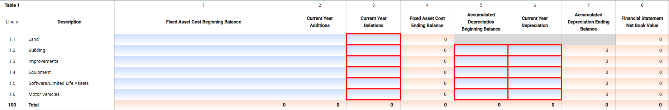
Financial Statement Net Book Value (Column 8): This amount is a calculation of the Fixed Asset Cost Ending Balance (Column 4) net of the Accumulated Depreciation Ending Balance (Column 7). The amounts reported in this column must match amounts entered on lines Schedule 6, Table 2 Non-Current Fixed Assets.

TABLE 2 – CLAIMED FIXED ASSETS
It is important to note that amounts reported on this table should only include fixed assets that can be claimed as nursing facility fixed assets to be used for the benefit of publicly aided residents. The allowable cost basis may differ from Table 1 in certain circumstances.
When completing this table, preparers should apply the following principles:
- Generally accepted accounting principles for reporting fixed assets using the historical cost basis, and
Examples provided by CHIA below
Where 101 CMR 206.00 and this instruction manual have omitted reporting principles, use Medicare cost reporting (Form 2540-10) rules for reporting allowed fixed costs and depreciation expense.
In addition, the following definitions should be applied when completing this table:
Allowable Fixed Assets Beginning Basis (Column 1): Beginning with the cost report year ending December 31, 2021, this amount represents the historical cost for each asset category in accordance with generally accepted accounting principles (GAAP basis). NOTE: This is a change from the reporting requirements in years prior to 2021. When reporting allowable fixed assets beginning balances for each asset type, preparers should review the examples below to determine how to report the allowable fixed asset beginning balances, additions, deletions, and depreciation expense.
Claimed Additions from Renovations (DON), Claimed Other Additions, Claimed Deletions from Renovations (DON), and Claimed Other Deletions (Columns 2-5): These amounts represent claimed additions and deletions to the fixed assets of the nursing facility used for publicly aided residents. Claimed additions and deletions for approved Determination of Need (DON) projects placed into service cannot exceed the DPH approved maximum capital expenditure (MCE). Preparers are to use column 4 to report all fixed assets that were retired because of the DON project. Refer to examples 6 and 7 below when completing columns 2 and 4.
Allowable Cost Basis Ending Balance (Column 6) The sum of columns 1 through 5 are automatically tabulated.
Depreciation % (Column 7) The depreciation rate associated with the Allowable Cost Basis Ending Balance (Column 6).
Financial Statement Depreciation Expense (Column 8) The values are automatically posted from Schedule 7 Table 1 Column 6 Lines 1.1 through 1.5. CHIA recognizes the straight-line method of depreciation, and the table below lists the useful life of assets by category:
Asset Category | Useful Life (in years)
Building | 40
Improvements | 20
Equipment | 10
Limited Life Assets/Software | 3

Add-backs (Column 9): This amount represents depreciation expense that is being added as claimed fixed asset expenses. Depreciation expense that is claimed on the REA-CR for facilities whose assets are owned by a realty company should be reported as an add-back expense.
Non-Allowable Expenses (Column 10): This amount represents depreciation expense that is not allowable. Examples include:
- The portion of depreciation expense that relates to fixed assets used for non-nursing facility activities, fixed assets not used for the benefit of publicly aided residents, or fixed assets specifically not allowed.
- The portion of financial statement depreciation expense recognized by the facility when using a depreciation methodology other than the straight-line method of depreciation.
- The portion of financial statement depreciation related to the use of a different useful life than recognized in the above table.
- The portion of depreciation expense on fixed asset bases not based on historical cost as recognized by generally accepted accounting.
- The portion of financial statement depreciation expense that relates to fixed asset additions from a DON project that exceeded the MCE.

Below are examples of scenarios that providers can use when preparing tables 1 and 2 of this schedule. Please note that these examples are to be applied when completing the Claimed Fixed Assets Schedule in the REA-CR for nursing facilities whose realty companies own the fixed assets.
EXAMPLE 1: Same Facility Owner or Facility Assets Owned Since 1995 - A SNF was constructed in 1995 at a cost of $10 million and the costs were allocated as follows: Land $200,000, Building $7,800,000 and Equipment $2,000,000, totaling $10 million. The facility reported the following additions/deletions between 2016 and 2020:
2016 – Equipment -$2,000,000
2016 – Improvements $100,000
2019 – Improvements $500,000
2020 – Equipment $100,000
The allowable fixed cost basis is $8.7 million.
EXAMPLE 2: Sale of a Facility’s Assets - An SNF was constructed in January 1987 at a cost of $15 million and approved for Medicaid participation. It was sold to a non-related party in 1992 for $35 million. Its fair market value was $35 million. The allowable fixed cost basis of the new owner is $35 million. Note: If the sale of the facility was not a bona fide sale (e.g., it was a related party sale), then the cost basis would be $15 million.
EXAMPLE 3: Facility with other Non-Nursing Activities - A SNF was constructed in 2000 at a cost of $50 million and 50% of the facility houses an assisted living community. The allowable fixed cost basis for the SNF is $25 million.
EXAMPLE 4: Stock Sale - An SNF was constructed in January 1987 at a cost of $15 million and approved for Medicaid participation. One owner sold its stock to the 3 remaining owners in 1992 for $5 million. Its fair market value was $20 million. The allowable fixed cost basis to the new owners is $15 million.
EXAMPLE 5: Determination of Need Project Limitations: A SNF was constructed in 1970 for $2 million. The owners completed a DON approved project to add a new wing and 50 beds. The DON approved project maximum capital expenditure was $10 million. The actual costs totaled $15 million, and the facility did not request a modification to the DON. The allowable addition to the fixed cost building and improvement basis is limited to $10 million.
EXAMPLE 6: Determination of Need Project Limitations: A SNF was constructed in 1970 for $2 million. The owners completed a DON approved project to add a new wing and 50 beds. The DON approved project maximum capital expenditure was $10 million. The completed DON project included a theater and music conservatory costing $1 million that was not part of the approved DON MCE. The allowable addition to the fixed cost building and improvements bases is limited to $9 million.
EXAMPLE 7: Determination of Need Project Retiring Assets: A SNF was constructed in 1970 for $2 million. The owners completed a DON approved project totaling $4.5 million to renovate therapy rooms, nursing stations, and 3 dining halls, including installing a new electronic medical records system to take the place of a system that was installed 18 months prior costing $500,000. The allowable addition to the fixed cost building and improvements bases is $4.5 million, and the facility must retire the $500,000 previous electronic medical records software.
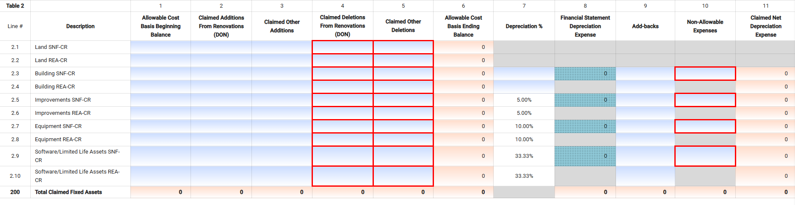

Table 3 – General FiXED Cost Information

Line | Line Description | Usage | Instructions
3.1 | What is the original year the facility was built? | YYYY | Enter the year the facility was built.
3.2 | What was the date of the most recent assessed property value of this facility? | MM-DD-YYYY | Enter the date of most recent property value assessment.
3.3 | What was the value from the most recent municipal property assessment for this facility? | XX,XXX | Enter the most recent property value assessment.
3.4 | Was there a change of ownership of this facility during the reporting period? | Drop-down menu | Select from drop-down menu: Yes/No. If you select Yes, you will need to complete Table 4 providing details of the ownership change.
3.5 | Was there a change of ownership of company that owns the real assets of the facility (realty company) during the reporting period? | Drop-down menu | Select from drop-won menu: Yes/No. If you select Yes, you will need to complete Table 4 providing details of the ownership change.
3.6 | What is the number of nursing facility resident rooms? | XX,XXX | Report the number of rooms that are designated for resident occupancy, including skilled, residential, and pediatric care levels.
3.7 | What is the total gross square footage of the facility used for patient care, including communal areas and therapy rooms? | XX,XXX | Communal areas are areas in the facility where residents may gather with other residents, visitors, and staff or engage in individual pursuits, apart from their residential rooms. This includes but is not limited to living rooms, dining rooms, activity rooms, and meeting rooms where residents are located on a regular basis.
3.8 | What is the square footage applicable to nursing facility resident rooms, including nurse stations? | XX,XXX | Enter the square footage.
3.9 | What is the square footage applicable to other business activities, e.g., adult day health, child day care, etc. | XX,XXX | If you reported other business activities on Schedule 4, Other Business Revenues and Expenses, you must report the amount of square footage of space these other business activities use.
3.10 | What is the total acreage of the facility site? | XXXX.X | Round to one decimal place when entering acreage.
3.11 | Were any current year fixed asset additions or renovations subject to a Determination of Need (DON) project? | Drop-down menu | Select from drop-down menu: Yes/No. If you select Yes, you will need to complete Table 5.
3.12 | Were there any claimed additions or renovations this year that were not part of a DON? | Drop-down menu | Select from drop-down menu: Yes/No. For additions or deletions to fixed assets that were not part of a DON, you must report these on Table 2, column 3 and/or column 5.

Table 4 – Changes in Facility or Realty COmpany Ownership
This table provides you with three lines to report the details of facility and/or realty company ownership changes.
Line # | Type of Ownership Change | Transaction Date | Purchased From | Purchased By | Sale Price
4.1+ | Select type from drop-down menu. | Use calendar widget to select date. | Enter names of sellers. | Enter names of buyers. | Enter purchase price.

Table 5 – Determination of Need Projects Detail
There are two columns in this table for you to enter up to two DON projects. If you have more than two DON projects to report, please provide the same information on the additional project(s) in the Footnotes and Explanations section of Schedule 12.
Line | Line Description | Usage | Instructions
5.1 | List the DON project #. | Text | Enter DON project #.
5.2 | Please briefly describe the DON project. | Text | Describe project.
5.3 | What is the date of the original DON approval? | MM-DD-YYYY | Enter date.
5.4 | What is the approved Maximum Capital Expenditure of the original DON? | XX,XXX | Enter MCE.
5.5 | Has this facility received a letter from the DPH Office of Determination of Need approving any significant change in the capital project resulting in an increase in the Maximum Capital Expenditure? | Drop-down Menu | Select from drop-down menu: Yes/No.
5.6 | What is the date of the significant change letter received from DPH? | MM-DD-YYYY | Enter date.
5.7 | What is the revised Maximum Capital Expenditure resulting from the approved significant change? | XX,XXX | Enter the revised MCE amount.
5.8 | What is the amount of assets placed into service for Phase 1? | XX,XXX | Enter the amount.
5.9 | What is the amount of assets placed into service for Phase 2? | XX,XXX | Enter the amount.
5.10 | What is the amount of assets placed into service for Phase 3? | XX,XXX | Enter the amount.
5.11 | Do you have more than 2 DON Projects? | Text | If you have more than 2 construction or renovation projects subject to a Determination of Need (DON), you must provide responses to questions 5.1 through 5.14 in Schedule 12, Table 1 for each additional DON project.
5.12 | List the net book value of fixed assets categorized as building that were written off or retired during this reporting year as a result of the DON project. | XX,XXX | Enter the amounts retired building assets. For example, if the roof is replaced but still had useful life, then this asset must be retired and removed from the claimed fixed assets.
5.13 | List the net book value of fixed assets categorized as improvements that were written off or retired during this reporting year as a result of the DON project. | XX,XXX | Enter the amounts of retired improvements. For example, if there was remaining useful like on windows installed, but the windows are being removed for a new wing, then the windows need to be removed from the claimed fixed assets.
5.14 | List the net book value of fixed assets categorized as equipment that were written off or retired during this reporting year as a result of the DON project. | XX,XXX | Enter the amounts of retired equipment. For example, if old patient lift systems that are still being depreciated are replaced with new lift systems, the old systems must be removed from the claimed fixed assets.

SCHEDULE 8 – STATEMENT OF CASH FLOWS
Nursing facilities are required to complete Schedule 8 Statement of Cash Flows. This schedule is an informational tool that reflects the sources and uses of cash for the entity. There are five (5) tables in this schedule, four (4) of which cost report preparers must complete. Several lines have checks and balances to ensure that information reported on lines in this schedule are consistent with information reported elsewhere in the SNF-CR.

Table 1 – Beginning Cash and Cash Equivalents Balance

Line | Line Description | Usage | Instructions
1.1 | Cash and Cash Equivalents (Beginning of Year) | (XX,XXX) OR XX, XXX | The amount reported here must equal Cash and Cash Equivalents Ending Balance reported in your prior year cost report.

Table 2 – Cash FLows from Operating Activities

Line | Line Description | Usage | Instructions
2.1 | Change in Net Assets (Net Income) | (XX,XXX) OR XX, XXX | Enter net income as reported on Schedule 5.
2.2 | Adjustments to Reconcile Changes in Net Assets (Net Income) | (XX,XXX) OR XX, XXX | Enter any reconciling items.
2.3 | Increases (Decreases) to Cash Provided by Operating Activities | (XX,XXX) OR XX, XXX | Enter any other amounts from operating activities.

Table 3 – Cash FLows from Investing Activities
Line | Line Description | Usage | Instructions
3.1 | Capital Expenditures | (XX,XXX) OR XX, XXX | Enter capital expenditures during the year.
3.2 | Cash Flows from Other Investing Activities | (XX,XXX) OR XX, XXX | Enter earnings/expenses from other investing activities.

Table 4 – Cash Flows from FInancing Activities

Line | Line Description | Usage | Instructions
4.1 | Proceeds from Issuance of Long-Term Debt | (XX,XXX) OR XX, XXX | Enter proceeds from new long-term debt.
4.2 | Payments on Long-Term Debt and Capital Lease Expenditures | (XX,XXX) OR XX, XXX | Enter payments on long-term debt and capital leases.
4.3 | Cash Flows from Other Financing Activities | (XX,XXX) OR XX, XXX | Enter amounts of other financing cash flows.

SCHEDULE 9 – LICENSURE AND PATIENT STATISTICS

Table 1 – Bed Licensure
The information displayed on this table will be provided by CHIA’s systems as indicated by the green cell colors. Your most recent bed licenses will be listed in this table in lines 1.1-1.5. If this information is out of date or incorrect, you will need to contact CHIA at Costreports.LTCF@chiamass.gov for corrections. You will need to complete questions 1.6 and 1.7.
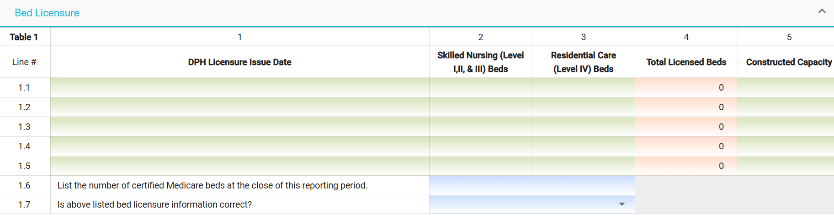

Table 2 – Patient Statistics
This table is designed to report annual patient day information. Please refer to the definitions of payer types in this instruction manual for Schedule 2. Below are definitions of the various nursing programs that you are to use when completing this table.
Nursing: Days for patients in Level I, II and III nursing home beds. Do not include Pediatric, Ventilator Unit, Head Trauma or Other Medicaid Special Contract patient days.
Resident Care: Days for patients in Level IV nursing home beds.
Pediatrics: Days for pediatric patients.
Ventilator Unit: Days for patients billed at the special contract Ventilator rate.
Head Trauma/ABI: Days for patients billed at the special contract Head Trauma/ABI rate.
Amyotrophic Lateral Sclerosis (ALS): Days for patients billed at the special contract ALS rate.
Multiple Sclerosis (MS): Days for patients billed at the special contract MS rate.
Other Medicaid Special Contract: Days for patients billed at all other MassHealth special contract rates.
Nursing Leave of Absence (Paid): Days that the nursing facility held a bed for a Level I, II or III patient and was paid.
Nursing Leave of Absence (Unpaid): Days that the nursing facility held a bed for a Level I, II or III patient but was not paid.
Resident Leave of Absence (Paid): Days that the nursing facility held a bed for a Level IV patient and was paid.
Resident Leave of Absence (Unpaid): Days that the nursing facility held a bed for a Level IV patient but was not paid.
An illustration of the table is provided here for you.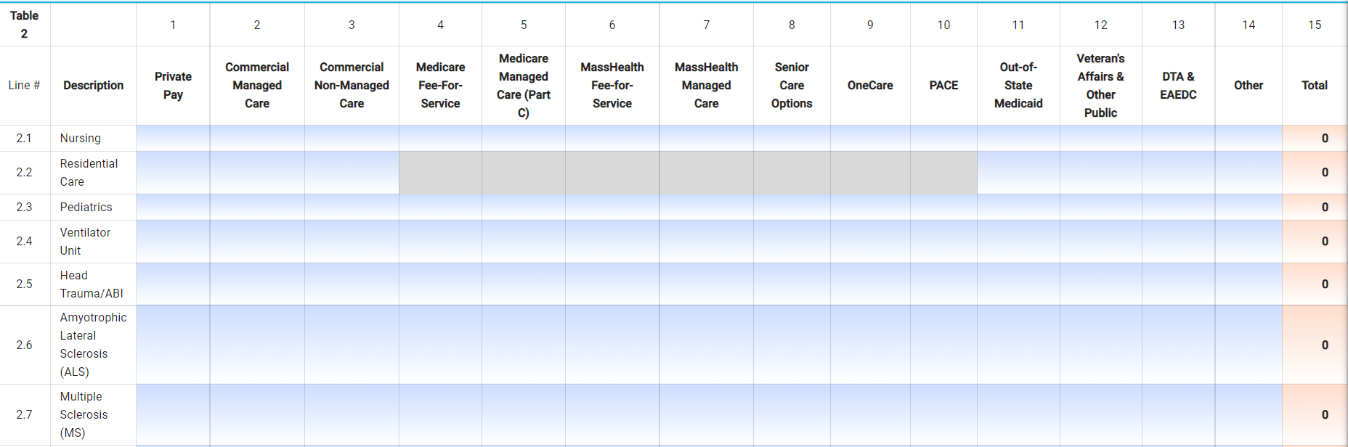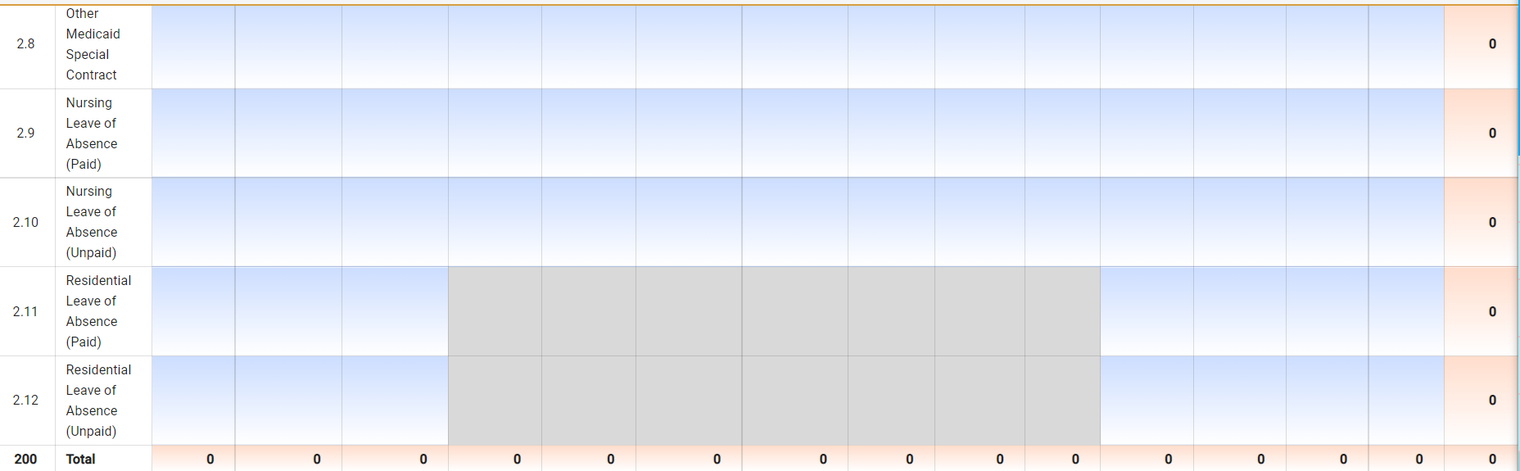
Table 3 – Patient Statistics
Line | Line Description | Usage | Instructions
3.1 | Number of Admissions During Year | XX,XXX | Enter number of admissions.
3.2 | Number of MassHealth Admissions During Year | XX,XXX | Enter number of MassHealth admissions.
3.3 | Number of Discharges During Year | XX,XXX | Enter number of discharges.
3.4 | Average Length of Stay | XX,XXX | This the sum of each resident’s Length of Stay (LOS) divided by the total number of residents surveyed. LOS is defined as the period of stay from the date of the resident’s most recent admission to the facility to the date of the survey interview (for current residents) or to the day of discharge (for discharges).
3.5 | Number of Unduplicated Residents (<= 100 day stay) | XX,XXX | Enter number of residents with less than or equal to a total of 100 days in their stay.
3.6 | Number of Unduplicated Residents (> 100 day stay) | XX,XXX | Enter number of residents with greater than or equal to a total of 100 days in their stay. Please count the total length of stay, even if some of the days occurred outside of the reporting year. Do not include residents in this line if included in line 3.5.

SCHEDULE 10 – DETAIL OF FACILITY COMPENSATION AND PURCHASED NURSING SERVICES

Table 1 – Detail of Staff Nursing Services Wages and Hours
This table is for reporting data on nursing services wages and hours. Report wages in whole dollars. Report hours rounded to the nearest tenth (one decimal place).
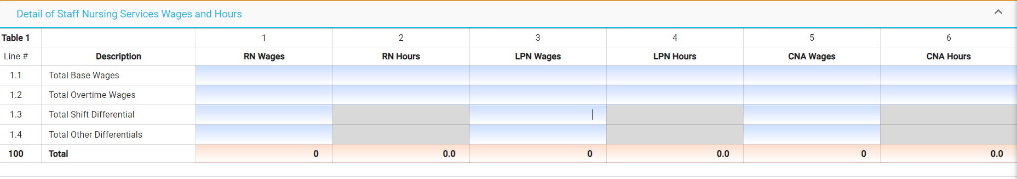

Table 2 – Detail of Nursing Services Shift Differentials
This schedule is for reporting nursing services shift differential wage data. Report data to the nearest cent (two decimal places).
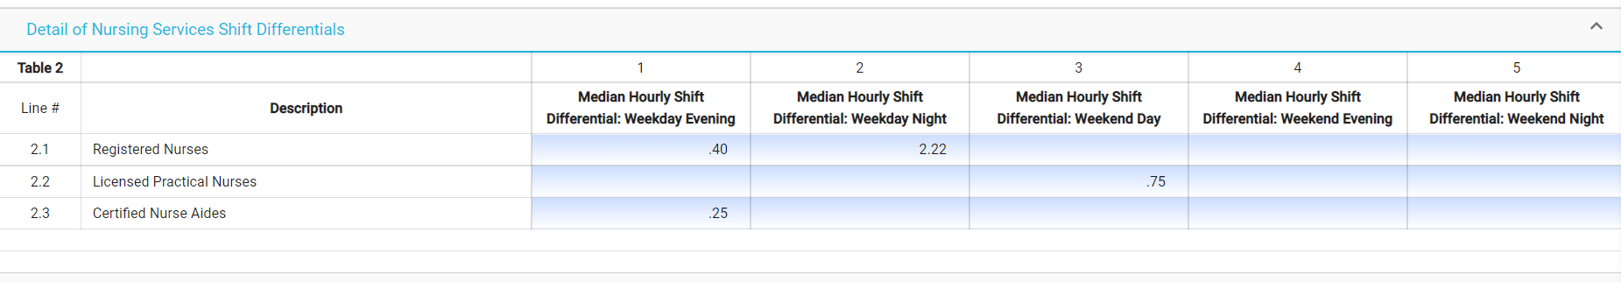

Table 3 – Detail of Staff and Hours by Position
The table below illustrates the usage for each column of data requested.
Line | Line Description | Number of Staff | Total Full Time Equivalents | Total Hours | Instructions
3.1 | Staff Development | XX,XXX | XXX.X | XXX.X | Enter values based on usage.
3.2 | Plant Operations | XX,XXX | XXX.X | XXX.X | Enter values based on usage.
3.3 | Dietary Staff | XX,XXX | XXX.X | XXX.X | Enter values based on usage.
3.4 | Dietician | XX,XXX | XXX.X | XXX.X | Enter values based on usage.
3.5 | Housekeeping/Laundry Staff | XX,XXX | XXX.X | XXX.X | Enter values based on usage.
3.6 | Unit Clerk & Medical Records Staff | XX,XXX | XXX.X | XXX.X | Enter values based on usage.
3.7 | Quality Assurance | XX,XXX | XXX.X | XXX.X | Enter values based on usage.
3.8 | MMQ Nurses and MDS Coordinator | XX,XXX | XXX.X | XXX.X | Enter values based on usage.
3.9 | Social Services Staff | XX,XXX | XXX.X | XXX.X | Enter values based on usage.
3.10 | Interpreters | XX,XXX | XXX.X | XXX.X | Enter values based on usage.
3.11 | Restorative Therapy - Direct Staff | XX,XXX | XXX.X | XXX.X | Enter values based on usage.
3.12 | Restorative Therapy - Indirect Staff | XX,XXX | XXX.X | XXX.X | Enter values based on usage.
3.13 | Recreational Staff | XX,XXX | XXX.X | XXX.X | Enter values based on usage.
3.14 | Administration and Officers | XX,XXX | XXX.X | XXX.X | Enter values based on usage.
3.15 | Security Staff | XX,XXX | XXX.X | XXX.X | Enter values based on usage.
3.16 | Clerical Staff | XX,XXX | XXX.X | XXX.X | Enter values based on usage.
3.17 | Director of Nurses | XX,XXX | XXX.X | XXX.X | Enter values based on usage.
3.18 | Registered Nurses | XX,XXX | XXX.X | XXX.X | See table 1, col 2, line 100.
3.19 | Licensed Practical Nurses | XX,XXX | XXX.X | XXX.X | See table 1, col 4, line 100.
3.20 | Certified Nurse Aides | XX,XXX | XXX.X | XXX.X | See table 1, col 6, line 100.
3.21 | Resident Care Assistants | XX,XXX | XXX.X | XXX.X | Enter values based on usage.
3.22 | Behavioral Health Specialist Staff | XX,XXX | XXX.X | XXX.X | Enter values based on usage.
3.23 | This line is intentionally left blank | N/A | N/A | N/A | No entry permitted.
3.24 | This line is intentionally left blank | N/A | N/A | N/A | No entry permitted.

Table 4 – Detail of Purchased Nursing Services
Use this table to report data on purchased services from 1) Unregistered Temporary Nursing Service Agencies or 2) Registered Temporary Nursing Service Agencies. The total line 400 is carried to Schedule 3 as reported expenses. Subtotal line 4.1 is carried over to Schedule 3 as a non-allowable cost.
The registered temporary nursing services agencies section of this table is a dynamic table and allows users to manipulate the number of rows added or subtracted. Please refer to the General User Instructions for how to use dynamic tables. To start, you must first select one of the registered temporary nursing agencies using the drop-down menu selection tool. The drop-down list of agencies is in alphabetical order. This will populate the agency name and the corresponding DPH License #. These fields are color coded green and come from CHIA systems. If you are not able to find your agency, please use the select “Other” from the drop-down menu and fill out the rest of the columns for the TNS agency the facility contracted with during the fiscal year.
The table below depicts the schedule by column rather than by line.
Column | Column Description | Usage | Instructions
1 | Temporary Nursing Services Agencies Name | Drop down menu | For registered agencies, you will need to select an agency using the drop-down menu options. If you are not able to find your agency, please select “Other” from the drop-down menu.
2 | DPH Registration # | N/A | For registered agencies, this field will populate based on the selection in column 1. For unregistered agencies, this field is greyed out.
3 | RN Total Hours of Service | XXX.X | Enter the total hours of purchased services for RNs.
4 | RN Total Charges | XX,XXX | Enter the total cost of the purchased services for RNs.
5 | LPN Total Hours of Service | XXX.X | Enter the total hours of purchased services for LPNs.
6 | LPN Total Charges | XX,XXX | Enter the total cost of the purchased services for LPNs.
7 | CNA Total Hours of Service | XXX.X | Enter the total hours of purchased services for CNAs.
8 | CNA Total Charges | XX,XXX | Enter the total cost of the purchased services for CNAs.
9 | DON Total Hours of Service | XXX.X | Enter the total hours of purchased services for director of nursing.
10 | DON Total Charges | XX,XXX | Enter the total cost of the purchased services for director of nursing.

Table 5 – Five Highest Paid Salaries
Use this table to report the compensation paid to the five persons who have the highest compensation during the year. Compensation includes salaries, payroll taxes, worker’s compensation, fringe benefits, and draws.
Column 4 requires that you enter the center expense category where the person reported most of their time.
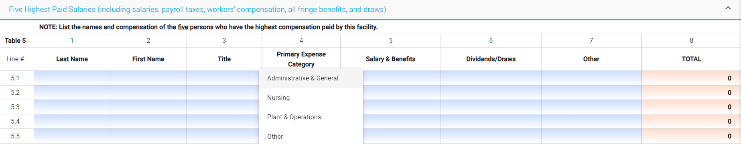

table 6 – earnings and compensation disclosures
Use this table to report the names and compensation of all owners, partners, and officers. This includes reporting any drawings and dividends paid by the facility to the owners, partners, or officers and the accounts that were charged.
There are three different tables depending on the legal status you selected in line 1.17 of Schedule 1: Table 6A for sole proprietorships, Table 6B for partnerships, and 6C for corporations. Similar to Table 5 above, column 4 requires that you enter the cost center expense category where the person reported most of their time.
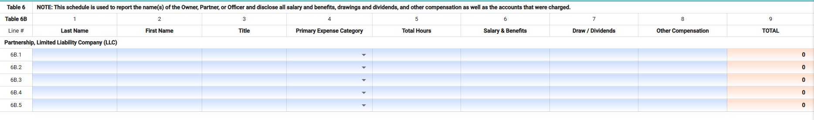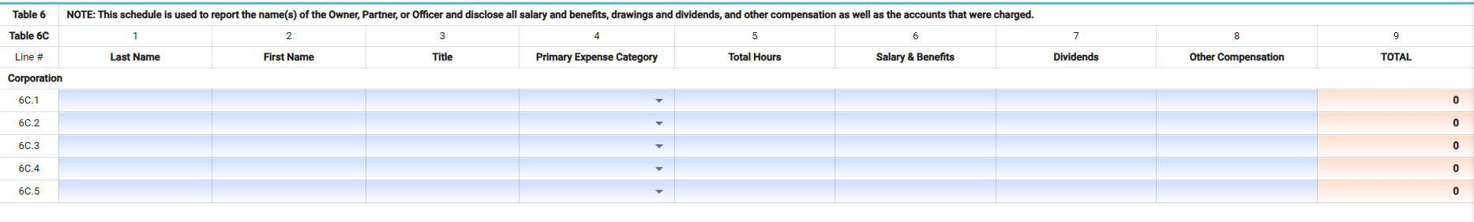

SCHEDULE 11 – NOTES PAYABLE AND WORKING CAPITAL DEBT

table 1 – Mortgages and Notes Supporting Fixed Assets
This table should include all long-term mortgages and notes payable whether interest expense has been incurred or not. Rates of interest should be clearly indicated.
- For variable rate loans, leave the columns labeled “Interest Rate %” blank, and add "VAR” to the end of the columns labeled “Lender Name”.
- Period expenses such as mortgage insurance should be reported as a period expense and a detailed disclosure should be made in the Footnotes and Explanation section.
- All existing debt should reconcile to the Balance Sheet and Income Statement accounts. Consistent balances should be carried forward from the previous year's cost report.
- New financing or refinancing should be completely disclosed. Details of items such as Mortgage Acquisition Costs, Bond Discounts, Bond Premiums, Bond Service Fees, Interest earned on Escrow Funds and Negative Principal Payments, as well as any other significant information with regards to this Long-Term Debt should be disclosed in the Footnotes and Explanations section. Long-Term Debt Bonds should be reported at Face or Stated Value of the Bonds at the time of issue and Bond Discounts, or Premiums reported as a Mortgage Acquisition Cost. Total disclosure of all facts regarding such financing should be made in the Footnotes and Explanations section.

Line # | Column # | Description | Usage | Instructions
- 1.20 | 1 | Type of Notes Payable | Drop Down List | Select type of long-term debt from the dropdown list: 1st Mortgage, 2nd Mortgage, 3rd Mortgage, 4th Mortgage, Capital Lease, Motor Vehicle, Other.
1.1 – 1.20 | 2 | Lender Name | Text | Enter Lender Name.
1.1 – 1.20 | 3 | Related Party | Drop Down List | Select Yes/No for whether the loan is a related party loan.
1.1 – 1.20 | 4 | Date Mortgage Acquired | MM-DD-YYYY | Enter the date the mortgage was acquired.
1.1 – 1.20 | 5 | Due Date | MM-DD-YYYY | Enter the due date.
1.1 – 1.20 | 6 | Number of Months Amortized | XX,XXX | Enter number of months of amortization.
1.1 – 1.20 | 7 | Monthly Payments | XX,XXX | Enter monthly payment amount.
1.1 – 1.20 | 8 | Original Loan Amount | XX,XXX | Enter original loan amount.
1.1 – 1.20 | 9 | Mortgage Acquisition Costs | XX,XXX | Enter total mortgage acquisition amount.
1.1 – 1.20 | 10 | Amortization of Mortgage Acquisition Costs | XX,XXX | Enter current year amortization expense for mortgage acquisition costs.
1.1 – 1.20 | 11 | Beginning Loan Balance: Jan 1 | XX,XXX | For existing loans, enter beginning of the year loan balance.
1.1 – 1.20 | 12 | Beginning Balance - New Loans | XX,XXX | For new loans, enter new loan balance.
1.1 – 1.20 | 13 | Principal Payments | XX,XXX | Enter principal payments.
- 1.20 | 14 | Pay Off Amount | XX,XXX | If loan is paid off, enter pay off amount.
1.1 – 1.20 | 15 | Pay Off Date | MM-DD-YYYY | Enter pay-off date.
1.1 – 1.20 | 16 | Ending Loan Balance: Dec 31 | XX,XXX | No Entry; Calculated Total
1.1 – 1.20 | 17 | Interest Rate % | XX.XXX% | Enter interest rate. Interest on non-related party loans that support the underlying fixed assets is limited to 3% over the federal hospital insurance trust fund rate. Any interest expense over this amount is not an allowable expense and must be reported as disallowed expenses in the Income Statement.
1.1 – 1.20 | 18 | Interest Expense | XX,XXX | Report Interest Expense on each loan.
1.1 – 1.20 | 19 | Period Expenses | XX,XXX | Report period expenses on each loan. Period expenses are mortgage insurance costs and other similar nominal fees.
1.1 – 1.20 | 20 | Total Amortization, Interest and Period Expenses | XX,XXX | No Entry; Calculated Total

table 2 – working capital debt
This table should include all working capital debt whether interest expense has been incurred or not. Rates of interest should be clearly indicated.
Line # | Column # | Description | Usage | Instructions
2.1 – 2.7 | 1 | Lender Name | Text | Enter Lender Name.
2.1 2.7 | 2 | Related Party | Drop Down List | Select Yes/No on drop down list for whether the loan is a related party loan.
2.1 – 2.7 | 3 | Beginning Balance: Jan 1 | XX,XXX | For new loans, enter new loan balance.
2.1 – 2.7 | 4 | Amount | XX,XXX | For existing loans, enter amount of loan.
2.1 – 2.7 | 5 | Start Date | MM-DD-YYYY | Enter date of loan.
2.1- 2.7 | 6 | Principal Payment | XX,XXX | Enter principal payments.
2.1 – 2.7 | 7 | Ending Loan Balance: Dec 31 | XX,XXX | No Entry; Calculated Total
2.1 – 2.7 | 8 | Interest Rate % | XX.XXX% | Enter interest rate. Interest on non-related party loans that support the underlying fixed assets is limited to 3% over the federal hospital insurance trust fund rate. Any interest expense over this amount is not an allowable expense and must be reported as disallowed expenses in the Income Statement.
2.1 – 2.7 | 9 | Interest Expense | XX,XXX | Report Interest Expense on each loan.

SCHEDULE 12 – FOOTNOTES AND FINANCIAL STATEMENTS
In prior years, the SNF-CR required users to upload files related to other disclosures. Beginning with CY2024 reporting, the SNF-CR has incorporated this data into tables throughout the report and no longer requires these uploads.

Schedule 12.1: Footnotes and Explanations
Provide additional detail on any of the information included in this report as required.
Schedule 12.2: Financial Statements
To satisfy the financial statement requirement in 957 CMR 7.03(1)(d), if the organization is required to or elects to obtain independent audited financial statements for purposes other than 957 CMR 7.00, those audited financial statements must be filed with CHIA. If the nursing facility does not obtain audited financial statements but is required or elects to obtain reviewed or compiled financial statements for purposes other than 957 CMR 7.00, a complete copy of those financial statements must be filed with CHIA.
Select one option from the menu, and send applicable statements for A, B, or C to data@chiamass.gov.

In descending order of preference:
- Audited Financial Statement: Audited financial statements prepared by a Certified Public Accountant (CPA) for the reporting period.
- Unaudited Financial Statement: Externally prepared, reviewed, or compiled financial statements for the reporting period.
- Internally Prepared Financial Statements: Internally Prepared Financial Statements (e.g., documentation of reported costs) for the reporting period.
When sending financial statements to data@chiamass.gov, the facility name, cost reporting year, and option selected above must be included in the email title to be accepted. An acceptable email title would be:
- “Facility Name_20XX_A) Audited Financial Statements” or
- “Facility Name_20XX_B) Unaudited Financial Statements” or
- “Facility Name_20XX_C) Internally Prepared Financial Statements”.
Please also name the financial statement attachment using the same naming convention as the email title.

SCHEDULE 13 – SUBMISSION AND ATTESTATION
There are two sections that require attestation in Schedule 13: the preparer and the owner. Prior to completing this schedule, you must resolve all validation errors.
To avoid submission errors, you must “save and validate” each schedule sequentially from Schedule 1 to Schedule 13prior to locking the report for owner review.
Section A – Certification by Preparer (Other than Owner, Partner, or Officer)
- This section must be completed and signed off by the preparer, someone other than the owner, partner, or officer. The preparer needs to perform all steps identified below before the “Locked for Owner Review” button is enabled for clicking. T
Line 1.1 through Line 1.9– Use login users’ information to fill fields below
- The pre-populated information (lines 1.1-1.2 and lines 1.4-1.9) is linked to Schedule 1 Table 3 Preparer Information. If the information is not correct, you can fix it in Schedule 1.
- Line 1.3 – Title
  - Input the job title of the preparer.
Line 1.10 – Is this information correct?
- Select “Yes” or “No.”
  - If the pre-populated information is not correct, contact CHIA at Costreports.LTCF@chiamass.gov. If pre-populated information is correct, select “Yes.”
  - This must be answered “Yes” to submit the report.
Line 1.11 – Certification/attestation checkbox
- Click here to certify that you are the preparer of the report and that to the best of your knowledge the information you reported in this cost report is true, accurate, and complete.
Line 1.12 – Date of Authorization
- This cell will automatically pre-populate with the date when the checkbox on Line 1.11 is selected.

Section B – Certification by Owner, Partner, or Officer

- This section must be completed by the owner, officer, or partner. This person must be an authorized legal signatory for the entity. Section A must be completed prior to this section. The owner, partner, or officer needs to perform all steps identified below before the “Submit” button is enabled for clicking.

Line 2.1 – Certification/attestation checkbox
- Click here to certify that you are the authorizing person of the report and agree with the accuracy of reported costs and use of public funds statements.
Line 2.2 through Line 2.4
- This information will populate based on the user’s information. If the pre-populated information is not correct, contact CHIA at Costreports.LTCF@chiamass.gov.
Line 2.5 – Title
- Input the job title of the owner, partner, or officer that is certifying the report.

Line 2.6 – Is this information correct?
- Select “Yes” or “No.”
  - If the pre-populated information is not correct, contact CHIA at Costreports.LTCF@chiamass.gov. If pre-populated information is correct, select “Yes.”
  - This must be answered “Yes” to submit the report.

Centers for Medicare and Medicaid Services (CMS) Publication 15.1, Medicare Provider Reimbursement Manual– Part I, dated November 16, 2007

