CENTER FOR HEALTH INFORMATION AND ANALYSIS (CHIA)

CHIA Submissions Technical Instruction and User Guide for the
Realty Company Cost Report
(REA-CR)
02/2025

Table of Contents
Introduction 3
IMPORTANT: Please Clear your Cache! 3
Changes To The Cost Report And Filing Tips For CY2024 3
Filing Requirements 4
Who Must File? 4
When to File 4
How to File 4
General Information 4
General User Instructions 5
Logging In and Getting Started 5
Home Screen 6
Cost Report Year Selection 7
Navigating in the REA-CR 7
Saving Your Work 8
Entering Data 8
Understanding Cell Colors 9
Hover Messaging 9
Dynamic Tables 10
Data Validations 11
Submitting Your Cost Report 14
Detailed Instructions by Schedule 14
Schedule 1: Contact and Disclosure Information 14
Schedule 2: Income and Expenses 18
Schedule 3: Allowable Fixed Assets and Expenses 19
Schedule 4: Balance Sheet 20
Schedule 5: Summary of Long-Term Debt 25
Schedule 6: Reconciliations and Disclosures 27
Schedule 7: Footnotes and Other Disclosures 33
Schedule 8: Submission Attestation 36

Introduction
The Center for Health Information and Analysis (CHIA), in accordance with its statutory authority under M.G.L. c. 12C, collects cost reports in furtherance of its mission to monitor the health care system in Massachusetts and to provide reliable information and meaningful analysis for those seeking to improve health care quality, affordability, access and outcomes. The data CHIA collects through the Realty Company Cost Report (REA-CR) is used, among other things, to support the rate-setting obligations of the Executive Office of Health and Human Services (EOHHS), which uses the data to establish rates for nursing facility and residential care facility providers, and to complete additional analyses to inform policymaking and to support transparency initiatives. Once filed with CHIA, these reports become public documents and will be provided upon request to any interested party.

It is essential that these reports are prepared by persons who are familiar with the regulation 101 CMR 206.00 Standard Payments to Nursing Facilities and/or 101 CMR 204.00 Rates of Payment to Resident Care Facilities. Copies of these regulations may be obtained on the EOHHS website at https://www.mass.gov/lists/provider-payment-rates-hospitalsnursing-facilities-and-rest-homes
The CHIA REA-CR is an electronic filing located at https://chiasubmissions.chia.state.ma.us.
For assistance in completing these forms, contact the CHIA Help Desk at Costreports.LTCF@chiamass.gov.

IMPORTANT: Please Clear your Cache!
As part of continuous improvement of the Nursing Facility Cost Reports, changes and upgrades have been implemented. In order for the system to function properly, users should clear their web browser cache.
If you do not clear your cache it may cause your browser to display older versions of SNF/MGT/REA Cost Report and generate error messages.
Instructions on how to clear your cache can be found here: https://www.mass.gov/guides/clear-your-browser-cache

Changes To The Cost Report And Filing Tips For CY2024
In an effort to improve cost report accuracy and promote a more efficient user experience, below are some changes and cost report filing tips for users when filing the REA Cost Report:
- Previously, users needed to upload files related to other disclosures. This year’s REA-CR still requires several uploads, but the way to submit financial statements has changed.

  - Financial statements must be sent to data@chiamass.gov.

  - “Financial Statements Unavailable” is no longer an option to select in Schedule 7.

- As a reminder, in order to “lock for review” on the Submission and Attestation schedules, users must “save and validate” each schedule sequentially starting with Schedule 1 of each cost report.

- Based on updates to the regulation 101 CMR 206.00 that went into effect in October 2022, expenses paid for using funds from any low interest or forgivable loan administered by EOHHS must be reported as non-allowable costs. These expenses should be self-disallowed.

Filing Requirements

Who Must File?
In accordance with Sections 204.07(b) and 206.08(b) of Title 101 of the Code of Massachusetts Regulations (CMR), each nursing and residential care facility must file or cause to be filed a REA-CR if it does not own its real property and pays rent to either an affiliated or non-affiliated realty trust or other business entity.

When to File
The REA-CR is a calendar year cost report. Providers will receive an E-blast notification of the cost report deployment, which will include filing deadlines for the realty company cost report. Additionally, filing deadlines will be posted on CHIA’s webpage located at Information for Data Submitters: Nursing Facility Cost Reports.

Providers who fail to submit timely reports and required data may be subject to penalties in accordance with 957 CMR 7.07. Additionally, in accordance with 101 CMR 206.08(7), EOHHS may reduce the provider’s rates for current services by 5% on the day following the date the submission is due and 5% for each month of noncompliance thereafter.

How to File
The REA-CR is an electronic filing using the CHIA Submissions website. The website can be found at: https://chiasubmissions.chia.state.ma.us/ .
Please note that the CHIA Submissions web application works best in Google Chrome.

General Information
For assistance in completing your submission, contact the CHIA Long-term Care Facility Help Desk at Costreports.LTCF@chiamass.gov.

The REA-CR must be completed on the accrual basis. It is essential that each report reflect the entire financial statement of the realty company. (Partial reporting is not acceptable.) There is a minor exception to this requirement. Certain timing differences between the books of the provider and the claim for reimbursement requirements may occur which could result in modest variances between the report and the provider’s books. Schedule 5 of the REA-CR, Reconciliation of Income per Report with Income per Books should identify the variances.

In addition to being a complete financial statement, these forms are used as a basis for establishing rates of payment.

General User Instructions

Logging In and Getting Started
Users will log-in to CHIA Submissions at https://chiasubmissions.chia.state.ma.us using their unique Username and Password, as follows:

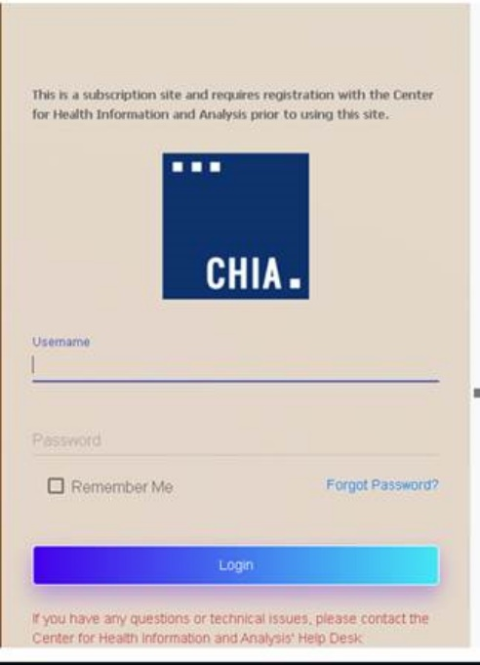

Next users will select the “Launch” button under the LTC Realty Company application module. Users may have access to more than one application, such as the SNF-CR or MGT-CR.

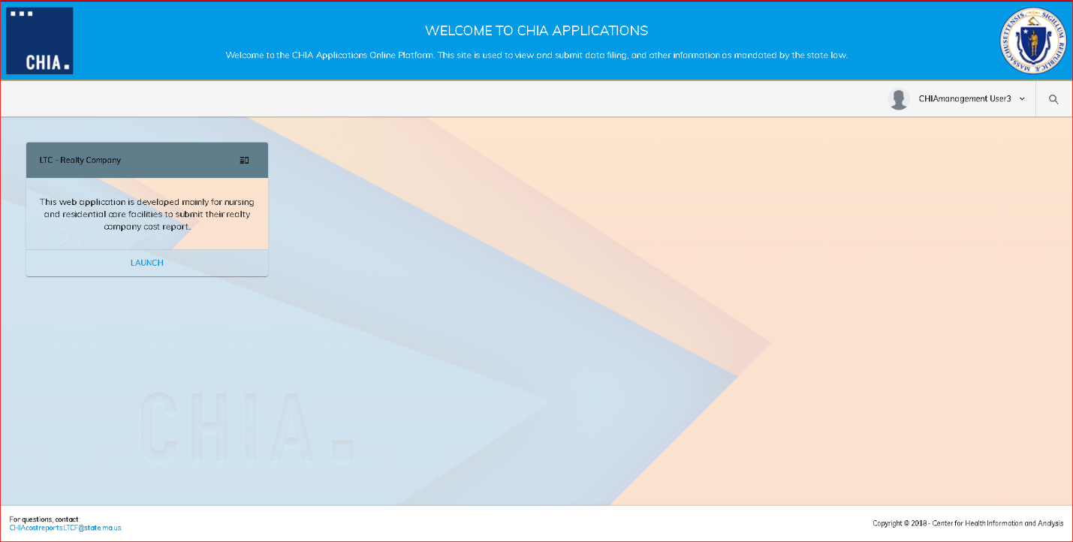
This will bring the user to the home screen of the REA-CR.

Home Screen
Your home screen is customized for your user privileges and will be like the picture below.
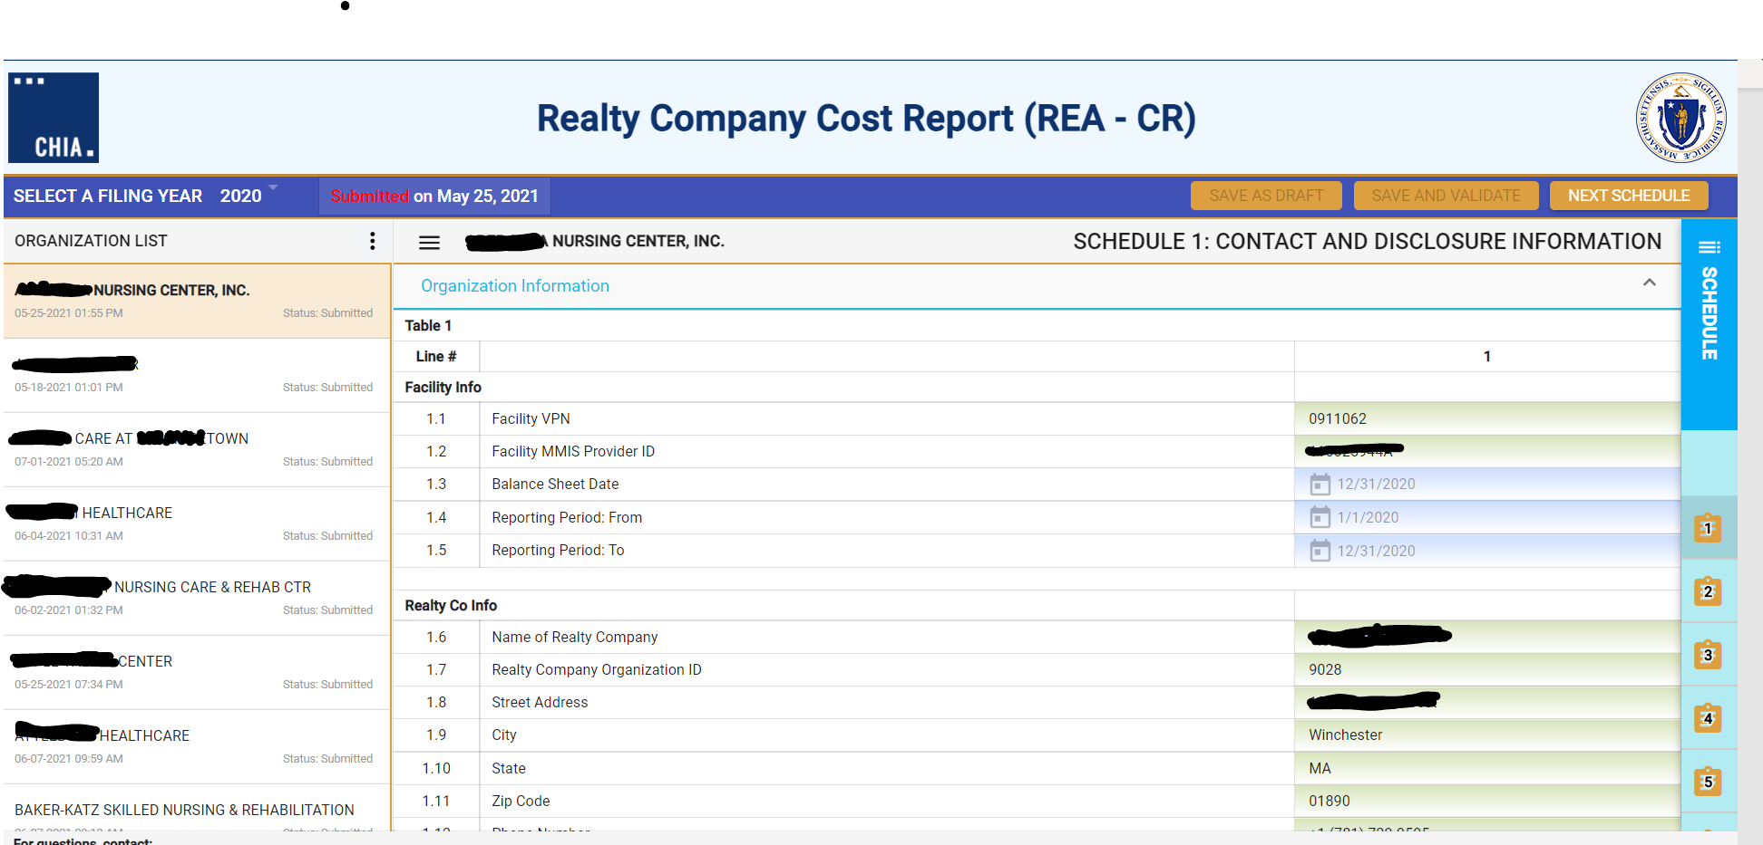

The far-left side of the screen lists all facilities that are registered to your username.

Clicking on a facility name will activate that account and display the information entered in Schedule 1 for the Reporting Year selected.

By clicking on the facility name in the organization list, the system will highlight that facility and activate the cost report schedules for the reporting year selected.

Users with access privileges to only one nursing facility’s realty company cost report will not have an organization list in their view.

By clicking on the ellipses, you can collapse the Organization List.

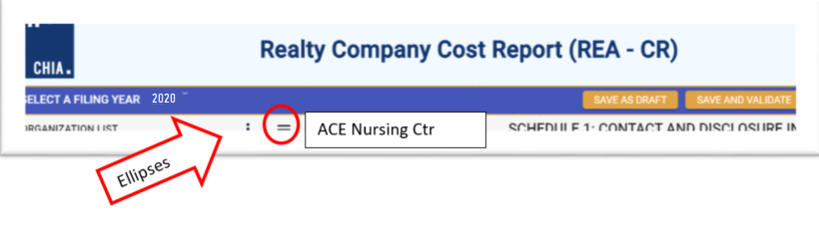

Cost Report Year Selection
A user may change the reporting year by using the dropdown menu at the top of the screen labeled “Select a Filing Year.”

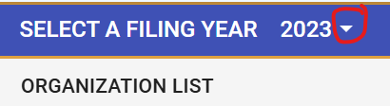

Navigating in the REA-CR
To move between schedules in the report, users can use the Schedule number listing to the right, select the “Jump To” menu option in the top left, or use the “Next Schedule” button in the top right.

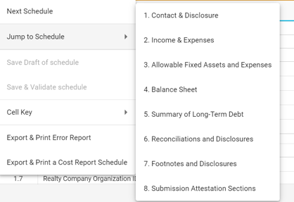

Saving Your Work
CHIA suggests that you save your reported data at frequent intervals as you move through each schedule of the cost report. To save your work, you can select the “Save as Draft” button which is located at the top right-hand corner of each schedule.



A screen will appear to “Cancel” or “Continue”. Select “Continue” to save. A screen confirming that the information is saved will appear. Select “Continue” again to return to the report.

Entering Data
Many of the data fields in the cost report have been formatted to accept data as text, whole dollars, and percentages. Some of the data fields will allow users to enter decimals and those fields are specifically indicated in the application.
When entering negative figures, users need to enter a negative sign (“- “) AFTER the figure as follows:
123,456-

Understanding Cell Colors
Each cell in the electronic cost report has been color shaded. The Cell Color Legend, illustrated below, provides an explanation of each color for how the cost report can be completed. Users are only able to enter information in the cells colored light blue or dark green. Cells with any other color will be either prepopulated from CHIA’s own system or from other cells in the cost report.

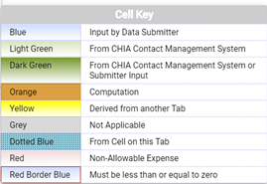

Note: Cells with red borders will automatically be shown as negative numbers.

Hover Messaging
Throughout the cost report, you will encounter hover messages when your mouse “hovers” over cells. These hover messages are designed to help in the following ways:
- Assist in providing information on the cell usage, i.e., percentage, number of decimal places permitted in a certain cell, etc.
- Assist with the location the cell where data comes from. This is for cells colored yellow and dotted blue.
- Assist with what information should be reported in the cell.
An example of a hover message is illustrated in the picture below. This hover message explains that the data for line 4.3 “Other Deferred Charges and Other Non-Current Assets” is derived from a dynamic table, in this case, Table 5.
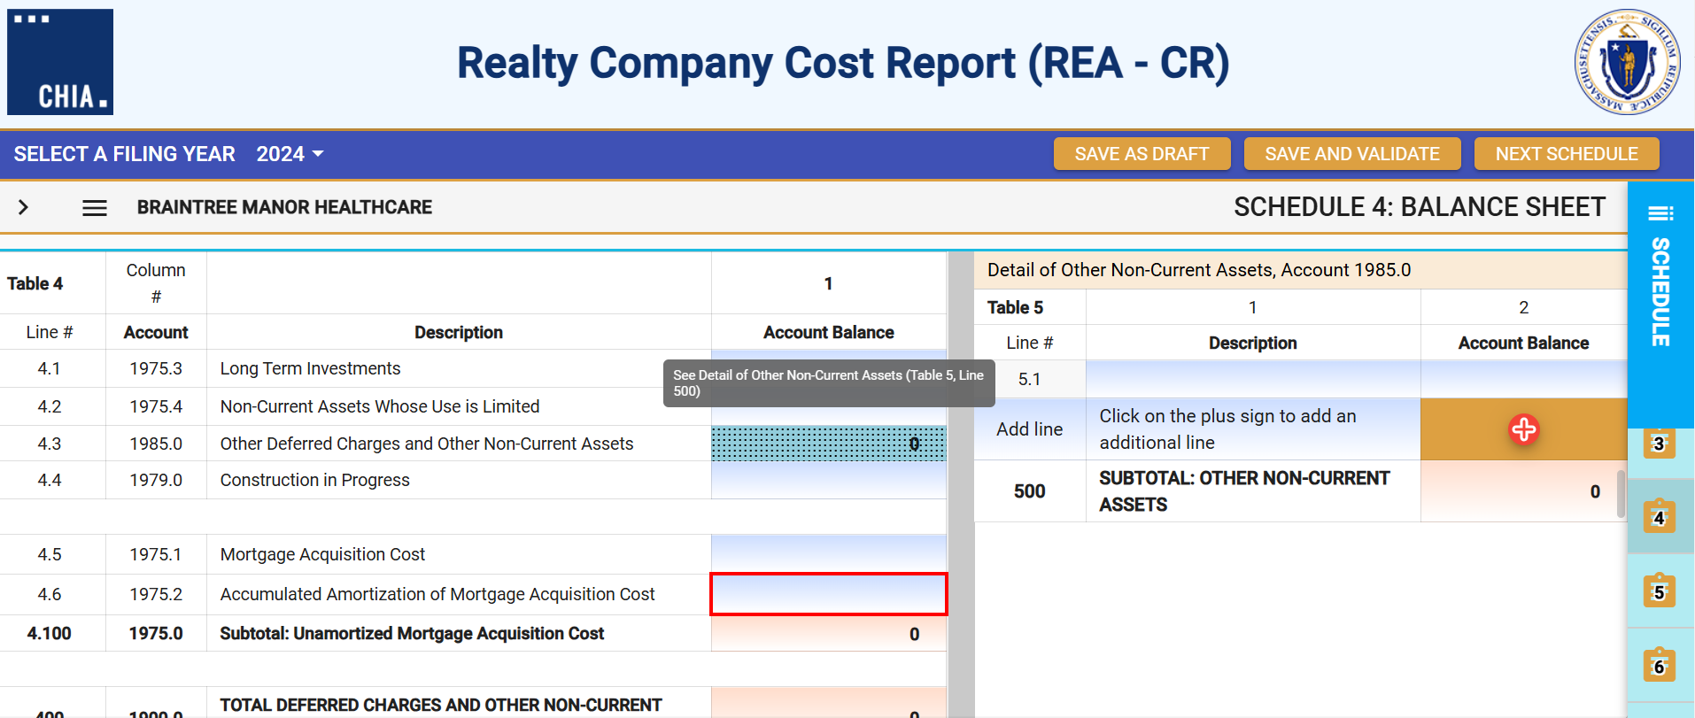

Dynamic Tables
This cost report uses dynamic tables that can be expanded to allow for flexible entry of additional detailed cost information. These tables will appear to the right of the main schedule tables and require users to enter information in these tables that will be automatically carried over to the main tables. Users can select the + button to add a line or hover over any added line number and click the red X to remove that line. An example of a dynamic table is illustrated below:
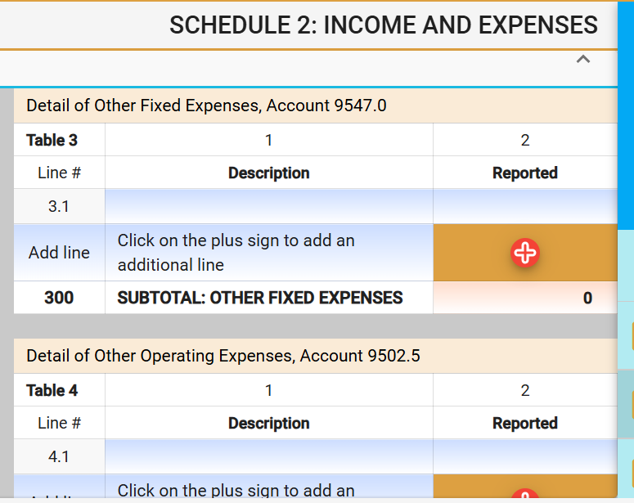

Data Validations
The REA-CR includes several edits or checks within each schedule which need to be managed through the validation process described below. Preparers and submitters will not be able to lock the REA-CR for review or submit the cost report unless all schedules have been validated and the errors fixed.
To ease this process, CHIA has created a validation report listing all validation errors. To access the validation report, you will select the “Save and Validate” Button on the top right corner of each schedule.



When this button is selected, users will encounter the following:
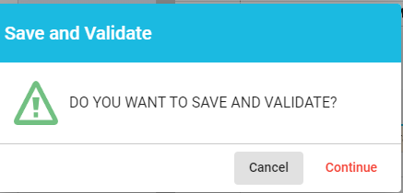

Users will select “Continue”. Once this is done, there will be two results. If there are validation errors, users will need to select the method they would like to view the validation report, as shown below:

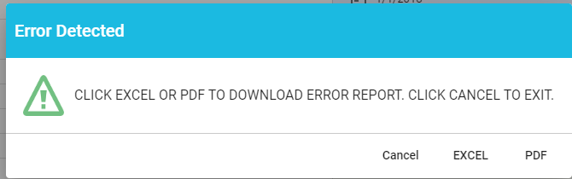

The validation report will provide users with the schedule number and line number of the error along with a description of what the problem is.
- If there are no validation errors, users will be notified that their schedule saved successfully and can continue completing the cost report.

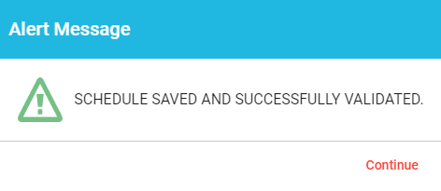
Additionally, users can launch the validation reports two additional ways.
First, users can click on the hamburger menu button to pull down the menu options on the top left corner as follows:
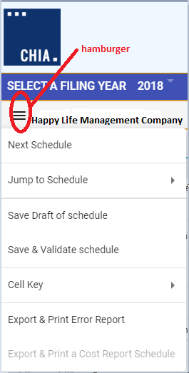

Then users will select the “Save & Validate schedule” option. This option validates only the current schedule in your view.
Finally, users can launch the “Export & Print Error Report” from the hamburger icon. Users should check each box for each Schedule an error report is desired. Please only use this option if you have already saved and validated the current schedule.
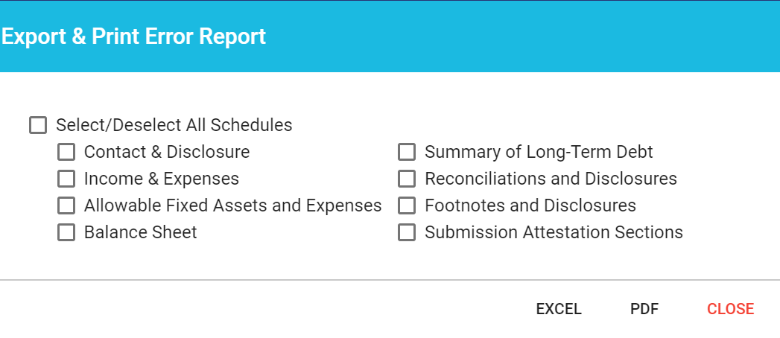

Submitting Your Cost Report
All validation errors must be resolved before users can attest and submit their cost reports. The submission process is designed with the following process based on access privileges. Those users with data access privileges can only prepare the report. Users with owner, partner, or officer privileges can certify and submit their cost reports. CHIA recommends that management companies use the following process to successfully complete and submit the MGT-CR.

As illustrated above, users with data access only privileges, also known as preparers, prepare the cost report and, once complete, lock the report for final review. Only users with owner, partner, or officer privileges can certify and submit the cost report, which is managed on Schedule 8 of the report. NOTE: Users who have data access only privileges cannot access Schedule 8.

Preparers:
- Checking Line 1.13 certifies the report. Owners, who are also preparers, have this privilege too.
- Select “Lock for Owner Review”

Owner/Partner/Officer:
- Owners/partners/officers cannot submit until the preparer has locked for owner review.
- Checking Line 2.1 certifies the report.
- Click the “Submit” button

Detailed Instructions by Schedule

Schedule 1: Contact and Disclosure Information
Please contact CHIA at Costreports.LTCF@chiamass.gov if any of the prepopulated cells are incorrect.
Schedule 1 - Table 1: Organization Information

Line # | Line Description | Usage | Instructions
1.1 | Facility VPN | Text | This cell pre-populates from CHIA’s internal systems.
1.2 | Facility MMIS Provider ID | Text | This cell pre-populates from CHIA’s internal systems.
1.3 | Balance Sheet Date | MM-DD-YYYY | Enter the date of the Realty Company balance sheet. Defaults to last date of filing year (ex: For Filing Year 2024, this would be 12/31/2024).
1.4 | Reporting Period: From | MM-DD-YYYY | Enter the date of the Realty Company balance sheet. Defaults to last date of filing year (ex: For Filing Year 2024, this would be 12/31/2024).
1.5 | Reporting Period: To | MM-DD-YYYY | Enter the date of the Realty Company balance sheet. Defaults to last date of filing year (ex: For Filing Year 2019, this would be 12/31/2019)
1.6 | Name of Realty Company | Text | This cell pre-populates from CHIA’s internal systems.
1.7 | Realty Company Organization ID | Text | This cell pre-populates from CHIA’s internal systems.
1.8 | Street Address | Text | This cell pre-populates from CHIA’s internal systems.
1.9 | City | Text | This cell pre-populates from CHIA’s internal systems.
1.10 | State | Text | This cell pre-populates from CHIA’s internal systems.
1.11 | Zip Code | ZIP + 4 | This cell pre-populates from CHIA’s internal systems.
1.12 | Phone Number | (XXX) XXX-XXXX | This cell pre-populates from CHIA’s internal systems.
1.13 | Fax | (XXX) XXX-XXXX | This cell pre-populates from CHIA’s internal systems.
1.14 | Legal Status | XX,XXX | This cell pre-populates from CHIA’s internal systems.
1.15 | Is this information correct? | Drop down menu | Select from dropdown list: Yes/No. “Yes” must be selected for the report to be submitted. If the information in this table is incorrect, contact CHIA at Costreports.LTCF@chiamass.gov.
1.16 | Has the realty company changed ownership during the year? | Text | Select from dropdown list: Yes/No.
1.17 | If yes, please enter the transaction date. | MM-DD-YYYY | Enter date of realty company ownership change.

Schedule 1, Table 1, Line 1.14 Legal Status, will automatically be prepopulated. The Legal Status code references are shown in the following table:

Legal Code | Description | Profit / Non-Profit
1 | MA Corp (Chapter 156B) | Profit
2 | MA Corp (Chapter 156B with 501c(3) exemption) | Non-Profit
3 | MA Non-Profit Corp (Chapter 180) | Non-Profit
4 | Partnership/LLP | Profit
5 | Sole Proprietorship | Profit
6 | Governmental Entity | Non-Profit
7 | Other For-Profit | Profit
8 | Other Non-Profit | Non-Profit
9 | Non-MA Corporation | Profit
10 | Limited Liability Corporation/LLC | Profit

Schedule 1 - Table 2: Contact Information

Line # | Line Description | Usage | Instructions
2.1 | Contact person for this report | Text | Use login users’ information to fill fields below
2.2 | Name | Text | This cell is pre-populated from CHIA Systems or allows for user entry.
2.3 | Firm (if not Realty Company) | Text | This cell is pre-populated from CHIA Systems or allows for user entry.
2.4 | Title | Text | This cell is pre-populated from CHIA Systems or allows for user entry.
2.5 | Street Address | Text | This cell is pre-populated from CHIA Systems or allows for user entry.
2.6 | City | Text | This cell is pre-populated from CHIA Systems or allows for user entry.
2.7 | State | Text | This cell is pre-populated from CHIA Systems or allows for user entry.
2.8 | Zip Code | ZIP + 4 | This cell is pre-populated from CHIA Systems or allows for user entry.
2.9 | Phone Number | (XXX) XXX-XXXX | This cell is pre-populated from CHIA Systems or allows for user entry.
2.10 | Fax | (XXX) XXX-XXXX | This cell is pre-populated from CHIA Systems or allows for user entry.
2.11 | Email Address | Text | This cell is pre-populated from CHIA Systems or allows for user entry.
2.12 | Is this information correct? | Text | Select from dropdown list: Yes/No.

Schedule 1 - Table 3: Preparer Information
- This section indicates whether a “Preparer” will be used to assist in completing the cost report. A preparer may be an accounting firm, or another authorized user, who is not the owner, and may formally attest to the information provided herein.
- The information provided in this section determines Schedule 8: Submission and Attestation.
- If there is not a Preparer, and the Owner is completing this cost report alone as the sole attesting individual, the box in Line 3.1 must be checked.

Line # | Line Description | Usage | Instructions
3.1 | I am the sole individual completing this cost report as an Owner, Partner, or Officer, and do not have a Preparer formally attesting to this information. | Checkbox | Check this box if you are the sole individual completing this cost report (without a Preparer).
3.2 | Preparer | Text | Use login users’ information to fill fields below.
3.3 | Firm Name / Realty Company | Text | This cell is pre-populated from CHIA Systems or allows for user entry.
3.4 | Preparer's Last Name | Text | This cell is pre-populated from CHIA Systems or allows for user entry.
3.5 | Preparer's First Name | Text | This cell is pre-populated from CHIA Systems or allows for user entry.
3.6 | Preparer's Middle Name | Text | This cell is pre-populated from CHIA Systems or allows for user entry.
3.7 | Title | Text | This cell is pre-populated from CHIA Systems or allows for user entry.
3.8 | Street Address | Text | This cell is pre-populated from CHIA Systems or allows for user entry.
3.9 | City | Text | This cell is pre-populated from CHIA Systems or allows for user entry.
3.10 | State | Text | This cell is pre-populated from CHIA Systems or allows for user entry.
3.11 | Zip Code | ZIP + 4 | This cell is pre-populated from CHIA Systems or allows for user entry.
3.12 | Phone Number | (XXX) XXX-XXXX | This cell is pre-populated from CHIA Systems or allows for user entry.
3.13 | Fax | (XXX) XXX-XXXX | This cell is pre-populated from CHIA Systems or allows for user entry.
3.14 | Email Address | Text | This cell is pre-populated from CHIA Systems or allows for user entry.
3.15 | Is this information correct? | Text | Select from dropdown list: Yes/No.
3.16 | Type of Accounting Service Performed | Text | Select from dropdown list: Audit, Compilation, Review, Other (Explain in Footnotes if Other selected.)

Schedule 2: Income and Expenses
Schedule 2 - Table 1: Income
Line # | Line Description | Usage | Instructions
1.1 | Rental Income from: Nursing Facilities | (XX,XXX) OR XX, XXX | Report income earned from renting the building and/or equipment to a nursing facility.
1.2 | Rental Income from: Residential Care Facilities | (XX,XXX) OR XX, XXX | Report income earned from renting the building and/or equipment to a residential care facility.
1.3 | Rental Income from: Other Rental | (XX,XXX) OR XX, XXX | Report rental income earned from any person or entity, except for a nursing or residential care facility.
1.4 | Other Income | (XX,XXX) OR XX, XXX | Report other income.
1.5 | Recoverable Fixed Income | (XX,XXX) OR XX, XXX | Report any fixed cost recoverable income.
100 | Total Income | (XX,XXX) OR XX, XXX | No Entry; Calculated Total

Schedule 2 - Table 2: Expenses
- Table 2 has three (3) columns.
- In Column 1, enter the depreciation %, unless it is prepopulated.
- In Column 2, enter the Reported Expenses. These are your gross expenses.
- In Column 3, enter the amount of the reported expense related to non-nursing or non-residential care facility operations or other non-allowable amount as Non-Allowable Expenses, and enter any applicable Add-Backs.
- Column 4 is a computation of Column 2 less Column 3.
- Other Fixed Expenses, Other Operating Expenses, and Utilities & Plant Operations Expenses require user to enter the description and amounts in separate dynamic tables.
Line # | Line Description | Usage | Instructions
2.1 | Depreciation: Building | XXX.XX% | Report building depreciation expense. Disallow any amounts that cannot be claimed.
2.2 | Depreciation: Improvements | XXX.XX% | Report depreciation expense on improvements. Disallow any amounts that cannot be claimed.
2.3 | Depreciation: Equipment | XXX.XX% | Report depreciation expense on equipment. Disallow any amounts that cannot be claimed.
2.4 | Depreciation: Software/Limited Life Assets | XXX.XX% | Report depreciation expense on software and limited life assets. Disallow any amounts that cannot be claimed.
2.5 | Long Term Interest: Nursing Facilities | (XX,XXX) OR XX, XXX | Report long-term interest expense supporting nursing facility fixed assets. Disallow any amounts that cannot claimed. You cannot claim interest expense on related party loans or working capital loans. Additionally, long-term interest can only be claimed to the extent that it supports the cost or purchase of the underlying fixed assets. Interest on long-term debt that was not used to finance or purchase the fixed assets of the facility cannot be claimed. You must make an adjustment in column 2 to disallow the interest.
2.6 | Long Term Interest: Residential Care Facilities | (XX,XXX) OR XX, XXX | Report long-term interest expense supporting residential care facility fixed assets. Disallow any amounts that cannot be claimed. You cannot claim interest expense on related party loans or working capital loans. You cannot claim interest expense on related party loans or working capital loans. Additionally, long-term interest can only be claimed to the extent that it supports the cost or purchase of the underlying fixed assets. Interest on long-term debt that was not used to finance or purchase the fixed assets of the facility cannot be claimed. You must make an adjustment in column 2 to disallow the interest.
2.7 | Real Estate Taxes | (XX,XXX) OR XX, XXX | Report real estate taxes related to nursing and residential care facility land and building. Disallow any amounts that cannot be claimed.
2.8 | Personal Property Taxes | (XX,XXX) OR XX, XXX | Report personal property taxes related to nursing and residential care facility operations. Disallow any amounts that cannot be claimed
2.9 | MA Corp. Excise Tax Non-Income Portion | (XX,XXX) OR XX, XXX | Report the non-income portion of MA corporate excise taxes related to nursing and residential care facility operations. Disallow any amounts that cannot be claimed.
2.10 | Insurance: Building, Building Improvements, Equipment | (XX,XXX) OR XX, XXX | Report building and equipment insurance expenses related to nursing and residential care facility operations. Disallow any amounts that cannot be claimed.
2.11 | Other Fixed Expenses | (XX,XXX) OR XX, XXX | Report any other fixed asset expenses related to nursing and residential care facility operations. Disallow any amounts that cannot be claimed.
2.12 | Other Operating Expenses | (XX,XXX) OR XX, XXX | Using the dynamic table 4, report details of other operating expense related to nursing and residential care facility operations using the dynamic table 4. Disallow any amounts that cannot be claimed.
2.13 | Utilities & Plant Operations Expenses | (XX,XXX) OR XX, XXX | Using the dynamic table 5, report details of utilities and plant operating expenses related to nursing and residential care facilities using the dynamic table 4. Disallow any amounts that cannot be claimed.
2.14 | Interest on Working Capital | (XX,XXX) OR XX, XXX | Report interested on working capital related to nursing and residential care facilities. Disallow any amounts that cannot be claimed. Interest on non-related party loans that support the underlying fixed assets is limited to 3% over the federal hospital insurance trust (FHIT) fund rate. In 3rd quarter 2021, that rate was 1.50%. Any interest expense over 4.50% is not an allowable expense and must be reported as a disallowed expense in the Income Statement.
2.15 | Interest on Late Payments, Penalties | (XX,XXX) OR XX, XXX | Report interested on late payments and penalties related to nursing and residential care facilities. Disallow any amounts that cannot be claimed.
2.16 | Recoverable Fixed Income | (XX,XXX) OR XX, XXX | Report recoverable fixed asset income related to nursing and residential care facilities. Disallow any amounts that cannot be claimed.
200 | Total Reported REA-CR Expenses | (XX,XXX) OR XX, XXX | No Entry; Calculated Total

Schedule 3: Allowable Fixed Assets and Expenses

Schedule 3 - Table 1: Allowable Fixed Assets and Expenses
- Beginning October 1, 2021, the 101 CMR 206.00 regulations were revised to allow for recognition of allowable fixed assets at their historical fixed costs versus the prior method. You are to report claimed fixed assets using a historical cost method of accounting in accordance with generally accepted accounting principles (GAAP) to ensure proper determination of your capital reimbursement. For further information, consult the 101 CMR 206.00 regulations and the SNF-CR Technical Instructions and User Guide. The SNF-CR Technical Instructions and User Guide includes multiple examples and scenarios to help with proper reporting of allowable fixed assets. It is essential that you report allowable fixed assets as their historical cost so that you can report the proper depreciation expense allowable for the period.
- Table 1 has four (4) columns.
  - In Column 1, enter the Allowable Assets (Basis), Beginning of Year.
  - In Column 2, enter the Asset Additions for the cost report year.
  - In Column 3, enter the Asset Deletions for the cost report year. NOTE: Values in this column will be populated as negatives.
  - Column 4, Allowable Assets (Basis), End of Year is a computation, summing Column 1 and Column 2, subtracting Column 3.

Line # | Line Description | Usage | Instructions
1.1 | Land | (XX,XXX) OR XX, XXX | Enter the claimed beginning balance in column 1, any claimed additions and deletions in columns 2 and 3 for land being claimed for long-term care facility operations.
1.2 | Building | (XX,XXX) OR XX, XXX | Enter the claimed beginning balance in column 1, any claimed additions and deletions in columns 2 and 3 for building being claimed for long-term care facility operations.
1.3 | Improvements | (XX,XXX) OR XX, XXX | Enter the claimed beginning balance in column 1, any claimed additions and deletions in columns 2 and 3 for improvements being claimed for long-term care facility operations.
1.4 | Equipment | (XX,XXX) OR XX, XXX | Enter the claimed beginning balance in column 1, any claimed additions and deletions in columns 2 and 3 for equipment being claimed for long-term care facility operations.
1.5 | Software/Limited Life Assets | (XX,XXX) OR XX, XXX | Enter the claimed beginning balance in column 1, any claimed additions and deletions in columns 2 and 3 for software and limited life assets being claimed for long-term care facility operations.

Schedule 4: Balance Sheet
Schedule 4 - Table 1: Current Assets
Line # | Line Description | Usage | Instructions
1.1 | Cash and Equivalents | (XX,XXX) OR XX, XXX | Report cash and cash equivalent balances as of the end of the cost report year.
1.2 | Short-term Investments | (XX,XXX) OR XX, XXX | Report balances of investments that are short-term (e.g., can easily be converted to cash in the next 3 to 12 months).
1.3 | Current Portion Assets Whose Use is Limited | (XX,XXX) OR XX, XXX | Report the balances of the current portion of assets whose use is limited.
1.4 | Other Cash and Equivalents | (XX,XXX) OR XX, XXX | Report the balances of other case assets not included in any of the other cash and cash equivalent balances.
1.100 | Subtotal: Cash and Equivalents | (XX,XXX) OR XX, XXX | No Entry; Calculation Total
1.5 | Accounts Receivable | (XX,XXX) OR XX, XXX | Report the balances of any accounts receivable at the end of the year.
1.6 | Rent Receivable | (XX,XXX) OR XX, XXX | Report the balances of any rent receivable at the end of the year.
1.7 | Reserve for Bad Debt | (XX,XXX) | This line allows for a negative entry for any reserves for bad debts on any receivables.
1.200 | Subtotal: Accounts Receivable | (XX,XXX) OR XX, XXX | No Entry; Calculation Total
1.8 | Officers/Owners | (XX,XXX) OR XX, XXX | Report the balances of any short-term receivables due from owners or officers at the end of the year.
1.9 | Affiliates/Related Parties | (XX,XXX) OR XX, XXX | Report the balances of any short-term receivables due from affiliates and related parties at the end of the year.
1.10 | Other | (XX,XXX) OR XX, XXX | Report the balances of any short-term receivables at the end of the year.
1.300 | Subtotal: Loans Receivable | (XX,XXX) OR XX, XXX | No Entry; Calculation Total
1.11 | Prepaid Interest | (XX,XXX) OR XX, XXX | Report any interest paid in advance.
1.12 | Prepaid Insurance | (XX,XXX) OR XX, XXX | Report any insurance paid in advance.
1.13 | Other Prepaid Expenses | (XX,XXX) OR XX, XXX | This account should be used to record expenditures for future benefits. An example would be prepaid rent. This account should not be used to capitalize improvements or maintenance expenses which, in the provider's opinion, may benefit future periods. Improvements or maintenance costs that will benefit future periods should be capitalized into the appropriate Improvement Fixed Asset Account and depreciated over the aggregate useful lives established by the Center's regulations. Similarly, this account should not be used to record and subsequently claim pre-opening costs which are not reimbursable or training costs which, while reimbursable, are to be expensed in the period in which they are incurred.
1.400 | Subtotal: Prepaid Expenses and Other Current Assets | (XX,XXX) OR XX, XXX | No Entry; Calculation Total
1.14 | Other Current Assets | (XX,XXX) OR XX, XXX | Report details of all current assets using the dynamic table 2: Detail of Other Current Assets. You must report detail descriptions.
100 | TOTAL CURRENT ASSETS | (XX,XXX) OR XX, XXX | No Entry; Calculated Total

Schedule 4 - Table 3: Non-Current (Fixed) Assets
Line # | Line Description | Usage | Instructions
3.1 | Land – Cost | (XX,XXX) OR XX, XXX | Report your financial statement cost of land.
3.2 | Building – Cost | (XX,XXX) OR XX, XXX | Report your financial statement cost for building assets.
3.3 | Building – Accumulated Depreciation | (XX,XXX) | Report financial statement accumulated depreciation expense for building as of the end of the year.
3.100 | Building – Book Value | (XX,XXX) OR XX, XXX | No Entry; Calculated Total
3.4 | Building Improvements – Cost | (XX,XXX) OR XX, XXX | Report your financial statement cost for building improvement assets.
3.5 | Building Improvements – Accumulated Depreciation | (XX,XXX) | Report financial statement accumulated depreciation expense for building improvements as of the end of the year.
3.200 | Building Improvements – Book Value | (XX,XXX) OR XX, XXX | No Entry; Calculated Total
3.6 | Other Improvements – Cost | (XX,XXX) OR XX, XXX | Report your financial statement cost for other improvement assets.
3.7 | Other Improvements – Accumulated Depreciation | (XX,XXX) | Report financial statement accumulated depreciation expense for other improvements as of the end of the year.
3.300 | Other Improvements – Book Value | (XX,XXX) OR XX, XXX | No Entry; Calculated Total
3.8 | Equipment – Cost | (XX,XXX) OR XX, XXX | Report your financial statement cost for equipment assets.
3.9 | Equipment – Accumulated Depreciation | (XX,XXX) | Report financial statement accumulated depreciation expense for equipment as of the end of the year.
3.400 | Equipment – Book Value | (XX,XXX) OR XX, XXX | No Entry; Calculated Total
3.10 | Motor Vehicles – Cost | (XX,XXX) OR XX, XXX | Report your financial statement cost for motor vehicle assets.
3.11 | Motor Vehicles – Accumulated Depreciation | (XX,XXX) | Report financial statement accumulated depreciation expense for motor vehicle as of the end of the year.
3.500 | Motor Vehicles – Book Value | (XX,XXX) OR XX, XXX | No Entry; Calculated Total
3.12 | Software/Limited Life Assets - Cost | (XX,XXX) OR XX, XXX | Report your financial statement cost for software and limited life assets.
3.13 | Software/Limited Life Assets – Accumulated Depreciation | (XX,XXX) | Report financial statement accumulated depreciation expense for software and limited life assets as of the end of the year.
3.600 | Software/Limited Life Assets – Book Value | (XX,XXX) OR XX, XXX | No Entry; Calculated Total
300 | TOTAL NON-CURRENT (FIXED) ASSETS | (XX,XXX) OR XX, XXX | No Entry; Calculated Total

Schedule 4 - Table 4: Deferred Charges and Other Non-Current Assets
Line # | Line Description | Usage | Instructions
4.1 | Long Term Investments | (XX,XXX) OR XX, XXX | Report ending balances of all long-term investments.
4.2 | Non-Current Assets Whose Use is Limited | (XX,XXX) OR XX, XXX | Report long-term assets whose use is limited.
4.3 | Other Deferred Charges and Other Non-Current Assets | (XX,XXX) OR XX, XXX | Use the dynamic table 5 to report details of all Other Non-Current Assets.
4.4 | Construction in Progress | (XX,XXX) OR XX, XXX | Construction in progress or work in progress should be reported in this account. Such construction or work in progress should never be reported and claimed as an allowable asset on the Detail of Claimed Fixed Costs schedule 3. Only when the asset has been converted to full use for the care of patients should it be entered there.
4.5 | Mortgage Acquisition Cost | (XX,XXX) OR XX, XXX | Report the balances that relate to the annual amortization reported as additional interest expense on Schedule 5, Summary of Long-Term Debt.
4.6 | Accumulated Amortization of Mortgage Acquisition Cost | (XX,XXX) | Report the accumulated amortization related to mortgage acquisition costs.
4.100 | Subtotal: Unamortized Mortgage Acquisition Cost | (XX,XXX) OR XX,XXX | No Entry; Calculated Total
400 | TOTAL DEFERRED CHARGES AND OTHER NON-CURRENT ASSETS | (XX,XXX) OR XX, XXX | No Entry; Calculated Total

Schedule 4 - Table 5: Deferred Charges and Other Non-Current Assets
500 | SUBTOTAL: OTHER NON-CURRENT ASSETS | (XX,XXX) OR XX, XXX | No Entry; Calculated Total

Schedule 4 - Table 6: Total Assets
Line # | Line Description | Usage | Instruction
600 | TOTAL ASSETS | (XX,XXX) OR XX,XXX | No Entry; Calculated Total

Schedule 4 - Table 7: Current Liabilities
Line # | Line Description | Usage | Instructions
7.1 | Trade Payables | (XX,XXX) OR XX,XXX | Report ending balance of trade payables.
7.2 | Accrued Expenses | (XX,XXX) OR XX,XXX | Report ending balance of accrued expenses.
7.100 | Subtotal: Accounts Payable | (XX,XXX) OR XX XXX | No Entry; Calculated Total
7.3 | Officer, Owner, Related Parties | (XX,XXX) OR XX,XXX | Report the portion of loans to the realty company by the Owner, Officer, or Related Parties due within a year.
7.4 | Subsidiaries and Affiliates | (XX,XXX) OR XX,XXX | Report the portion of loans to the realty company by subsidiaries and affiliates due within a year.
7.5 | Banks | (XX,XXX) OR XX, XXX | Report Line of credit due within a year.
7.6 | Motor Vehicles | (XX,XXX) OR XX, XXX | Report the current portion of motor vehicle loans due within one year.
7.7 | Other Short-Term Financing | (XX,XXX) OR XX, XXX | Report other short-term loans and financing from any source not individually listed that is due within one year.
7.8 | Long-Term Debt, Current Portion | (XX,XXX) OR XX, XXX | Most providers have long-term debt and accordingly, report values in Mortgages, and Other Long-Term Debt. Any provider who reports a mortgage or other Long-Term Debt must also enter the amount, which is due within one year under Current Liabilities. If no portion of the long-term debt is due within one year, an explanation should be provided in the Footnotes and Explanations section.
7.200 | Subtotal: Total Current Portion of Long-Term Debt | (XX,XXX) OR XX, XXX | No Entry; Calculated Total
7.9 | Total Other Current Liabilities | (XX,XXX) OR XX, XXX | Report all other current liabilities not cited in other lines using the Dynamic Table 8: Detail of Other Current Liabilities.
7.10 | Accrued Taxes – Realty and Management | (XX,XXX) OR XX, XXX | Report accrued taxes that have been incurred, but not yet paid.
700 | Total Current Liabilities | (XX,XXX) OR XX, XXX | No Entry; Calculated Total

Schedule 4 - Table 8: Detail of Other Current Liabilities
Line # | Line Description | Usage | Instruction
800 | SUBTOTAL: OTHER CURRENT LIABILITIES | (XX,XXX) OR XX,XXX | No Entry; Calculated Total

Schedule 4 - Table 9: Non-Current Liabilities
Line # | Line Description | Usage | Instructions
9.1 | Mortgages | (XX,XXX) OR XX, XXX | Report ending balance of mortgages.
9.2 | Other Long-Term Debt | (XX,XXX) OR XX, XXX | Report ending balances of all other long-term debt.
9.100 | Subtotal: Mortgages and Other Long-Term Debt | (XX,XXX) OR XX, XXX | No Entry; Calculated Total
9.3 | Due to Affiliates/Related Parties | (XX,XXX) OR XX, XXX | Report ending balances of all other long-term liabilities due to affiliates and related parties.
900 | TOTAL NON-CURRENT LIABILITIES | (XX,XXX) OR XX, XXX | No Entry; Calculated Total

Schedule 4 - Table 10: Total Liabilities
Line # | Line Description | Usage | Instruction
1000 | TOTAL LIABILITIES | (X,XXX) OR XX, XXX | No Entry; Calculated Total

Schedule 4 - Table 11: Net Worth
- Table 11 will be populated based upon the applicable legal status of the reporting entity shown in Schedule 1. There are 3 types of Net Worth Tables: Not-for-Profit, Proprietorship, Partnership or Limited Liability Company (LLC), or Corporation.

Not-for-Profit Net Worth Option

Line # | Line Description | Usage | Instruction
11.1 | Net Assets Without Donor Restrictions | (XX,XXX) OR XX, XXX | Report the amount of net assets that is not donor restricted.
11.2 | Net Assets with Donor Restrictions | (XX,XXX) OR XX, XXX | Report the amount of net assets that is donor restricted.
11.100 | Total Not-for-Profit Net Assets | (XX,XXX) OR XX, XXX | No Entry; Calculated Total
1100 | TOTAL NET WORTH | (XX,XXX) OR XX, XXX | No Entry; Calculated Total

Proprietorship, Partnership or Limited Liability Company (LLC) Net Worth Option

Line # | Line Description | Usage | Instructions
11.3 | Capital | (XX,XXX) OR XX, XXX | Report capital as of the end of the year.
11.4 | Proprietor Drawings | (XX,XXX) | For sole proprietorships, report annual draws. This amount is also carried over to Schedule 6 Reconciliation of Owner’s Equity.
11.5 | Partnership/Member (LLC) Drawings | (XX,XXX) | For partnerships, report annual draws. This amount is also carried over to Schedule 6 Reconciliation of Owner’s Equity.
11.6 | Contributions | (XX,XXX) OR XX, XXX | Report contributions during the year. This amount is also carried over to Schedule 6 Reconciliation of Owner’s Equity.
11.7 | Net Profit/(Loss) Year to Date | (XX,XXX) OR XX, XXX | Report profit/loss as of the end of the year.
11.200 | Total Proprietorship, Partnership, or LLC Net Assets | (XX,XXX) OR XX, XXX | No Entry; Calculated Total
1100 | TOTAL NET WORTH | (XX,XXX) OR XX, XXX | No Entry; Calculated Total

Corporation Net Worth Option
Line # | Line Description | Usage | Instructions
11.8 | Capital Stock | (XX,XXX) OR XX, XXX | Report capital stock as of the end of the year.
11.9 | Additional Paid in Capital | (XX,XXX) OR XX, XXX | Report additional paid in capital during the year.
11.10 | Treasury Stock | (XX,XXX) OR XX, XXX | Report capital stock repurchased during the year.
11.11 | Retained Earnings | (XX,XXX) OR XX, XXX | Report the cumulative corporate earnings.
11.300 | Total Corporation Net Worth | (XX,XXX) OR XX, XXX | No Entry; Calculated Total
1100 | TOTAL NET WORTH | (XX,XXX) OR XX, XXX | No Entry; Calculated Total

Schedule 4 - Table 12: Total Liabilities and Net Worth
Line # | Line Description | Usage | Instruction
1200 | TOTAL LIABILITIES AND NET WORTH | (XX,XXX) OR XX, XXX | No Entry; Calculated Total

Schedule 5: Summary of Long-Term Debt

- This schedule should include all mortgages and notes payable whether interest expense has been incurred. Rates of interest should be clearly indicated.
- For Variable rate mortgages use "VAR" or "P + #" if appropriate.
- Period expenses such as mortgage insurance should be reported as a period expense and a detailed disclosure should be made in the Footnotes and Explanation section.
- All existing debt should reconcile to the Balance Sheet and Income Statement accounts. Consistent balances should be carried forward from the previous year's cost report.
- New financing or refinancing should be completely disclosed. Details of items such as Mortgage Acquisition Costs, Bond Discounts, Bond Premiums, Bond Service Fees, Interest earned on Escrow Funds and Negative Principal Payments, as well as any other significant information with regards to this Long-Term Debt should be disclosed in the Footnotes and Explanations section. Long-Term Debt Bonds should be reported at Face or Stated Value of the Bonds at the time of issue and Bond Discounts, or Premiums reported as a Mortgage Acquisition Cost. Total disclosure of all facts regarding such financing should be made in the Footnotes and Explanations section.

Line # | Column # | Description | Usage | Instructions
1.1+ | 1 | Borrower Entity | Text | Enter the borrower entity name.
1.1+ | 2 | Type of Notes Payable | Text | Select type of long-term debt from the dropdown list: 1st Mortgage, 2nd Mortgage, 3rd Mortgage, 4th Mortgage, Motor Vehicle, Capital Lease, Other.
1.1+ | 3 | Lender Name | Text | Enter Lender Name.
1.1+ | 4 | Related Party | Text | Select Yes/No for whether the loan is a related party loan.
1.1+ | 5 | Date Mortgage Acquired | MM-DD-YYYY | Enter the date the mortgage was acquired.
1.1+ | 6 | Due Date | MM-DD-YYYY | Enter the due date.
1.1+ | 7 | Number of Months Amortized | XX, XXX | Enter number of months of amortization.
1.1+ | 8 | Monthly Payments | XXX,XXX,XXX | Enter monthly payment amount.
1.1+ | 9 | Original Loan Amount | XXX,XXX,XXX | Enter original loan amount.
1.1+ | 10 | Mortgage Acquisition Costs | XXX,XXX,XXX | Enter total mortgage acquisition amount.
1.1+ | 11 | Amortization of Mortgage Acquisition Costs | XXX,XXX,XXX | Enter current year amortization expense for mortgage acquisition costs.
1.1+ | 12 | Beginning Loan Balance: Jan 1 | XXX,XXX,XXX | For existing loans, enter beginning of the year loan balance.
1.1+ | 13 | Beginning Balance (New Loans) | XXX,XXX,XXX | For new loans, enter new loan balance.
1.1+ | 14 | Principal Payments | XXX,XXX,XXX | Enter principal payments.
1.1+ | 15 | Pay Off Amount | XXX,XXX,XXX | If loan is paid off, enter pay off amount.
1.1+ | 16 | Pay Off Date | MM-DD-YYYY | Enter pay-off date.
1.1+ | 17 | Ending Loan Balance: Dec 31 | XX,XXX | Enter ending loan balance.
1.1+ | 18 | Interest Rate % | XX.XXXX% | Enter interest rate. Interest on non-related party loans that support the underlying fixed assets is limited to 3% over the federal hospital insurance trust fund rate. In 2021, that rate was 1.50%. Any interest expense over 4.50% is not an allowable expense and must be reported as disallowed expenses in the Income Statement.
1.1+ | 19 | Interest Expense | XX,XXX | Report Interest Expense on each loan.
1.1+ | 20 | Period Expenses | XX,XXX | Report period expenses on each loan. Period expenses are mortgage insurance costs and other similar nominal fees.
1.1+ | 21 | Total Interest & Mortgage Acquisition Costs | XX,XXX | No Entry; Calculated Total
100 | 10 | Mortgage Acquisition Costs | XXX,XXX,XXX | No Entry; Calculated Total
100 | 11 | Amortization of Mortgage Acquisition Costs | XXX,XXX,XXX | No Entry; Calculated Total
100 | 17 | Ending Loan Balance: Dec 31 | XXX,XXX,XXX | No Entry; Calculated Total
100 | 19 | Interest Expense | XX,XXX | No Entry; Calculated Total
100 | 20 | Period Expenses | XX,XXX | No Entry; Calculated Total
100 | 21 | Total Interest, Period Expenses, & Mortgage Acquisition Costs. | XX,XXX | No Entry; Calculated Total
200 | 19 | Amount Reported for Long-term Interest and Amortization of Mortgage Acquisition Costs (Schedule 2 Line 2.5. Column 2 and Schedule 2 Line 2.6. Column 2) | XX,XXX | No Entry. This figure represents the interest and amortization of mortgage acquisition costs reported on the Income Statement in Schedule 2. The amounts reported on Schedule 5 must match the amounts reported on Schedule 2.

Schedule 6: Reconciliations and Disclosures

PART 1: RECONCILIATION OF INCOME AND EXPENSES PER FINANCIAL STATEMENTS TO COST REPORT
Schedule 6 - Table 1: Income/Loss per REA-CR
Line # | Line Description | Usage | Instructions
1.1 | Total Income (reported on REA-CR Schedule 2) | (XX,XXX) OR XX, XXX | No Entry: number derived from Schedule 2
1.2 | Total Operating Expenses (reported on REA-CR Schedule 2) | (XX,XXX) OR XX, XXX | No Entry: number derived from Schedule 2
100 | REA-CR Net Income/(Loss) before reconciling items. | (XX,XXX) OR XX, XXX | No Entry; Calculation Total

Schedule 6 - Table 2: Reconciling Items: Reported on REA-CR not on Financial Statements
Line # | Column # | Line Description | Usage | Instructions
2.1+ | 1 | Description | Text | Enter a description of any reconciling item reported on the REA-CR but not on books. This field is to report timing differences on recognition of revenue and accrual of expenses between the cost report and the provider’s financial statements.
2.1+ | 2 | Reported [Amount] | (XX,XXX) OR XX, XXX | Enter the value of any reconciling item report on the REA-CR but not on the books.
200 | NA | Subtotal | (XX,XXX) OR XX, XXX | No Entry; Calculated Total

Schedule 6 - Table 3: Reconciling Items: Reported on Financial Statements not on REA-CR
Line # | Column # | Line Description | Usage | Instructions
3.1+ | 1 | Description | Text | Enter a description of any reconciling item reported on the providers books and records but not on the REA-CR. This field is to report timing differences on recognition of revenue and accrual of expenses between the cost report and the provider’s financial statements.
3.1+ | 2 | Reported [Amount] | (XX,XXX) OR XX, XXX | Enter the value of any reconciling item report on the books but not on the REA-CR>
300 | NA | Subtotal | (XX,XXX) OR XX, XXX | No Entry; Calculated Total

Schedule 6 - Table 4: Net Income/Loss per Financial Statements
Line # | Line Description | Usage | Instructions
400 | Net Income/Loss per Financial Statements | (XX,XXX) OR XX, XXX | No Entry; Calculated Total

PART 2: RECONCILIATION OF NET WORTH
This cost report will populate the appropriate reconciliation of net worth table based on the Legal Status field in Schedule 1. There are three options:
- Table 5 - Proprietorship, Partnership, Limited Liability Company (LLC)
- Table 6 - Corporation
- Table 8 - Non-Profit
Table 7 is a dynamic table for users to enter details of all prior period adjustments.

Schedule 6 - Table 5: Reconciliation of Net Worth – Proprietorship, Partnership, Limited Liability Company (LLC)
Line # | Line Description | Usage | Instructions
5.1 | Balance: PRIOR YEAR | (XX,XXX) OR XX, XXX | Enter prior year owner’s equity balance here.
5.2 | Other: Prior Period Adjustment(s) | (XX,XXX) OR XX, XXX | Use the Dynamic Table 7: Prior Period Adjustments to enter descriptions and values for any prior period adjustments.
5.3 | Capital Contributions during the year | (XX,XXX) OR XX, XXX | All owner and partnership contribution are to be reported on the Balance Sheet on Schedule 4 Table 11, Line 11.6.
5.4 | REA-CR Net Income/(Loss) | (XX,XXX) OR XX, XXX | No User Entry. This amount is the same amount reported on Table 1 Line 100 of this same schedule.
5.5 | Proprietor Drawings during the year | (XX,XXX) OR XX, XXX | No User Entry. All proprietor drawings are to be reported on the Balance Sheet, Schedule 4 Table 11, Line 11.4.
5.6 | Partnership/Member(LLC) Drawings during the year | (XX,XXX) OR XX, XXX | No User Entry. All partner drawings are to be reported on the Balance Sheet, Schedule 4 Table 11, Line 11.5.
500 | BALANCE: CURRENT YEAR | (XX,XXX) OR XX, XXX | No User Entry; Calculation Total

Schedule 6 - Table 6: Reconciliation of Net Worth - Corporation
Line # | Column # | Description | Usage | Instructions
6.1 | 1 | Balance Prior Year: Capital | (XX,XXX) OR XX, XXX | Enter prior year capital ending balance.
6.1 | 2 | Balance Prior Year: Additional Paid-In | (XX,XXX) OR XX, XXX | Enter prior year additional paid-in capital ending balance.
6.1 | 3 | Balance Prior Year: Treasury Stock | (XX,XXX) OR XX, XXX | Enter prior year treasury stock ending balance.
6.1 | 4 | Balance Prior Year: Retained Earnings | (XX,XXX) OR XX, XXX | Enter prior year retained earnings ending balance.
6.1 | 5 | Balance Prior Year: Total | (XX,XXX) OR XX, XXX | No User Entry; Calculation Total
6.2 | 4 | Prior Period Adjustments: Retained Earnings | (XX,XXX) OR XX, XXX | Enter the details for any prior period adjustments in the Dynamic Table 7: Prior Period Adjustments.
6.2 | 5 | Total | (XX,XXX) OR XX, XXX | No User Entry; Calculation Total
6.3 | 1 | Sale of Stock: Capital | (XX,XXX) OR XX, XXX | Enter the proceeds from any current year sale of stock.
6.3 | 5 | Total | (XX,XXX) OR XX, XXX | No User Entry; Calculation Total
6.4 | 2 | Additional Paid-In | (XX,XXX) OR XX, XXX | Enter amount of any additional paid in capital for the current year.
6.4 | 5 | Total | (XX,XXX) OR XX, XXX | No User Entry; Calculation Total
6.5 | 4 | Retained Earnings | (XX,XXX) OR XX, XXX | No User Entry. Current year net income/loss is populated from this schedule in table 1, Line 100.
6.5 | 5 | Total | (XX,XXX) OR XX, XXX | No User Entry; Calculation Total
6.6 | 4 | Retained Earnings | (XX,XXX) OR XX, XXX | User Entry. Amount of current year dividends paid will be automatically will display as a negative value.
6.6 | 5 | Total | (XX,XXX) OR XX, XXX | No User Entry; Calculation Total
6.7 | 3 | Treasury Stock | (XX,XXX) OR XX, XXX | Enter amount of outstanding capital stock repurchased during the year.
6.7 | 5 | Total | (XX,XXX) OR XX, XXX | No User Entry; Calculation Total
600 | 1 | Capital | (XX,XXX) OR XX, XXX | No User Entry; Calculation Total
600 | 2 | Additional Paid-In | (XX,XXX) OR XX, XXX | No User Entry; Calculation Total
600 | 3 | Treasury Stock | (XX,XXX) OR XX, XXX | No User Entry; Calculation Total
600 | 4 | Retained Earnings | (XX,XXX) OR XX, XXX | No User Entry; Calculation Total
600 | 5 | Total | (XX,XXX) OR XX, XXX | No User Entry; Calculation Total

Schedule 6 - Table 8 – Reconciliation of Net Worth - Non-Profit
Line # | Column # | Description | Usage | Instructions
8.1 | 1 | Balance Prior Year: Net Assets Without Donor Restrictions | (XX,XXX) OR XX, XXX | Enter prior year ending balance of net assets without donor restrictions.
8.1 | 2 | Balance Prior Year: Net Assets with Donor Restrictions | (XX,XXX) OR XX, XXX | Enter prior year ending balance of net assets with donor restrictions.
8.1 | 3 | Balance Prior Year: Total Net Assets | (XX,XXX) OR XX, XXX | No Entry; Calculated Total
8.2 | 1 | Prior Period Adjustments: Assets Without Donor Restrictions | (XX,XXX) OR XX, XXX | User Entry from Dynamic Table 7: Prior Period Adjustments
8.2 | 2 | Prior Period Adjustments: Net Assets with Donor Restrictions | (XX,XXX) OR XX, XXX | Enter any prior period adjustment to net assets with donor restrictions.
8.2 | 3 | Prior Period Adjustments: Total Net Assets | (XX,XXX) OR XX, XXX | No Entry; Calculated Total
8.3 | 2 | REA-CR Net Income/Loss: Net Assets Without Donor Restrictions | (XX,XXX) OR XX, XXX | Net income/loss is populated from table 1 of this same schedule.
8.3 | 3 | REA-CR Net Income/Loss: Total Net Assets | (XX,XXX) OR XX, XXX | No Entry; Calculated Total
8.4 | 1 | Gain/Loss Realized on Investments: Net Assets Without Donor Restrictions | (XX,XXX) OR XX, XXX | Report any realized gain/loss on net assets without donor restrictions.
8.4 | 2 | Gain/Loss Realized on Investments: Net Assets with Donor Restrictions | (XX,XXX) OR XX, XXX | Report any realized gain/loss on net assets with donor restrictions.
8.4 | 3 | Gain/Loss Realized on Investments: Total Net Assets | (XX,XXX) OR XX, XXX | No Entry; Calculated Total
8.5 | 1 | Contributions, Gifts, and Other: Net Assets Without Donor Restrictions | (XX,XXX) OR XX, XXX | Report any current year contributions, gifts or other increases/decreases in net assets without donor restrictions.
8.5 | 2 | Contributions, Gifts, and Other: Net Assets with Donor Restrictions | (XX,XXX) OR XX, XXX | Report any current year contributions, gifts or other increases/decreases in net assets with donor restrictions.
8.5 | 3 | Contributions, Gifts, and Other: Total Net Assets | (XX,XXX) OR XX, XXX | No Entry; Calculated Total
8.6 | 1 | Change in Unrealized Gains/Losses: Net Assets Without Donor Restrictions | (XX,XXX) OR XX, XXX | Report any unrealized gain/loss on net assets without donor restrictions.
8.6 | 2 | Change in Unrealized Gains/Losses: Net Assets with Donor Restrictions | (XX,XXX) OR XX, XXX | Report any unrealized gain/loss on net assets with donor restrictions.
8.6 | 3 | Change in Unrealized Gains/Losses: Total Net Assets | (XX,XXX) OR XX, XXX | No Entry; Calculated Total
8.7 | 1 | Net Asset Released from Restriction: Net Assets Without Donor Restrictions | (XX,XXX) OR XX, XXX | Report the increase in net assets without donor restrictions for amounts released from net assets with donor restrictions.
8.7 | 2 | Net Asset Released from Restriction: Net Assets with Donor Restrictions | (XX,XXX) OR XX, XXX | Report the decrease in net assets with donor restrictions for amounts released to net asset without donor restrictions.
8.7 | 3 | Net Asset Released from Restriction: Total Net Assets | (XX,XXX) OR XX, XXX | No Entry; Calculated Total
8.8 | 1 | Other: Net Assets Without Donor Restrictions | (XX,XXX) OR XX, XXX | Report any other increases/decreases in net assets without donor restrictions.
8.8 | 2 | Other: Net Assets with Donor Restrictions | (XX,XXX) OR XX, XXX | Report any current year other increases/decreases in net assets with donor restrictions.
8.8 | 3 | Other: Total Net Assets | (XX,XXX) OR XX, XXX | No Entry; Calculated Total
800 | 1 | Balance Current Year: Net Assets Without Donor Restrictions | (XX,XXX) OR XX, XXX | No Entry; Calculated Total
800 | 2 | Balance Current Year: Net Assets with Donor Restrictions | (XX,XXX) OR XX, XXX | No Entry; Calculated Total
800 | 3 | Balance Current Year: Total Net Assets | (XX,XXX) OR XX, XXX | No Entry; Calculated Total

PART 3: EARNINGS AND COMPENSATION DISCLOSURES
Tables 9, 10, and 11 are used to report the name(s) of owners, partners, or officers and disclose all salary and benefits, drawings, dividends, and other compensation as well as that accounts that were charged, as follows:
- Table 9 – Report compensation for sole proprietorship
- Table 10 – Report compensation for partnership, limited liability company
- Table 11 – Report compensations for corporation

Schedule 6 - Table 9: Sole Proprietorship
Line # | Column # | Field Description | Usage | Instructions
9.1+ | 1 | Account Number | Text | Select the account number from the dropdown options that was the primary cost center that the owner charged time.
9.1+ | 2 | Description | Text | Enter description of responsibilities.
9.1+ | 3 | Last Name | Text | Enter last name of owner.
9.1+ | 4 | First Name | Text | Enter first name of owner.
9.1+ | 5 | Title | Text | Enter owner’s title.
9.1+ | 6 | % Of Time Devoted | XX.XX% | Enter percent of time devoted to the business.
9.1+ | 7 | Salary & Benefits | XX,XXX | Report total salary and benefits received.
9.1+ | 8 | Draw/Dividends | XX,XXX | Report any draws or dividends received during the year.
9.1+ | 9 | Other Compensation | XX,XXX | Enter any other compensation received.
9.1+ | 10 | Total | XX,XXX | No User Entry; Calculation Total

Schedule 6 - Table 10: Partnership, Limited Liability Company
Line # | Column # | Column Name | Usage | Instructions
10.1+ | 1 | Account Number | Text | Select the account number from the dropdown options that was the primary cost center that the partner charged time.
10.1+ | 2 | Description | Text | Enter description of responsibilities.
10.1+ | 3 | Last Name | Text | Enter last name of partner.
10.1+ | 4 | First Name | Text | Enter the first name of the partner.
10.1+ | 5 | Title | Text | Enter partner’s title.
10.1+ | 6 | % Of Time Devoted | XX.XX% | Enter % of time devoted to the business.
10.1+ | 7 | Salary & Benefits | XX,XXX | Report total salary and benefits received.
10.1+ | 8 | Draw/Dividends | XX,XXX | Report any draws or dividends received during the year.
10.1+ | 9 | Other Compensation | XX,XXX | Enter any other compensation received.
10.1+ | 10 | Total | XX,XXX | No User Entry; Calculation Total

Schedule 6 - Table 11: Corporations
Line # | Column # | Column Name | Usage | Instructions
11.1+ | 1 | Account Number | Text | Select the account number from the dropdown options that was the primary cost center that the officer charged time.
11.1+ | 2 | Description | Text | Enter description of responsibilities.
11.1+ | 3 | Last Name | Text | Enter officer’s last name.
11.1+ | 4 | First Name | Text | Enter officer’s first name.
11.1+ | 5 | Title | Text | Enter officer’s title.
11.1+ | 6 | % Of Time Devoted | XX.XX% | Enter % of time devoted to the business.
11.1+ | 7 | Salary & Benefits | XX,XXX | Report total salary and benefits received.
11.1+ | 8 | Draw/Dividends | XX,XXX | Report any draws or dividends received during the year.
11.1+ | 9 | Other Compensation | XX,XXX | Enter any other compensation received.
11.1+ | 10 | Total | XX,XXX | No User Entry; Calculation Total

Schedule 7: Footnotes and Other Disclosures

Schedule 7.1: Entity Level Cost Report Information

Upload Type: Excel Template
Download the available template, complete, and upload.
NOTE: This template should be completed if any of the following conditions apply: (1) the realty trust/company owns more than one property and receives rent from a nursing facility and/or residential care facility, or (2) the realty trust/company claims nursing facility and/or residential care facility fixed cost expenses or allowances.

Example: If a realty company/trust owns a nursing facility in Athol, a parking garage in Orange and apartments in Greenfield, one realty company cost report must be filed which includes uploaded cost report information using this schedule for the following: (a) cost report information of the realty company relating to other non-nursing facilities, which in this example is the apartments in Greenfield and the parking garage in Orange; and (b) cost report information of the entire realty company, which in this example is the realty trust.

Schedule 7.2: Footnotes and Explanations

Upload Type: Excel, Word, or PDF
This schedule is used to provide detail to any of the information requested to be provided when completing in this cost report.

Note: You must upload additional information if you reported any of the following:

- If you selected “Other” from the dropdown box on Schedule 1 Line 3.14 (“Type of Accounting Service Performed”), and

- Any other relevant information to support amounts reported in the cost report.

Additionally, realty trusts/companies may want to upload a copy of the real-estate assets owned, as follows:
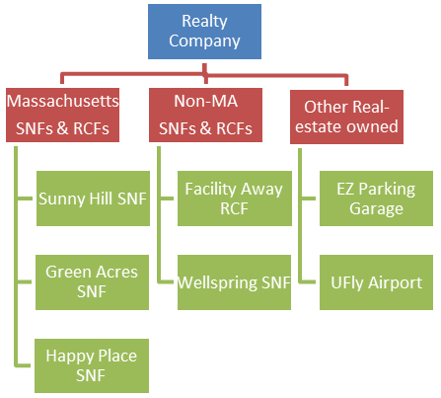

Schedule 7.3: Related Party Debt

Upload Type: Excel Template
Download and complete the template, and then upload the completed template.
In the excel template, you will be asked to provide a detailed listing of all loans to related parties reported on Schedule 4 in Account 2330.0, “Due to Affiliates/Related Parties” or if you selected the “yes” option from the dropdown menu in Schedule 5, column 4, labeled “Related Party”.

Schedule 7.4: Ownership and Facility Information
Upload Type: Excel Template
Download and complete the template, and then upload the template.
In the excel template tab labeled Direct Indirect Owners, list all realty company owner(s), address, whether ownership interest is direct or indirect , and the owner(s) ownership share (%). In the excel template tab labeled Facility Information, list the name(s) of any Massachusetts and non-Massachusetts nursing or residential care facilities owned, directly or indirectly, with an interest of 5% or more, by the realty company owners listed in the tab labeled "Direct Indirect Owners". Note: If Schedule 2 Line 2.39 (Account 9382.3, “Expenses: property Rent”) has reported amounts, this file must be completed and updated.

Schedule 7.5: Related Party Markup

Upload Type: Excel Template
Download and complete the template, and then upload template.
In this excel template, you must list any entity or person who meets the definition of “related party”, as defined in Regulation 101 CMR 206.00, that (a) provides services, facilities, goods and/or supplies to this company; or (b) receives any salary, fee, or other compensation from this company. Provide the amount paid by this company for this reporting year.

Schedule 7.6: Financial Statement Documentation

To satisfy the financial statement requirement in 957 CMR 7.03(1)(d), if the organization is required to or elects to obtain independent audited financial statements for purposes other than 957 CMR 7.00, those audited financial statements must be filed with CHIA. If the nursing facility does not obtain audited financial statements but is required or elects to obtain reviewed or compiled financial statements for purposes other than 957 CMR 7.00, a complete copy of those financial statements must be filed with CHIA.

Select one option from the menu, and send applicable statements for A, B, or C to data@chiamass.gov.

In descending order of preference:
- Financial Statement: Audited financial statements prepared by a Certified Public Accountant (CPA) for the reporting period.
- Unaudited Financial Statement: Externally prepared, reviewed, or compiled financial statements for the reporting period.
- Internally Prepared Financial Statements: Internally Prepared Financial Statements (e.g., documentation of reported costs) for the reporting period.

When sending financial statements to data@chiamass.gov, the facility name, cost reporting year, and option selected above must be included in the email title to be accepted. An acceptable email title would be:
- “Facility Name_20XX_A) Audited Financial Statements” or
- “Facility Name_20XX_B) Unaudited Financial Statements” or
- “Facility Name_20XX_C) Internally Prepared Financial Statements.”
Please also name the financial statement attachment using the same naming convention as the email title.

Schedule 8: Submission Attestation

There are two sections that require attestation in Schedule 8: the preparer and the owner. Prior to completing this section, you must resolve all validation errors. Please save and validate all schedules sequentially starting from Schedule 1 prior to submission. The validation process can be accessed using the “Save and Validate” button located at the top of your screen.
Section A – Certification by Preparer (Other than Owner, Partner, or Officer)
- This section must be completed and signed off by the preparer, someone other than the owner, partner, or officer. The preparer needs to perform all steps identified below before the “Locked for Owner Review” button is enabled for clicking. This button will be disabled (grayed out) unless all lines in Section A are completed.
Line 1.1 through Line 1.11 – Pre-populated user information
- The pre-populated information is linked to Schedule 1 Table 3 Preparer information. If the information is not correct, you can fix it in Schedule 1.

Line 1.12 – Is this information correct?
  - Select “Yes” or “No.” This must be answered “Yes” to submit the report.

Line 1.13 – Certification/attestation checkbox
- Click here to certify that you are the preparer of the report and that to the best of your knowledge the information you reported in this cost report is true, accurate, and complete.

Line 1.14 – Date of Authorization
- This cell will automatically pre-populate with the date when the checkbox on Line 1.13 is selected.

Section B – Certification by Owner, Partner or Officer

- NOTE: This section must be completed by the owner, officer, or partner. This person must be an authorized legal signatory for the entity. Section A must be completed prior to this section. The owner, partner, or officer needs to perform all steps identified below before the “Submit” button is enabled for clicking. This button will be disabled (grayed out) unless all lines in Section B are completed.
Line 2.1 – Certification/attestation checkbox
- Click here to certify that you are the authorizing person of the report and agree with the accuracy of reported costs and use of public funds statements.

Line 2.2 through Line 2.6 – Pre-populated user information
- The pre-populated information is linked to Schedule 1 Table 2 Certifier information. If the information is not correct, you can fix it in Schedule 1.

Line 2.7 – Is this information correct?
- Select “Yes” or “No.” This must be answered “Yes” to submit the report.

