Commonwealth of Massachusetts

Center for Health Information and Analysis

Fiscal Year 2012

Inpatient Hospital Discharge Database

Documentation Manual

Issued: January 2014
Updated: September 2014

Commonwealth of Massachusetts
Deval L. Patrick, Governor
Center for Health Information and Analysis
Áron Boros, Executive Director

Contents
Introduction ............................................................................................................................................................ 4

Section I. General Documentation ...................................................................................................................... 4

Section II. Technical Documentation................................................................................................................... 4

Compact Disc (CD) File Specifications ..................................................................................................................... 5

Hardware Requirements: ................................................................................................................................... 5

CD Contents: ....................................................................................................................................................... 5

File Naming Conventions .................................................................................................................................... 5

Overview ................................................................................................................................................................. 6

Part A. Background Information: .................................................................................................................... 7

1. Quarterly Reporting Periods ....................................................................................................................... 7

2. Development of Fiscal Year Database......................................................................................................... 7

3. DRG Groupers and Methodology................................................................................................................ 8

Part B. Data ................................................................................................................................................... 10

1. Data Quality Standards ............................................................................................................................. 10

2. General Data Caveats................................................................................................................................ 11

3. Data Elements ........................................................................................................................................... 12

Part C. Important Note Regarding the Use of Race Codes ........................................................................... 18

Race Code Data for FY2006 and prior years: ................................................................................................ 18

Part D. CHIA Calculated Fields ....................................................................................................................... 19

1. Admission Sequence Number ............................................................................................................... 19

2. Age Calculations .................................................................................................................................... 19

3. Days Between UHIN Stays..................................................................................................................... 19

4. Newborn Age Calculations .................................................................................................................... 20

5. Preoperative Days................................................................................................................................. 20

6. Length of Stay (LOS) Calculations.......................................................................................................... 21

7. Unique Health Information Number (UHIN) Sequence Number .......................................................... 21

Part E. Hospital Responses ........................................................................................................................... 22

1. Summary of Hospital Responses........................................................................................................... 22

2. Individual Hospital Discrepancy Documentation .................................................................................... 24

Part F. Cautionary Use Hospitals....................................................................................................................... 33

PART G. SUPPLEMENTARY INFORMATION ................................................................................................. 34

SUPPLEMENT I. LIST OF TYPE "A" AND TYPE "B" ERRORS ............................................................................. 34

SUPPLEMENT II. Content of Hospital Verification Report Package ............................................................... 36

SUPPLEMENT III. HOSPITAL ADDRESSES, ORG ID, AND SERVICE SITE ID NUMBERS...................................... 37

SUPPLEMENT III. HOSPITAL ADDRESSES, ORG ID, AND SERVICE SITE ID NUMBERS...................................... 38

SUPPLEMENT III. HOSPITAL ADDRESSES, ORG ID, AND SERVICE SITE ID NUMBERS...................................... 39

SUPPLEMENT IV. REFERENCES....................................................................................................................... 43

Introduction

This documentation manual consists of two sections, General Documentation and Technical
Documentation. This documentation manual is for use with the HDD FY2012 database. The FY2012
HDD data reflected in this manual is based on the June 2012 refresh date; updates from Sept. 2014 are found in Part E: Hospital Responses (Items 1 & 2) .

Section I. General Documentation

The General Documentation for the Fiscal Year 2012 Hospital Discharge Database includes background on its development and the DRG Groupers, and is intended to provide users with an understanding of the data quality issues connected with the data elements they may decide to examine. This document contains hospital- reported discrepancies received in response to the data verification process.

Section II. Technical Documentation

The Technical Documentation includes information on the fields calculated by the Center for Health Information and Analysis (CHIA), and a data file summary section describing the hospital data that is contained in the file.
The data file section contains the Discharge File Table (formerly the record layout), Revenue File
Table, and Data Code Tables. Also included are revenue code mappings.

For your reference, CD Specifications are listed in the following section to provide the necessary information to enable users to access files.

Please note that significant changes were made to the Discharge File Table for FY2007. New fields and values have been added.

Copies of Regulation 114.1 CMR 17.00: Requirement for the Submission of Hospital Case Mix and Charge Data and Regulation 957 CMR 5.00: Health Care Claims, Case Mix and Charge Data Release Procedures may be obtained by logging on to the Center’s web site at http://www.mass.gov/chia/ or by faxing a request to the Center at 617-727-7662.

Compact Disc (CD) File Specifications

Hardware Requirements:

• CD ROM Device
• Hard Drive with 1.60 GB of space available

CD Contents:

This CD contains the Final / Full Year 2012 Hospital Inpatient Discharge Data Product. It contains the following Microsoft
Access data base (MDB) files.

• The first file is the Discharge Table and contains one record per discharge.
• The second file is the Revenue Code Table that contains one record per revenue code
reported for each discharge.
• In addition, Grouper files are now in separate Microsoft Access tables.
• The RecordType20ID are key fields on the tables to be utilized for linkage purposes.

As an approved applicant, or its agent, you are reminded that you are bound by your application and confidentiality agreement to secure this data in a sufficient manner, so as to protect the confidentiality of the data subjects.

File Naming Conventions

This CD contains self-extracting compressed files, using the file-naming convention below. a) Hosp_Inpatient_Discharge_2012_L1_zipped.exe will expand out to
Hosp_Inpatient_Discharge_2012_L2.mdb
b) Hosp_Inpatient_Services_2012_zipped.exe will expand out to
Hosp_Inpatient_Services_2012.mdb

In the above example, 2012 represents hospital Fiscal Year 2012 and L1 represents Level 2 data elements.

To extract data from the CD and put it on your hard drive, select the CD file you need and double click on it. You will be prompted to enter the name of the target destination.

Overview

Part A. Background Information:
Provides information on the quarterly reporting periods, the development of the FY2011 hospital case mix database, and the DRG methodology used.

Part B. Data:
Describes the basic data quality standards as contained in Regulation 114.1 CMR 17.00: Requirement for the Submission of Hospital Case Mix and Charge Data, some general data definitions, general data caveats, and information on specific data elements.

Case mix data plays a vital role in health care research and analysis. To ensure the database is as accurate as possible, the CHIA strongly encourages hospitals to verify the accuracy of their data. A standard Verification Report Response Form is issued by the Center, and is used by each hospital to verify the accuracy of their data as it appears on their FY2012 Final Case-mix Verification Report. If a hospital finds data discrepancies, the CHIA requests that the hospital submit written corrections that provide an accurate profile of that hospital’s discharges.

Part C. Hospital Responses:

Details hospital responses received as a result of the data verification process. From this section users can also learn which hospitals did not verify their data. This section contains the following lists and charts:

1. Summary of Hospitals’ FY2012 Verification Report Responses

2. Individual Hospital Discrepancy Documentation

Part D. Cautionary Use Hospitals:

Lists the hospitals for which the Center did not receive four (4) quarters of acceptable hospital discharge data, as specified under Regulation 114.1 CMR 17.00.

Part E. Hospitals Submitting Data:

Lists all hospitals submitting data for FY2012, and those that failed to provide any FY2012 data.

Part F. Supplementary Information:

Contains specific information on types of errors, hospital locations, and identification numbers.

Part A. Background Information:

1. Quarterly Reporting Periods

Massachusetts hospitals are required to file case-mix data which describes various characteristics of their patient population, as well as the charges for services provided to their patients in accordance with Regulation 114.1 CMR 17.00. Hospitals report data to the Center on a quarterly basis. For the 2012 period, these quarterly reporting intervals were as follows:

Quarter 1: October 1, 2011 - December 31, 2011

Quarter 2: January 1, 2012 – March 31, 2012

Quarter 3: April 1, 2012 – June 30, 2012

Quarter 4: July 1, 2012 – September 30, 2012

2. Development of Fiscal Year Database

To assure patient privacy, minimum data is released per 957 CMR 5.00 Health Care Claims, Case Mix and Charge Data Release Procedures. Data elements are grouped into six (6) levels:

LEVEL I: No identifiable data elements with exception of 5-digit ZIP code (In future years, Level I
will have 3-Digit ZIP code only).
LEVEL II: Unique Physician Number (UPN).

LEVEL III: Unique Health Information Number (UHIN).

LEVEL IV: UHIN and UPN.

LEVEL V: Date(s) of Admission; Discharge; Significant Procedures.

LEVEL VI: Contains all data elements except the patient identifier component of the Medicaid recipient
ID number.

3. DRG Groupers and Methodology

The FY2012 Hospital Discharge database has been grouped with five groupers:

• All Patient Version 21.0
• All Patient Version 25.1
• All Patient Refined Version 20.0
• All Patient Refined Version 26.1
• MS-DRG V29.0

In order to allow customers to perform trend analysis, with prior releases of the hospital discharge data, the All Patient Version 21.0 grouper and All Patient Refined Version 20.0 grouper have been maintained on the database.

The Centers for Medicare and Medicaid Services (CMS) grouper, MS-DRG Version 29.0, has replaced Version 28. In addition to discharge DRG, the initial DRG is also provided. The initial DRG is assigned before CMS HAC (hospital acquired conditions) is considered.

ICD-9-CM Mapping

The All Patient DRG methodology as well as the All Patient Refined DRG methodology is not totally congruent with the ICD-9-CM procedure and diagnosis codes in effect for this fiscal year. Therefore, it was necessary to convert some ICD-9-CM codes into a clinically representative code using the historical mapper utility provided by 3M Health Information Systems. This conversion was done internally for the purpose of DRG assignment and in no way alters the original ICD-9- CM codes that appear on the database. These codes remain on the database as they were reported by the hospitals.

The Center uses the version of the CMS grouper compatible with the fiscal year. Consequently, mapping ICD-9-CM codes is not necessary for this grouping system.

All Patient Refined Grouper (3M APR-DRG 6.1)

The All Patient Refined DRGs (3M APR-DRG) are a severity/risk adjusted classification system that provide a more effective means of adjusting for patient differences. APR-Version 26.1 replaces the previously used APR V20.0.

The 3M APR-DRGs expand the basic DRG structure by adding four subclasses to each illness and risk of mortality.

Severity of illness and risk of mortality relate to distinct patient attributes. Severity of illness relates to the extent of physiologic decompensation or organ system loss of function experience by the
patient, while risk of mortality relates to the likelihood of dying. For example, a patient with acute
cholecystitis as the only secondary diagnosis is considered a major severity of illness but a minor risk of mortality. The severity of illness is major since there is significant organ system loss of function

associated with acute cholecystitis. However, it is unlikely that the acute cholecystitis alone will result in Patient mortality and thus, the risk of mortality for this patient is minor. If additional diagnoses are present along with the acute cholecystitis, patient severity of illness and risk of mortality may increase. For example, if peritonitis is present along with the acute cholecystitis, the patient is considered an extreme severity of illness and a major risk of mortality.

Since severity of illness and risk of mortality are distinct patient attributes, separate subclasses are assigned to a patient for severity of illness and risk of mortality. Thus, in the APR-DRG system, a patient is assigned three distinct descriptors:

• The base APR-DRG (e.g., APR-DRG 194 – Heart Failure or APR-DRG 440 – Kidney
Transplant)
• The severity of illness subclass
• The risk of mortality subclass

The four severity of illness subclasses and the four risk of mortality subclasses are numbered sequentially from 1 to 4 indicating respectively:

0* | cannot be assigned
1 | minor
2 | moderate
3 | major
4 | extreme severity of illness or risk of mortality

*For a handful of discharges, the risk of mortality and/or the severity of illness indicator(s) cannot be assigned due to data or ICD-9-CM coding errors. In these cases, the risk of mortality and/or the severity of illness indicator(s) are assigned a code of
‘0’.

The CHIA Discharge Database contains the APR Discharge and Admit DRG Version 26.1, the APR Discharge and Admit MDC Version 26.1, the discharge and admit severity subclass and the discharge and admit mortality subclass.

APR-MDC 26.1, the severity subclass, and the mortality subclass:

For applications such as evaluating resource use or establishing patient care guidelines, the 3M APR-DRGs in conjunction with severity of illness subclass is used. The severity subclass data can be found in the Discharge File Table Summary in the variable named:

“APR _V261_Discharge_SOI” (Severity Level).

For evaluating patient mortality, the 3M APR-DRG in conjunction with the risk of mortality subclass is used. The mortality subclass data can found the Discharge File Table in the variable
named

“APR_V261_Discharge_ROM ” (Mortality Level).

Please note that the Center maintains listings of the DRG numbers and associated descriptions for all DRG Groupers included in the database. These are available upon request.

Part B. Data

1. Data Quality Standards

The Case Mix Requirement Regulation 114.1 CMR 17.00 requires hospitals to submit case mix and charge data to the Center 75 days after each quarter. The quarterly data is edited for compliance with regulatory requirements, as specified in Regulation 114.1 CMR 17.00: Requirement for the Submission of Hospital Case Mix and Charge Data, using a one percent error rate. The one percent error rate is based upon the presence of Type A and Type B errors as follows:

• Type A: One error per discharge causes rejection of discharge.
• Type B: Two errors per discharge cause rejection of discharge.

If one percent or more of the discharges are rejected, the entire submission is rejected by the CHIA. These edits primarily check for valid codes, correct formatting, and presence of the required data elements. Please see Supplement I for a list of data elements categorized by error type.

Each hospital receives a quarterly error report displaying invalid discharge information. Quarterly data which does not meet the one percent compliance standard must be resubmitted by the individual hospital until the standard is met.

Verification Report Process

The verification report process is intended to present the hospitals with a profile of their individual data as reported and retained by the Center. The purpose of this process is to function as a quality control measure for hospitals. It allows the hospitals the opportunity to review the data they have provided to the Center and affirm its accuracy. The Verification Report itself is a series of frequency reports covering the selected data elements including the number of discharges, amount of charges by accommodation and ancillary center, and listing of Diagnostic Related Groups (DRGs). Please refer to Supplement II for a description of the Verification Report contents.

The Verification Report is produced after a hospital has successfully submitted the four quarters of data. The hospital is then asked to review and verify the data contained within the report. Hospitals need to affirm to the Center that the data reported is accurate or to identify any discrepancies. All hospitals are strongly encouraged to closely review their report for inaccuracies and to make corrections so that subsequent quarters of data will be accurate. Hospitals are then asked to certify the accuracy of their data by completing a Case Mix Verification Report Response Form.

The Verification Report Response Form allows for two types of responses as follows:

“A” Response: By checking this category, a hospital indicates its agreement that the data appearing on the
Verification Report is accurate and that it represents the hospital’s case mix profile.

“B” Response: By checking this category, a hospital indicates that the data on the report is accurate except for the discrepancies noted.

If any data discrepancies exist (e.g., a “B” response), the Center requests that hospitals provide written explanations of the discrepancies, so that they may be included in this General Documentation Manual.

Note: The verification reports are available for review. Please direct requests to the attention of CHIA Public Records by facsimile to 617-727-7662.

2. General Data Caveats

The following general data caveats have been developed from the Center’s Case Mix Data Advisory Group, staff members at the Massachusetts Hospital Association (MHA), the Massachusetts Health Data Consortium (MHDC), and the numerous admitting, medical records, financial, administrative, and data processing personnel who call to comment on the Center’s procedural requirements.

Information may not be entirely consistent from hospital to hospital due to differences in:

• Collection and Verification of Patient supplied information before or at admission;
• Medical record coding, consistency, and/or completeness;
• Extent of hospital data processing capabilities;
• Flexibility of hospital data processing systems;
• Varying degrees of commitment to quality of merged case mix and charge data;
• Capacity of financial processing system to record late occurring charges on the Center for
Health Information and Analysis’s electronic submission;
• Non-comparability of data collection and reporting.

In general terms, the case mix data is derived from patient discharge summaries, which can be traced to information gathered upon admission, or from information entered by admitting and attending physicians into the medical record. The quality of the case mix data is dependent upon hospital data collection policies and coding practices of the medical record staff, as well as the DRG optimizing software used by the hospital.

Charge Data

Issues to consider with charge data: A few hospitals do not have the capacity to add late occurring charges to their electronic submission within the present time frames for submitting data. In some hospitals, “days billed” or “accommodation charges” may not equal the length of the patient’s stay in the hospital. One should note that charges are a reflection of the hospital’s pricing strategy and may not be indicative of the cost of patient care delivery.

Expanded Data Elements

Care should also be used when examining data elements that have been expanded, especially when analyzing multi-year trends. In order to maintain consistency across years, it may be necessary to merge some of the expanded codes.

For example, the Patient Disposition codes were expanded as of January 1, 1994 to include a new code for “Discharged/Transferred to a Rehab Hospital”. “Prior to this quarter, these discharges would have been reported under the code “Discharged/Transferred to Chronic or Rehab Hospital” which itself was changed to “Discharged/Transferred to Chronic Hospital”. If examining these codes across years, one will need to combine the “rehab” and “chronic” codes in the data beginning January 1, 1994. Further, the data submissions questions changed significantly in 2001 and 2006. New data fields and code values were added. This will affect users conducting long term longitudinal studies.

3. Data Elements

The purpose of the following section is to provide the user with an explanation of some of the data elements included in Regulation 114.1 CMR 17.00, and to give a sense of their reliability.

Details of Specific Data Elements

DPH Hospital ID Number – REPLACED with Org ID for FY2007

The Massachusetts Department of Public Health’s four-digit identification number. (See Supplement III). Please note that DPH Hospital ID number has been replaced with Org ID for FY2007, beginning October 1, 2006.

Patient Race

The accuracy of the reporting of this data element for any given hospital is difficult to ascertain. Therefore, the user should be aware that the distribution of patients for this data element may not represent an accurate grouping of the hospital’s population.

Leave of Absence (LOA) Days

Hospitals are required to report these days to the Center, if they are used. At present, the Center is unable to verify the use of these days if they are not reported, nor can the Center verify the number reported if a hospital does provide the information. Therefore, the user should be aware that the validity of this category relies solely on the accuracy of a given hospital’s reporting practices.

Principal External Cause of Injury Code

The ICD-9-CM code categorizes the event and condition describing the principal external cause of injuries, poisonings, and adverse effects.

Unique Physician Number (UPN)

The encrypted Massachusetts Board of Registration in Medicine’s license number for the attending and operating physician.

Physicians that do not have Board of Registration in Medicine license numbers that are submitted in the Hospital Discharge Database as DENSG, PODTR, and OTHER (codes for Dental Surgeon, Podiatrist, and Other physician) appear in the AttendingPhysID and OperatingPhysID fields as:

MMMMM or MMMMM3?

MIDWIF (the code for Midwife) appears in the AttendingPhysID and OperatingPhysID fields as:

K##### or K######.

Payer Codes

In January 1994, payer information was expanded to include payer type and payer source. Payer type is the general payer category, such as HMO, Commercial, or Workers’ Compensation. Payer source is the specific health care coverage plan, such as Harvard Pilgrim Health Plan or Tufts Associated Health Plan.

Over the years, payer type and payer source codes have been further expanded and updated to reflect the current industry. A complete listing of Payer types and sources, including the new codes, can be found in this manual under Part G. Supplementary Information.

Source of Admission

In January 1994, three new sources of admission were added: ambulatory surgery, observation, and extramural birth (for newborns).

The codes were further expanded effective October 1, 1997, to better define each admission source . Physician referral was further clarified as “Direct Physician Referral” (versus calling a health plan for an HMO Referral or Direct Health Plan Referral”). “Clinic Referral” was separated into “Within Hospital Clinic Referral” and “Outside Hospital Clinic Referral”. And “Emergency Room Transfer was further delineated to include “Outside Hospital Emergency Room Transfers” and “Walk-In/Self- Referrals”. (The latter was added to reflect the fact that Walk- In/Self-Referrals are a common source of admission in hospital emergency rooms.)

Effective October 1, 1999, the Center added a new data element, Secondary Source of Admission, as well as a new source of admission code, “Transfer from Within Hospital Emergency Room”. These additions were intended to accommodate those patients with two sources of admission (for example, patients transferred twice prior to being admitted). It is important to note that the code “Transfer from within” is intended to be used as a Secondary Source of Admission only, except in cases where the hospital is unable to determine the originating or primary source of admission.

Patient Disposition

Six new discharge/transfer categories were added in January 1994 and October 1997.

• Code 05: To another type of institution for inpatient care or referred for outpatient services to another institution;
• Code 08: To home under care of a Home IV Drug Therapy Provider;
• Code 13: To rehab hospital;
• Code 14: To rest home;
• Code 50: Discharged to Hospice – Home (added 10/1/97);
• Code 51: Discharged to Hospice Medical Facility (added 10/1/97).

Accommodation and Ancillary Revenue Codes

Accommodation and Ancillary Revenue Codes have been expanded to coincide with the current UB-92 Revenue Codes. Effective October 1, 1997, new Accommodation Revenue codes were added for Chronic (code 192), Subacute (code 196), Transitional Care Unit (TCU) (code 197), and for Skilled Nursing Facility (SNF) (code 198).
Also, effective in 1998, Ancillary Revenue Code 760 was separated into individual UB-92 components which include Treatment Room (code 761), Observation Room (code 762), and Other Observation Room (code 769). Please note that the required standard unit of service for codes 762 and 769 is “hours.”

Unique Health Identification Number (UHIN)

The patient’s social security number is reported as a nine-digit number, which is then encrypted by the Center into a Unique Health Information Number (UHIN). Therefore, a social security number is never considered a case mix data element. Only the UHIN is considered a database element and only the encrypted number is used by the Center. Please note that per regulation
114.1 CMR 17.00, the number reported for the patient’s social security number should be the patient’s social security number, not the social security number of some other person, such as the husband or wife of the patient. Likewise, the social security number for the mother of a newborn should not be reported in this field, as there exists a separate field designated for social security number of the newborn’s mother.

Race

Prior to October 1, 2006, there was a single field to report patient race. Beginning October 1,
2006, there are three fields to report race: Race 1, Race 2, and Other Race (a free text field for reporting any additional races). Also, race codes have been updated.
• Please see the Data Codes section for a listing of updated values. These are consistent
with both the federal OMB standards and code set values, and the EOHHS Standards for
Massachusetts.

Hispanic Indicator

A flag to indicate whether the patient is or is not Hispanic/Latino/Spanish.

Ethnicity

Three fields–separate from patient race–to report patient ethnicity. Ethnicity 1, Ethnicity 2, and Other Ethnicity (a free text field for reporting additional ethnicities). Please see the Data Codes section for a listing of the 33 ethnicities.

Homeless Indicator

A flag to indicate whether the patient is or is not known to be homeless.

Condition Present on Admission Indicator

This is a qualifier for each diagnosis code (Primary, Diagnosis I– XIV, and primary E-Code field)
indicating onset of diagnosis preceded or followed admission.

Permanent & Temporary US Patient Address

Includes the following fields:
• Patient Street Address
• Patient City/Town
• Patient State
• Permanent Patient Country (ISO-3166) New Zip Code

Requirements

Zip codes must be 0’s, if unknown or if the patient country is not the United States.

New Patient Status Values

Please see Data Codes section for new values. Values were updated to be consistent with UB-92 standards.

HCF Organization ID

This replaces the MDPH Hospital Computer #. Previously this was reported for ED data only.

Transfer Hospital Org ID

Organization ID of the transferring hospital, if any.

Hospital Service Site Reference

OrgID for site of service.

Surgeon License Number & Date

Expanded from 3 to 15 procedures beginning October 1, 2001.

ER Indicator

A flag to indicate whether the patient was admitted from the hospital’s emergency department.

Observation Indicator

A flag to indicate whether the patient was admitted from the hospital’s outpatient observation department.

Secondary Source of Admission

A code indicating the source of referring or transferring the patient to inpatient status in the hospital. The Primary Source of Admission is the originating, referring, or transferring facility or primary referral source causing the patient to enter the hospital’s care. The secondary source of admission is the secondary referring or transferring source for the patient. For example, if a patient has been transferred from a SNF to the hospital’s Clinic and is then admitted, the Primary Source of Admission is reported as “5 – Transfer from a SNF” and the Secondary Source of Admission is reported as “Within Hospital Clinic Referral”.

Do Not Resuscitate (DNR) Status

A status indicating that the patient had a physician order not to resuscitate or the patient had a status of receiving palliative care only. Do not resuscitate status means not to revive a patient from potential or apparent death or that a patient was being treated with comfort measures only.

Mother’s Social Security Number (for infants up to one year old)

The social security number of the patient’s mother reported as a nine-digit number for newborns or for infants less than 1 year old. The mother’s social security number is encrypted into a Unique Health Information Number (UHIN) and is never considered a case mix data element. Only the UHIN is considered a database element and only this encrypted number is used by the Center.

Mother’s Medical Record Number (for newborns born in the hospital)

The medical record number assigned within the hospital to the newborn’s mother. This medical record number distinguishes the patient’s mother and the patient’s mother’s hospital record(s) from all others in that institution.

Facility Site Number

A hospital determined number used to distinguish multiple sites that fall under one organizational ID number.

Organization ID

A unique facility number assigned by the Center.

Associated Diagnosis 9 – 14

This data element was expanded in 1999 to allow for up to 14 diagnoses.

Attending Physician License Number (Board of Registration in Medicine Number), and Operating
Physician for Principal Procedure (Board of Registration in Medicine Number)

There is now choice of a Nurse Midwife Code for the Attending and Operating MD License Field:

• Must be a valid and current Mass. Board of Registration in Medicine license number
-OR-
• Must be “DENSG”, “PODTR”, “OTHER” or “MIDWIF” as specified in Inpatient Data Elements
Definitions (9)(b) of the Submission Guide.

Other Caregiver Field

The primary caregiver responsible for the patient’s care other than the attending physician, operating room physician, or nurse midwife as specified in the Regulation. Other caregiver includes: resident, intern, nurse practitioner, and physician’s assistant.

Attending, Operating, and Additional Caregiver National Provider Identifier Fields

Please note that these are not yet part of the database. They are just placeholders for when they are implemented. These data elements will be required when available on a national basis.

Part C. Important Note Regarding the Use of Race Codes

Beginning in FY07, the Center started using the federal OMB standard race codes and code set values. These are also consistent with the EOHHS standards for Massachusetts.

There are now three fields for reporting race. Race 1 and Race 2 require the use of one of the codes in the table below.
Other Race is a free text field for reporting additional races when R9 “Other Race” is indicated in Race
1 or Race 2.

Please see the following table for new HCF Race Codes Beginning FY 2007:

New Race Code Beginning FY 2007 | Description
R1 | American Indian /Alaska Native
R2 | Asian
R3 | Black/African American
R4 | Native Hawaiian or Other Pacific Islander
R5 | White
R9 | Other Race
Unknown | Unknown/not specified

Race Code Data for FY2006 and prior years:

If you have used data in previous years, you may have noted that the Race_Code information in the Inpatient file prior to FY2000 was inconsistent with the way the data was reported to the Center. Furthermore, the Inpatient data product was inconsistent with other data products, such as the Outpatient Observation data product. In FY2000, we corrected this inconsistency by standardizing the Race Code as the following table shows. Please note that to compare pre-FY2000 Inpatient data to data submitted between FY2000 – FY2006, you will have to standardize using the translation
table below.

Race Code | Description - FY2000 –  FY2006 | Pre-2000 Inpatient FIPA Code
1 | White | White
2 | Black | Black
3 | Asian | Other
4 | Hispanic | Unknown
5 | American Indian | American Indian
6 | Other | Asian
9 | Unknown | Hispanic

This format is consistent across all Center data products for these fiscal years, except pre-2000
Inpatient, and was the same format as reported to the Center.

Part D. CHIA Calculated Fields

1. Admission Sequence Number

This calculated field indicates the chronological order of admissions for patients with multiple inpatient stays. A match with the UHIN only, is used to make the determination that a patient has had multiple stays.**

2. Age Calculations

Age is calculated by subtracting the date of birth from the admission date.
Age is calculated if the date of birth and admission date are valid. If either one is invalid, then
‘999’ is placed in this field.
Discretion should be used whenever a questionable age assignment is noted. Researchers are advised to consider other data elements (i.e., if the admission type is newborn) in their analysis of this field.
If the patient has already had a birthday for the year, his or her age is calculated by subtracting
the year of birth from the year of admission. If not, then the patient’s age is the year of admission minus the year of birth, minus one.
If the age is 99 (the admission date is a year before the admission date or less) and the MDC is 15
(the patient is a newborn), then the age is assumed to be zero.
Discretion should be used when a questionable age assignment is noted.

3. Days Between UHIN Stays

This calculated field indicates the number of days between each discharge and each consecutive admission for applicable patients. Again, a match with the UHIN only, is used to make a determination that a patient has been readmitted. (Please read the comments below.)**

Analysis of UHIN data by the Center has turned up problems with some of the reported data. For a small number of hospitals, little or no UHIN data exists, as these hospitals failed to report patients’ social security numbers (SSN). Other hospitals reported the same SSN repeatedly, resulting in numerous admissions for one UHIN. In other cases, the demographic information (age, sex, etc.) was not consistent when a match did exist with the UHIN. Some explanations for this include assignment of a mother’s SSN to her infant or assignment of a spouse’s SSN to a patient. This demographic analysis shows a probable error rate in the range of 2% – 10%.

In the past, the CHIA has found that, on average, 91% if the SSNs submitted are valid when edited for compliance with rules issued by the Social Security Administration. Staff continually monitors the encryption process to ensure that duplicate UHINs are not inappropriately generated, and that recurring SSNs consistently encrypt to the same UHIN. Only valid SSNs are encrypted to a UHIN. It is valid for hospitals to report that the SSN is unknown. In these cases, the UHIN appears as ‘000000001’.

Invalid SSNs are assigned 7 or 8 dashes and an error code. The list of error codes is as follows:

ssn_empty = 1 ssn_notninec hars = 2 ssn_allcharse qual = 3 ssn_firstthree charszero = 4 ssn_midtwoc harszero=5 ssn_lastfourc harszero = 6 ssn_notnume ric = 7 ssn_rangeinv alid = 8 ssn_errorocc urred = 9 ssn_encrypte rror = 10

**Based on these findings, the CHIA strongly suggests that users perform some qualitative checks of the data prior to drawing conclusions about that.

4. Newborn Age Calculations

Discharges less than one year old have their age calculated by subtracting the date of birth from the admission date. This gives the patient’s age in days. This number is divided by seven, the remainder is dropped.
Newborn age is calculated to the nearest week (the remainder is dropped). Thus, newborns zero to six days old are considered to be zero weeks old.
Discharges that are not newborns have ‘99’ in this field.
If a patient is 1 year old or older, the age in weeks is set to ‘99’.
If a patient is less than 1 year old then:
Patients’ age is calculated in days using the Length of Stay (LOS) routine, described herein. Number of days in step ‘a’ above is divided by seven, and the remainder is dropped.

5. Preoperative Days

A procedure performed on the day of admission will have preoperative days set to zero. One performed on the day after admission will have preoperative days set to 1, etc. A procedure performed on the day before admission will have preoperative days set to negative one (-1).
Preoperative days are set to 0000 when preoperative days are not applicable.
• For procedures performed before the day of admission, a negative sign (-) will appear in the

first position of the preoperative day field.
Preoperative days are calculated by subtracting the patient’s admission date from the surgery date.
If there is no procedure date, or if the procedure date or admission date is invalid, or if the procedure date occurs after the discharge date, then preoperative days is set to 0000.
Otherwise preoperative days are calculated using the Length of Stay (LOS) Routine, as described elsewhere.

6. Length of Stay (LOS) Calculations

Length of Stay (LOS) is calculated by subtracting the Admission Date from the Discharge Date (and then subtracting Leave of Absence Days (LOA) days). If the result is zero (for same day discharges), then the value is changed to 1.
Same day discharges have a length of stay of 1 day.
If either the Admission Date or Discharge Date are invalid , LOS =0.
Patient stays ending beyond the end of the reporting year are adjusted to give the correct LOS.

7. Unique Health Information Number (UHIN) Sequence Number

The Sequence Number is calculated by sorting the file by Unique Health Information Number, admission date, and discharge date. The sequence number is then calculated by incrementing a counter for each UHIN’s set of admissions.
UHIN Sequence Number is calculated by sorting the entire database by UHIN, admission date, then discharge date (both dates are sorted in ascending order).
If the UHIN is undefined (not reported, unknown or invalid), the sequence number is set to zero. If the UHIN is valid, the sequence number is calculated by incrementing a counter from 1 to
nnnn, where a sequence number of 1 indicates the first admission for the UHIN, and nnnn
indicates the last admission for the UHIN.
If a UHIN has 2 admissions on the same day, the discharge date is used as the secondary sort key.

Part E. Hospital Responses

1. Summary of Hospital Responses

FY 2012  VERIFICATION RESPONSE TRACKING  LOG |  |  | HDD | HDD | HDD
 | Organization | Date Sent | Date Form Recvd. | Resubmit  Date | Hospital Response
1 | Anna Jaques Hosp. | 4/5/13 | 4/18/13 |  | A
2 | Athol Memorial Hosp. | 4/5/13 | 5/9/13 |  | A
5 | Baystate Franklin Hospital | 4/5/13 | 4/25/13 |  | A
6 | Baystate Mary Lane Hospital | 4/5/13 | 4/19/13 |  | A
4 | Baystate Med. Ctr. | 4/5/13 | 4/25/13 |  | A
7 | Berkshire Health Sys. - Berkshire Campus | 4/8/13 | 4/19/13 |  | A
10 | Beth Israel Deaconess Med. Ctr. | 4/8/13 | 4/18/13 |  | A
53 | Beth Israel Deaconess Med.- Needham Campus | 4/5/13 | 4/19/13 |  | A
98 | Beth Israel Deaconess Med - Milton | 4/5/13 | 4/24/13 |  | A
46 | Boston Children's Hospital | 4/5/13 | 4/11/13 |  | A
16 | Boston Med. Ctr. | 4/8/13 | 4/23/13 |  | A
59 | Brigham & Women's Faulkner Hospital | 4/8/13 | 4/18/13 |  | A
22 | Brigham & Women's Hosp. | 4/8/13 | 4/11/13 |  | A
27 | Cambridge Health Alliance | 4/8/13 | 4/19/13 |  | A
39 | Cape Cod Hosp. | 5/31/13 |  |  | Data not verified
132 | Clinton Hosp. | 4/5/13 |  |  | Data not verified
50 | Cooley Dickinson Hosp. | 5/13/13 | 6/3/13 |  | A
51 | Dana Farber Cancer Ctr. | 4/5/13 | 4/11/13 |  | A
57 | Emerson | 4/5/13 | 4/18/13 |  | A
8 | Fairview Hosp. | 4/5/13 | 4/19/13 |  | A
40 | Falmouth Hosp. | 5/31/13 |  |  | Data not Verified
66 | Hallmark Health Sys. - Lawrence Memorial Hosp. | 4/8/13 | 4/18/13 |  | A
141 | Hallmark Health Sys. - Melrose, Wakefield Hosp. Campus | 4/8/13 | 4/18/13 |  | A
68 | Harrington Memorial Hosp. | 4/5/13 | 4/22/13 |  | A
71 | HealthAlliance Hosps., Inc | 4/5/13 | 4/18/13 |  | A
73 | Heywood Hosp. | 4/5/13 | 4/18/13 |  | A
77 | Holyoke Hosp. | 4/5/13 | 4/19/13 |  | A
79 | Jordan Hosp. | 5/31/13 | 4/26/13 |  | B
81 | Lahey Clinic Burlington Campus | 4/8/13 | 4/19/13 |  | A
83 | Lawrence General Hosp. | 4/8/13 | 4/18/13 |  | B
85 | Lowell General Hosp. | 4/8/13 | 4/15/13 |  | A

115 | Lowell General Hosp. Saints Campus | 4/8/13 | 4/18/13 |  | A
133 | Marlborough Hosp | 4/8/13 | 4/19/13 |  | A
88 | Martha's Vineyard Hosp. | 4/8/13 | 4/18/13 |  | A
88 | Mass Eye & Ear Infirmary | 5/31/13 | 6/5/13 |  | A
91 | Mass General Hosp. | 4/8/13 | 4/18/13 |  | A
118 | Mercy Hosp. - Providence Campus | 4/8/13 | 5/20/13 |  | A
119 | Mercy Hosp. - Springfield Campus | 4/8/13 | 4/16/13 |  | A
11466 | Merrimack Valley Hosp. | 4/8/13 | 4/25/13 |  | A
49 | MetroWest Med. Ctr. - Framingham & Leon | 4/8/13 | 4/18/13 |  | A
97 | Milford Regional Medical Center | 4/8/13 | 4/17/13 |  | A
99 | Morton | 4/8/13 | 5/15/13 |  | B
100 | Mount Auburn | 4/8/13 | 4/18/13 |  | A
101 | Nantucket Cottage Hosp. | 4/8/13 | 4/18/13 |  | A
11467 | Nashoba Valley Med. Ctr. | 4/8/13 | 4/18/13 |  | A
103 | New England Baptist Hosp. | 4/8/13 | 4/18/13 |  | A
105 | Newton-Wellesley Hosp. | 4/8/13 | 4/30/13 |  | A
106 | Noble Hosp. | 5/31/13 |  |  | Data not verified
107 | North Adams Regional Hosp. | 4/8/13 | 5/29/13 |  | A
109 | Northeast Health Sys - Addison | 4/8/13 | 4/18/13 |  | A
110 | Northeast Health Sys - Beverly | 4/8/13 | 4/18/13 |  | A
116 | North Shore Med. Ctr. / Salem Hosp & Union | 4/8/13 | 4/19/13 |  | A
112 | Quincy Hosp. | 4/8/13 | 4/22/13 |  | A
127 | Saint Vincent Hosp @ Worcester Med Ctr | 4/8/13 | 4/23/13 |  | A
6963 | Shriners Hospital for Children - Boston | 4/8/13 | 5/3/13 |  | A
11718 | Shriners Hospital for Children - Springfield | 4/8/13 | 4/18/13 |  | A
25 | Signature Healthcare Brockton Hosp | 4/8/13 | 4/18/13 |  | A
122 | South Shore Hosp. | 4/8/13 | 4/26/13 |  | A
123 | Southcoast Health - Charlton Memorial | 5/31/13 |  |  | Data not verified
124 | Southcoast Health - St. Lukes | 5/31/13 |  |  | Data not verified
145 | Southcoast Health - Tobey Campus | 5/31/13 |  |  | Data not verified
42 | Steward Carney Hospital | 4/8/13 | 5/13/13 |  | A
62 | Steward Good Samaritan Medical Center | 4/8/13 | 5/13/13 |  | A
4460 | Steward Good Sam Med Ctr - Norcap Lodge | 4/8/13 | 5/12/13 |  | A
75 | Steward Holy Family Hospital | 4/8/13 | 5/12/13 |  | A
41 | Steward Norwood Hospital | 4/8/13 | 5/13/13 |  | A
114 | Steward Saint Anne's Hospital | 4/8/13 | 5/12/13 |  | A
126 | Steward St. Elizabeth's Medical Center | 4/8/13 | 5/13/13 |  | A
129 | Sturdy Memorial Hospital | 4/8/13 | 4/22/13 |  | A
104 | Tufts-New England Med. Ctr. | 4/8/13 | 4/22/13 |  | A
131 | U Mass. / Memorial Health - U. Mass Campus | 4/8/13 | 4/29/13 |  | B
139 | U Mass / Wing Memorial Hosp. | 4/8/13 |  |  | Data not verified
138 | Winchester Hosp. & Family Med. Ctr. | 4/8/13 | 4/13/13 |  | A

2. Individual Hospital Discrepancy Documentation

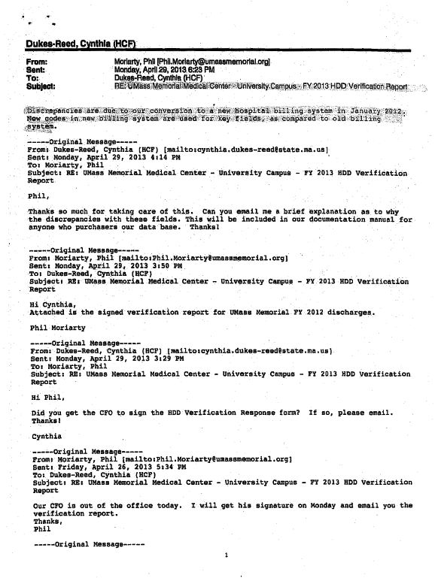

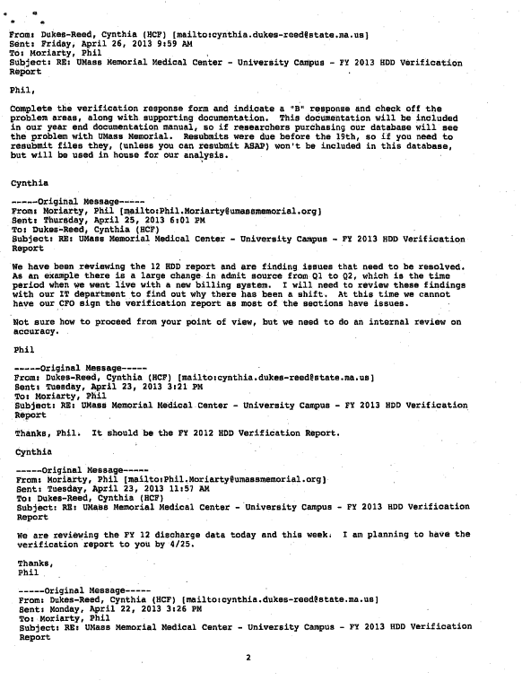

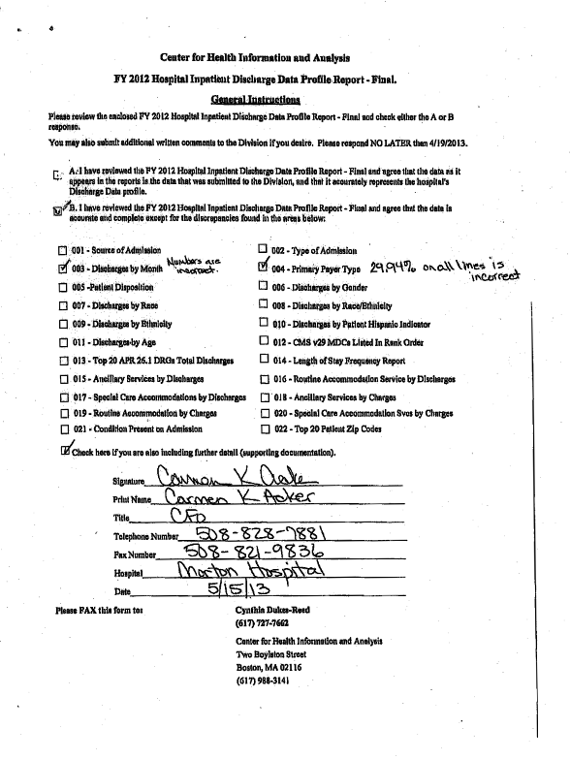

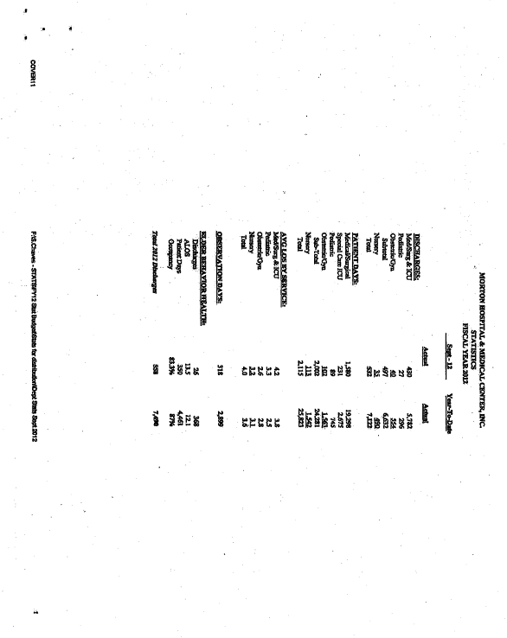

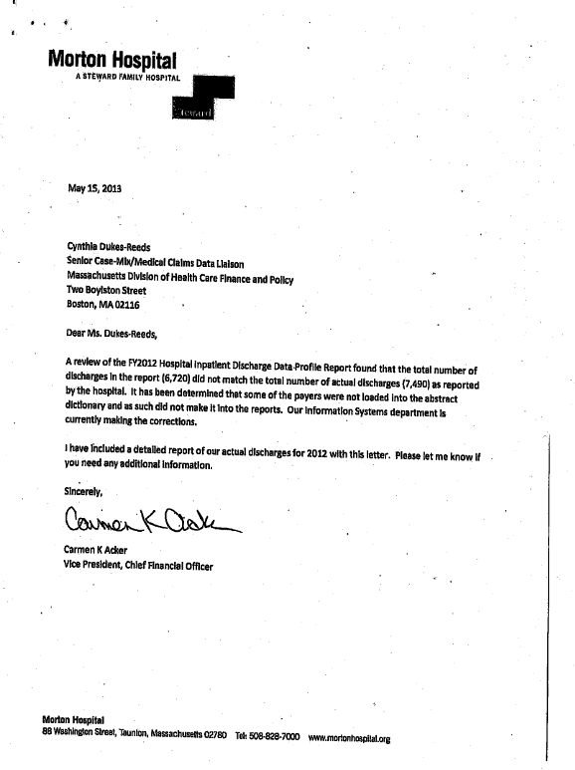

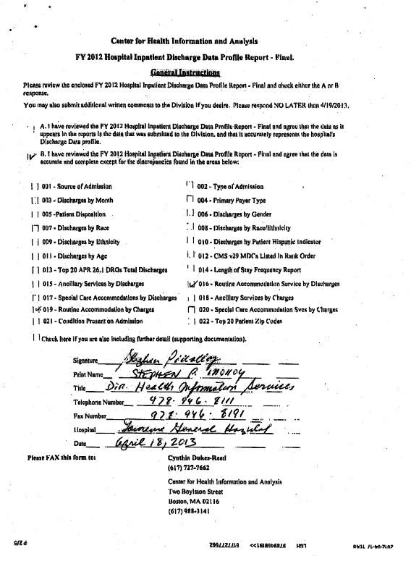

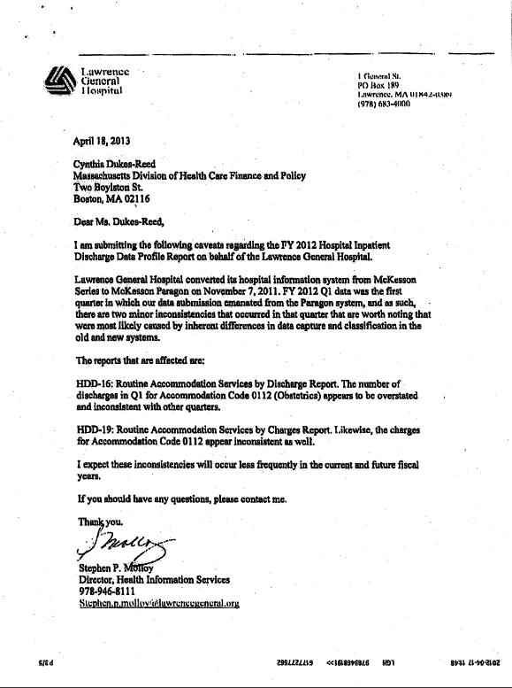

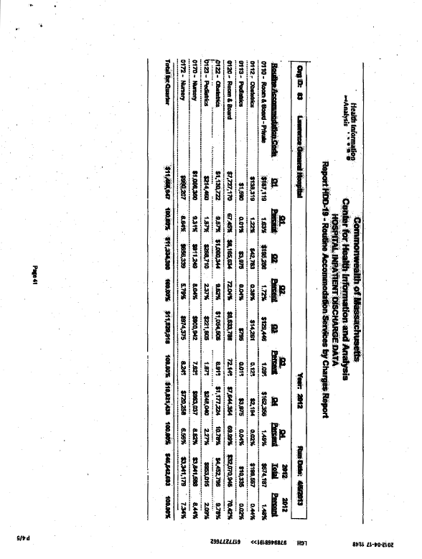

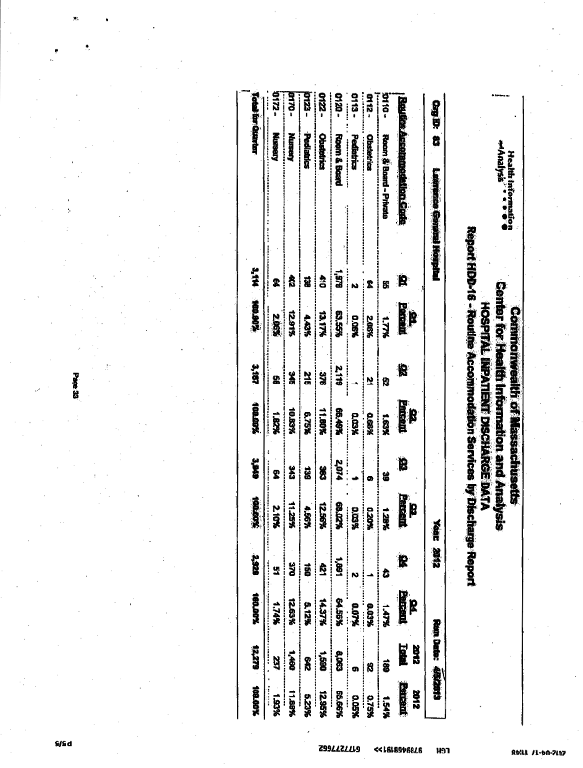

Part F. Cautionary Use Hospitals

FY 2012: There are no cautionary use hospitals in FY2012. All hospitals submitted 4 quarters of passed data for FY 2012.

PART G. SUPPLEMENTARY INFORMATION

SUPPLEMENT I. LIST OF TYPE "A" AND TYPE "B" ERRORS

TYPE "A" ERRORS

Record Type
Starting Date Period Ending Date Medical Record Number
Patient Sex
Patient Birth Date Admission Date Discharge Date
Primary Source of Payment
Patient Status Billing Number Primary Payer Type Primary Payer Type Secondary
Mother’s Medical Record Number
Revenue Code
Units of Service
Total Charges (by Revenue Code) Principal Diagnosis Code
Associate Diagnosis Code (I – XIV)
Number of ANDS Principal Procedure Code Significant Procedure Code I
Significant Procedure Code II Significant Procedure
Code III-XIV Physical Record Count
Record Type 2X Count
Record Type 3X Count Record Type 4X Count Record Type 5X Count Record Type
6X Count
Total Charges: Special Services Total Charges: Routine Services Total Charges: Ancillaries
Total Charges: (ALL CHARGES) Number of
Discharges
Total Charges: Accommodations
Total Charges: Ancillaries
ED Flag Observation Flag HCF Org ID Hospital Service Site Reference

TYPE "B" ERRORS

Patient Race
Type of Admission Source of Admission
Patient Zip Code Veteran Status
Patient Social Security Number
Birth Weight - grams Employer Zip Code
DNR Status
Homeless Indicator
Mother's Social Security Number
Facility Site Number
External Cause of Injury Code Attending Physician License Number Operating Physician License Number Other Caregiver Attending Physician
National Provider Identifier (NPI) ATT NPI Location Code
Operating Physician
National Provider Identifier (NPI) Operating
NPI
Location Code Additional Caregiver National Provider Identified Date of Principal Procedure
Date of Significant Procedures (I and
II)
Race 1, 2, and Other Race
Hispanic Indicator
Ethnicity 1, 2, and Other Ethnicity Condition Present on Admission Primary Diagnosis Associate Diagnoses I-XIV Primary E-Code Significant Procedure Date
Operating Physician for Significant
Procedure
Permanent Patient Street Address, City/Town, State, Zip Code
Patient Country
Temporary Patient Street Address, City/Town, State, Zip Code

SUPPLEMENT II. Content of Hospital Verification Report Package

The Hospital Verification Report includes the following frequency distribution tables:

Hospital Verification Report frequency distribution tables:
Source of Admissions Type of Admissions Discharges by Month Primary Payer Type Patient Disposition Discharges by Gender Discharges by Race 1
Discharges by Race 2
Discharges by Race/Ethnicity 1
Discharges by Race/Ethnicity 2
Discharges by Ethnicity1
Discharges by Ethnicity 2
Discharges by Patient Hispanic Indicator
Discharges by Age
CMS v 29 MDC’s Listed in Rank Order
Top 20 APR 26.1 DRG with Most Total Discharges
Length of Stay
Ancillary Services by Discharges
Routine Accommodation Services by Discharges Special Care Accommodation by
Discharges Ancillary Services by Charges
Routine Accommodation by Charges
Special Care Accommodation Services by Charges
Condition Present on Admission
Top 20 Patient Zip Code

Verification Response Forms: Completed by hospitals after data verification and returned to CHIA.

*NOTE: Hospital discharges were grouped with All Patient Version 25.1, 21.0, All Patient Refined Version
26.1, and CMS-DRG v28.0. A discharge report showing counts by DRG for both groupers was supplied to hospitals for verification.

SUPPLEMENT III. HOSPITAL ADDRESSES, ORG ID, AND SERVICE SITE ID NUMBERS

Current Organization Name | Hospital Address | ID ORG HOSP | ID ORG FILER | SITE NO.*
Anna Jaques Hospital | 25 Highland Ave | 1 | 1 | 1
 | Newburyport, MA 01950
Athol Memorial Hospital | 2033 Main Street | 2 | 2 | 2
 | Athol, MA 01331
Baystate Franklin Medical Center | 164 High Street | 5 | 5
 | Greenfield, MA 01301
Baystate Mary Lane Hospital | 85 South Street | 6 | 6
 | Ware, MA 01082
Baystate Medical Center | 759 Chestnut St Springfield, MA 01199 | 4 | 4 | 4
Berkshire Medical Center – Berkshire | 725 North Street | 6309 | 7 | 7
Campus | Pittsfield, MA., 01201
Berkshire Medical Center – Hillcrest | 165 Tor Court |  |  | 9
Campus | Pittsfield, MA 01201
Beth Israel Deaconess Hospital – | 148 Chestnut Street | 53 | 53 | 53
Needham | Needham, MA 02192
Beth Israel Deaconess Medical Center | 330 Brookline Avenue | 8702 | 10 | 10
- East Campus | Boston, MA 02215
Boston Children's Hospital | 300 Longwood Avenue | 46 | 46
 | Boston, MA 02115
Boston Medical Center – Menino | One Boston Medical Center Place | 3107 | 16 | 16
Pavilion | Boston, MA 02118
Boston Medical Center - Newton | One Boston Medical Center Place |  |  | 144
Pavilion Campus | Boston, MA 02118
Brigham and Women's Faulkner | 1153 Centre Street | 22 | 59 | 59
Hospital | Jamaica Plain, MA 02130
Brigham and Women's Hospital | 75 Francis St | 22 | 22 | 22
 | Boston, MA 02115
Cambridge Health Alliance – | 1493 Cambridge Street | 3108 | 27 | 27
Cambridge Hospital Campus | Cambridge, MA 02139
Cambridge Health Alliance – | 230 Highland Avenue |  |  | 143
Campus | Somerville, MA

SUPPLEMENT III. HOSPITAL ADDRESSES, ORG ID, AND SERVICE SITE ID NUMBERS

Current Organization Name | Hospital Address | ID ORG | ID ORG | SITE NO.*
Cambridge Health Alliance – Whidden | 103 Garland Street |  |  | 142
Hospital Campus | Everett, MA 02149
Cape Cod Hospital | 27 Park Street | 39 | 39
 | Hyannis, MA 02601
Clinton Hospital | 201 Highland Street | 132 | 132
 | Clinton, MA 01510
Cooley Dickinson Hospital | 30 Locust Street | 50 | 50
 | Northampton, MA 01061-5001
Dana-Farber Cancer Institute | 44 Binney Street | 51 | 51
 | Boston, MA 02115
Emerson Hospital | 133 Old Road to Nine Acre Corner | 57 | 57
 | Concord, MA 01742
Fairview Hospital | 29 Lewis Avenue | 8 | 8
 | Great Barrington, MA 01230
Falmouth Hospital | 100 Ter Heun Drive | 40 | 40
 | Falmouth, MA 02540
Faulkner Hospital | see Brigham & Women’s Faulkner Hospital
Hallmark Health System – Lawrence | 170 Governors Avenue | 3111 | 66
Memorial Hospital Campus | Medford, MA 02155
Hallmark Health System - Melrose- | 585 Lebanon Street | 3111 | 141
Wakefield Hospital Campus | Melrose, MA 02176
Harrington Memorial Hospital | 100 South Street | 68 | 68
 | Southbridge, MA 01550
Health Alliance Hospitals, Inc. | 60 Hospital Road | 71 | 71
 | Leominster, MA 01453-8004
Health Alliance Hospital – Burbank | 275 Nichols Road |  |  | 8548
Campus | Fitchburg, MA 01420
Health Alliance Hospital –Leominster | 60 Hospital Road |  |  | 8509
Campus | Leominster, MA 01453
Heywood Hospital | 242 Green Street | 73 | 73
 | Gardner, MA 01440

SUPPLEMENT III. HOSPITAL ADDRESSES, ORG ID, AND SERVICE SITE ID NUMBERS

Current Organization Name | Hospital Address | ID ORG | ID ORG | SITE NO.*
Holyoke Medical Center | 575 Beech Street | 77 | 77
 | Holyoke, MA 01040
Jordan Hospital | 275 Sandwich Street | 79 | 79
 | Plymouth, MA 02360
Lahey Clinic - Burlington Campus | 41 Mall Road | 6546 | 81 | 81
 | Burlington, MA 01805
Lahey Clinic - North Shore | One Essex Center Drive |  |  | 4448
 | Peabody, MA 01960
Lawrence General Hospital | One General Street | 83 | 83
 | Lawrence, MA 01842-0389
Lowell General Hospital | 295 Varnum Avenue | 85 | 85
 | Lowell, MA 01854
Marlborough Hospital | 57 Union Street | 133 | 133
 | Marlborough, MA 01752-9981
Martha's Vineyard Hospital | One Hospital Road | 88 | 88
 | Oak Bluffs, MA 02557
Massachusetts Eye and Ear Infirmary | 243 Charles Street | 89 | 89
 | Boston, MA 02114-3096
Massachusetts General Hospital | 55 Fruit Street | 91 | 91
 | Boston, MA 02114
Mercy Medical Center – Providence | 1233 Main St | 6547 | 118 | 118
Behavioral Health Hospital Campus | Holyoke, MA 01040
Mercy Medical Center - Springfield | 271 Carew Street | 6547 | 119
Campus | Springfield, MA 01102
Merrimack Valley Hospital | 140 Lincoln Avenue | 70 | 70
Merrimack Valley Hospital, A Steward | Haverhill, MA 01830-6798
Family Hospital |  | 11466* | 11466
(*11466 New Org ID as of 5/1/2011)
MetroWest Medical Center – | 115 Lincoln Street | 3110 | 49 | 49
Framingham Campus | Framingham, MA 01702
MetroWest Medical Center – Leonard | 67 Union Street | 3110 | 49 | 457
Morse Campus | Natick, MA 01760

SUPPLEMENT III. HOSPITAL ADDRESSES, ORG ID, AND SERVICE SITE ID NUMBERS

Current Organization Name |  | Hospital Address | ID ORG | ID ORG | SITE NO.*
Milford Regional Medical Center |  | 14 Prospect Street | 97 | 97
 |  | Milford, MA 01757
Milton Hospital |  | 199 Reedsdale Rd | 98 | 98
(NOTE: 1/1/12 merger – name |  | Milton, MA 02186
to Beth Israel Deaconess Hospital-
Milton)
Morton Hospital, A Steward Family |  | 88 Washington St | 99 | 99
Hospital, Inc. |  | Taunton, MA 02780
Mount Auburn Hospital |  | 330 Mt. Auburn St. | 100 | 100
 |  | Cambridge, MA 02138
Nantucket Cottage Hospital |  | 57 Prospect St | 101 | 101
 |  | Nantucket, MA 02554
Nashoba Valley Medical Center |  | 200 Groton Road | 52 | 52 | 52
 |  | Ayer, MA 01432
Nashoba Valley Medical Center, A
11467* 11467
Steward Family Hospital, Inc
*(11467 new org id as of 5/1/2011)
New England Baptist Hospital |  | 125 Parker Hill Avenue | 103 | 103
 |  | Boston, MA 02120
Newton Wellesley Hospital |  | 2014 Washington St | 105 | 105
 |  | Newton, MA 02462
Noble Hospital |  | 115 West Silver Street | 106 | 106
 |  | Westfield, MA 01086
North Adams Regional Hospital |  | 71 Hospital Avenue | 107 | 107
 |  | North Adams, MA 02147
North Shore Medical Center, | – | 81 Highland Avenue | 345 | 116 | 116
Salem Campus |  | Salem, MA 01970
North Shore Medical Center, Inc. – |  | 500 Lynnfield Street |  |  | 3
Union Campus |  | Lynn, MA 01904
Northeast Hospital - Addison Gilbert |  | 298 Washington St | 3112 | 109
Campus |  | Gloucester, MA 01930

SUPPLEMENT III. HOSPITAL ADDRESSES, ORG ID, AND SERVICE SITE ID NUMBERS

Current Organization Name | Hospital Address | ID ORG | ID ORG | SITE NO.*
Northeast Hospital – Beverly Campus | 85 Herrick Street | 3112 | 110
 | Beverly, MA 01915
Quincy Medical Center, A Steward | 114 Whitwell Street | 112 | 112
Family Hospital, Inc. | Quincy, MA 02169
Saint Vincent Hospital | 123 Summer St | 127 | 127
 | Worcester, MA 01608
Saints Memorial Medical Center | One Hospital Drive | 115 | 115
 | Lowell, MA 01852
Signature Healthcare Brockton | 680 Centre Street | 25 | 25
Hospital | Brockton, MA 02302
South Shore Hospital | 55 Fogg Road | 122 | 122
 | South Weymouth, MA 02190
Southcoast Hospitals Group – | 363 Highland Avenue | 3113 | 123
Memorial Campus | Fall River, MA 02720
Southcoast Hospitals Group - St. | 101 Page Street | 3113 | 124
Campus | New Bedford, MA 02740
Southcoast Hospitals Group – Tobey | 43 High Street | 3113 | 145
Hospital Campus | Wareham, MA 02571
Steward Carney Hospital | 2100 Dorchester Avenue | 42 | 42
 | Dorchester, MA 02124
Steward Good Samaritan Medical | 235 North Pearl Street | 8701 | 62
Center – Brockton Campus | Brockton, MA 02301
Steward Good Samaritan Medical Ctr - | 71 Walnut Street | 8701 | 4460
Norcap Lodge Campus | Foxboro, MA 02035
NO ED
Steward Holy Family Hospital and | 70 East Street | 75 | 75
Medical Center | Methuen, MA 01844
Steward Norwood Hospital | 800 Washington Street | 41 | 41
 | Norwood, MA 02062
Steward St. Anne's Hospital | 795 Middle Street | 114 | 114
 | Fall River, MA 02721

SUPPLEMENT III. HOSPITAL ADDRESSES, ORG ID, AND SERVICE SITE ID NUMBERS

Current Organization Name | Hospital Address | ID ORG | ID ORG | SITE NO.*
Steward St. Elizabeth's Medical | 736 Cambridge Street | 126 | 126
 | Boston, MA 02135
Sturdy Memorial Hospital | 211 Park Street | 129 | 129
 | Attleboro, MA 02703
Tufts Medical Center | 800 Washington Street | 104 | 104
 | Boston, MA 02111
UMass. Memorial Medical Center – | 55 Lake Avenue North | 3115 | 131
University Campus | Worcester, MA 01655
UMass. Memorial Medical Center – | 119 Belmont Street |  |  | 130
Memorial Campus | Worcester, MA 01605
Winchester Hospital | 41 Highland Avenue | 138 | 138
 | Winchester, MA 01890
Wing Memorial Hospital | 40 Wright Street | 139 | 139
 | Palmer, MA 01069-1187

* For data users trying to identify specific care sites, use site number. However, if site number is blank, use IdOrgFiler

SUPPLEMENT IV. REFERENCES

Data Release File Specifications:

The specification document outlining the HDD data release file fields and Access 3 database structure for the various HDD Data Release Levels is in development at the time of release of this document. When complete this will be published on the CHIA website.

Submission File Specifications:

For the record layout and field descriptions along with the starting and ending positions, as specified for the Hospital Inpatient Discharge submission files refer to the Hospital Inpatient Discharge Data Electronic Records Submission Specification on the CHIA website:
http://www.mass.gov/chia/docs/g/chia-regs/114-1-17-inpatient-specs.pdf or
http://www.mass.gov/chia/docs/g/chia-regs/114-1-17-inpatient-specs.doc

Inpatient Data Code Tables:

Please refer to the Hospital Inpatient Discharge Data Electronic Records Submission Specification on the CHIA website regarding the Inpatient Data Code tables for all data elements requiring codes not otherwise specified in 114.1 CMR 17.00:
http://www.mass.gov/chia/docs/g/chia-regs/114-1-17-inpatient-specs.pdf or http://www.mass.gov/chia/docs/g/chia-regs/114-1-17-inpatient-specs.doc

Revenue Code Mappings:

Please refer to the Hospital Inpatient Discharge Data Electronic Records Submission Specification on the CHIA website regarding the Inpatient Data Code tables for all data elements requiring codes not otherwise specified in 114.1 CMR 17.00:
http://www.mass.gov/chia/docs/g/chia-regs/114-1-17-inpatient-specs.pdf or http://www.mass.gov/chia/docs/g/chia-regs/114-1-17-inpatient-specs.doc

