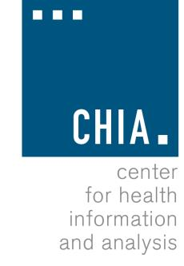Health Information and Analysis Oversight Council
Administration & Finance Committee

Executive Office for Administration and Finance State House, Room 373, Boston, MA September 13, 2016 9:00 AM

Approval of Prior Meeting Minutes (VOTE) Discussion of CHIA’s FY17 Spending Plan

