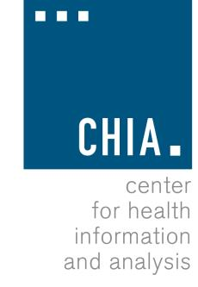
Health Information and Analysis Oversight Council
Administration & Finance Committee

Executive Office for Administration and Finance State House, Room 373, Boston, MA
September 11, 2017 11:00 AM

MEETING NOTICE AND AGENDA

- Approval of Prior Meeting Minutes
- Fiscal Year 2018 Update

