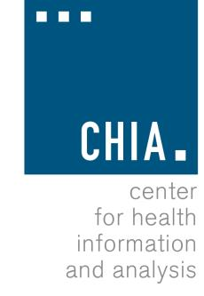
Health Information and Analysis Oversight Council
Administration & Finance Committee

Executive Office for Administration and Finance State House, Room 373, Boston, MA
February 27, 2018 9:30 AM

MEETING NOTICE AND AGENDA

- Approval of Prior Meeting Minutes (VOTE)
- November 15, 2017
- September 11, 2017
- Update on Fiscal Year 2018 Budget
- Planning for Fiscal Year 2019

