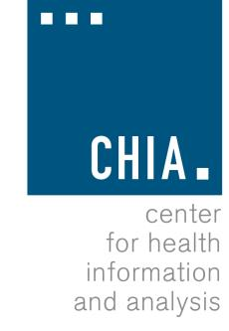
Health Information and Analysis Oversight Council

Center for Health Information and Analysis
501 Boylston Street, Suite 5100, Boston, MA October 4, 2018, 2:30 – 4:30 PM

MEETING NOTICE AND AGENDA

Anticipated topics include:

- Approval of Prior Meeting Minutes

- CHIA’s Annual Report

- Prescription Drug Report

- Transparency Initiatves

- APCD Procurement

- Data Science Institute

