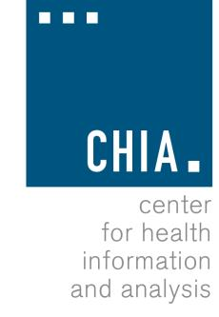
Health Information and Analysis Oversight Council

Center for Health Information and Analysis
501 Boylston Street, Suite 5100, Boston, MA
June 28, 2018 9:30-11:30 AM

MEETING NOTICE AND AGENDA

- Approval of Prior Meeting Minutes

- Finance Committee Update

- Discussion Item – CHIA's Transparency Agenda

- Discussion Item – House Health Care Bill

