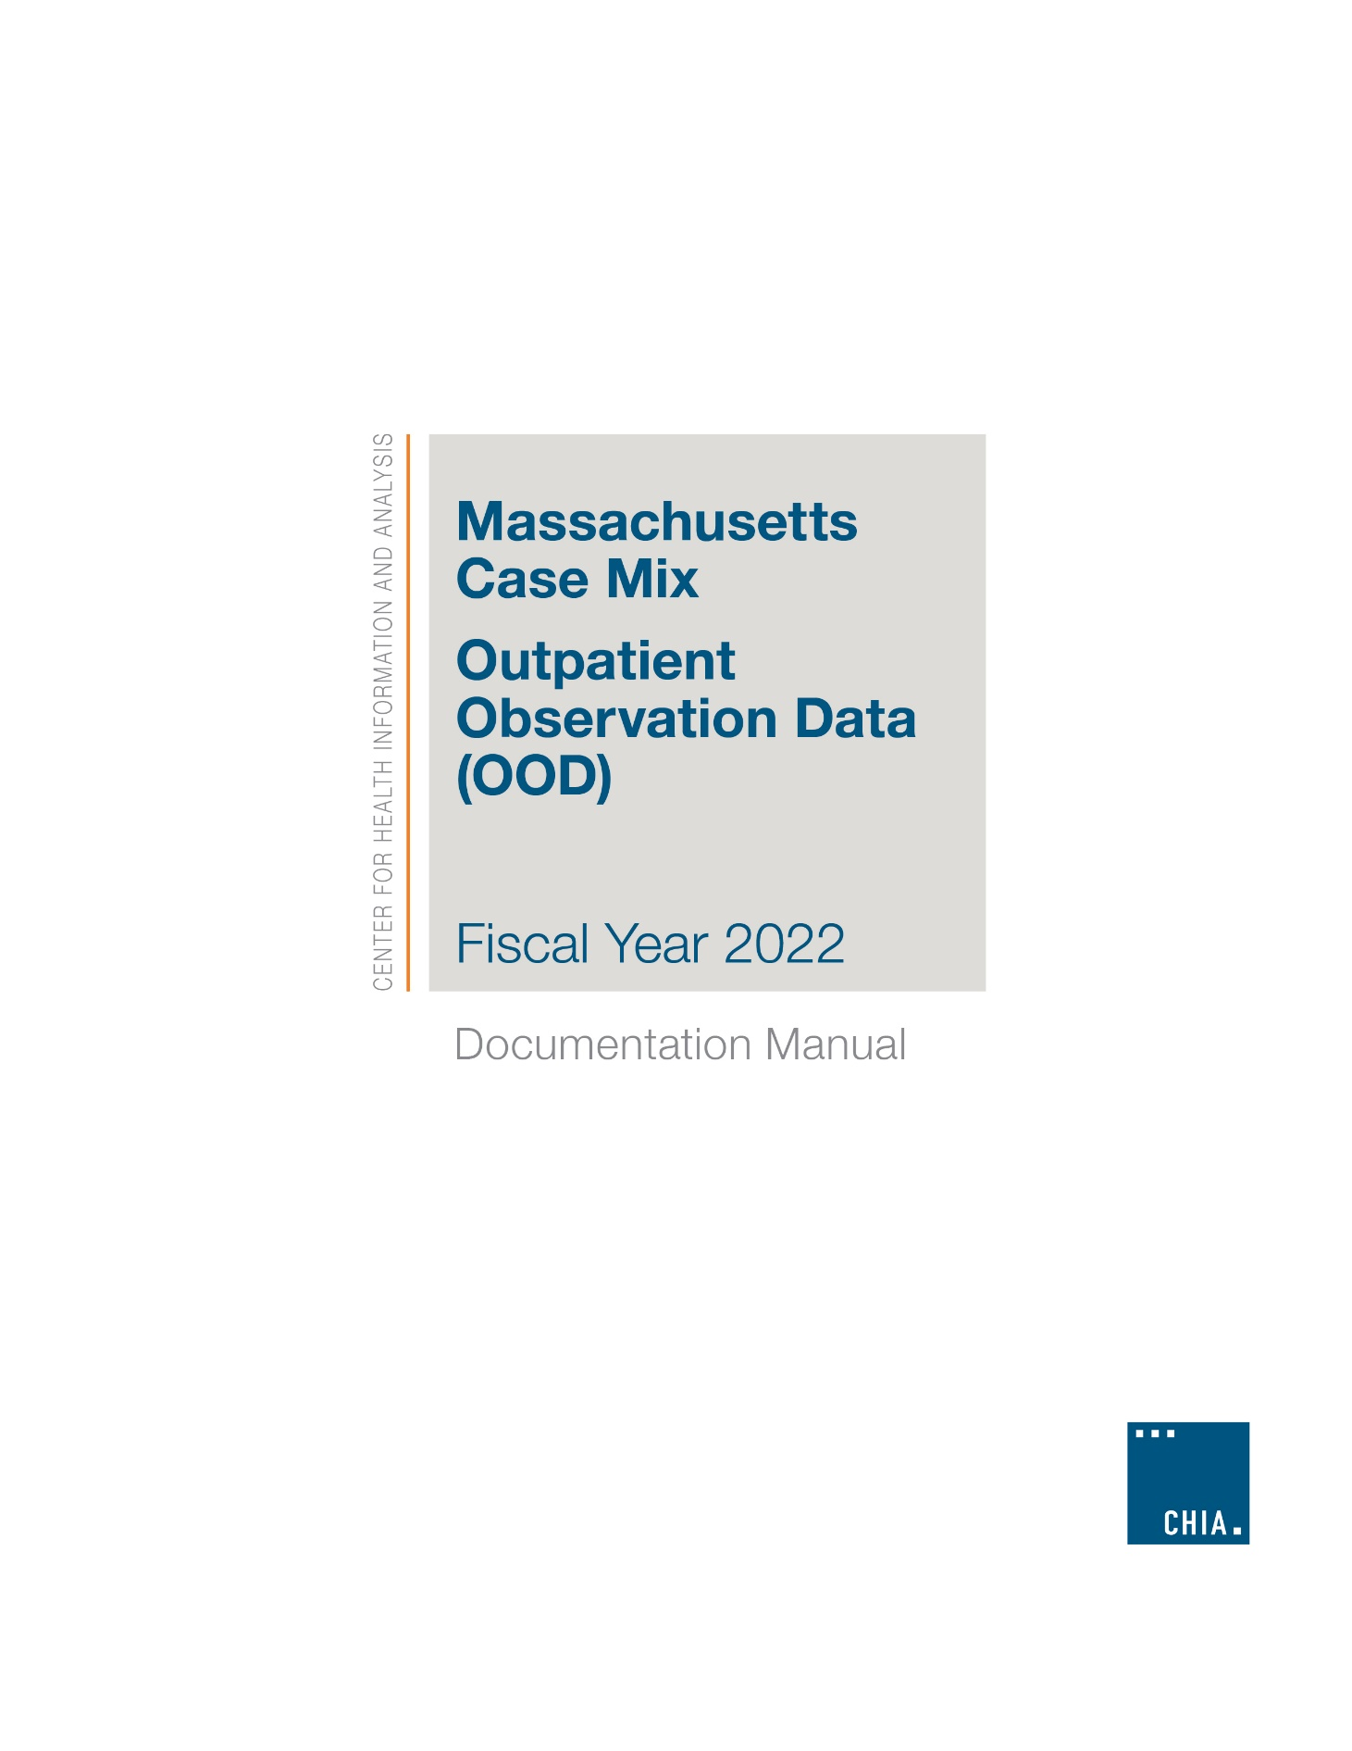
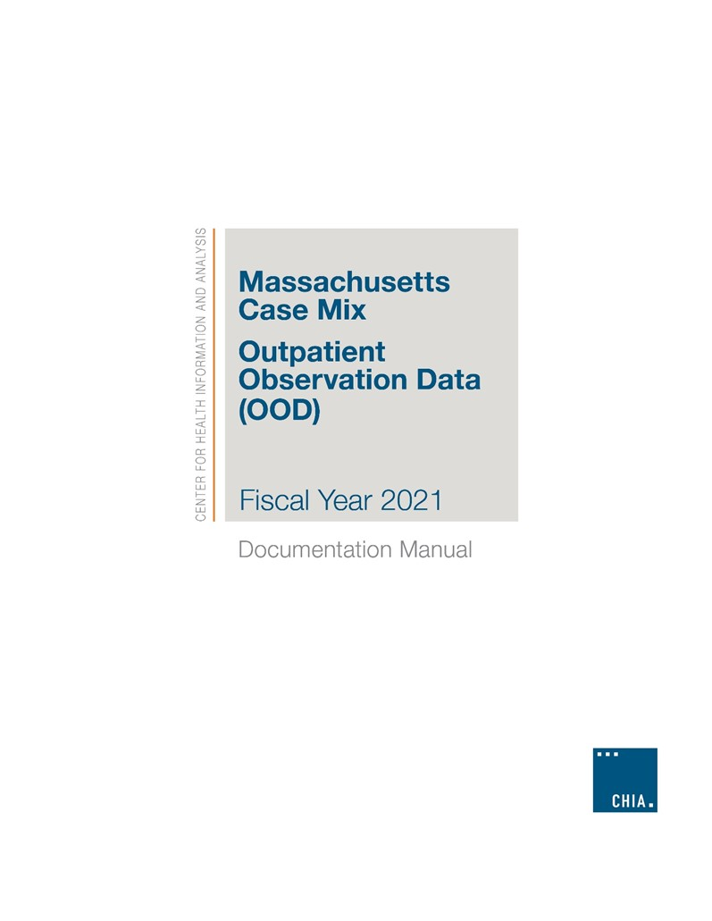
2022

Massachusetts Case Mix
FY 2022 Outpatient Observation Data

USER GUIDE

Table of Contents

Executive Summary 3
Part A. Data Collection 4
Part B: Applying for and Using CHIA Data 7
Part C: Data Elements 9
Part D. Data Notes 48
Part E. Frequently Asked Questions 49

Executive Summary
Each quarter, Massachusetts facilities provide to the Center for Health Information and Analysis (CHIA) data collected from outpatient observation units about patient stays that did not end in an inpatient admission. Data on observation stay patients who were admitted to the same acute inpatient facility at which their observation stay occurred can be found in the FY 2022 Hospital Inpatient Discharge Database (HIDD). The FY 2022 Outpatient Observation Database (OOD) includes observation stays that occurred between October 1, 2021 and September 30, 2022. Facilities reported a total of 187,099 stays.

The FY 2022 OOD Guide provides general information about CHIA’s most recent outpatient observation data holdings. This information includes high level data notes (data collection, data application, use and FAQs) and a codebook (data element, data dictionary, reference tables, and summary statistics).

Part A. Data Collection
Select facilities in Massachusetts are required to submit outpatient observation stay data to CHIA under regulation 957 CMR 8.00 - APCD and Case Mix Data Submission. Researchers can access OOD regulations by visiting CHIA’s web site at http://www.chiamass.gov/regulations.

957 CMR 8.00 - APCD and Case Mix Data Submission requires acute care hospitals to submit inpatient discharge data to
CHIA 75 days after each quarter. The quarterly reporting intervals for the FY 2022 OOD are as follows:
- Quarter 1: October 1, 2021 – December 31, 2021
- Quarter 2: January 1, 2022 – March 31, 2022
- Quarter 3: April 1, 2022 – June 30, 2022
- Quarter 4: July 1, 2022 – September 30, 2022

CHIA reviews each facility’s quarterly data for compliance with 957 CMR 8.00 - APCD and Case Mix Data Submission using a one percent error rate. The one percent error rate is based upon the presence of one or more errors per stay for the facility’s quarterly submission. CHIA checks for valid codes, correct formatting, and presence of the required data elements. If one percent or more of the stays are rejected, CHIA rejects the entire submission.
Each facility receives a quarterly error report displaying invalid stay information. Quarterly data that does not meet the one percent compliance standard must be resubmitted by the reporting facility until the standard is met.
Data Sources
Any stay for which the patient was admitted to observation, but which did not result in an inpatient admission of the patient at the reporting hospital, is included in the FY 2022 OOD. Observation services may include monitoring, assessment, and short term treatment before determining whether a patient requires further hospital inpatient treatment or step down monitoring of a patient discharged from inpatient care. An observation stay may occur even if the only service provided is the short term use of a bed to a registered patient for triage or screening. Observation services are further defined in the Hospital Uniform Reporting Manual (HURM), Chapter III, § 3241.
Observation Stays Originating from Emergency Department Visits
FY 2022 outpatient Emergency Department (ED) visits which result in an observation stay at the reporting hospital are not included in the reporting hospital’s FY 2022 ED visit data. Observation stays that began in the reporting hospital’s ED now report in the OOD stay record, the patient’s ED registration and discharge date and times associated with the observation stay which originated from an ED visit. While the source of admission codes and ED Flag fields are also used to indicate observation stays originating from an ED Visit, there has been more consistency and completeness in the reporting of the ED registration and ED discharge fields for such stays.

Based on the records reporting ED registration/discharge dates (n=162,004) and records which indicated inside hospital ED as the source but omitted ED registration information (n=57), a high proportion of observation stays originate from ED visits. As shown in Figure 1 below, 86.6% (n = 162,061) of all FY 2022 observation stays (n=187,099) originated in the reporting hospital’s ED.
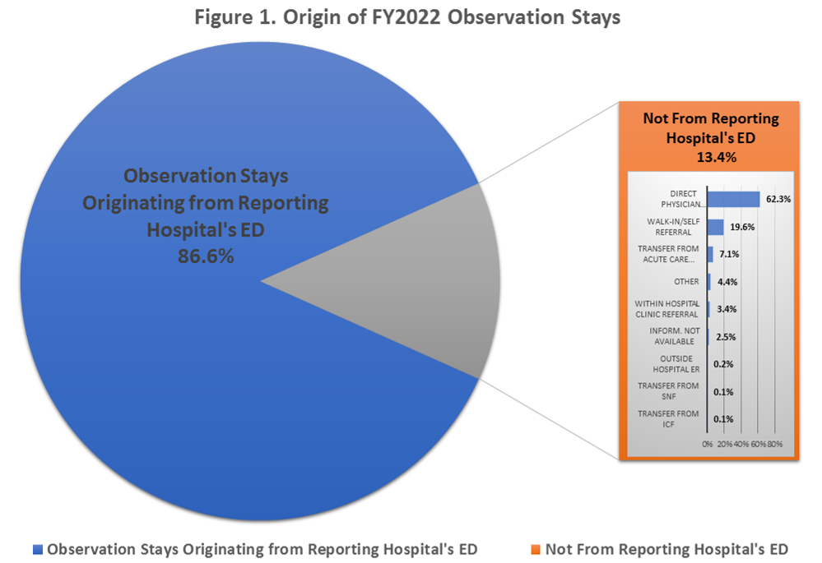
Observation Stays Resulting in Inpatient Admissions
If the patient was admitted to inpatient care, observation services were reported as inpatient observation services and included in the reporting hospital’s inpatient discharge data (HIDD) and not in the FY 2022 OOD. Data users interested in observation stays that result in an inpatient admission should use the FY 2022 HIDD. The HIDD database has an “Observation Indicator” flag which identifies admissions that include an observation stay. Their ED Registration and Discharge Dates and Time are also included in the HIDD database.
OOD Verification Report Process
CHIA sends each facility a report with their observation stay data to maintain and improve the quality of their data submissions. The Verification Report process gives the facilities the opportunity to review the data they have provided to CHIA and affirm data accuracy and completeness.

CHIA produces facility specific Verification Reports at year-end. CHIA asks each facility to review and verify the data contained within the report. Each Verification Report has a series of frequency tables for selected data elements that include, but are not limited to, the number of stays per month and breakouts by admission type, admission source, patient race, and patient disposition.
Facilities must affirm that reported data was accurate or identify any discrepancies. Facilities certify the accuracy and completeness of their data by completing a Verification Report Response form. CHIA accepts two response types from facilities:

A: A facility indicates its agreement that the data appearing on the Verification Report is accurate and that it represents the facility’s case mix profile.
B: A facility indicates that the data on the report is accurate except for the discrepancies noted. If any data discrepancies exist, CHIA requests that facilities provide written explanations of the discrepancies.

Users interested in the FY 2022 OOD Verification Reports should contact CHIA at casemix.data@chiamass.gov. Please indicate the fiscal year of the Verification Report, the dataset name, and if the information is needed for a specific facility or set of facilities.

Part B: Applying for and Using CHIA Data
Researchers interested in receiving approval to access CHIA data should follow the instructions below to apply for the data. Due to the custom nature of each data request, limited information covering all data uses is provided. Data applicants needing additional assistance applying for data or using the data should contact CHIA at casemix.data@chiamass.gov.
How to Apply for the Data
- To obtain a copy of the Application Form, Data Use Agreement, Data Management Plan and/or other documents required for application, go to: http://www.chiamass.gov/chia-data/

- Follow the links to the forms that correspond to the data (Case Mix, MA APCD) and application type (Government, Non-Government) that are appropriate to the data request.

- Information on the Hospital Case Mix and Charge Data Fee Schedule is available at the following link: https://www.chiamass.gov/assets/docs/g/chia-ab/1705.pdf

- All application documents must be submitted to CHIA and are managed through IRBNet.org. Instructions for submitting application materials through IRBNet are available on the following link: https://www.chiamass.gov/assets/Uploads/data-apps/Application-Submission-IRBNet-Tutorial.pdf

- Non-Government applicants can request approval to use a pre-configured Limited Data Set (LDS), designed to protect patient data confidentiality while ensuring analytic utility. This streamlined dataset also improves CHIA’s ability to deliver the data efficiently.

- The data contained in Case Mix databases include personal information and Protected Health Information, the release of which is restricted by state and federal laws and regulations. The application process has been designed to help applicants prepare applications that will allow for the release of data while protecting patient privacy. For this reason, applicants should familiarize themselves with CHIA’s APCD and Case Mix Data Release Regulation (957 CMR 5.00) and the forms and other background information referenced above.
Securing CHIA Data Prior to Use
Approved data recipients or agents are obliged by the application and confidentiality agreement to secure the data in a manner that protects the confidentiality of the records and complies fully with the terms of CHIA’s Data Use Agreement. All data obtained from CHIA must reside on an encrypted hard drive and/or secure network.
Data Delivery
CHIA delivers OOD electronically via Secure File Transfer Protocol (SFTP). Users must also be able to read and download the data files to their back office.
Hardware Requirements:
Encrypted Hard Drive with 2.0 GB of space available.

Data Use
The FY 2022 Case Mix OOD consists of ASCII text files (.txt), Microsoft Access Database files (.mdb) or SAS files (.sas7bdat). Each file name will have a suffix of “_Full” or “_Full_AAAA.” Full indicates a full year or final release. AAAA indicates whether the data is from an LDS or Government dataset.
- The main FIPA_OOD_2022_Observation (table name: Observation), contains one record per observation stay.
- FIPA_OOD_2022_Organization (table name: Organization) contains one record per organization reported. This table is the look-up table for hospitals and transfer destination organization identifiers. This table can be used to lookup all facility names and hospital teaching status.
- FIPA_OOD_2022_SubmissionLog (table name: SubmissionLog) contains one record per quarter for each of the observation facilities filing data.
- FIPA_OOD_2022_ErrorLog (table name: ErrorLog) contains records by quarter and by fiscal year for the number of records passed and failed and the reason for fail by IdOrgFiler.
Linking Files
Historically, case mix data users receive a Microsoft Access version of the data. Many users import the data into SQL, STATA™, SPSS™, SAS™, or R for analysis or data management. Organization Ids should be used to link facility data.

Part C: Data Elements
The following section should provide the user with an explanation of some of the data. For more information about specific data elements, facility reporting thresholds, or other questions, please contact CHIA at casemix.data@chiamass.gov.
About the Limited Data Set (LDS)
The pre-configured Limited Data Set (LDS) is designed to protect patient data confidentiality while ensuring analytic utility. All approved data applicants receive the “core” data elements. Data applicants seeking approval to add to the “core” elements must indicate this by selecting from the list of “buy-ups.” An applicant could use the “Buy-up” process to receive more granular data. For example, the user can request a “buy-up” to a 5-digit patient ZIP code instead of a 3 digit patient ZIP code. CHIA must review buy-up requests and may approve the request based on the project description. CHIA makes an additional set of core elements available only to government data applicants. Government data applicants must specifically identify requested Government-Only elements in their application and provide justification for their request.
Master Data Elements List
For the FY 2022 OOD, CHIA provides a master data elements list by table. Not every approved data applicant has access to every data element – some are reserved for limited dataset buy-ups or for government use. All approved data applicants have access to the “CORE” data. Data applicants who choose limited dataset buy-ups may have access to some “LDS” elements. Only government data applicants may request the “GOV” fields. Data applicants interested in purchasing the data should visit the CHIA website for instructions.

 | OBSERVATION TABLE-CORE ELEMENTS
AgeLDS | IdOrgSite | Secondary PayerType
AssocConditionPresentCode1-10 | IdOrgTransfer | SecondarySourceOfPayment
AssociatedDiagnosisCode1-15 | LengthOfStayHours | SecondarySourceOfVisit
AssociatedProcedureCode1-3 | NewbornAgeWeeks | SexLDS
Charges | OtherCareGiver | SourceOfVisit
CPTCode1-10 | PermanentPatientCountryLDS | SubmissionControlID
DepartureStatus | PermanentPatientStateLDS | SubmissionQuarter
DaysBetweenObsStays | PermanentPatientZIP3CodeLDS | SubmissionYear
ED_Flag | PrimaryPayerType | TemporaryPatientStateLDS
HispanicIndicator | PrimarySourceOfPayment | TemporaryPatientZIP3CodeLDS
HomelessIndicator | PrincipalConditionPresent | TypeOfVisitObs
ICDIndicator | PrincipalDiagnosisCode | VisitPassed
IdOrgFiler | PrincipalProcedureCode | NumberOfHoursInED
IDOrgHosp | RecordType01ID

 | OBSERVATION TABLE-LDS ELEMENTS
AssociatedProcedureCode1Date-3Date | LegacyCHIAPatientUHIN | PrincipalProcedureCodeYYYYMM
AssociatedProcedureCode1YYYYMM-YYYYMM | LegacyCHIAPhysicianNumber | Race1
DischargeDate | LegacyCHIAOtherPhysicianNumber | Race2
DischargeMonth | ObservationSequence | RegistrationDate
DischargeYear | OtherPhysicianNumber | RegistrationMonth
EmergencyDepartmentRegistrationDate | PermanentPatientCityLDS | RegistrationYear
Ethnicity1 | PermanentPatientZIP5CodeLDS | SurgeonAssociatedProcedure1-3
Ethnicity2 | PhysicianNumber | TemporaryPatientCityLDS
LegacyCHIAMothersUHIN | PrincipalProcedureCodeDate | TemporaryPatientZip5CodeLDS

OBSERVATION TABLE-GOVERNMENT-ONLY ELEMENTS
EmergencyDepartmentDischargeHour | EmergencyDepartmentRegistrationTime | OtherRace
EmergencyDepartmentDischargeMinute | HospitalBillNumber | PatientBirthDate
EmergencyDepartmentDischargeTime | MedicaidMemberID | RegistrationTime
EmergencyDepartmentRegistrationHour | MedicalRecordNumber
EmergencyDepartmentRegistrationMinute | OtherEthnicity

 | SUBMISSION TABLE
Active | OrgName | SubmissionControlID
IdOrgFiler | Passed | TotalCharges
NumberofObservations | Quarter | Year

 | ERROR LOG TABLE
ErrorCategory | NumberofErrors | SubmissionActive
ErrorDescription | NumberofObservations | SubmissionControlID
ErrorLogKey | NumberofObservationsFailed | SubmissionQuarter
FieldName | NumberofObservationsPassed | SubmissionPassed
IdOrgFiler | OrgName | SubmissionYear

 | ORGANIZATION TABLE
City | OrganizationNumber | State
DateInactive | OrganizationTypeID | Type
GroupName | OrgID
OrganizationGroupID | OrgName

Organization of the Diagnosis and Procedure Codes
For FY 2022 OOD, CHIA organizes the procedure (CPT-4 or ICD-10-PCS) and diagnosis (ICD-10-CM) fields into one main OOD table. See Figure 2 below. Diagnoses and procedures are ordered as submitted to CHIA. CHIA does not require the order of diagnoses and procedures to be medically relevant. CHIA does not affirm or confirm the medical relevancy of the principal diagnosis, procedure, or external cause codes.
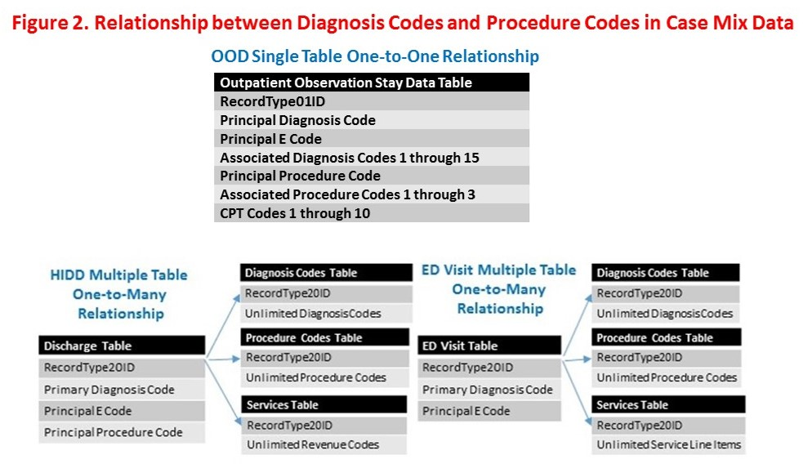

Registration Date, Discharge Date and Observation Time
The Registration Date, Discharge Date and Observation Time reflects the actual date and time that the patient visit began and was discharged from the OOD. Default values, such as 11:59 PM of the day the patient was registered, were unacceptable. Time was reported as military time, and valid values include 0000 through 2359.
ED Registration and Discharge Date and Time Data
If the Observation Stay was due to a transfer from the hospital’s internal Emergency Department, then providers were asked to include the ED registration and discharge dates and times. For F Y2022, release of this data is limited to Government recipients only. Time was reported as military time, and valid values include 0000 through 2359.
Organization Identifiers (OrgID)
FY 2022 OOD contains four organization identifier fields. These fields are a CHIA assigned unique code for each Massachusetts facility:
- Massachusetts Filer Organization ID (IdOrgFiler): The Organization ID for the facility that submitted the observation unit data to CHIA.
- Massachusetts Site Organization ID (IdOrgSite): The Organization ID for the site where the patient received outpatient observation care.
- Massachusetts Hospital Organization ID (IdOrgHosp): The Organization ID for the main hospital affiliation. For example 3108 (Cambridge Health Alliance) is the IdOrgHosp for the IdOrgSite 142 (Everett Hospital).
- Massachusetts Transfer Hospital Organization ID (IdOrgTransfer): The Organization ID for the facility from which a patient is transferred. If the patient is transferred from outside of Massachusetts, the IdOrgTransfer will be 9999999.
Age LDS
If the date of birth and admission date are valid, then CHIA calculated Age LDS in years. The calculation was as follows:
- Age is calculated to be the rounded integer value – of the difference between Date of Birth and Discharge date.
- If Age is valid and < 1 year, then AgeLDS = 0.
- If Age is valid and =>1 year and < 90 years, then AgeLDS = a year between 1 and 89
- If Age is valid and > 89 and <= 115, AgeLDS = 999
- If Age is missing, negative value, or value > 115, then AgeLDS = null
Discretion should be used whenever a questionable age assignment is noted. Researchers are advised to consider other data elements in their analysis of this field.
Data Limitations
The OOD is derived from outpatient observation stay summaries, which can be traced to information gathered upon registration or from information entered by admitting and attending health professionals into the medical record. The quality of the OOD depends on facility data collection policies and coding practices of the medical record staff.
Information may not be entirely consistent from facility to facility due to differences in:
- Collection and verification of patient supplied information before or at admission,
- Update to information following forensic autopsy,
- Medical record coding, consistency, and/or completeness,
- Extent of facility data processing capabilities,
- Flexibility of facility data processing systems,
- Capacity of financial processing system to record late occurring charges on CHIA’s
electronic submission,
- Non-comparability of data collection and reporting.
Historical Data Elements
Users of multiple years of Case Mix data should be careful when merging multiple years of data. To maintain consistency across years, it may be necessary to merge some codes used for specific data elements. For example, keep in mind the transition from ICD-9-CM to ICD-10-CM/PCS which began in FY2015 (October 2015) and the change in race/ethnicity coding rubric which began in FY2007 (October 2007). Users with questions about new data elements or changes in coding from year to year should contact CHIA at casemix.data@chiamass.gov.

Data Dictionary
FY 2022 OOD data dictionary provides metadata for the following attributes:

- Data Element: name as it appears in the file
- Short description: to help users understand what the element contains
- Primary table: the main table (MS ACCESS) or file (SAS) that the data element will appear in
- Linking tables: other tables that contain the data element
- Availability to users: indicates if the data is available to all users (“CORE”), a buy-up (“LDS”), or available only to government (“GOV”)
- Type of Data: describes if the data element is Categorical, Ordinal, Currency, an Identifier, Continuous, Date/Time, or Open Text
- Format: indicates if the data is formatted in a specific fashion
- CHIA derived or calculated: indicates if the field was created by CHIA
- Description: is a longer explanation of the data element and its limitations
- Reference table: indicates if a Categorical data element has set of valid values that are associated with other information
- Summary statistics: links to frequencies or means for that data element

Users of the data with additional questions about any specific data element should contact CHIA at casemix.data@chiamass.gov.

Active
Short Description: | CHIA processing field.
Primary Table: | SubmissionLog
Availability to Users: | CORE
Type of Data: | Categorical
Format: | Varchar
Description: | CHIA indicator of quarterly submission status.

AgeLDS
Short Description: | Age of the patient.
Primary Table: | Observation
Availability to Users: | CORE
Type of Data: | Continuous
Format: | YYY
CHIA Derived: | Yes
Description: | Age of the patient as calculated by CHIA based on the registration date and patient’s birth date. If either field is null, the calculated age will be blank. The calculated age is rounded up to the nearest integer.  Patients younger than 1 year or older than 89 years have their ages grouped. Patients younger than 1 year old are grouped as ‘0’.  Patients older than 89 years are grouped as ‘999’.  Discretion should be used whenever a questionable age assignment is noted. Researchers are advised to consider other data elements in their analysis of this field.

AssocConditionPresentCode1-10
Short Description: | Flags whether the diagnosis was present on admission to Observation unit.
Primary Table: | Observation
Availability to Users: | CORE
Type of Data: | Categorical
CHIA Derived: | No
Description: | A qualifier for each diagnosis code indicating the onset of diagnosis preceded or followed by admission. These flags indicate the onset of a diagnosis preceded or followed by admission. There is a POA indicator for 96% of the diagnosis and external cause codes. There are instances where the diagnosis code is exempt from POA indicator reporting. In some of these instances, instead of using the POA exemption indicator of ‘1’, the data submitter has left the POA indicator blank.

AssociatedDiagnosisCode1-15
Short Description: | ICD-10-CM code for each diagnosis reported by the facility. Up to 15 associated diagnoses in FY 2022.
Primary Table: | Observation
Availability to Users: | CORE
Type of Data: | Categorical
Format: | VARCHAR
Description: | ICD-10-CM Associated Diagnosis.
Reference Table: | Standard ICD-10-CM Diagnosis Codes

AssociatedProcedureCode1-3
Short Description: | ICD-10-PCS codes for each associated significant procedure reported by the facility. Up to 3 ICD-10-PCS procedures in FY 2022.
Primary Table: | Observation
Availability to Users: | CORE
Type of Data: | Categorical
Format: | VARCHAR
Description: | Patient’s significant procedure, as reported in FL 74 of the UB-04. ICD code (exclude decimal point).
Reference Table: | Standard ICD-10-PCS Procedure Codes

AssociatedProcedureCode1Date-3Date
Short Description: | The date on which this procedure was performed
Primary Table: | Observation
Availability to Users: | LDS
Type of Data: | Date
Format: | YYYYMMDD
Description: | Calendar date that 1st non-primary procedure was performed.

AssociatedProcedureCode1YYYYMM-3YYYYMM
Short Description: | Month and Year in which this procedure was performed
Primary Table: | Observation
Availability to Users: | LDS
Type of Data: | Date
Format: | YYMM
Description: | Month and year that 1st non-primary procedure was performed.

Charges
Short Description: | Facility reported costs for a stay.
Primary Table: | Observation
Availability to Users: | CORE
Type of Data: | Currency
Format: | Integer
Description: | This is the grand total of charges associated with the patient’s Observation stay. The total charge amount should be rounded to the nearest dollar. A charge of $0 is not permitted unless the patient has a special Departure Status reported by facility.

City
Short Description: | Municipality in which the Observation unit is located.
Primary Table: | Organization
Availability to Users: | CORE
Format: | Varchar
Type of Data: | Categorical
Description: | City in which Observation facility is located.

CPTCode1-10
Short Description: | CPT Code for each significant procedure reported by the facility. Up to 10  Procedures in FY 2022.
Primary Table: | Observation
Availability to Users: | CORE
Type of Data: | Categorical
Reference Table: | Standard CPT codes

DateInactive
Short Description: | Date in which facility was inactive as an Observation facility.
Primary Table: | Organization
Availability to Users: | CORE
Type of Data: | Date
Format: | YYYMMDD
Description: | Date in which facility was inactive as an Observation facility.

DaysBetweenObsStays
Short Description: | Number of days between Observation stays as calculated by CHIA.
Primary Table: | Observation
Availability to Users: | CORE
Type of Data: | Continuous
Format: | NNN
CHIA derived: | Yes
Description: | Count of calendar days between Observation stays for a unique patient. Patients were identified using their encrypted patient ID (field name PT_ID). The calculation is Date of stay 2 - Date of stay 1.

DepartureStatus
Short Description: | Standardized discharge status.
Primary Table: | Observation
Availability to Users: | CORE
Type of Data: | Categorical
Format: | N
Description: | CHIA defined discharge status as reported by Observation facility. This field identifies the disposition and destination of the patient after discharge from Observation.
Reference Table: | CODE DESCRIPTION  1 Routine  2 Admission to Hospital  3 Transferred  4 Against medical advice (AMA)  5 Expired

DischargeDate
Short Description: | Date of discharge from Observation.
Primary Table: | Observation
Availability to Users: | LDS
Type of Data: | Date
Format: | YYYYMMDD
Description: | Calendar date of discharge from Observation.

DischargeMonth
Short Description: | Month in which patient was discharged from Observation.
Primary Table: | Observation
Availability to Users: | LDS
Type of Data: | Date
Format: | MM
Description: | Month of discharge from Observation. Only two-digit values are valid.

DischargeYear
Short Description: | Year in which patient was discharged from Observation.
Primary Table: | Observation
Availability to Users: | LDS
Type of Data: | Date
Format: | YYYY
Description: | Year of discharge from Observation unit.

ED_Flag
Short Description: | Flag indicating stay began in Emergency Department.
Primary Table: | Observation
Availability to Users: | CORE
Type of Data: | Categorical
Format: | N
Description: | Indicates whether an observation stay began in the Emergency Department.
Reference Table: | CODE DESCRIPTION  0 Not admitted to observation from the emergency department (ED)/no ED visit(s) reflected on this record  1 Not admitted to observation from the emergency department but ED visit(s) reflected in this record  2 Admitted to observation from the emergency department

EmergencyDepartmentRegistrationDate
Short Description: | Date of patient registration to the hospital’s Emergency Department.
Primary Table: | Observation
Availability to Users: | GOV
Type of Data: | Date
Format: | YYYYMMDD
Description: | Calendar date of registration to the ED.

EmergencyDepartmentRegistrationTime
Short Description: | Time of patient registration in the hospital’s Emergency Department.
Primary Table: | Observation
Availability to Users: | GOV
Type of Data: | Time
Format: | HH:MM
Description: | Time at which patient was registered in the emergency department. Hours in military  time (0-24 hours). Only values between 0000 and 2359 are valid.

EmergencyDepartmentDischargeDate
Short Description: | Date of patient discharge from the hospital’s Emergency Department.
Primary Table: | Observation
Availability to Users: | GOV
Type of Data: | Date
Format: | YYYYMMDD
Description: | Calendar date of discharge from the ED.

EmergencyDepartmentDischargeTime
Short Description: | Time of patient discharge from the hospital’s Emergency Department.
Primary Table: | Observation
Availability to Users: | GOV
Type of Data: | Time
Format: | HH:MM
Description: | Time at which patient was discharged from the emergency department. Hours in military time (0-24 hours). Only values between 0000 and 2359 are valid.

ErrorCategory
Short Description: | Indicates the error on a stay record.
Primary Table: | ErrorLog
Availability to Users: | CORE
Type of Data: | Categorical
CHIA Derived: | Yes
Description: | CHIA flag that indicates what the error was on a stay record.. Used for processing.

ErrorDescription
Short Description: | Standardized description of the reported error.
Primary Table: | ErrorLog
Availability to Users: | CORE
Type of Data: | Open Text
Description: | CHIA flag for a reported error in data.. Used for processing.

ErrorLogKey
Short Description: | Unique identifier of each error.
Primary Table: | ErrorLog
Availability to Users: | CORE
Type of Data: | Identifier
Description: | Unique identifier of each error.

Ethnicity1, Ethnicity2
Short Description: | Standardized, facility reported ethnicity.
Primary Table: | Observation
Availability to Users: | LDS
Type of Data: | Categorical
CHIA Derived: | No
Description: | OOD includes two main fields to report Ethnicity: Ethnicity 1 and Ethnicity 2.  The ethnicity codes are based on the CDC Race and Ethnicity Code Set:  https://www.cdc.gov/nchs/data/dvs/Race_Ethnicity_CodeSet.pdf
Reference Table: | CODE DESCRIPTION  AMERCN American  BRAZIL Brazilian  CVERDN Cape Verdean  CARIBI Caribbean Island  PORTUG Portuguese  RUSSIA Russian  EASTEU Eastern European  OTHER Other Ethnicity  UNKNOW Unknown/Not Specified

FieldName
Short Description: | Name of the data element that caused the error.
Primary Table: | ErrorLog
Availability to Users: | CORE
Type of Data: | Open Text
Description: | Name of the data element that caused the error. Used for processing.

GroupName
Short Description: | Name of the system running the Observation unit.
Primary Table: | Organization
Availability to Users: | CORE
Type of Data: | Open Text
Description: | System that runs or owns the Observation facility.

HispanicIndicator
Short Description: | Indicates whether patient was Hispanic.
Primary Table: | Observation
Availability to Users: | CORE
Type of Data: | Categorical
Description: | A flag for patients of Hispanic/Latino/Spanish culture or origin regardless of race.
Reference Table: | CODE DESCRIPTION  Y Patient is Hispanic/Latino/Spanish.  N Patient is not Hispanic/Latino/Spanish.

HomelessIndicator
Short Description: | Indicates whether the patient was homeless.
Primary Table: | Observation
Availability to Users: | CORE
Type of Data: | Categorical
Description: | This flag indicates that the patient was homeless at the time of stay. Data users studying homelessness are advised to also review the ICD-10-CM diagnosis codes. There are instances when diagnosis code Z59.0 (homelessness) is reported in the case mix data and the homeless indicator is not reported.
Reference Table: | CODE DESCRIPTION  Y Patient is known to be homeless.  N Patient is not known to be homeless.

HospitalBillNumber
Short Description: | Unique patient billing record.
Primary Table: | Observation
Availability to Users: | GOV
Type of Data: | Identifier
Format: | Varchar
Description: | Facility unique number associated with all billing for the stay.

ICDIndicator
Short Description: | ICD version
Primary Table: | Observation
Availability to Users: | CORE
Type of Data: | Categorical
Description: | Indicator for 10-CM/PCS diagnoses, external cause codes, and procedure codes
Reference Table: | CODE DESCRIPTION  0 ICD-10-CM/PCS Code

IdOrgFiler
Short Description: | ID number of the facility that submitted Observation claims.
Primary Table: | Observation
Linking Tables: | SubmissionLog  ErrorLog
Availability to Users: | CORE
Type of Data: | Categorical
Description: | The Organization ID for the facility that submitted the Observation stay data to  CHIA.
Reference Table: | Table 3

IDOrgHosp
Short Description: | Facility identifier.
Primary Table: | Observation
Availability to Users: | CORE
Type of Data: | Categorical
Description: | The Organization ID for the main facility affiliation.
Reference Table: | Table 3

IdOrgSite
Short Description: | Facility identifier.
Primary Table: | Observation
Availability to Users: | CORE
Type of Data: | Categorical
Description: | The Organization ID for the site where the patient received Observation care.
Reference Table: | Table 3
IdOrgTransfer
Short Description: | Indicates where patient was transferred from.
Primary Table: | Observation
Availability to Users: | CORE
Type of Data: | Categorical
Description: | Organization ID for the facility from which a patient is transferred. If the patient was transferred from outside of Massachusetts, the IdOrgTransfer will be  9999999.
Reference Table: | Table 3

LegacyCHIAMothersUHIN
Short Description: | Patient's mother's unique id.
Primary Table: | Observation
Availability to Users: | LDS
Type of Data: | Identifier
Format: | VARCHAR
Length: | 9
CHIA Derived: | Yes
Description: | CHIA generated unique identifier of a newborn's mother. For newborns or for infants less than 1 year old, CHIA derives a unique ID for the patient’s mother. This unique ID allows a newborn visit to be associated with a Mother’s visit. Linkable across records and fiscal years. Each patient is given by CHIA a Unique Health Information Number (UHIN), which is a surrogate key that can link patients over time and across facilities. The data element is blank, a single dash (-) appears in the UHIN field. It is valid for facilities to report that the unique patient identifier is unknown. In these cases, the UHIN appears as ‘000000001’. The utility of the UHIN field is dependent on the reporting data. For a small number of facilities, little or no UHIN data exists,  as these institutions failed to report patients’ uniquely identified information. Other facilities reported the same data repeatedly, resulting in numerous admissions for one UHIN. In other cases, the demographic information (age, sex, etc.) was not consistent when a match did exist with the UHIN. Some explanations for this include assignment of a mother’s unique identifier to her infant or assignment of a spouse’s  unique identifier to a patient. Invalid data uses the code UHIN=‘ --------4’

LegacyCHIAPatientUHIN
Short Description: | Patient's unique id.
Primary Table: | Observation
Availability to Users: | LDS
Type of Data: | Identifier
Format: | VARCHAR
Length: | 9
CHIA Derived: | No
Description: | CHIA generated unique identifier of the patient. Linkable across records and fiscal years. Each patient is given by CHIA a Unique Health Information Number (UHIN), which is a surrogate key that can link patients over time and across facilities. The data element is blank, a single dash (-) appears in the UHIN field. It is valid for facilities to report that the unique patient identifier in unknown. In these cases, the UHIN appears as ‘000000001’. The utility of the UHIN field is dependent on the reporting data. For a small number of facilities, little or no UHIN data exists, as these institutions failed to report patients’ uniquely identified information. Other facilities reported the same data repeatedly, resulting in numerous admissions for one UHIN. In other cases, the demographic information (age, sex, etc.) was not consistent when a match did exist with the UHIN. Some explanations for this include assignment of a mother’s unique identifier for her infant or assignment of a spouse’s unique identifier to a patient. Invalid data uses the code UHIN=‘--------4’.

LegacyCHIAPhysicanNumber
Short Description: | Unique identifier of the attending physician.
Primary Table: | Observation
Availability to Users: | LDS
Type of Data: | Identifier
Description: | Identifier for the Observation Physician who provided services related to this stay. Report if the physician’s involvement in the patient’s Observation stay  was captured in the facility’s electronic information systems.

LegacyCHIAOtherPhysicanNumber
Short Description: | Unique identifier of a non-attending physician.
Primary Table: | Observation
Availability to Users: | LDS
Type of Data: | Identifier
Description: | Identifier for physician other than the Observation Physician who provided services related to this stay. Report if the physician’s involvement in the patient’s Observation stay was captured in the facility’s electronic information systems.

LengthOfStayHours
Short Description: | Count of hours spent in the Observation unit.
Primary Table: | Observation
Availability to Users: | CORE
Type of Data: | Continuous
Format: | NNN
CHIA Derived: | Yes
Description: | Count of hours between the registration and discharge time for an Observation stay.

MedicaidMemberID
Short Description: | Patient's MassHealth unique ID.
Primary Table: | Observation
Availability to Users: | GOV
Type of Data: | Identifier
Description: | Unique MassHealth Identifier of a patient.

MedicalRecordNumber
Short Description: | Stay identifier assigned by the facility.
Primary Table: | Observation
Availability to Users: | GOV
Type of Data: | Identifier
Description: | The unique number assigned to each patient within the hospital that distinguishes the patient and the patient’s hospital record(s) from all others in that institution.

NewbornAgeWeeks
Short Description: | Age of children younger than age 1. Valid values are 1-52.
Primary Table: | Visit
Availability to Users: | CORE
Type of Data: | Continuous
Format: | NN
CHIA Derived: | Yes
Description: | Age in weeks for children younger than 53 weeks of age who were admitted for Observation. Weeks are calculated from the Admitting Date - the DOB, and then rounded to the nearest week. Only values between 0 and 52 are valid. All other values are invalid.

NumberOfErrors
Short Description: | Count of errors in submission from Observation.
Primary Table: | ErrorLog
Availability to Users: | CORE
Type of Data: | Continuous
Description: | CHIA processing field.

NumberOfObservations
Short Description: | Count of Observation stay records for a facility in a quarter.
Primary Table: | SubmissionLog
Linking Table: | ErrorLog
Availability to Users: | CORE
Type of Data: | Continuous
Description: | Total number of registered observation stays occurring during the reporting period.

NumberOfObservationsFailed
Short Description: | Count of Observation stay records that failed CHIA intake.
Primary Table: | ErrorLog
Availability to Users: | CORE
Type of Data: | Continuous
Description: | Count of observation stay records that failed CHIA intake.

NumberOfObservationsPassed
Short Description: | Count of observation stay records that passed CHIA intake.
Primary Table: | ErrorLog
Availability to Users: | CORE
Type of Data: | Continuous
Description: | Count of observation stay records that passed CHIA intake.

ObservationSequence
Short Description: | Order in which observation stays occurred for a patient.
Primary Table: | Observation
Availability to Users: | LDS
Type of Data: | Continuous
CHIA Derived: | Yes
Description: | Numeric order of observation stays in Massachusetts for a patient based on the patient’s social security number.

OrganizationGroupID
Short Description: | Code indicating the system that runs the Observation unit.
Primary Table: | Organization
Availability to Users: | CORE
Type of Data: | Categorical
Description: | Code indicating the system that runs the Observation unit.
Reference Table: | Table 3

OrganizationNumber
Short Description: | ORGID of the facility that owns the Observation unit.
Primary Table: | Organization
Availability to Users: | CORE
Type of Data: | Categorical
Description: | Identifier of the facility that owns the Observation unit.
Reference Table: | Table 3

OrganizationTypeID
Short Description: | Analogue to all the organization identifiers.
Primary Table: | Organization
Availability to Users: | CORE
Type of Data: | Categorical
Description: | Organization ID that can be linked to all “IdOrg” fields.
Reference Table: | Table 3

OrgID
Short Description: | Facility identifier.
Primary Table: | Organization
Availability to Users: | CORE
Type of Data: | Open Text
Description: | CHIA assigned identifier for a facility.
Reference Table: | Table 3

OrgName
Short Description: | Name of Observation facility.
Primary Table: | Organization
Linking Tables: | SubmissionLog  ErrorLog
Availability to Users: | CORE
Type of Data: | Open Text
Description: | Facility name.

OtherCareGiver
Short Description: | Indicates if the patient had a caregiver.
Primary Table: | Observation
Availability to Users: | CORE
Type of Data: | Categorical
Description: | Indicates the type of primary caregiver responsible for the patient’s care other than the attending physician, operating room physician, or nurse midwife as specified in the Regulation. Other caregiver codes include resident, intern, nurse practitioner, and physician assistant.
Reference Table: | CODE DESCRIPTION  1 Resident  2 Intern  3 Nurse Practitioner  4 Not Used  5 Physician Assistant

OtherEthnicity
Short Description: | Non-standard patient ethnicity designation.
Primary Table: | Observation
Availability to Users: | GOV
Type of Data: | Open Text
Description: | Patient’s ethnicity as entered by the facility. Other ethnicity is an open text field for reporting any additional ethnicities when Ethnicity 1 or Ethnicity 2 equals “OTHER-Other Ethnicity”.

OtherPhysicianNumber
Short Description: | Unique identifier of a non-attending physician.
Primary Table: | Observation
Availability to Users: | LDS
Type of Data: | Identifier
Description: | Physician’s state license number (BORIM #) for physician other than the Observation Physician who provided services related to the stay. Report if the physician’s involvement in the patient’s Observation stay was captured in the facility’s electronic information systems. If BORIM is unable, then must be “DENSG”, “PODTR”, “OTHER”, “NURSEP”, “PHYAST” or “MIDWIF”.

OtherRace
Short Description: | Non-standard patient race designation.
Primary Table: | Observation
Availability to Users: | GOV
Type of Data: | Open Text
Description: | Patient’s Race as entered by the facility. Other Race is an open text field for reporting additional races when Race 1 or Race 2 equals “R9 -Other Race”.

Passed
Short Description: | CHIA processing field.
Primary Table: | SubmissionLog
Availability to Users: | CORE
Type of Data: | Continuous
Description: | Count of observation stay records that passed CHIA processing.

PatientBirthDate
Short Description: | Patient date of birth.
Primary Table: | Observation
Availability to Users: | GOV
Type of Data: | Date
Format: | YYYYMMDD
Description: | Calendar date of patient's birth.

PermanentPatientCityLDS
Short Description: | Permanent city of residence for the patient.
Primary Table: | Observation
Availability to Users: | LDS
Type of Data: | Categorical
Description: | Primary city of residency for patient.

PermanentPatientCountryLDS
Short Description: | Permanent country of residence for the patient.
Primary Table: | Observation
Availability to Users: | CORE
Type of Data: | Categorical
Description: | Primary country of residency for patient. The LDS populates PermanentPatientCountryLDS for only the countries of US, CA and MX which covers 99% of the records. The other country values for 1% of the records are suppressed.

PermanentPatientStateLDS
Short Description: | Permanent state of residence for the patient.
Primary Table: | Observation
Availability to Users: | CORE
Type of Data: | Categorical
Description: | Primary state of residency for patient. Only values in the reference table are valid. While patients from all states have received observation stay care, the LDS populates the PermanentPatientStateLDS field for only the states of MA, NH, RI, CT, ME, VT, and NY which covers 98% of the records. The other state values for 2% of the records are suppressed.

PermanentPatientZIP3CodeLDS
Short Description: | 3-digit ZIP code of the patient's permanent residence.
Primary Table: | Observation
Availability to Users: | CORE
Type of Data: | ZIP code
Format: | NNN
Description: | First three digits of patient's permanent ZIP code. ZIP codes were not standardized and this field was as reported from a nine-digit ZIP code.

PermanentPatientZIP5CodeLDS
Short Description: | 5-digit ZIP code of the patient's permanent residence.
Primary Table: | Observation
Availability to Users: | LDS
Type of Data: | ZIP code
Format: | NNNNN
Description: | First five digits of patient's permanent ZIP code. ZIP codes were not standardized and this field was as reported from a nine-digit ZIP code.

PhysicianNumber
Short Description: | Unique identifier of the attending physician.
Primary Table: | Observation
Availability to Users: | LDS
Type of Data: | Identifier
Description: | Physician’s state license number (BORIM #) for the Observation Physician who provided services related to this stay. Report if the physician’s involvement in the patient’s Observation stay was captured in the facility’s electronic information systems. If BORIM is unable, then must be “DENSG”, “PODTR”, “OTHER”, ”NURSEP”, “PHYAST” or “MIDWIF”.

PrimaryPayerType
Short Description: | Primary payer type for the stay.
Primary Table: | Observation
Availability to Users: | CORE
Type of Data: | Categorical
Description: | Patient’s expected primary payer type for the Observation stay. Report the single character text code indicating the type of payer who has primary responsibility for the payment of the services related to the Observation stay.
Reference Table: | Table 4 and online at CHIA website: Payer Codes (Excel)

PrimarySourceOfPayment
Short Description: | Primary payer for the stay.
Primary Table: | Observation
Availability to Users: | CORE
Type of Data: | Categorical
Description: | Primary payer for the Observation stay.
Reference Table: | Online at CHIA website: Payer Codes (Excel)

PrincipalConditionPresent
Short Description: | Flag indicating that principal condition was present on admission.
Primary Table: | Observation
Availability to Users: | CORE
Type of Data: | Categorical
Description: | Indicates that principal condition was present on admission.
Reference Table: | Table 2

PrincipalDiagnosisCode
Short Description: | ICD-10-CM code for the condition that led to the admission to the Observation unit.
Primary Table: | Observation
Availability to Users: | CORE
Type of Data: | Categorical
Description: | The condition established after study to be chiefly responsible for occasioning the admission of the patient to the observation unit. Facility determined.
Reference Table: | Standard ICD-10-CM Diagnosis Codes

PrincipalProcedureCode
Short Description: | ICD-10-PCS code for the principal procedure in the Observation unit stay.
Primary Table: | Observation
Availability to Users: | CORE
Type of Data: | Categorical
CHIA Derived: | No
Description: | The chief procedure performed in the Observation unit. Facility determined.
Reference Table: | Standard ICD-10-PCS Procedure Codes

PrincipalProcedureCodeDate
Short Description: | Date of the principal Procedure.
Primary Table: | Observation
Availability to Users: | LDS
Type of Data: | Date
Format: | YYYYMMDD
Description: | Calendar date of principal procedure. There are instances when observation stay patients do not have a principal procedure and therefore, the principal procedure code date field is blank. An anomaly in the FY 2022 OOD release is that many of these blank date fields are populated with 19000101. Since no principal procedure is associated with this date, 19000101 can be recoded as NULL.

PrincipalProcedureCodeYYYYMM
Short Description: | Month and Year of the principal procedure.
Primary Table: | Observation
Availability to Users: | LDS
Type of Data: | Date
Primary Table: | Observation
Availability to Users: | CORE
Type of Data: | Categorical
Description: | Indicates that principal condition was present at admission. There are instances when observation stay patients do not have a principal procedure and therefore, the principal procedure code date field is blank. An anomaly in the FY 2022 OOD release is that many of these blank date fields are populated with 190001. Since no principal procedure is associated with this date, 190001 can be recoded as NULL.

Quarter
Short Description: | Quarter of submission.
Primary Table: | SubmissionLog
Availability to Users: | CORE
Type of Data: | Date
Description: | Quarter in which the observation stay was submitted to CHIA.

Race1, Race2
Short Description: | Standardized, facility reported race.
Primary Table: | Observation
Availability to Users: | LDS
Type of Data: | Categorical
Description: | CHIA has adopted federal Office of Management and Budget standard race and ethnicity values that are consistent with CDC standards.
Reference Table: | CODE DESCRIPTION  R1 American Indian/Alaska Native  R2 Asian  R3 Black/African American  R4 Native Hawaiian or other Pacific Islander  R5 White  R9 Other Race  UNKNOW Unknown

RecordType01ID
Short Description: | Stay identifier.
Primary Table: | Observation
Availability to Users: | CORE
Type of Data: | Identifier
Description: | Stay identifier used for CHIA processing.

RegistrationDate
Short Description: | Date of admission to the Observation unit.
Primary Table: | Observation
Availability to Users: | LDS
Type of Data: | Date
Format: | YYYYMMDD
Description: | Calendar date of admission to Observation.

RegistrationMonth
Short Description: | Month of admission to the Observation unit.
Primary Table: | Observation
Availability to Users: | LDS
Type of Data: | Date
Format: | MM
Description: | Month in which the patient was admitted to Observation. Only values between 1 and 12 are valid.

RegistrationTime
Short Description: | Time stamp indicating when the patient was admitted to the Observation unit.
Primary Table: | Observation
Availability to Users: | GOV
Type of Data: | Time
Format: | HH:MM
Description: | Time at which the patient was admitted to Observation. Hours in military  time (0-24 hours). Only values between 0000 and 2359 are valid.

RegistrationYear
Short Description: | Year of admission to the Observation unit.
Primary Table: | Observation
Availability to Users: | LDS
Type of Data: | Date
Format: | YYYY
Description: | Year patient was admitted to Observation. Valid values may be 2021 and 2022.
SecondaryPayerType
Short Description: | Secondary payer for the Observation stay.
Primary Table: | Observation
Availability to Users: | CORE
Type of Data: | Categorical
Description: | Patient’s expected secondary payer type for the Observation stay. Report the single character text code indicating the type of payer who has secondary responsibility for the payment of the services related to the Observation stay.
Reference Table: | Table 4 and online at CHIA website: Payer Codes (Excel)

SecondarySourceOfPayment
Short Description: | Secondary payer for the Observation stay.
Primary Table: | Observation
Availability to Users: | CORE
Type of Data: | Categorical
Description: | Secondary payer for the observation stay.
Reference Table: | Online at CHIA website: Payer Codes (Excel)

SecondarySourceOfVisit
Short Description: | Secondary cause of the Observation stay.
Primary Table: | Observation
Availability to Users: | CORE
Type of Data: | Categorical
Description: | The two sources of stay codes (Source of stay and Secondary Source of stay) which indicate the source originating, referring or transferring the patient to Observation. Please note that the terms “visit” and “stay” are used interchangeably for observation services.
Reference Table: | Table 1

SexLDS
Short Description: | Indicates gender.
Primary Table: | Observation
Availability to Users: | CORE
Type of Data: | Categorical
Description: | Gender flag as assigned by the observation unit.
Reference Table: | CODE DESCRIPTION  M Male  F Female  U Unknown

SourceOfVisit
Short Description: | How a patient reached the Observation unit.
Primary Table: | Observation
Availability to Users: | CORE
Type of Data: | Categorical
CHIA Derived: | No
Description: | The two sources of stay codes (Source of Visit and Secondary Source of Visit) which indicate the source originating, referring or transferring the patient to Observation. Reporting patterns for the Source of Visit data element may vary widely and, as a result, may not be reliable. Please note that the terms “visit” and “stay” are used interchangeably for observation services.
Reference Table: | Table 1

State
Short Description: | Facility state.
Primary Table: | Organization
Availability to Users: | CORE
Type of Data: | Categorical
Description: | State in which reporting facility is located.
Reference Table: | Table 5

SubmissionActive
Short Description: | CHIA processing field.
Primary Table: | ErrorLog
Availability to Users: | CORE
Type of Data: | Identifier
Description: | CHIA flag. Used for processing.

SubmissionControlID
Short Description: | Unique per facility-quarter-submission identifier. Key link from the stay table.
Primary Table: | Observation
Linking Tables: | SubmissionLog  ErrorLog
Availability to Users: | CORE
Type of Data: | Identifier
Description: | Unique id for a facility’s submission of data to CHIA. Usually one Submission Control ID is associated with a facilities’ quarterly submission.

SubmissionPassed
Short Description: | CHIA flag.
Primary Table: | ErrorLog
Availability to Users: | CORE
Type of Data: | Identifier
Description: | Indicates that observation stay data was submitted to CHIA and passed.

SubmissionQuarter
Short Description: | Indicates the quarter (1-4) in which the record was submitted to CHIA.
Primary Table: | Observation
Linking Tables: | ErrorLog
Availability to Users: | CORE
Type of Data: | Categorical
Description: | Quarter in which the observation stay data was submitted to CHIA.

SubmissionYear
Short Description: | Year in which the observation stay data was submitted to CHIA.
Primary Table: | Observation
Linking Tables: | ErrorLog
Availability to Users: | CORE
Type of Data: | Categorical
Description: | Indicates the year (2021-2022) in which the record was submitted to CHIA.

SurgeonAssociatedProcedure1-3
Short Description: | ICD-10-PCS or CPT code for each significant procedure reported by the facility. Up to 3 procedures in FY 2022.
Primary Table: | Observation
Availability to Users: | LDS
Type of Data: | Categorical
Description: | Patient’s significant procedure, as reported in FL 74 of the UB-04. ICD code  (exclude decimal point).
Reference Table: | Standard ICD-10-PCS Procedure Codes

TemporaryPatientCityLDS
Short Description: | Current municipality of patient residence, if different from permanent residence.
Primary Table: | Observation
Availability to Users: | LDS
Type of Data: | Categorical
Description: | MA City in which the patient temporarily resides.

TemporaryPatientStateLDS
Short Description: | Current state of patient residence, if different from permanent residence.
Primary Table: | Observation
Availability to Users: | CORE
Type of Data: | Categorical
Description: | Indicates "MA" if the patient temporarily resides in Massachusetts.

TemporaryPatientZip3CodeLDS
Short Description: | Current 3-digit ZIP code of patient residence, if different from permanent residence.
Primary Table: | Observation
Availability to Users: | CORE
Type of Data: | ZIP code
Format: | NNN
Description: | First three digits of patient's temporary, Massachusetts ZIP code. ZIP codes are not standardized and this field is as reported from a nine-digit ZIP code. The Limited Data Set (LDS) supports selection of 3-character ZIP Code or 5- character ZIP Code for approval by CHIA. Government users may be able to request a 9-character ZIP Code. For LDS users only, if the patient state was not in Massachusetts or a state bordering Massachusetts (Connecticut, Maine, New Hampshire, New York, Rhode Island or Vermont), ZIP codes are set to zeros (0s) and the state is removed.

TemporaryPatientZip5CodeLDS
Short Description: | Current 5-digit ZIP code of patient residence, if different from permanent residence.
Primary Table: | Observation
Availability to Users: | LDS
Type of Data: | ZIP code
Format: | NNNNN
Description: | First five digits of patient's temporary, Massachusetts ZIP code. ZIP codes are not standardized and this field is as reported from a nine-digit ZIP code. The Limited Data Set (LDS) supports selection of 3-character ZIP Code or 5-character ZIP Code for approval by CHIA. Government users may be able to request a 9-character ZIP Code. For LDS users only, if the patient state was not in Massachusetts or a state bordering Massachusetts (Connecticut, Maine, New Hampshire, New York, Rhode Island or Vermont), ZIP codes are set to zeros (0s) and the state is removed.

TotalCharges
Short Description: | Total charges associated with Observation stay(s) in a Facility-Submission-Quarter.
Primary Table: | SubmissionLog
Availability to Users: | CORE
Type of Data: | Currency
Description: | Sum of charges for the submission.

Type
Short Description: | Indicates the type of facility where stay occurred.
Primary Table: | Organization
Availability to Users: | CORE
Type of Data: | Categorical
Description: | Categorizes observation stays by facility type. Curated by CHIA.

TypeOfVisitObs
Short Description: | Indicates the type of stay.
Primary Table: | Observation
Availability to Users: | CORE
Type of Data: | Categorical
Description: | Facilities indicate whether the stay was Emergency, Urgent, Non-Urgent, Newborn, or Unavailable.
Reference Table: | CODE DESCRIPTION  1 Emergency  2 Urgent  3 Elective  4 Newborn  5 Information Not Available
VisitPassed
Short Description: | CHIA flag.
Primary Table: | Observation
Availability to Users: | CORE
Type of Data: | Identifier
Description: | CHIA flag. Used for processing.

Year
Short Description: | Indicates year of submission.
Primary Table: | SubmissionLog
Availability to Users: | CORE
Type of Data: | Categorical
Format: | YY
Description: | Calendar Year the data was submitted.

Longer Reference Tables
FY 2022 OOD has several standard reference tables. These relate to categorical variables driven by the Outpatient Observation Database Submission Guide. Some of the tables have been integrated into the data dictionary. This section contains longer tables used by multiple data elements. Users of the data with additional questions about any specific Reference table should contact CHIA at casemix.data@chiamass.gov.

Table 1. SOURCE OF VISIT
Principal Data Element: | SourceOfVisit
Other Data Elements: | SecondarySourceofVisit
Rules: | All other values are invalid

CODE | DESCRIPTION
0 | Information Not Available
1 | Direct Physician Referral
2 | Within Hospital Clinic Referral
3 | Direct Health Plan Referral/HMO Referral
4 | Transfer from Acute Care Hospital
5 | Transfer from a Skilled Nursing Facility (SNF)
6 | Transfer from Intermediate Care Facility (ICF)
7 | Outside Hospital Emergency Room Transfer
8 | Court/Law Enforcement
9 | Other
F | Transfer from a Hospice Facility
L | Outside Hospital Clinic Referral
M | Walk-In/Self-Referral
R | Inside Hospital ER Transfer
T | Transfer from Another Institution’s Ambulatory Surgery (SDS)
W | Extramural Birth
Y | Within Hospital Ambulatory Surgery Transfer (SDS Transfer)

Table 2. CONDITION PRESENT
Principal Data Element: | Principal ConditionPresent
Rules: | All other values invalid.

CODE | DESCRIPTION
Y | Yes
N | No
U | Unknown
W | Clinically undetermined
1 | Exempt
A | Not applicable

Table 3. ORGANIZATION
Data Elements: | IdOrgFiler  IdOrgHosp  IdOrgSite  IdOrgTransfer  OrgID

Note: The organization table contains information on all organizations submitting data and other organizations transferring patients to organizations. Below is a list of the 68 organizations submitting observation data in FY 2022.
See Part D: Data Notes for additional information on data submitters.

CODE | DESCRIPTION | OBSERVATION STAYS
1 | Anna Jaques Hospital | 2,219
2 | Athol Memorial Hospital | 297
4 | Baystate Medical Center | 11,310
5 | Baystate Franklin Medical Center | 1,776
7 | Berkshire Medical Center - Berkshire Campus | 3,862
8 | Fairview Hospital | 328
10 | Beth Israel Deaconess Medical Center - East Campus | 9,546
16 | Boston Medical Center - Menino Pavilion Campus | 7,850
22 | Brigham and Women's Hospital | 2,463
25 | Signature Healthcare Brockton Hospital | 2,477
27 | Cambridge Health Alliance - Cambridge Hospital Campus | 1,365
39 | Cape Cod Hospital | 3,899
40 | Falmouth Hospital | 1,393
42 | Steward Carney Hospital | 539
46 | Boston Children's Hospital | 8,711
49 | MetroWest Medical Center - Framingham Campus | 2,174
50 | Cooley Dickinson Hospital | 1,381
51 | Dana-Farber Cancer Institute | 41
53 | Beth Israel Deaconess Hospital - Needham | 2,048
57 | Emerson Hospital | 1,709
59 | Brigham and Women's Faulkner Hospital | 1,397
62 | Steward Good Samaritan Medical Center - Brockton Campus | 2,120
68 | Harrington Memorial Hospital | 1,342
71 | HealthAlliance - Leominster Campus | 1,691
73 | Heywood Hospital | 1,468
75 | Steward Holy Family Hospital | 1,456
77 | Holyoke Medical Center | 567
79 | Beth Israel Deaconess Hospital - Plymouth | 6,066
81 | Lahey Hospital & Medical Center, Burlington | 4,736
83 | Lawrence General Hospital | 3,775
85 | Lowell General Hospital | 3,095
88 | Martha's Vineyard Hospital | 517
89 | Massachusetts Eye and Ear Infirmary | 410
91 | Massachusetts General Hospital | 3,611
97 | Milford Regional Medical Center | 3,794
98 | Beth Israel Deaconess Hospital - Milton | 2,571
99 | Morton Hospital, A Steward Family Hospital | 1,135
100 | Mount Auburn Hospital | 3,580
101 | Nantucket Cottage Hospital | 241
103 | New England Baptist Hospital | 34
104 | Tufts Medical Center | 3,668
105 | Newton-Wellesley Hospital | 6,243
106 | Baystate Noble Hospital | 1,568
109 | Lahey Health - Addison Gilbert Hospital | 690
110 | Lahey Health - Beverly Hospital | 3,066
114 | Steward Saint Anne's Hospital | 1,127
115 | Lowell General Hospital – Saints Campus | 1,931
116 | North Shore Medical Center - Salem Campus | 4,632
119 | Mercy Medical Center - Springfield Campus | 3,370
122 | South Shore Hospital | 7,349
123 | Southcoast Hospitals Group - Charlton Memorial Campus | 4,626
124 | Southcoast Hospitals Group - St. Luke's Campus | 7,409
126 | Steward St. Elizabeth's Medical Center | 1,456
127 | Saint Vincent Hospital | 3,218
129 | Sturdy Memorial Hospital | 3,575
130 | UMass Memorial Medical Center - Memorial Campus | 2,752
131 | UMass Memorial Medical Center - University Campus | 7,591
132 | HealthAlliance-Clinton Hospital Campus | 190
133 | Marlborough Hospital | 2,151
138 | Winchester Hospital | 3,030
139 | Baystate Wing Campus | 1,343
141 | Melrose Wakefield Hospital Campus – Melrose Wakefield Healthcare | 2,383
142 | Cambridge Health Alliance - Everett Hospital Campus | 1,369
145 | Southcoast Hospitals Group - Tobey Hospital Campus | 2,051
4448 | Lahey Medical Center, Peabody | 249
6963 | Shriners Hospitals for Children Boston | 30
11466 | Holy Family Hospital at Merrimack Valley, A Steward Family Hospital | 436
11467 | Nashoba Valley Medical Center, A Steward Family Hospital | 602

Table 4. PAYER TYPE
Principal Data Element: | PayerType
Other Data Elements: | ManagedCareCode  MCareMCaidPrivCode
Rules: | All other values are invalid

PAYER TYPE CODE | PAYER TYPE ABBREVIATION | PAYER TYPE DEFINITION
1 | SP | Self-Pay
2 | WOR | Worker's Compensation
3 | MCR | Medicare
F | MCR-MC | Medicare Managed Care
4 | MCD | Medicaid
B | MCD-MC | Medicaid Managed Care
5 | GOV | Other Government Payment
6 | BCBS | Blue Cross
7 | COM | Commercial Insurance
D | COM-MC | Commercial Managed Care
8 | HMO | HMO
9 | FC | Free Care
0 | OTH | Other Non-Managed Care Plans
E | PPO | PPO and Other Managed Care Plans Not Elsewhere Classified
H | HSN | Health Safety Net
J | POS | Point-of-Service Plan
K | EPO | Exclusive Provider Organization
T | AI | Auto Insurance
N | None | None (Valid only for Secondary Payer)
Q | ComCare | Commonwealth Care/ConnectorCare Plans
Z | DEN | Dental Plans
S | SCO/ICO | Senior Care Options / Integrated Care Organization
A | MCD-ACO | Medicaid Accountable Care Organization
C | COM-ACO | Commercial Accountable Care Organization

Table 5. STATE
Principal Data Element: | PermanentPatientStateLDS
Other Data Elements: | TemporaryPatientStateLDS
Rules: | All other values are invalid  Must be present when Patient Country is ‘US’  Must be valid U.S. postal code for state

CODE | DESCRIPTION
CT | Connecticut
ME | Maine
MA | Massachusetts
NH | New Hampshire
NY | New York
RI | Rhode Island
VT | Vermont

Note: The LDS includes only the states listed above. The default code of XX is used for any other state or U.S. possession.

Part D. Data Notes
At the time of this publication the following data notes were present. As data findings occur, CHIA will update the FY 2022 OOD Release Notes published on the CHIA website at https://www.chiamass.gov/case-mix-data/. Data notes will not be regularly updated in this Documentation Manual.

- Steward Norwood Hospital (Org Id 41) temporarily closed on June 29, 2020 due to flooding. OOD is not reported for FY 2022.

FY 2022 – Provider Specific Notes

Prior to releasing the FY 2022 OOD, CHIA provides the hospitals with a profile of the data submitted. Providers may resubmit data or may provide written feedback to CHIA. Below is a summary of some of the key feedback received.

- Anna Jaques Hospital (Org Id 1):
- Noted a workflow change relating to observation status beginning in quarter 4 resulted in a decline in the number of outpatient observation stays.
- Cape Cod Hospital (Org Id 39):
- Noted EMR system conversion mapping resulted in Source of Admission category shifts.
- Noted staff training on Type of Visit resulted in better reporting and a decline in ‘2-Urgent’ visits.
- Holyoke Medical Center (Org Id 77):
  - Noted all visit types included as ‘1-Emergency’ in quarters 1, 2 and 3 due to incorrect reporting at Registration related to an EMR system upgrade. This workflow issue was fixed for quarter 4.
- Southcoast Hospitals Group - St. Luke’s Campus (Org Id 124):
  - Noted increases in Type of Visit ‘5-Information Unavailable’ due to accreditation status as a Level II Trauma Center. There is no Trauma category available to identify this type of visit.

The following hospitals resubmitted data prior to finalizing the FY 2022 EDD release available in July 2023.

- Athol Hospital (Org Id 2) and Heywood Hospital (Org Id 73) resubmitted quarter 1 to correct source of visit.
- Berkshire Medical Center (Org Id 7) and Fairview Hospital (Org Id 8) resubmitted quarter 1 to correct Hispanic indicator.
- Cambridge Health Alliance - Cambridge Campus (Org Id 27) resubmitted quarters 3 and 4 to correct external cause codes of injury.
- Lowell General Hospital (Org Id 85), Lowell General Hospital - Saints Campus (Org Id 115), MelroseWakefield Hospital (Org Id 141) and Tufts Medical Center (Org Id 104) resubmitted quarters 3 and 4 to correct source of visit and patient departure status.
- Massachusetts General Hospital (Org Id 91) resubmitted quarter 1 to correct patient ethnicity.
- Milford Regional Medical Center (Org Id 97) resubmitted quarters 2 and 3 to correct source of visit.

,.

Part E. Frequently Asked Questions
Question: What difference in volume of observation stays should I expect if I applied only for the observation stay data and did not include observation stays who were admitted for hospital inpatient care?

Answer: Even though the volume of patients seen only in observation stay and not admitted trended downward from FY2019 to FY2020 (see Figure 1 below), the percent of observation stay patients admitted who would only be in the hospital inpatient data trended upward from 9% in FY2015 to 23% in FY 2022 (see Figure 2 below).
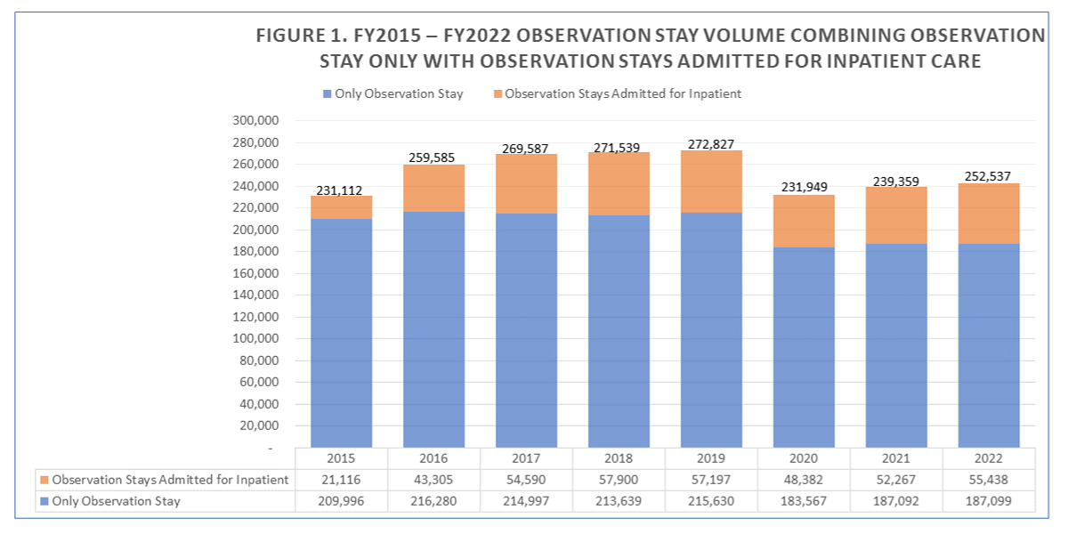
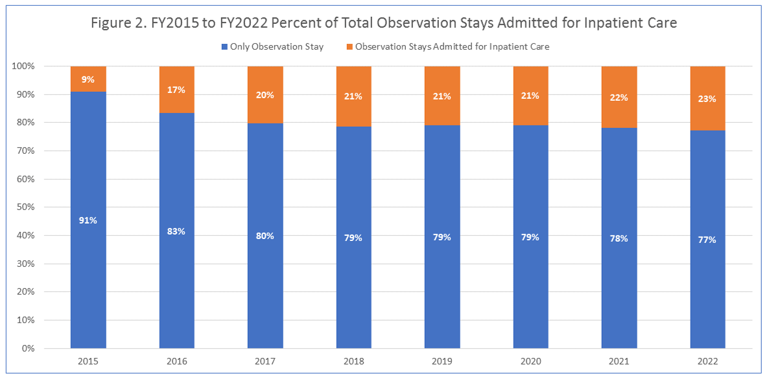

Question: If we wanted to analyze patients who are admitted through observation stay to inpatient hospitalization, what field should we use to ensure that we have filtered for all such patients?

Answer: Hospitals report observation room charges under revenue code 762. However, if the patient has been seen in Observation as well as another outpatient department and is then admitted, hospitals use Revenue Code 762 and use the alternate outpatient department as the admission source. Since this is frequently the case with observation stay patients, you will find a small number of discharges with source code ‘X’ for observation admission source and a larger number with Revenue Code 762 and Observation Stay Flag indicating ‘Yes’. It is important to note that the revenue code units of service are reported in hours and a patient might have a longer observation stay, say 48 hours, than inpatient length of say, which could be only 1 day.

Question: What timeframe constitutes an observation stay? I understand that emergency department visits typically do not exceed 24 hours. Is that the same for observation stay?

Answer: CMS indicates that observation stays are not expected to exceed a duration of 48 hours.
See: https://www.cms.gov/regulations-and-guidance/guidance/transmittals/downloads/r42bp.pdf
In Massachusetts FY 2022 observation stay data, 50% of observation stays were 24 hours of less, 32% were over 24 hours and 48 hours or less, and 18% were over 48 hours.

Question: If a patient is admitted for hospital inpatient care from observation stay and their observation stay rolled into their case mix hospital inpatient record and does not appear in the observation stay data, what does the observation stay "Departure Status = '2' (admitted to hospital) mean?

Answer: Medicare guidelines indicate that observation stay departure status code 2 is used when the hospital is aware of a planned admission even if it doesn’t occur immediately after the stay ends. CHIA was able to corroborate that code 2 patients were eventually admitted, some to the same hospital, some to different hospitals, and some not immediately after they end their observation stay. In Figure 1 below, you will see that the use of observation stay departure status code 2 has significantly decreased over the past seven years.

