CENTER FOR HEALTH INFORMATION AND ANALYSIS

___________________________________

**MA APCD**

**SUBMISSIONS**

__________________________________

**FILE SECURE 5.1**

UPLOAD INSTRUCTIONS

DOCUMENT VERSION 7.0

SEPTEMBER 2019



Contents

Introduction **2**

Software Prerequisites **2**

Installing the SFTP Client **4**

Installing the File Secure Application Executable Zip File **8**

Uploading the Encrypted Submission File from SFTP **18**

How to Retrieve Reports from File Secure **21**

| **Date** | **Version No.** | **writer** | **Notes** |
| --- | --- | --- | --- |
| 3 October 2016 | 1.01 | CHIA | Initial release |
| 02 February 2017 | 2.0 | CHIA | Updated release |
| 16 February 2017 | 3.00 | CHIA | Updated release with feedback |
| 30 March 2017 | 4.00 | CHIA | Update with CHIA File Secure Install instructions |
| 17 May 2017 | 5.00 | CHIA | Update with New Upload Instructions |
| 31 August 2017 | 6.00 | CHIA | Updates to FileSecure workflow |
| 05 September 2019 | 7.0 | CHIA | Updated release |

# Introduction

This document outlines the procedure for uploading APCD submission data to CHIA. The procedure essentially consists of two steps:

1. Use the File Secure executable provided by CHIA to encrypt the submission file prior to transmission.
2. Use an SFTP client of your choice to transfer the CHIA submission file from your PC to CHIA’s submission SFTP site at connect.chia.state.ma.us

# Software Prerequisites

The following software is required. Please make sure to have all the listed software available for installation before continuing.

1. A SFTP client of your choice. CHIA has verified that the following SFTP clients will reliably work with this process:

* Filezilla – available at <https://filezilla-project.org/> Cost: **FREE**
* WinSCP – available at <https://winscp.net/eng/download.php> Cost : **FREE**
* PuTTY/pSFTP – available at <http://www.chiark.greenend.org.uk/~sgtatham/putty/download.html> Cost: **FREE**
* VanDyke SecureSFX – available at <https://www.vandyke.com/> Cost: Commercial (about $85/seat)
* NOTE***: The File Secure application has been tested and certified to work with the above SFTP programs. There is no guarantee that File Secure will work with any other SFTP program (home grown or otherwise). Please consult with your local IT Security organization for further guidance.***

1. A CHIA supplied username and password for the connect.chia.state.ma.us SFTP site.
2. CHIA provided File Secure Application executable zip file to encrypt the submission file prior to submission to CHIA.

**IMPORTANT NOTE ABOUT THE FREE SFTP CLIENTS:**

Please make sure to download the free clients ***ONLY FROM THE LINKS PROVIDED ABOVE***. These links are the official repositories for the software and are provided by the authors of the software. These utilities can also be found on numerous other 3rd party download sites where they may include additional unwanted adware or potential malware, such as viruses/Trojans. ***Only use the links provided in this document*** and make sure to obtain the latest version of this document from CHIA at: [www.chiamass.gov](http://www.chiamass.gov/).

**CHIA SUPPORT:**

If you have any questions or technical issues, please contact the Center for Health Information and Analysis' Help Desk.

Phone: 617-701-8217.   
Email: [CHIA-DL-Data-Submitter-HelpDesk@MassMail.State.MA.US](mailto:CHIA-DL-Data-Submitter-HelpDesk@MassMail.State.MA.US%20%20)

# Installing the SFTP Client

The exact steps for installing each SFTP client will vary somewhat, but largely consist of running some sort of setup.exe or setup.msi. The exception is PuTTY’s pSFTP which is distributed as a standalone exe that can be used as is. Please consult the installation instructions for your selected client.

Step 1. Connecting to connect.chia.state.ma.us via SFTP

The process for connecting and transferring the files will vary by SFTP client used. For purposes of illustration, CHIA is providing detailed instructions for Filezilla (because it works well and is free), but you are free to use any SFTP client that you prefer.

**Note:** If you already have a SFTP client installed, proceed to **Step 4** (page 8).

Start the Filezilla client.

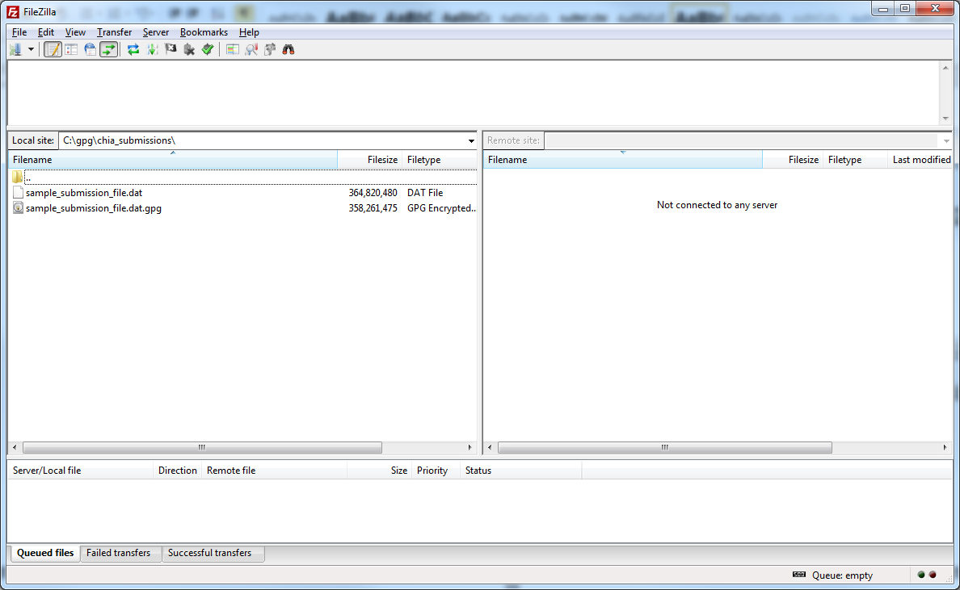

Step 2. Create the SFTP Site Connection for connect.chia.state.ma.us

If this is the first time you’re using Filezilla, you’ll have to create the SFTP site. Go to File-> Site Manager

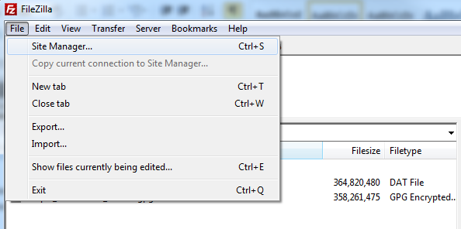

Step 3.

You’ll be presented with a screen similar to the following. Enter the data as shown to create the site.

Under the Site details section input the following information:

|  |  |
| --- | --- |
| **Host:** | connect.chia.state.ma.us |
| **Port:** | 22 |
| **Protocol:** | SFTP – SSH File Transfer Protocol |
| **Logon Type:** | Ask for password |
| **User:** | Blank (you will be prompted on connection) |
| **Password:** | Blank (you will be prompted on connection) |

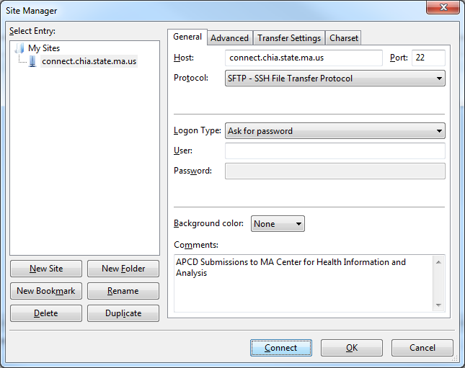

Press OK to save your changes.

Step 4. Connecting to connect.chia.state.ma.us

Click on the Site Manager icon in the toolbar and select the entry for connect.chia.state.ma.us.

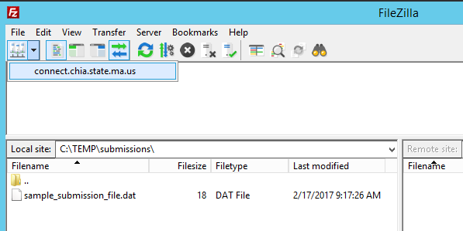

You’ll be prompted with a login box. Please enter the credentials that have been supplied by CHIA:

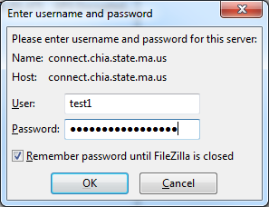

# Installing the File Secure Application Executable File

Access CHIA Submissions at: <https://chiasubmissions.chia.state.ma.us/>

* Enter Username and Password and click ‘Login’ (This is the same Username and Password that you used to log into SENDSPlus and INET.)

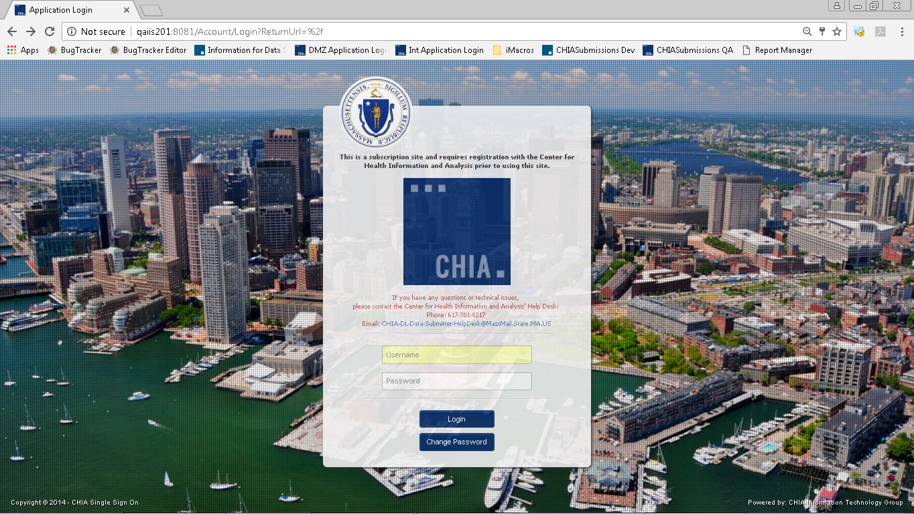

On the Select Application screen, click on the button labelled “FileSecure”



The following screen will appear:

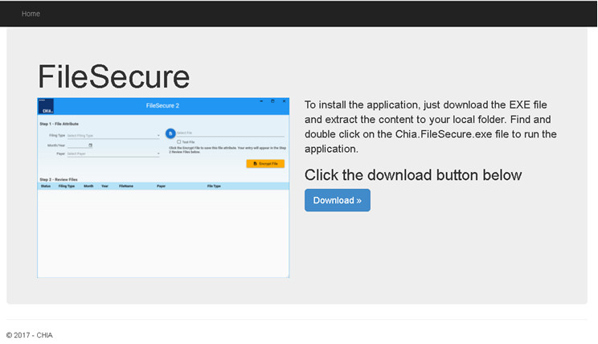

Clicking on the ‘Download >>’ button will start the local download of the executable file through the current browser.

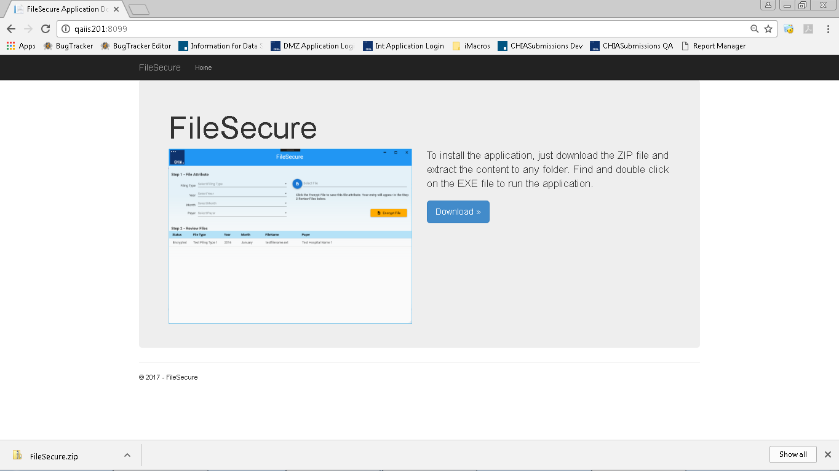

Clicking on the executable file will start the extraction process to the following address:

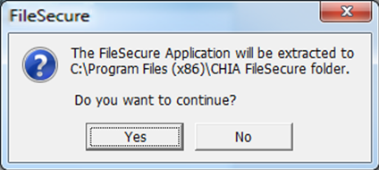

Clicking “Yes” will extract the files, “No” will cancel this process.

During extraction, a shortcut file will populate in the current user’s desktop.

***IMPORTANT NOTE: Each user must sign into CHIASubmissions and download their own version of FileSecure. Downloading of this system is user driven and will limit privileges based on requested access.***

To launch the application click on the file named “**Chia.FileSecure.exe**” in the address ‘C:/Program Files (x86)/CHIA FileSecure’ folder, or shortcut found on the desktop, to see the following screen:

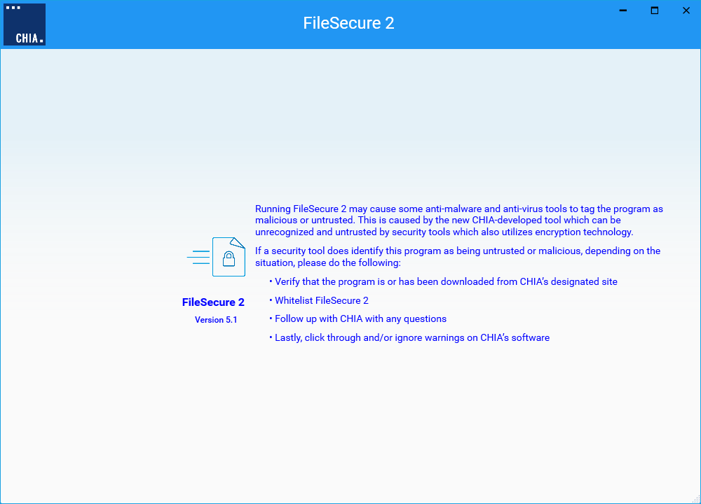

**IMPORTANT NOTE: *Running FileSecure may cause some anti-malware and anti-virus tools to tag the program as malicious or untrusted.  This is caused by the new CHIA-developed tool which can be unrecognized and untrusted by security tools which also utilizes encryption technology.***

***If a security tool does identify this program as being untrusted or malicious, depending on the situation, please do the following:***

* Verify that the program is or has been downloaded from CHIA’s designated site
* Whitelist FileSecure. Please consult your IT Security organization.
* Follow up with CHIA with any questions
* Lastly, click through and/or ignore warnings on CHIA’s software

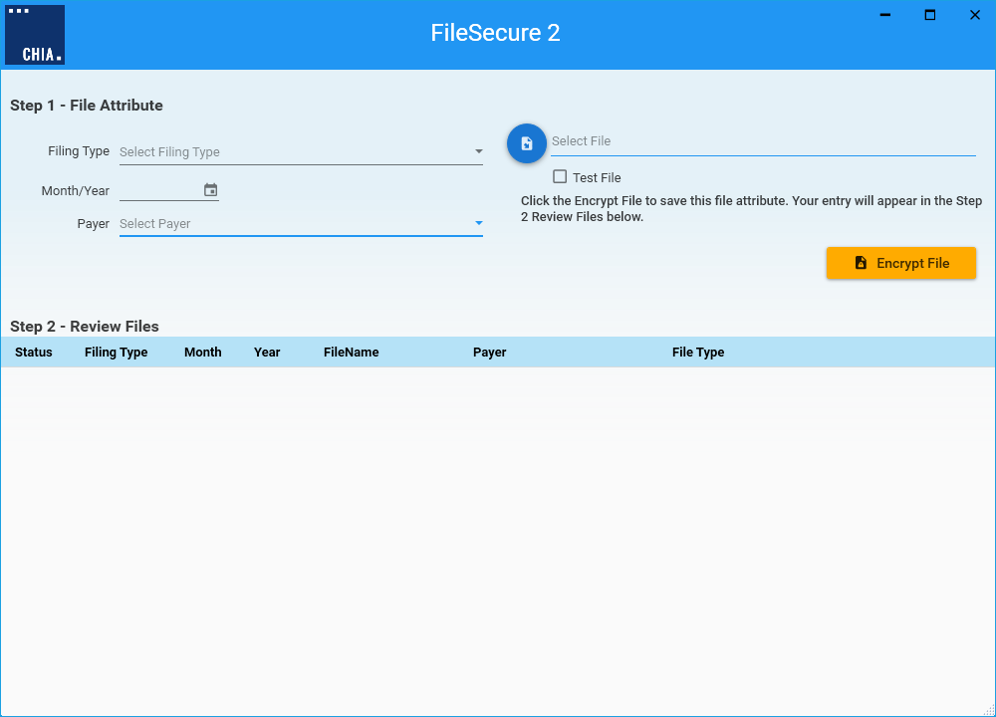

To start, click on the Filing Type dropdown, select the appropriate filing type.

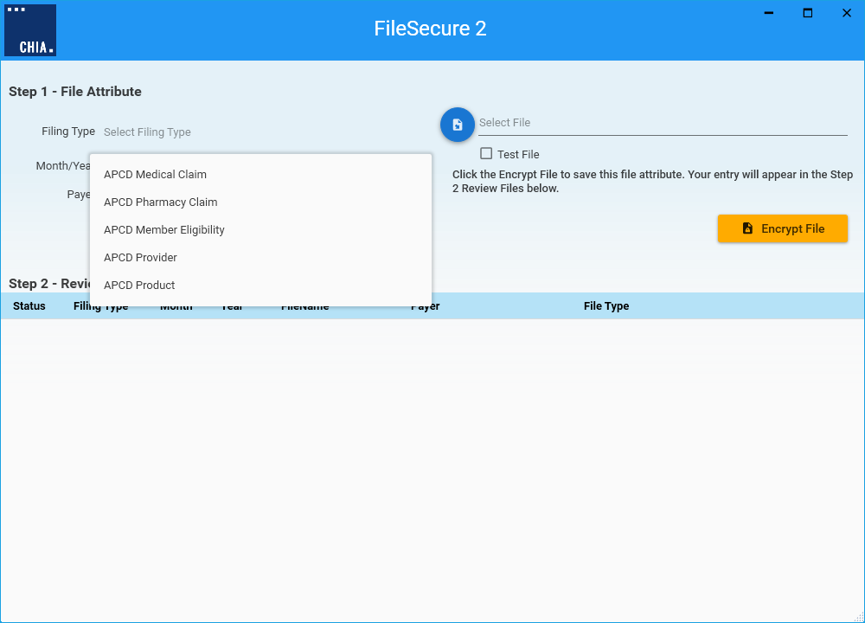

Click on the Year and Month to identify the submission’s month and year of the submission.

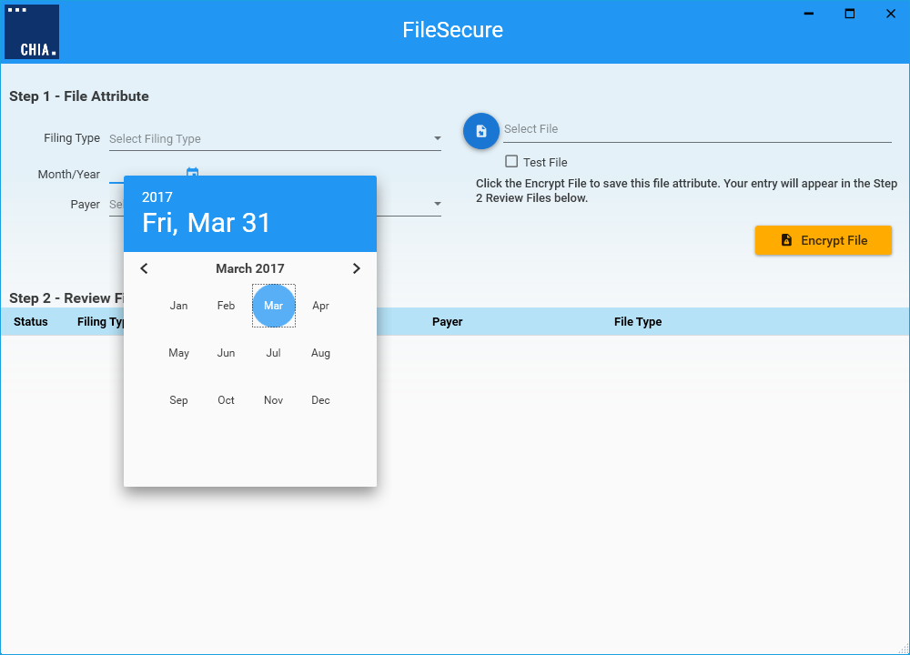

Click on the associated Payer for the file to be encrypted.

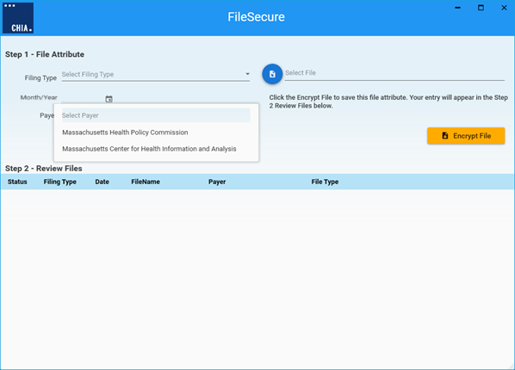

Click on the ‘Select File’ to open File Explorer. Find the file that will be encrypted. After choosing the file, click on the ‘Open’ button. Note – specifying the destination folder of the encryption file will need to be identified before selecting a file to be encrypted. This is identified on page 16.

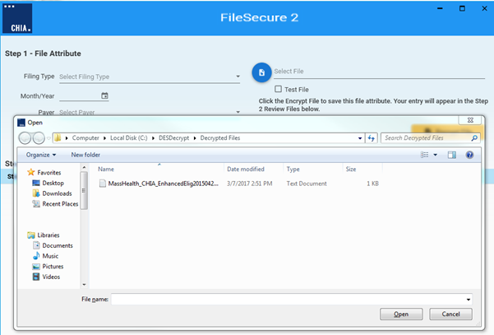

The file name will appear in the ‘Select File’ field, as shown below.

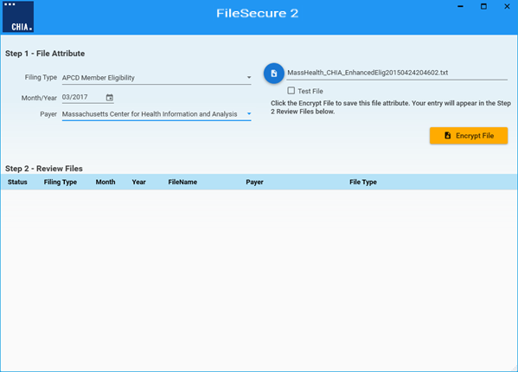

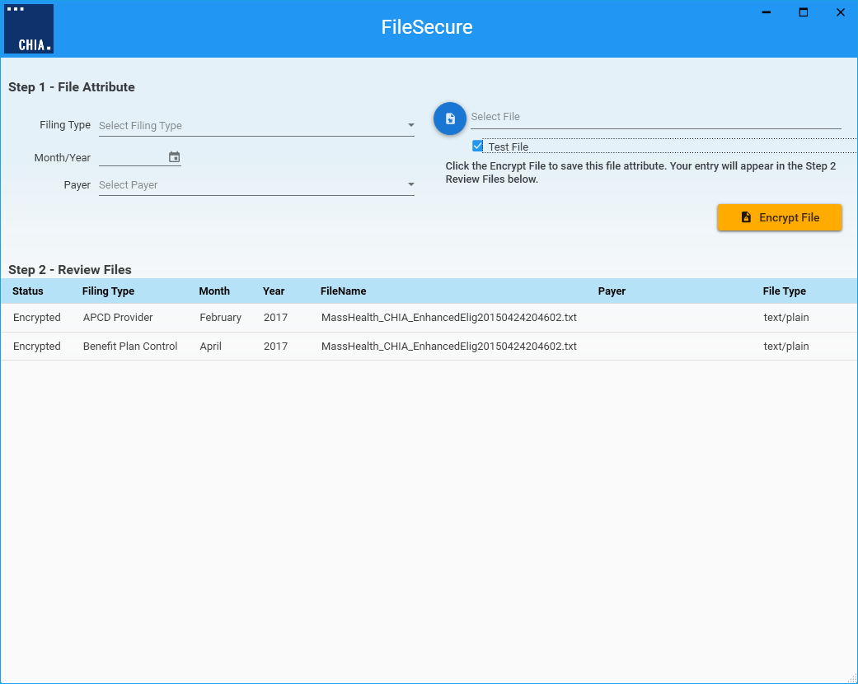Under the ‘Select File’ field, the Test parameter can be found. This is a checkbox that will identify that the file being encrypted should be treated as testing data and will include “Test” at the end of the file name.

Click on the ‘Encrypt File’ button to start the encryption process. The status of the process will display at the bottom of the window.

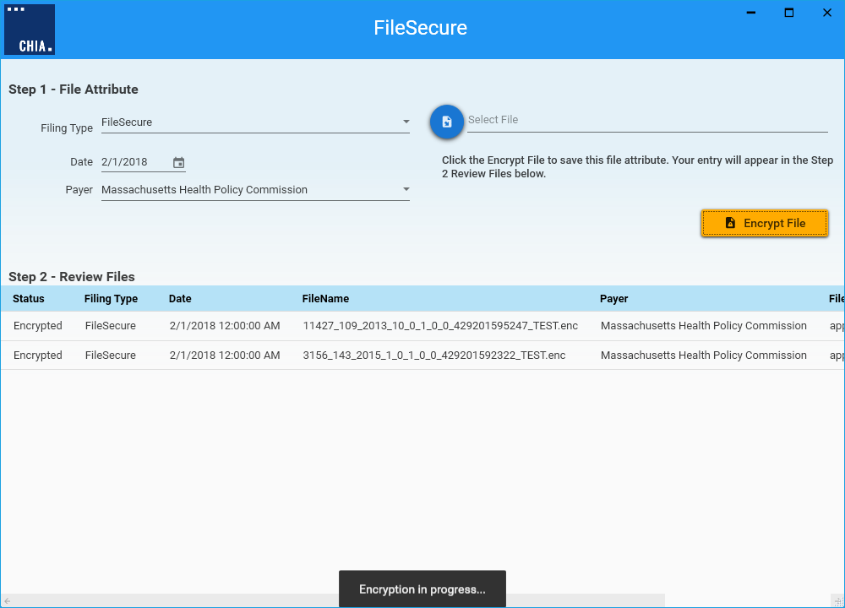

When the file has been successfully encrypted, the following message will appear:

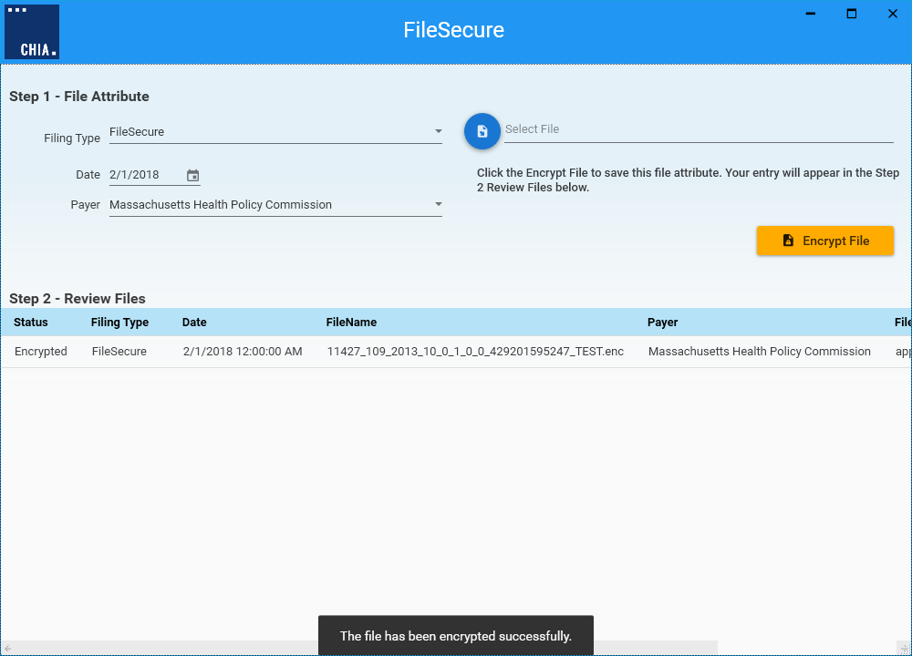

Files that have been successfully encrypted will be listed in Step 2 – Review Files, as shown below.

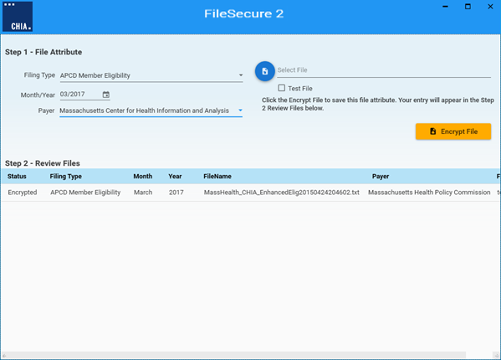

Encrypted files (*.enc) will populate in the defaulted folder, as shown below. The defaulted path for the encrypted file will need to be chosen. The list of encrypted files can be found by clicking on the CHIA icon and selecting “Browse Encrypted Files”:

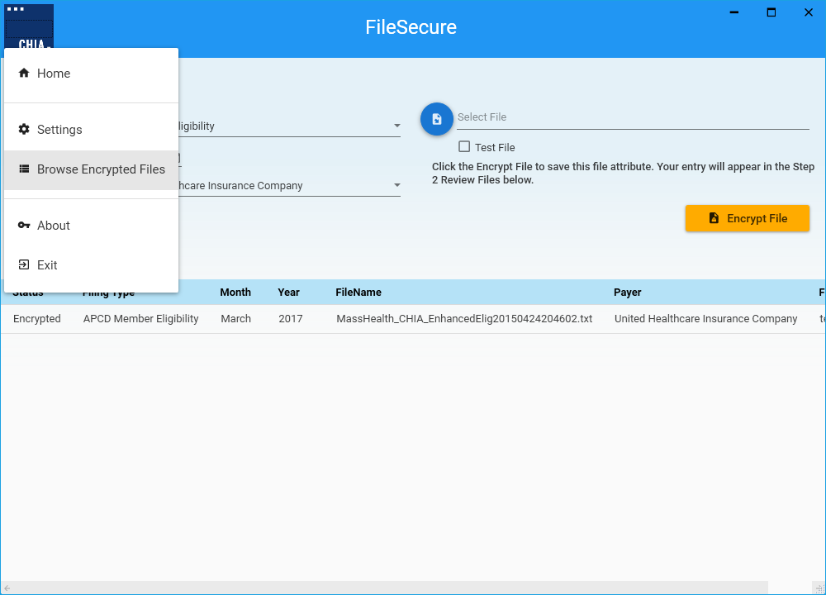

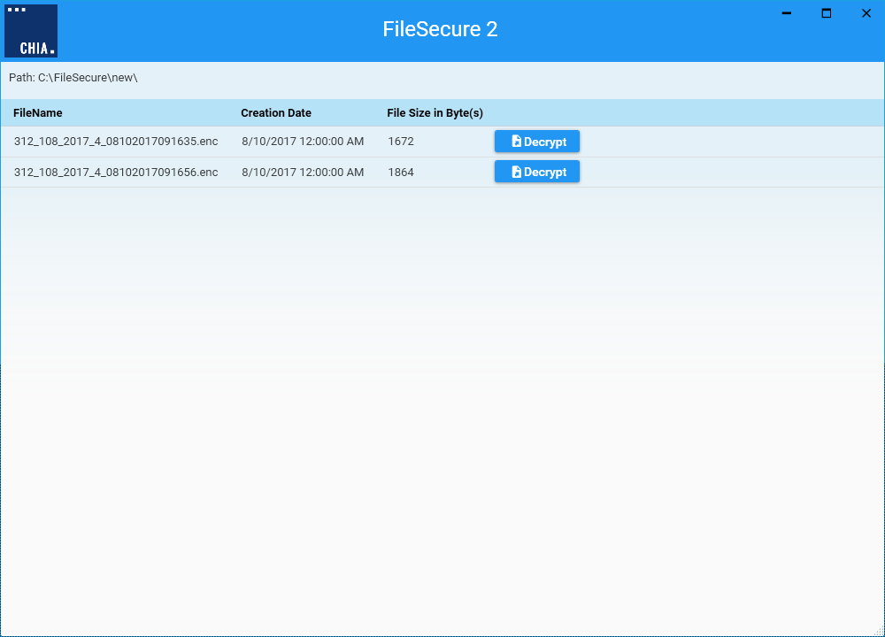

The list of encrypted files is dependent on the path that is established. Each file in the list can be decrypted by clicking on the ‘Decrypt’ button. Before the file can be decrypted, a location of the file is selected.

To change the default location, click on the CHIA icon and select Settings from the File menu.

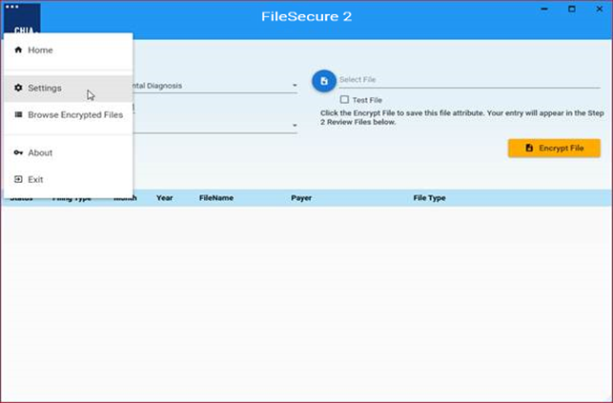

Click on the folder icon to select the desired folder location.

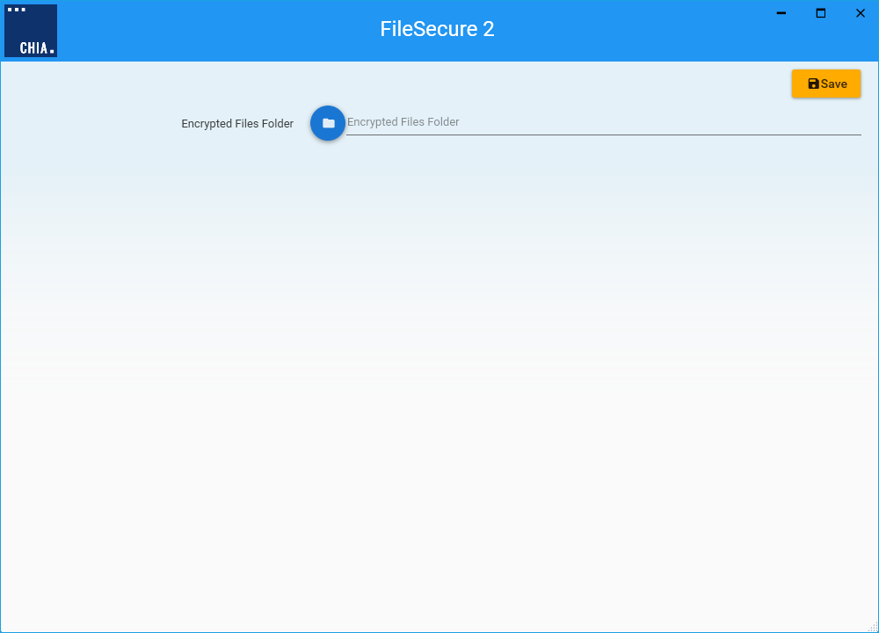

After setting the folder location on the dialog window and hitting the OK button, click the Save button to save your settings.

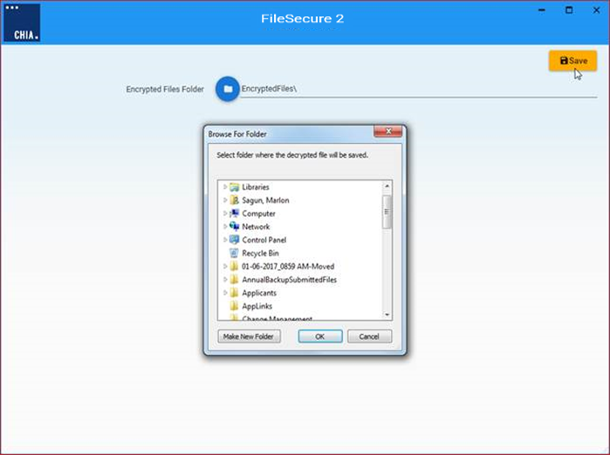

Click the CHIA icon and select Home to go back to the main window.

# Uploading the Encrypted Submission File from SFTP

After installing the SFTP client from Step 4 (page 7) AND after installing the File Secure application executable (page 8), you are ready to upload the encrypted CHIA submission file. You will log into the Connect.Chia.State.MA.US site. Upon successful login to the site, you’ll see something similar to the following. There will be a single folder that corresponds to your Org ID.

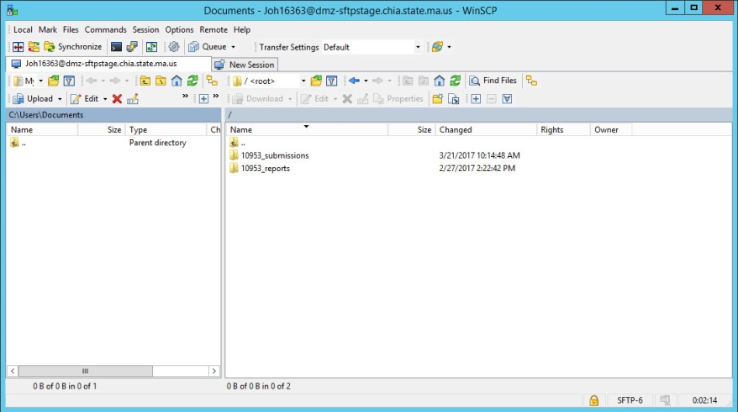

Note that the Org ID of 10953 is used for illustration purposes only.

You must select the Org ID folder before attempting to upload files.

For illustration purposes, we’ll use the **10953** directory. Progress of the file transfer and remaining estimated time of transfer will be shown in the status window as seen below:

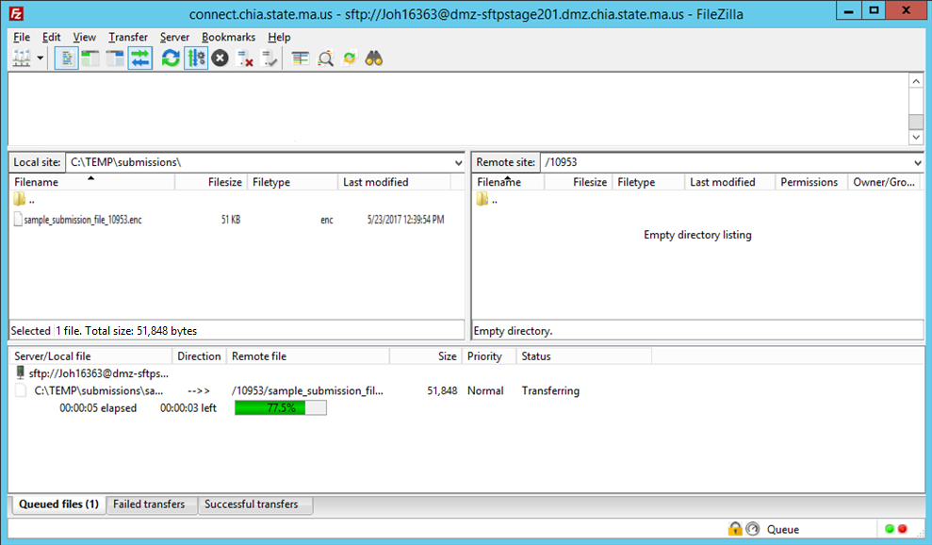

Once the file has been successfully transferred, you’ll see something like the following:

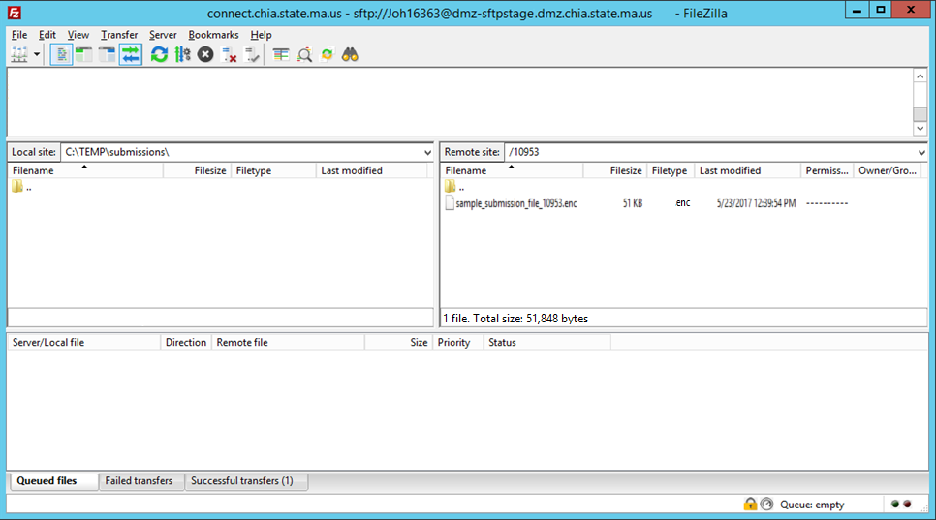

You may now safely disconnect from the site by either closing the SFTP application or manually disconnecting by going to Server->Disconnect. If you do not manually disconnect, you will be forcefully disconnected by the server after 5 minutes of inactivity has passed.

# How to Retrieve Reports from File Secure

For each submission, each attempt per file, a report will be generated and placed into the ‘Report’ folder, found using the sFTP application.



This report, which is in PDF format, will act as the receipt of the file submitted. The naming convention for the file is reflected by the file type that was submitted:

“OrgID_File Type_Submission Identifier_Submission Year_Submission Month”

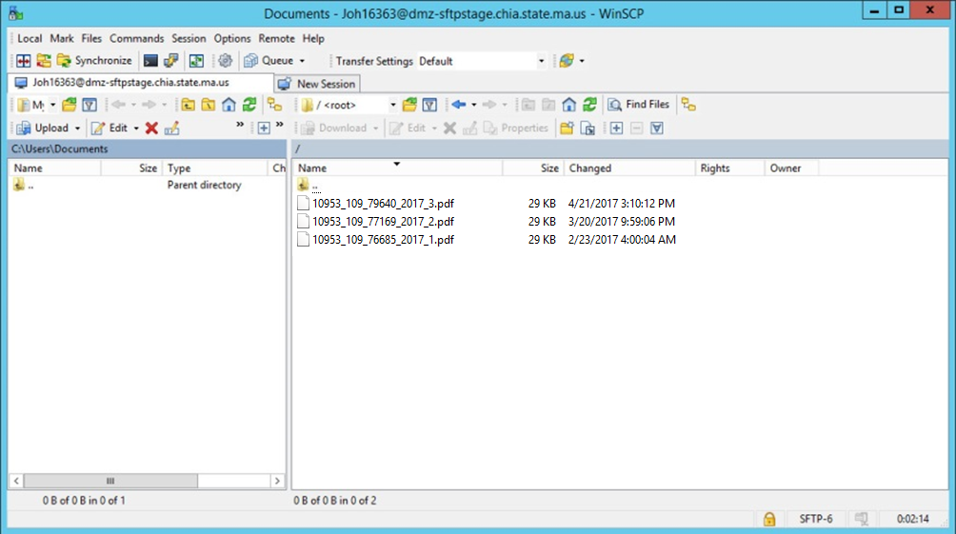

This report will include a summary and list of any errors that were identified during the submission process. When a file fails or is dropped, due to an error or issue during submission, a liasion will reach out to assist in correcting the issue for a re-file.

