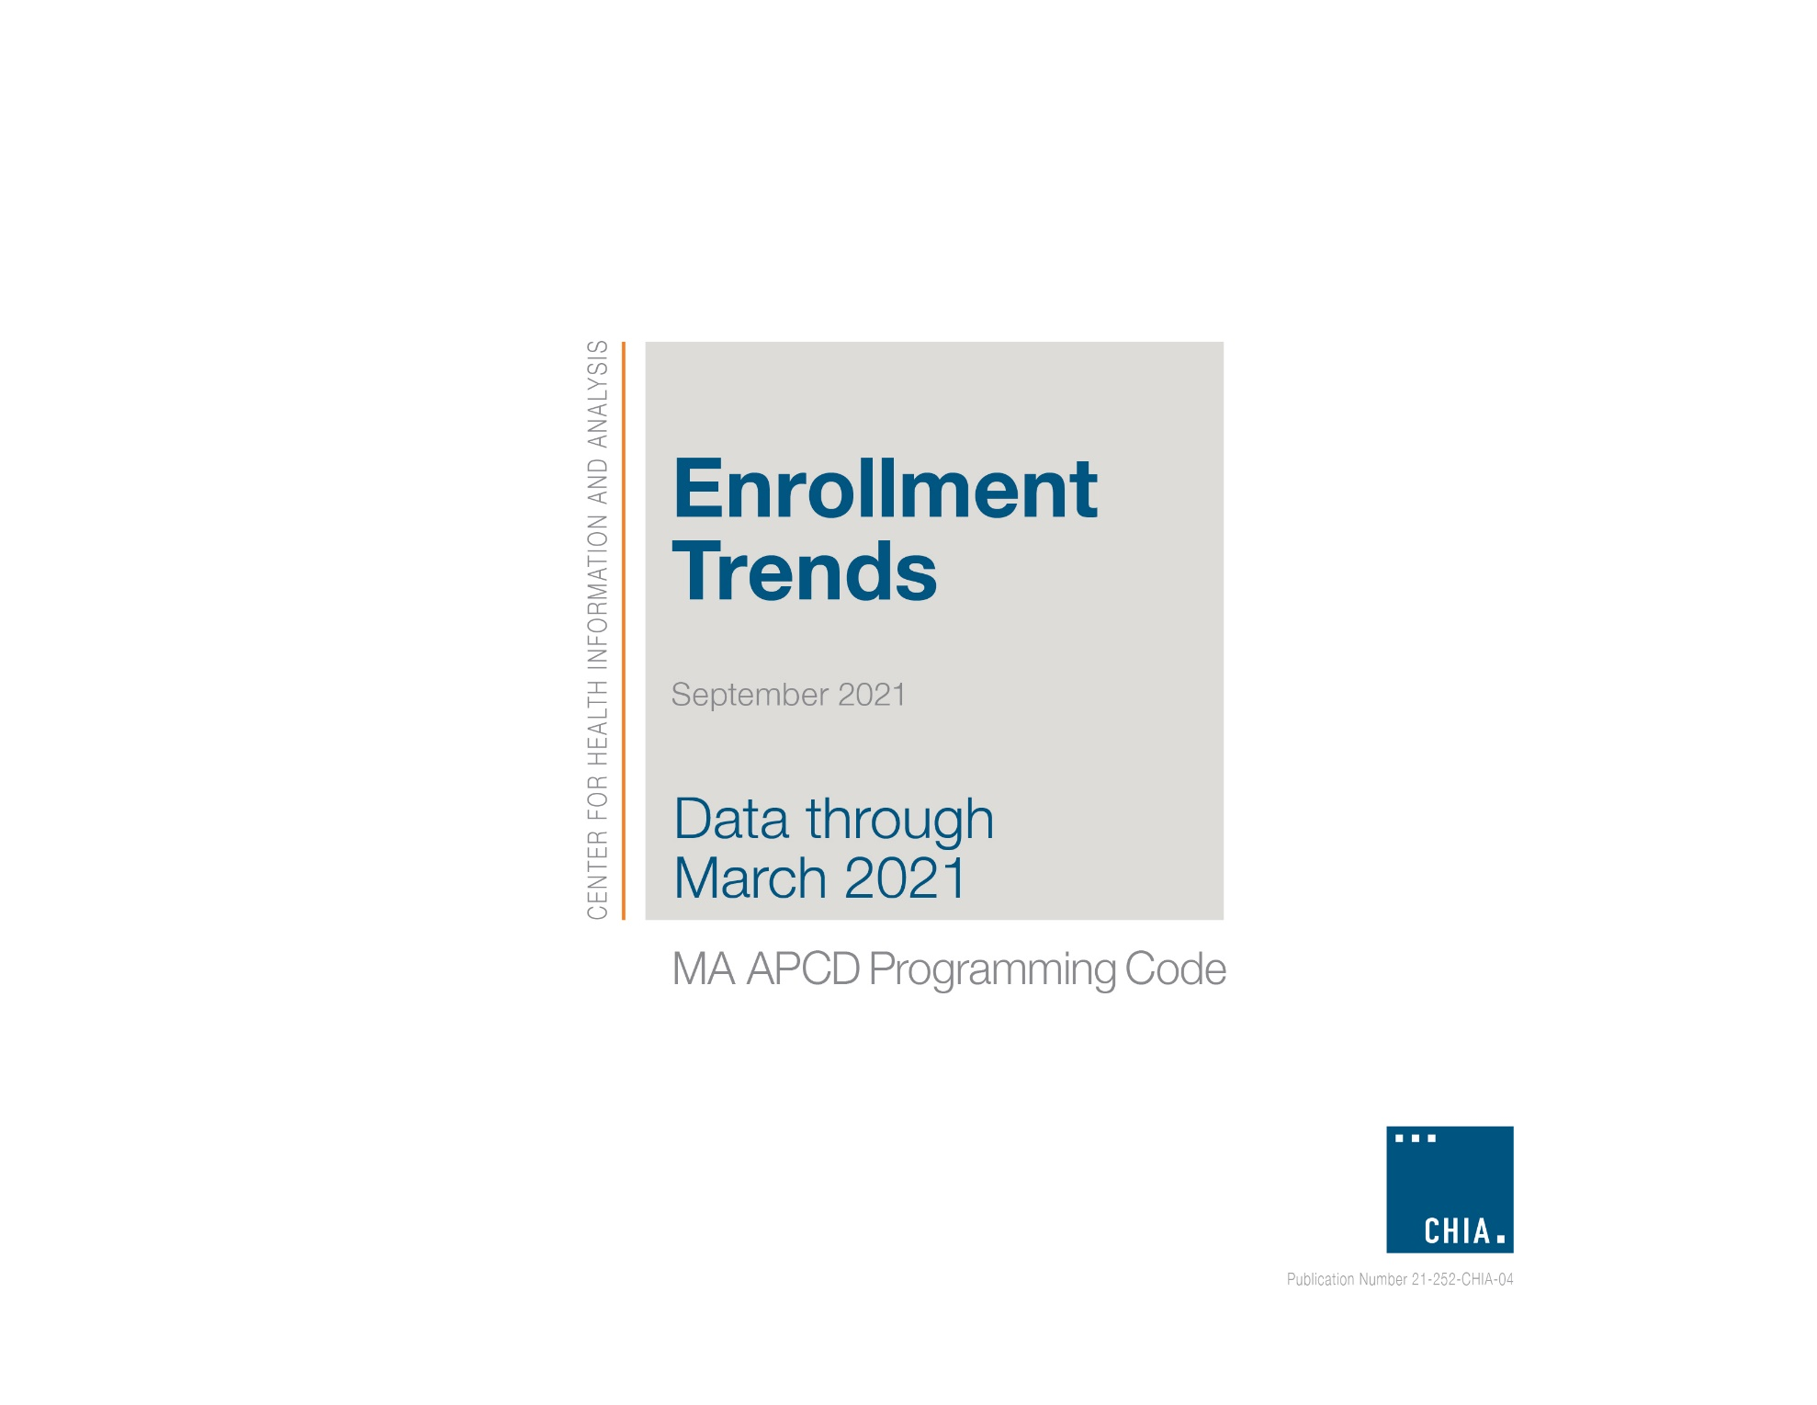

CHIA Enrollment Trends (March 2021 Edition)

MA APCD Programming Code

As described in the CHIA Enrollment Trends Technical Appendix, Enrollment Trends monitors unique Massachusetts residents with primary medical insurance coverage using eligibility data from the Massachusetts All Payer Claims Database (MA APCD). MA APCD membership reports are generated on a bi-annual basis and sourced from the most recently submitted payer-specific Member Eligibility (ME) file. Twenty-four months of membership data are used and segmented by product enrollment date spans.

Provided below are the methodology and programming code used by CHIA to create the MA APCD membership reports for Enrollment Trends. The methodology and code have been discussed with and reviewed by the top 12 commercial payers (and affiliated entities) but are subject to further development in order to arrive at the most accurate membership counts for each payer. On a case-by-case basis, CHIA may request supplemental data from payers to augment or replace MA APCD enrollment counts.

- Methodology

Enrollment is determined if the 15th day of the last month of each quarter (i.e., Snapshot Date) is within the Product Enrollment Start Date (ME041) and Product Enrollment End Date (ME042) of a member record (i.e., ME041 ≤ Snapshot Date ≤ ME042). Member records with NULL values for ME042 are considered actively enrolled. Members are distinguished using data element CHIACarrierSpecificUniqueMemberID (ME107) by OrgID (ME001).

MA APCD membership reports do not count duplicate member records. A unique member record is selected according to the following criteria, in order of significance:

De-duplicate by the following order:
- Medical coverage (ME018=1)
- Primary insurance (ME028)
  - ME028=1 for primary insurance
  - ME028=2 for non-primary insurance
  - ME028=(3,4,5) for unknown, other, N/A
- Greatest last activity date (ME056)
- Greatest Member Eligibility ID (CHIA-assigned record identifier)

Subset to the following:
- Massachusetts resident (ME016=MA)
- Medical coverage (ME018=1)
- Primary insurance (ME028=1)

- Programming Code

MA APCD data extraction and aggregation are implemented in SAS, using SQL pass-through to access data in Postgres. The code below may not be inclusive of all data manipulations performed on the final output dataset.

- SAS/SQL Code

/*************************************************************************************************

SAS/SQL CODE TO EXTRACT AGGREGATE APCD MEMBERSHIP DATA FOR ENROLLMENT TRENDS REPORTING
*************************************************************************************************/

*--------------- BEGIN ACTION ITEMS -------------------------------------------

1. Initialize global variables
2. Perform additional action items below prior to running program

--------------- END ACTION ITEMS ---------------------------------------------;

* Initialize global variables;
%let DataDir= C:\EnrollmentTrends\output;
%let SYM= 202003;
%let OrgIdList= (290, 291, 295, 296, 300, 301, 302, 312, 3505, 3735, 16621, 4962, 7655, 7789, 8026, 8647, 9913, 10353, 10441, 10444, 10632, 10647, 10728, 10920, 10926, 10929, 11474, 11726, 12814, 13074);
%let Snapshot1= '2018-06-15'; *First snapshot date, format: 'yyyy-mm-dd';
%let Snapshot2= '2020-09-15'; *Last snapshot date, format: 'yyyy-mm-dd';

* Fixed global variables;
libname out "&DataDir.";
%let OutFile= out.ME_ET_&SYM.;

option compress=binary;

/*************************************************

Begin: Netezza summary data extract
*************************************************/

*--------------- BEGIN ACTION ITEMS -------------------------------------------

Perform the checks below prior to running code

1. Review "Processing Summary" below for previous processing info
2. Check that source data is coming from correct data source

--------------- END ACTION ITEMS ---------------------------------------------;

* Processing Summary:

Extract 8 quarters, starting with snapshot date of 12/15/2018, of ME data for Enrollment Trends. The below dataset has the
following characteristics:
1) The dataset has been de-duplicated (to_keep_v1= 1)
2) The dataset contains only OrgIDs relevant to Enrollment Trends
3) The dataset contains Product fields: ProductIDNumber, ProductLineofBusinessModel, ProductBenefitType, NaicCode,
CarrierLicenseType, ProductName, InsurancePlanMarketCleaned
4) The dataset contains demographic fields: AgeGroup, County, and MemberGender

;

proc sql;
connect to odbc (dsn=odbc_database);
create table &OutFile. as
select * from connection to odbc (
with DateList as (select dates::date from generate_series(&Snapshot1., &Snapshot2., '3 month'::interval) dates
),
Product as (select *
, COALESCE(lag((to_date(submissionyearmonth||'01','yyyymmdd') + INTERVAL '1 MONTH') :: date)
over (partition by ORGID, PRODUCTIDNUMBER order by submissionyearmonth),to_date('18000101','yyyymmdd')) eff_start
, case when lead(submissionyearmonth)
over (partition by ORGID, PRODUCTIDNUMBER order by submissionyearmonth) is null
then to_date('99991231','yyyymmdd')
else (to_date(submissionyearmonth||'01','yyyymmdd') + INTERVAL '1 MONTH'):: date -1
end eff_end
from APCD_Product
)
select OrgID
, SubmissionControlID
, SubmissionYearMonth
, Dates
, InsuranceTypeCodeProduct
, MedicalCoverage
, PrimaryInsuranceIndicator
, CoverageType
, MarketCategoryCode
, SpecialCoverage
, ProductID
, ProductLineOfBusinessModel
, Situs
, ProductBenefitType
, NaicCode
, CarrierLicenseType
, ProductName
, InsurancePlanMarketCleaned
, GIC
, RACP
, MemberMA
, County
, MemberGender
, AgeGroup
, MAExchangeFlag
, to_keep_v1
, count(*) as nrecs
from (
select me.MemberEligibilityID
, me.OrgID
, me.SubmissionControlID
, me.SubmissionYearMonth
, me.InsuranceTypeCodeProduct
, MedicalCoverage
, PrimaryInsuranceIndicator
, CoverageType
, me.MarketCategoryCode
, SpecialCoverage
, cast(me.ProductIDNumber as char(20)) as ProductID
, prd.ProductLineOfBusinessModel
, prd.Situs
, prd.ProductBenefitType
, prd.NaicCode
, prd.CarrierLicenseType
, prd.ProductName
, prd.InsurancePlanMarketCleaned
, case when APCDIDCode='3' then 'GIC' else 'Non-GIC' end as GIC
, ProductEnrollmentStartDate as StartDate
, case when ProductEnrollmentEndDate is null then cast('99991231' as date) else ProductEnrollmentEndDate end as EndDate
, LastActivityDate
, CHIACarrierSpecificUniqueMemberID as UniqueMemberID
, MemberGenderCleaned as MemberGender
, case when extract(year from age(Dates, ad.DT)) >= 0 and extract(year from age(Dates, ad.DT)) < 1 then '< 1'
when extract(year from age(Dates, ad.DT)) >= 1 and extract(year from age(Dates, ad.DT)) < 10 then '1-9'
when extract(year from age(Dates, ad.DT)) >= 10 and extract(year from age(Dates, ad.DT)) < 20 then '10-19'
when extract(year from age(Dates, ad.DT)) >= 20 and extract(year from age(Dates, ad.DT)) < 27 then '20-26'
when extract(year from age(Dates, ad.DT)) >= 27 and extract(year from age(Dates, ad.DT)) < 45 then '27-44'
when extract(year from age(Dates, ad.DT)) >= 45 and extract(year from age(Dates, ad.DT)) < 65 then '45-64'
when extract(year from age(Dates, ad.DT)) >= 65 and extract(year from age(Dates, ad.DT)) < 75 then '65-74'
when extract(year from age(Dates, ad.DT)) >= 75 and extract(year from age(Dates, ad.DT)) < 85 then '75-84'
when extract(year from age(Dates, ad.DT)) >= 85 and extract(year from age(Dates, ad.DT)) < 121 then '85+'
else 'Unknown'
end as AgeGroup
, RiskAdjustmentCoveredBenefitPlan as RACP
, case when MemberStateorProvince ='MA' then 1 else 0 end as MemberMA
, case when MemberStateorProvince ='MA' then MemberCounty else 'Other' end as County
, PurchasedThroughMassachusettsExchangeFlag as MAExchangeFlag
, Dates
, case when lead(me.MemberEligibilityID) over (partition by me.OrgID, CHIACarrierSpecificUniqueMemberID, Dates
order by case when MedicalCoverage='1' then 1 else 0 end
, case when PrimaryInsuranceIndicator = '1' then 1
when PrimaryInsuranceIndicator = '2' then 0
when PrimaryInsuranceIndicator in ('3','4','5') then -1
else -1 end
, LastActivityDate
, me.MemberEligibilityID)
is null then 1 else 0
end as to_keep_v1 /* De-duplication hierarchy for Enrollment Trends */
FROM APCD_MemberEligibility as me
inner join DateList
on Dates between ProductEnrollmentStartDate and case when ProductEnrollmentEndDate is null then cast('99991231' as date) else ProductEnrollmentEndDate end
left join Product as prd
on me.linkorgidpr = prd.orgid and me.ProductIDNumber = prd.ProductIDNumber and Dates between prd.eff_start and prd.eff_end
left join Date_Table as ad /* Join to a date table to process only valid Member Date of Birth values */
on MEMBERDATEOFBIRTHYEARMONTH||'01' = ad.DT_YYYYMMDD /*MemberDOBYM only includes year and month of birth, adding dummy day to join to date table.*/
where me.SubmissionYearMonth=&SYM.
and me.OrgID in &OrgIdList.
) a
where to_keep_v1=1 /* Save out only de-duplicated records */
group by OrgID
, SubmissionControlID
, SubmissionYearMonth
, Dates
, InsuranceTypeCodeProduct
, MedicalCoverage
, PrimaryInsuranceIndicator
, CoverageType
, MarketCategoryCode
, SpecialCoverage
, ProductID
, ProductLineOfBusinessModel
, Situs
, ProductBenefitType
, NaicCode
, CarrierLicenseType
, ProductName
, InsurancePlanMarketCleaned
, GIC
, RACP
, MemberMA
, County
, MemberGender
, AgeGroup
, MAExchangeFlag
, to_keep_v1
order by 1,2,3,4
);
disconnect from odbc;
quit;
/*************************************************

End: postgres summary data extract
*************************************************/

* Apply hard-coded groupings
Macro Input: dataEdit(name of input dataset, name of output dataset)
Macro Output: a temporary SAS dataset
;

proc format;
value OrgName
290, 7655, 10353, 10441, 10442, 10647, 10929, 11745 = 'Aetna'
3735, 16621 = 'AllWays'
10632 = 'Anthem'
291 = 'BCBS'
3505 = 'BMC'
10728 = 'CCA'
10920 = 'CeltiCare'
293, 295, 7422, 10447, 11474, 11499, 11726, 11215 = 'CIGNA'
7041 = 'ConnectiCare'
296, 8026 = 'Fallon'
300, 13074 = 'HPHC'
302 = 'HPI' /* In later processing, re-classify HPI OrgID=302 as CompanyName=HPHC */
301 = 'HNE'
3156 = 'MassHealth'
12226 = 'Minuteman'
4962 = 'THPP'
9913 = 'SWH'
8647 = 'Tufts'
312, 313, 7789, 10444, 10925, 10926, 10932, 10933, 10934, 10935, 12814 = 'United'
other = 'Other'
;

value $MktSect
'IND', 'GCV', 'ISCO' = 'Individual'
'GS1', 'GS2', 'GS3' = 'Small Group (1-25)'
'GS4' = 'Small Group (26-50)'
'GLG1' = 'Mid-Size Group (51-100)'
'GLG2', 'GLG3' = 'Large Group (101-500)'
'GLG4' = 'Jumbo-Size Group (501+)'
'GSA' = 'Qualified Association'
other = 'Other'
;

value $CovType
'UND' = 'Fully-Insured'
'ASO', 'ASW' = 'Self-Insured'
other = 'Other'
;

value $ProdType
'MC', 'MO', '30' = 'Medicaid'
'CC' = 'Commonwealth Care'
'CE' = 'Commonwealth Choice'
'HM' = 'HMO'
'12' = 'PPO'
'13' = 'POS'
'14' = 'EPO'
'15' = 'Indemnity'
'16', 'HN', '20' = 'Medicare'
'IC' = 'OneCare'
'SC' = 'Senior Care Options'
other = 'Other'
;

/* Group HPI (OrgID 302) under HPHC */
value OrgNameReport
290, 7655, 10353, 10441, 10442, 10647, 10929, 11745 = 'Aetna'
10632 = 'Anthem'
291 = 'BCBS'
3505 = 'BMC'
10728 = 'CCA'
10920 = 'CeltiCare'
293, 295, 7422, 10447, 11474, 11499, 11726, 11215 = 'CIGNA'
7041 = 'ConnectiCare'
296, 8026 = 'Fallon'
300, 302, 13074 = 'HPHC'
301 = 'HNE'
3156 = 'MassHealth'
12226 = 'Minuteman'
3735, 16621 = 'AllWays'
9913 = 'SWH'
8647 = 'Tufts'
4962 = 'THPP'
312, 313, 7789, 10444, 10925, 10926, 10932, 10933, 10934, 10935, 12814 = 'United'
other = 'Other'
;
run;

%macro dataEdit(dataInfile, dataOutfile);
PROC SQL;
CREATE TABLE &dataOutfile. AS
SELECT *
, put(MarketCategoryCode, $MktSect.)as GROUPSIZE
, CASE
/* Finding: United (OrgID=7789) is a student health plan, which is classified as
CoverageType='STN'.
Resolutions: Need to hardcode MARKET='Fully-Insured' for ET reporting. */
WHEN ORGID=7789 THEN
CASE WHEN CoverageType in ('STN', 'UND') THEN 'Fully-Insured'
WHEN CoverageType in ('ASO', 'ASW') THEN 'Self-Insured'
ELSE 'Other' END
ELSE put(CoverageType, $CovType.) end as MARKET
, CASE WHEN OrgID=8026 and InsuranceTypeCodeProduct='ZZ' and MarketCategoryCode='ISCO' THEN 'Senior Care Options'
ELSE put(InsuranceTypeCodeProduct, $ProdType.)
END AS PLANTYPE
, put(OrgId, OrgName.) as CompanyName
, put(OrgID, OrgNameReport.) as CompanyName_Report
, CASE WHEN UPCASE(County) in ('BARNSTABLE', 'BERKSHIRE', 'BRISTOL', 'DUKES', 'ESSEX',
'FRANKLIN', 'HAMPDEN', 'HAMPSHIRE', 'MIDDLESEX', 'NANTUCKET', 'NORFOLK',
'PLYMOUTH', 'SUFFOLK', 'WORCESTER', '') THEN County
ELSE 'Other'
END AS MEMBERCOUNTY
FROM &dataInfile.;
QUIT;

%mend dataEdit;

%dataEdit(out.ET_&SYM., out.report_&SYM.);

/*************************************************
Begin: Export summary data extract
*************************************************/
/* Export data into txt-file and 1 SAS dataset to pivot in Power Pivot */

/* PROCESSING TIME: */
proc datasets library=work nolist;
delete temp;
quit;

data work.temp(drop=Dates);
set out.report_&SYM. (obs=max);
Date = Dates;
format Date MMDDYYS10.;
run;

proc export data=work.temp
outfile="&DataDir.\ET_&SYM..txt"
dbms=dlm replace;
delimiter='|';
run;
/*************************************************
End: Export summary data extract
*************************************************/

ConnectiCare is not included in reporting due to low Massachusetts enrollment.
CHIA is providing this methodology and programming code as a convenience. It has been prepared for informational purposes only and is based on information believed to be reliable. The methodology and programming code are subject to change without notice. CHIA does not provide any guarantee or opinion on its accuracy. CHIA disclaims any liability for the improper or incorrect use of the information contained herein.

