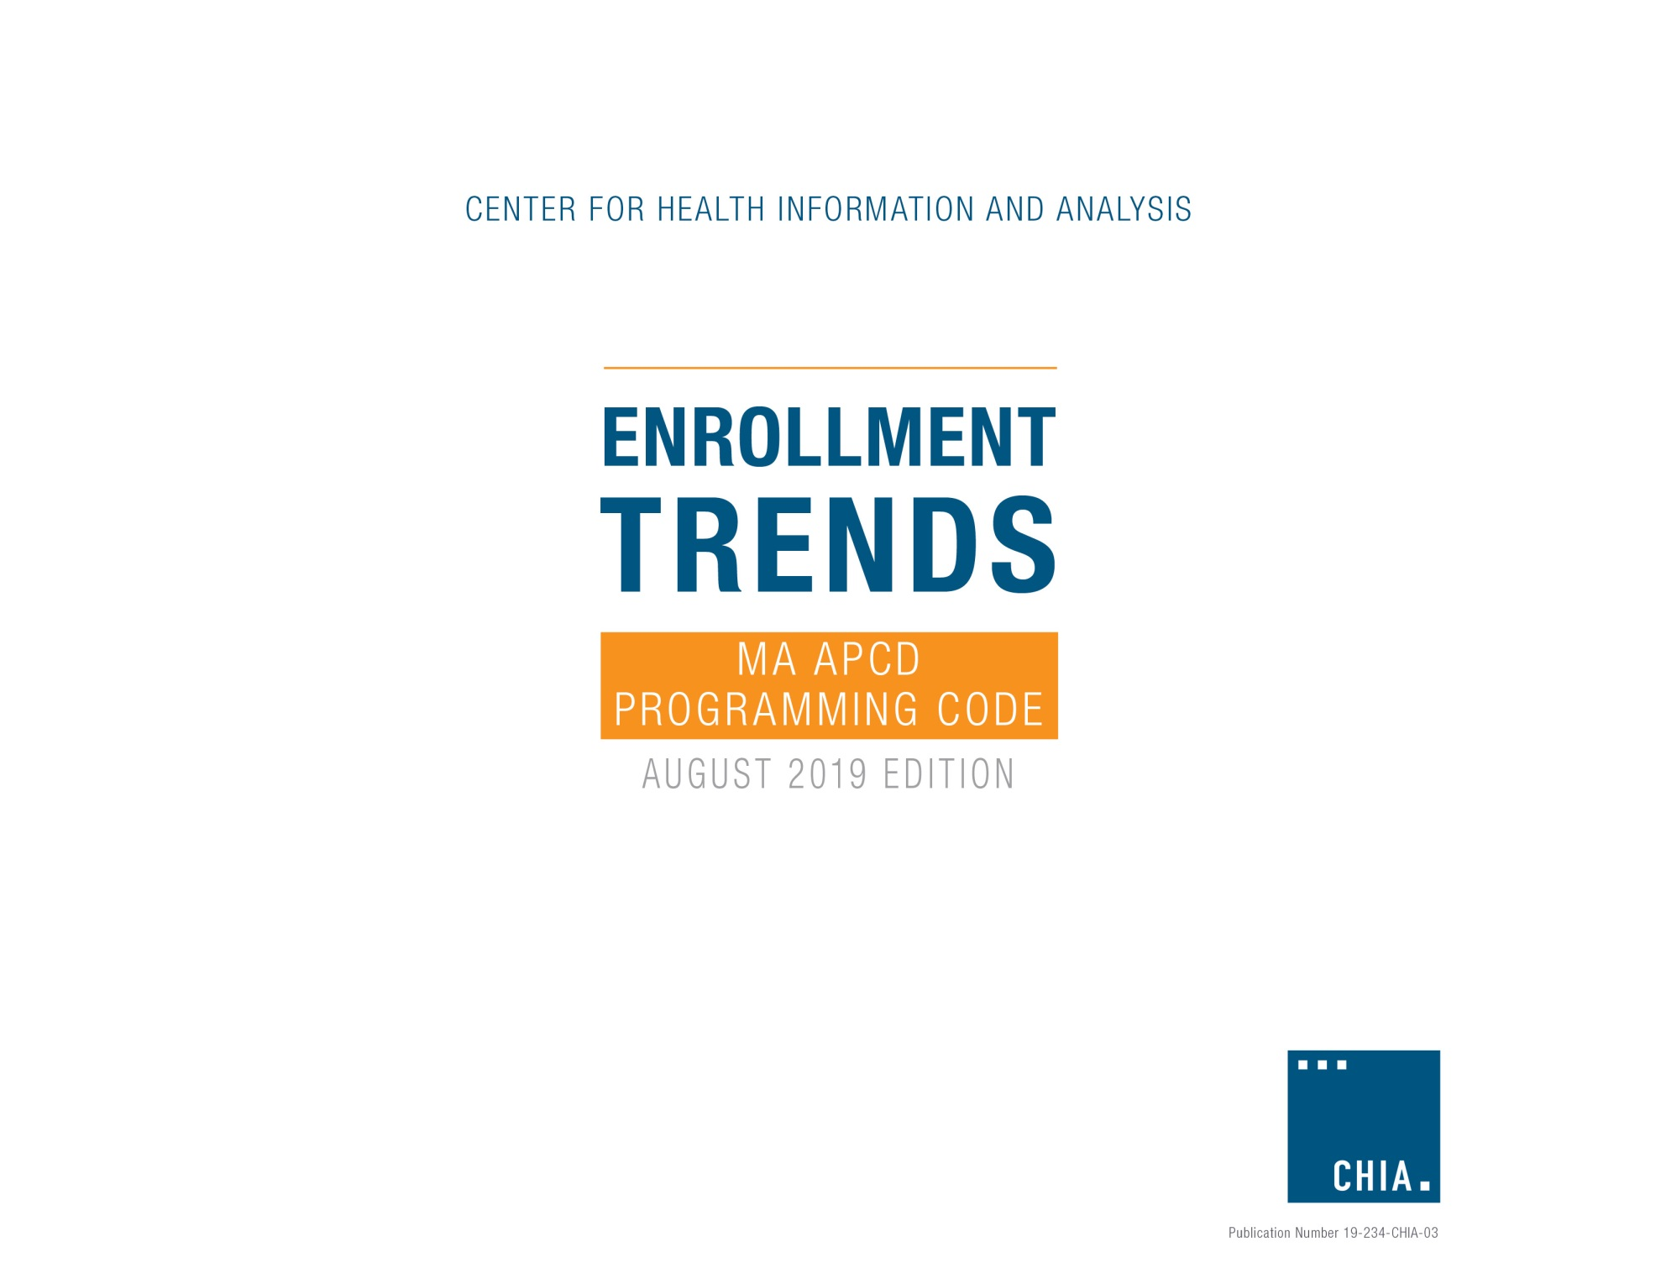

CHIA Enrollment Trends (August 2019 Edition)

MA APCD Programming Code

As described in the CHIA Enrollment Trends Technical Appendix, Enrollment Trends monitors unique Massachusetts residents with primary medical insurance coverage using eligibility data from the Massachusetts All Payer Claims Database (MA APCD). MA APCD membership reports are generated on a bi-annual basis and sourced from the most recently submitted payer-specific Member Eligibility (ME) file. Twenty-four months of membership data are used and segmented by product enrollment date spans.

Provided below are the methodology and programming code used by CHIA to create the MA APCD membership reports for Enrollment Trends. The methodology and code have been discussed with and reviewed by the top 14 commercial payers (and affiliated entities) but are subject to further development in order to arrive at the most accurate membership counts for each payer. On a case-by-case basis, CHIA may request supplemental data from payers to augment or replace MA APCD enrollment counts.

- Methodology

Enrollment is determined if the 15th day of the last month of each quarter (i.e., Snapshot Date) is within the Product Enrollment Start Date (ME041) and Product Enrollment End Date (ME042) of a member record (i.e., ME041 ≤ Snapshot Date ≤ ME042). Member records with NULL values for ME042 are considered actively enrolled. Members are distinguished using data element CHIACarrierSpecificUniqueMemberID (ME107) by OrgID (ME001).

MA APCD membership reports do not count duplicate member records. A unique member record is selected according to the following criteria, in order of significance:

Subset by the following:
- Massachusetts resident (ME016=MA)
- Medical coverage (ME018=1)
- Primary insurance (ME028=1)

De-duplicate by the following order:
- Coverage type (ME029)
  - ME029=(ASO, ASW) for Self-Insured
  - ME029=(UND) for Fully-Insured
  - ME029=(STN, OTH) for Other
- Last activity date (ME056)
- Member Eligibility ID (CHIA-assigned record identifier)

- Programming Code

MA APCD data extraction and aggregation are implemented in SAS, using SQL pass-through to access data in Netezza. The code below may not be inclusive of all data manipulations performed on the final output dataset.

- SAS/SQL Code

/*************************************************************************************************

SAS/SQL CODE TO EXTRACT AGGREGATE APCD MEMBERSHIP DATA FOR ENROLLMENT TRENDS REPORTING
*************************************************************************************************/

*--------------- BEGIN ACTION ITEMS -------------------------------------------

1. Initialize global variables
2. Perform additional action items below prior to running program

--------------- END ACTION ITEMS ---------------------------------------------;

* Initialize global variables;
%let DataDir= C:\EnrollmentTrends\output;
%let SYM= 201809;
%let OrgIdList= (290, 291, 295, 296, 300, 301, 302, 312, 3505, 3735, 4962, 7655, 7789, 8026, 8647, 9913, 10353, 10441, 10444, 10632, 10647, 10920, 10926, 10929, 11474, 11726, 12814, 13074, 16621);
%let Snapshot1= '2017-06-15'; *First snapshot date, format: 'yyyy-mm-dd';
%let nMonths= 3; *# of months to increment snapshot dates, Default=3 (e.g. nMonths=1 means monthly, nMonths=3 means quarterly);
%let nTimeSpan= 8; *# of time spans, Default=8 (e.g. if n=3 and nTimeSpan=8, then program will generate a snapshot date every 3 months, i.e. every quarter, for 8 quarters);

* Fixed global variables;
libname out "&DataDir.";
%let OutFile= out.ME_ET_&SYM.;
%let StartYear= %substr(&snapshot1,2,4); *Year of first snapshot date;
%let StartMonth= %substr(&snapshot1,7,2); *Month of first snapshot date;
%let StartDay= %substr(&snapshot1,10,2); *Day of first snapshot date;

option compress=binary;

/*************************************************

Begin: Netezza summary data extract
*************************************************/

*--------------- BEGIN ACTION ITEMS -------------------------------------------

Perform the checks below prior to running code

1. Review "Processing Summary" below for previous processing info
2. Check that source data is coming from correct data source

--------------- END ACTION ITEMS ---------------------------------------------;

* Processing Summary:

As of 11/16/2016: Changing snapshot date to the 15th of the month.
Extract 8 quarters, starting with snapshot date of 6/15/2017, of ME data for Enrollment Trends. The below dataset has the following characteristics:
1) The dataset has been de-duplicated (to_keep_v1= 1)
2) The dataset contains only OrgIDs relevant to Enrollment Trends
3) The dataset contains three Product fields: ProductID, ProductLineofBusinessModel, Situs
4) The dataset contains demographic fields: AgeGroup, County, and MemberGender

;

proc sql;
connect to odbc (dsn=odbc_database);
create table &OutFile. as
select * from connection to odbc (
with DateList as
(select add_months(cast(&startYear.&startMonth.&startDay. as datetime), &nMonths.*idx) as dates
from (select &Snapshot1. :: date start_date) starting_date
cross join _v_vector_idx
where idx < &nTimeSpan.
),
product as
(select OrgID
, ProductIDNumber
, ProductLineofBusinessModel
, Situs
from (select *
, row_number() over (partition by OrgID, ProductIDNumber order by SubmissionYearMonth desc) as S
from APCD_Product) PR
where S=1
)
select OrgID
, SubmissionControlID
, SubmissionYearMonth
, Dates
, InsuranceTypeCodeProduct
, MedicalCoverage
, PrimaryInsuranceIndicator
, CoverageType
, MarketCategoryCode
, SpecialCoverage
, ProductID
, ProductLineofBusinessModel
, Situs
, GIC
, RACP
, MemberMA
, County
, MemberGender
, AgeGroup
, PurchasedThroughMassachusettsExchangeFlag
, to_keep_v1
, count(*) as nrecs
from (
select MemberEligibilityID
, me.OrgID
, me.SubmissionControlID
, me.SubmissionYearMonth
, me.InsuranceTypeCodeProduct
, MedicalCoverage
, PrimaryInsuranceIndicator
, CoverageType
, me.MarketCategoryCode
, SpecialCoverage
, cast(me.ProductIDNumber as char(20)) as ProductID
, prd.ProductLineOfBusinessModel
, prd.Situs
, case when APCDIDCode='3' then 'GIC' else 'Non-GIC' end as GIC
, ProductEnrollmentStartDate as StartDate
, isnull(ProductEnrollmentEndDate,cast('99991231' as datetime)) as EndDate
, LastActivityDate
, CHIACarrierSpecificUniqueMemberID as UniqueMemberID
, MemberGenderCleaned as MemberGender
, case when months_between(Dates,ad.DT)/12 >= 0 and months_between(Dates,ad.DT)/12 < 1 then '< 1'
when months_between(Dates,ad.DT)/12 >= 1 and months_between(Dates,ad.DT)/12 < 10 then '1-9'
when months_between(Dates,ad.DT)/12 >= 10 and months_between(Dates,ad.DT)/12 < 20 then '10-19'
when months_between(Dates,ad.DT)/12 >= 20 and months_between(Dates,ad.DT)/12 < 27 then '20-26'
when months_between(Dates,ad.DT)/12 >= 27 and months_between(Dates,ad.DT)/12 < 45 then '27-44'
when months_between(Dates,ad.DT)/12 >= 45 and months_between(Dates,ad.DT)/12 < 65 then '45-64'
when months_between(Dates,ad.DT)/12 >= 65 and months_between(Dates,ad.DT)/12 < 75 then '65-74'
when months_between(Dates,ad.DT)/12 >= 75 and months_between(Dates,ad.DT)/12 < 85 then '75-84'
when months_between(Dates,ad.DT)/12 >= 85 and months_between(Dates,ad.DT)/12 < 121 then '85+'
else 'Unknown'
end as AgeGroup
, RiskAdjustmentCoveredBenefitPlan as RACP

, case when MemberStateorProvince ='MA' then 1 else 0 end as MemberMA
, case when MemberStateorProvince ='MA' then MemberCounty else 'Other' end as County
, PurchasedThroughMassachusettsExchangeFlag
, Dates
, case when lead(me.MemberEligibilityID) over (partition by me.OrgID, CHIACarrierSpecificUniqueMemberID, Dates
order by case when MemberStateorProvince='MA' then 1 else 0 end

, case when MedicalCoverage='1' then 1 else 0 end
, case when PrimaryInsuranceIndicator in ('1','3','4') then 1 else 0 end

, case when CoverageType in ('ASO', 'ASW') then 1
when CoverageType='UND' then 0
else -1 end
, LastActivityDate
, me.MemberEligibilityID)
is null then 1 else 0
end as to_keep_v1 /* De-duplication hierarchy for Enrollment Trends */

FROM APCD_MemberEligibility as me
inner join DateList
on Dates between ProductEnrollmentStartDate and isnull(ProductEnrollmentEndDate,cast('99991231' as
datetime))
left join Product as prd
on me.OrgID=prd.OrgID and me.ProductIDNumber=prd.ProductIDNumber
left join DATE_TABLE as ad /* Join to a date table to process only valid Member Date of Birth values */
on me.MemberDateofBirthYearMonth||'01' = ad.DT_YYYYMMDD
where me.SubmissionYearMonth=&SYM.
and me.OrgID in &OrgIdList.
) a
where to_keep_v1=1 /* Save out only de-duplicated records */
group by OrgID
, SubmissionControlID
, SubmissionYearMonth
, Dates
, InsuranceTypeCodeProduct
, MedicalCoverage
, PrimaryInsuranceIndicator
, CoverageType
, MarketCategoryCode
, SpecialCoverage
, ProductID
, ProductLineOfBusinessModel
, Situs
, GIC
, RACP
, MemberMA
, County
, MemberGender
, AgeGroup
, PurchasedThroughMassachusettsExchangeFlag
, to_keep_v1
order by 1,2,3,4
);
disconnect from odbc;
quit;

/*************************************************

End: Netezza summary data extract
*************************************************/

* Apply hard-coded groupings
Macro Input: dataEdit(name of input dataset, name of output dataset)
Macro Output: a temporary SAS dataset
;

proc format;
value OrgName
290, 7655, 10353, 10441, 10442, 10647, 10929, 11745 = 'Aetna'
3735 = 'AllWays (NHP)'
16621 = 'AllWays'
10632 = 'Anthem'
291 = 'BCBS'
3505 = 'BMC'
10920 = 'CeltiCare'
293, 295, 7422, 10447, 11474, 11499, 11726, 11215 = 'CIGNA'
296, 8026 = 'Fallon'
300, 13074 = 'HPHC'
302 = 'HPI'
301 = 'HNE'
3156 = 'MassHealth'
12226 = 'Minuteman'
4962 = 'THPP'
9913 = 'SWH'
8647 = 'Tufts'
312, 313, 7789, 10444, 10925, 10926, 10932, 10933, 10934, 10935, 12814 = 'United'
other = 'Other'
;

value $MktSect
'IND', 'GCV', 'ISCO' = 'Individual'
'GS1', 'GS2', 'GS3' = 'Small Group (1-25)'
'GS4' = 'Small Group (26-50)'
'GLG1' = 'Mid-Size Group (51-100)'
'GLG2', 'GLG3' = 'Large Group (101-500)'
'GLG4' = 'Jumbo-Size Group (501+)'
'GSA' = 'Qualified Association'
other = 'Other'
;

value $CovType
'UND' = 'Fully-Insured'
'ASO', 'ASW' = 'Self-Insured'
other = 'Other'
;

value $ProdType

'MC', 'MO', '30' = 'Medicaid'
'CC' = 'Commonwealth Care'
'CE' = 'Commonwealth Choice'
'HM' = 'HMO'
'12' = 'PPO'
'13' = 'POS'
'14' = 'EPO'
'15' = 'Indemnity'
'16', 'HN', '20' = 'Medicare'
'IC' = 'OneCare'
'SC' = 'Senior Care Options'
other = 'Other'
;

/* Group HPI (OrgID 302) under HPHC for reporting purposes.*/
value OrgNameReport
290, 7655, 10353, 10441, 10442, 10647, 10929, 11745 = 'Aetna'
3735, 16621 = 'AllWays'
10632 = 'Anthem'
291 = 'BCBS'
3505 = 'BMC'
10920 = 'CeltiCare'
293, 295, 7422, 10447, 11474, 11499, 11726, 11215 = 'CIGNA'
296, 8026 = 'Fallon'
300, 302, 13074 = 'HPHC'
301 = 'HNE'
3156 = 'MassHealth'
12226 = 'Minuteman'
9913 = 'SWH'
8647 = 'Tufts'
4962 = 'THPP'
312, 313, 7789, 10444, 10925, 10926, 10932, 10933, 10934, 10935, 12814 = 'United'
other = 'Other'
;
run;

%macro dataEdit(dataInfile, dataOutfile);
PROC SQL;
CREATE TABLE &dataOutfile. AS
SELECT *
, CASE WHEN ORGID=300 AND INSURANCETYPECODEPRODUCT='15' THEN '2'
when ORGID in (290, 7655, 10353, 10441, 10442, 10647, 10929, 11745) and PRIMARYINSURANCEINDICATOR='3' then '2'
ELSE PRIMARYINSURANCEINDICATOR
END AS PRIMARYCOVERAGE
, put(MarketCategoryCode, $MktSect.) as GROUPSIZE
/* Finding: United (OrgID=7789) is a student health plan, which is classified as CoverageType='STN'. Resolution: Need to hardcode MARKET='Fully-Insured' for ET reporting. */
, CASE WHEN ORGID=7789 THEN
CASE WHEN CoverageType in ('STN', 'UND') THEN 'Fully-Insured'
WHEN CoverageType in ('ASO', 'ASW') THEN 'Self-Insured'
ELSE 'Other' END
ELSE put(CoverageType, $CovType.) end as MARKET
, CASE WHEN OrgID=8026 and InsuranceTypeCodeProduct='ZZ' and MarketCategoryCode='ISCO' THEN 'Senior Care Options'
ELSE put(InsuranceTypeCodeProduct, $ProdType.)
END AS PLANTYPE
, put(OrgId, OrgName.) as CompanyName
, put(OrgID, OrgNameReport.) as CompanyName_Report
FROM &dataInfile.;
QUIT;

* Double check to make sure the County field is a true Massachusetts-based county;

PROC SQL;

CREATE TABLE &dataOutfile. AS
SELECT *
, CASE WHEN UPCASE(County) in ('BARNSTABLE', 'BERKSHIRE', 'BRISTOL', 'DUKES', 'ESSEX',

'FRANKLIN', 'HAMPDEN', 'HAMPSHIRE', 'MIDDLESEX', 'NANTUCKET', 'NORFOLK',

'PLYMOUTH', 'SUFFOLK', 'WORCESTER', '') THEN County
ELSE 'Other'
END AS MEMBERCOUNTY
FROM &dataOutfile.

QUIT;

%mend dataEdit;

%dataEdit(out.ME_ET_&SYM., out.report_&SYM.);

/* Export data into txt-file to pivot in Power Pivot */
proc sql noprint;
select '"'||trim(name)||'"'
into :vars
separated by "'|'"
from dictionary.columns
where upcase(libname)=upcase("out") and
upcase(memname)=upcase("Report_&SYM.")
;
quit;

filename outfile "&DataDir.\ET_&SYM..txt";
data _null_;
file outfile delimiter='|' DSD DROPOVER lrecl=32767;
if _n_ = 1 then do;
put &vars.;
end;
set out.Report_&SYM. (obs=max);
put (_all_) (+0) ;
run;

/*************************************************

End: Export summary data extract
*************************************************/

ConnectiCare is not included in reporting due to low Massachusetts enrollment.
Include ME028=(3, 4) if the payer stores primary insurance as such in its system.
This selection hierarchy is to ensure that self-insured plans are given preference over fully-insured plans for members with concurrent enrollment in both self-insured and fully-insured coverage.
CHIA is providing this methodology and programming code as a convenience. It has been prepared for informational purposes only and is based on information believed to be reliable. The methodology and programming code are subject to change without notice. CHIA does not provide any guarantee or opinion on its accuracy. CHIA disclaims any liability for the improper or incorrect use of the information contained herein.

