CENTER FOR HEALTH INFORMATION AND ANALYSIS

SUBMISSIONS

FILE SECURE 2.0
UPLOAD INSTRUCTIONS

VERSION 6.0

SEPTEMBER 2017

Contents

Introduction ..................................................................................................................................................... 2 Software Prerequisites ..................................................................................................................................... 2 Installing the SFTP Client ................................................................................................................................. 4 Installing the File Secure Application Executable Zip File ..................................................................................... 8 Uploading the Encrypted Submission File from SFTP ........................................................................................ 17 How to Retrieve Reports from File Secure ........................................................................................................ 20
DATE | VERSION NO. |  | WRITER | NOTES
3 October 2016 | 1.01 |  | CHIA | Initial release
02 February 2017 | 2.0 |  | CHIA | Updated release
16 February 2017 | 3.00 |  | CHIA | Updated release with feedback
30 March 2017 | 4.00 |  | CHIA | Update with CHIA File Secure Install instructions
17 May 2017 | 5.00 |  | CHIA | Update with New Upload Instructions
31 August 2017 | 6.00 |  | CHIA | Updates to FileSecure workflow

Introduction

This document outlines the procedure for uploading APCD submission data to CHIA. The procedure essentially consists of two steps:

1. Use the File Secure executable provided by CHIA to encrypt the submission file prior to transmission.
2. Use an SFTP client of your choice to transfer the CHIA submission file from your PC to CHIA’s submission
SFTP site at connect.chia.state.ma.us

Software Prerequisites

The following software is required. Please make sure to have all the listed software available for installation before continuing.

1. A SFTP client of your choice. CHIA has verified that the following SFTP clients will reliably work with this process:

n Filezilla – available at https://filezilla-project.org/ Cost: FREE

n WinSCP – available at https://winscp.net/eng/download.php Cost : FREE

n PuTTY/pSFTP – available at http://www.chiark.greenend.org.uk/~sgtatham/putty/download.html Cost:
FREE

n VanDyke SecureSFX – available at https://www.vandyke.com/ Cost: Commercial (about $85/seat)

n NOTE: The File Secure application has been tested and certified to work with the above SFTP programs. There is no guarantee that File Secure will work with any other SFTP program (home grown or otherwise). Please consult with your local IT Security organization for further
guidance.

2. A CHIA supplied username and password for the connect.chia.state.ma.us SFTP site.
3. CHIA provided File Secure Application executable zip file to encrypt the submission file prior to submission to CHIA.

IMPORTANT NOTE ABOUT THE FREE SFTP CLIENTS:

Please make sure to download the free clients ONLY FROM THE LINKS PROVIDED ABOVE. These links are the official repositories for the software and are provided by the authors of the software. These utilities can also be found on numerous other 3rd party download sites where they may include additional unwanted adware or potential malware, such as viruses/Trojans. Only use the links provided in this document and make sure to obtain the latest version of this document from CHIA at: www.chiamass.gov.

CHIA SUPPORT:

If you have any questions or technical issues, please contact the Center for Health Information and Analysis' Help
Desk.
Phone: 617-701-8217.
Email: CHIA-DL-Data-Submitter-HelpDesk@MassMail.State.MA.US

Installing the SFTP Client

The exact steps for installing each SFTP client will vary somewhat, but largely consist of running some sort of setup.exe or setup.msi. The exception is PuTTY’s pSFTP which is distributed as a standalone exe that can be used as is. Please consult the installation instructions for your selected client.

Step 1. Connecting to connect.chia.state.ma.us via SFTP

The process for connecting and transferring the files will vary by SFTP client used. For purposes of illustration, CHIA is providing detailed instructions for Filezilla (because it works well and is free), but you are free to use any SFTP client that you prefer.

Note: If you already have a SFTP client installed, proceed to Step 4 (page 7). Start the Filezilla client.
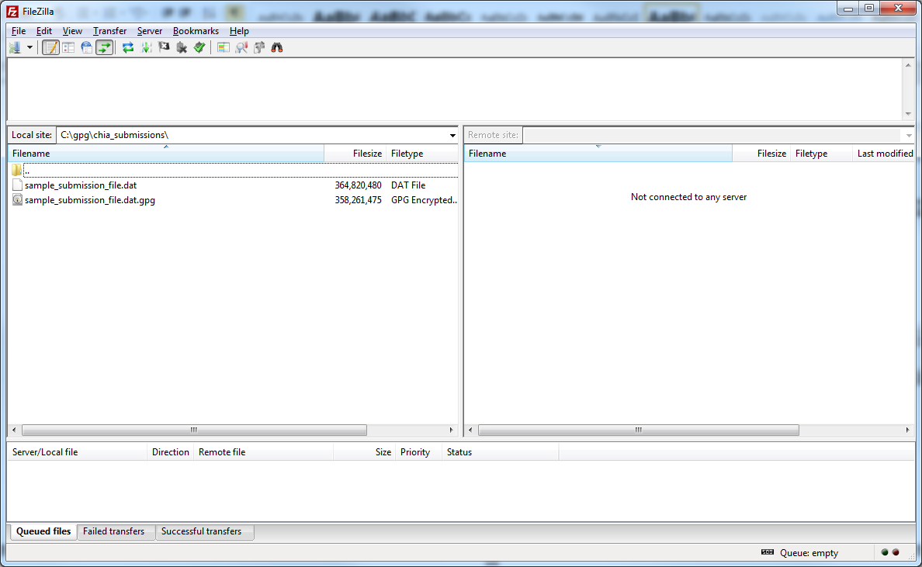

Step 2. Create the SFTP Site Connection for connect.chia.state.ma.us

If this is the first time you’re using Filezilla, you’ll have to create the SFTP site. Go to File-> Site Manager

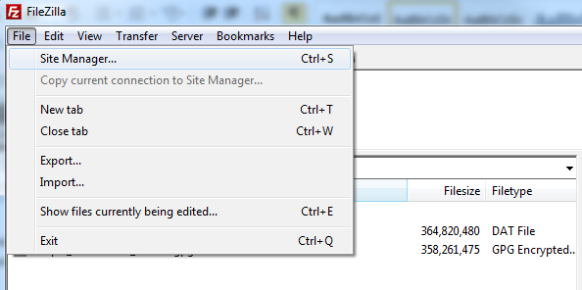
Step 3.

You’ll be presented with a screen similar to the following. Enter the data as shown to create the site. Under the Site details section input the following information:
Host: connect.chia.state.ma.us
Port: 22
Protocol: SFTP – SSH File Transfer Protocol
Logon Type: Ask for password
User: Blank (you will be prompted on connection)
Password: Blank (you will be prompted on connection)

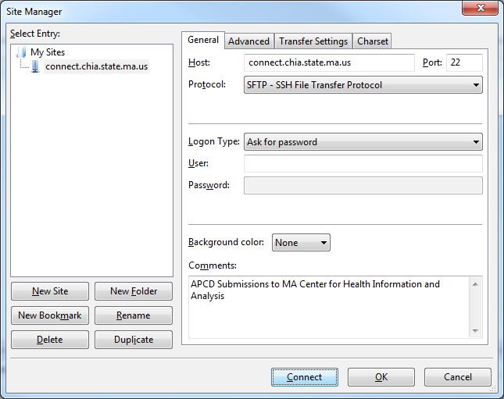

Press OK to save your changes.

Step 4. Connecting to connect.chia.state.ma.us

Click on the Site Manager icon in the toolbar and select the entry for connect.chia.state.ma.us.

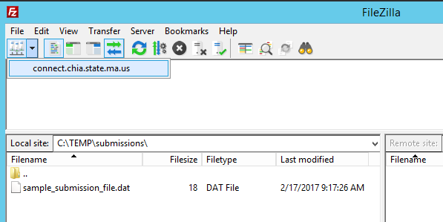

You’ll be prompted with a login box. Please enter the credentials that have been supplied by CHIA:

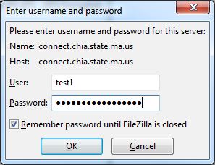
log into SENDSPlus and INET.)

Installing the File Secure Application Executable File

Access CHIA Submissions at: https://chiasubmissions.chia.state.ma.us/

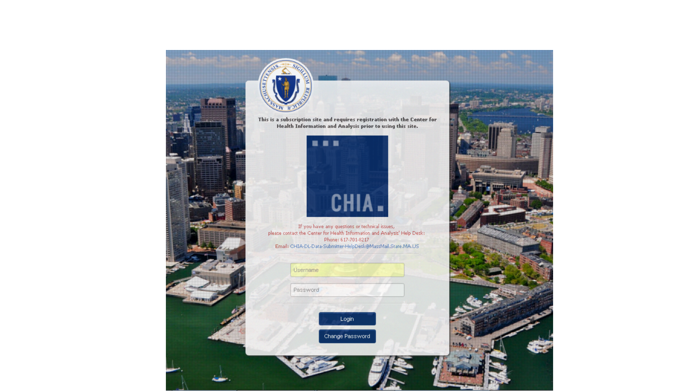n Enter Username and Password and click ‘Login’ (This is the same Username and Password that you use to

On the Select Application screen, click on the button labelled “FileSecure”

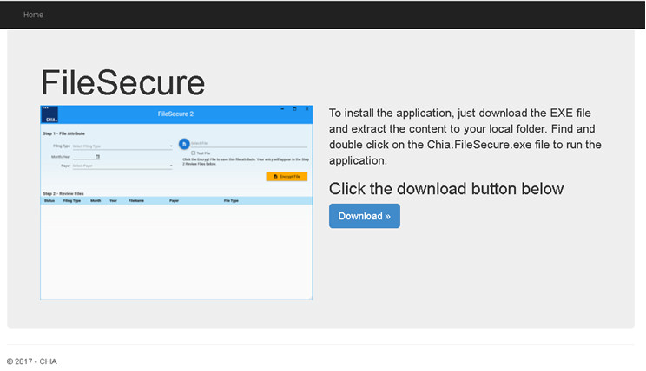

C ser.

he following screen will appear:

licking on the ‘Download >>’ button will start the local download of the executable file through the current brow

Clicking on the executable file will start the extraction process to the following address:

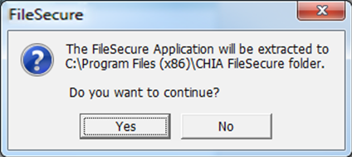

Clicking “Yes” will extract the files, “No” will cancel this process.

During extraction, a shortcut file will populate in the current user’s desktop.

IMPORTANT NOTE: Each user must sign into CHIASubmissions and download their own version of

FileSecure. Downloading of this system is user driven and will limit privileges based on requested access.

To launch the application click on the file named “Chia.FileSecure.exe” in the address ‘C:/Program Files (x86)/CHIA FileSecure’ folder, or shortcut found on the desktop, to see the following screen:

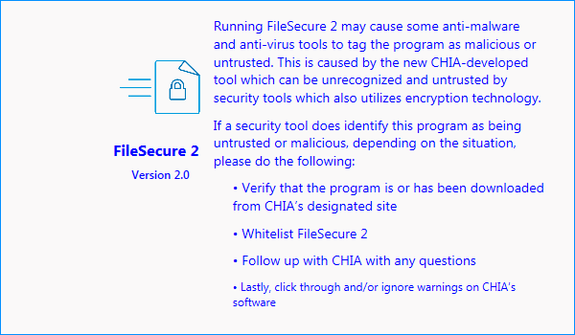

IMPORTANT NOTE: Running FileSecure may cause some anti-malware and anti-virus tools to tag the program as malicious or untrusted. This is caused by the new CHIA-developed tool which can be unrecognized and untrusted by security tools which also utilizes encryption technology.

If a security tool does identify this program as being untrusted or malicious, depending on the situation, please do the following:
n Verify that the program is or has been downloaded from CHIA’s designated site
n Whitelist FileSecure. Please consult your IT Security organization.
n Follow up with CHIA with any questions
n Lastly, click through and/or ignore warnings on CHIA’s software

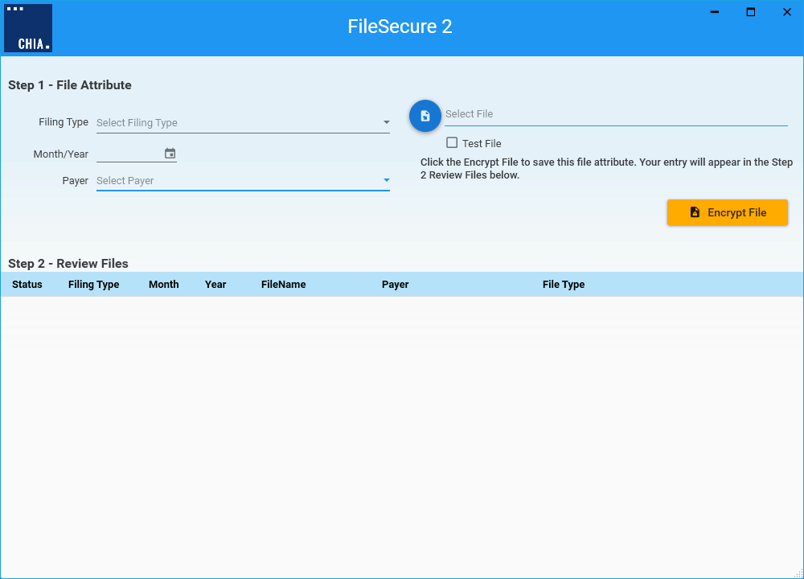

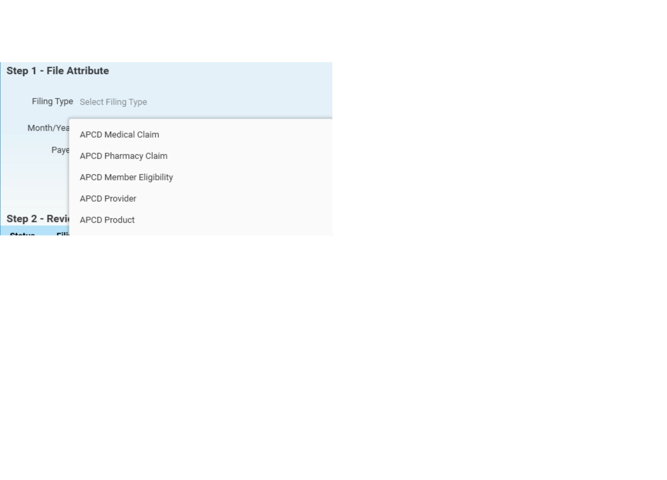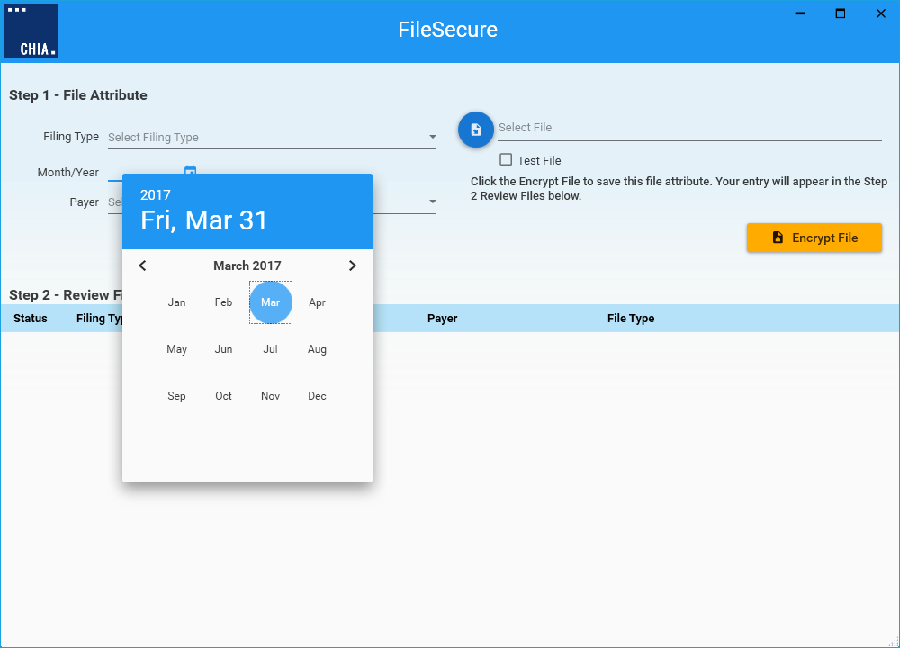

September 2017

To start, click on the Filing Type dropdown, select the appropriate filing type.

Click on the Year and Month to identify the submission’s month and year of the submission.
Page 11

Click on the ‘Select File’ to open File Explorer. Find the file that will be encrypted. After choosing the file, click on the
‘Open’ button. Note – specifying the destination folder of the encryption file will need to be identified before selecting a file to be encrypted. This is identified on page 16.

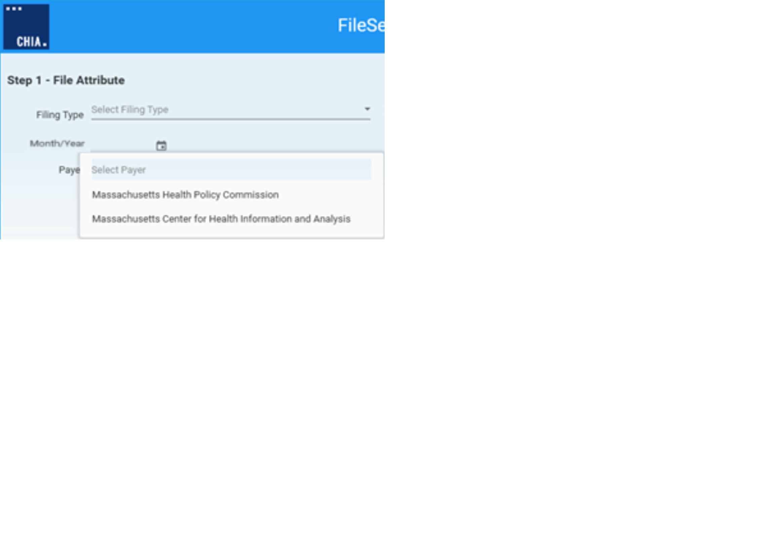Click on the associated Payer for the file to be encrypted.

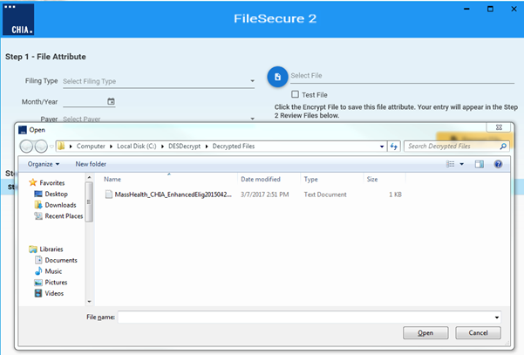

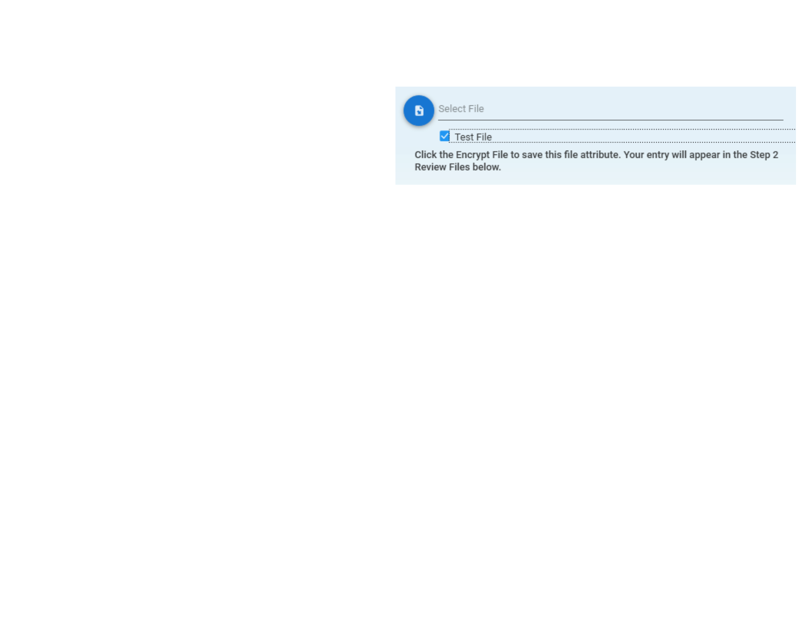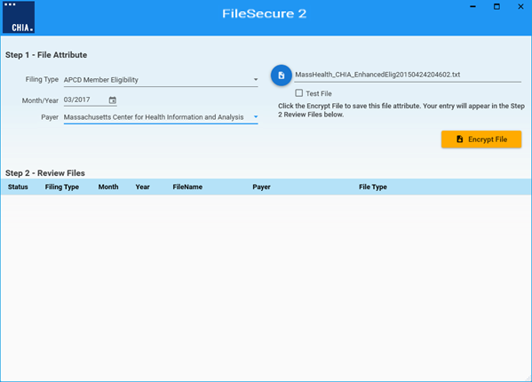
heckbox that will identify that the file being end of the file name.
Under the ‘Select File’ field, the Test parameter can be found. This is a c encrypted should be treated as testing data and will include “Test” at the

Click on the ‘Encrypt File’ button to start the encryption process. The sta of the window.

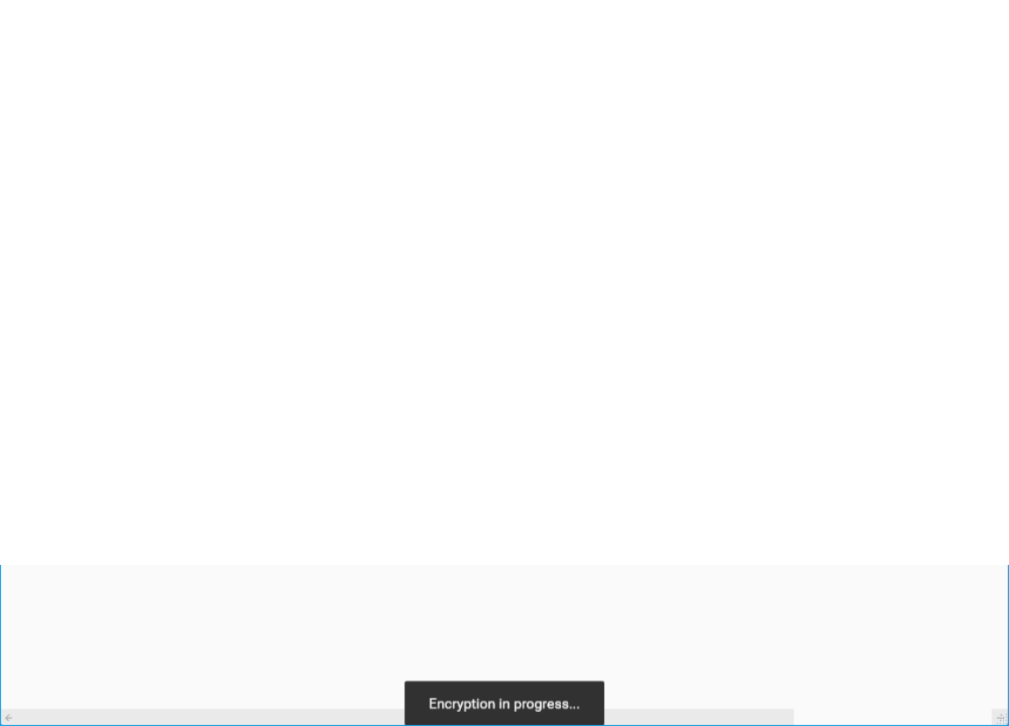tus of the process will display at the bottom

When the file has been successfully encrypted, the following message w

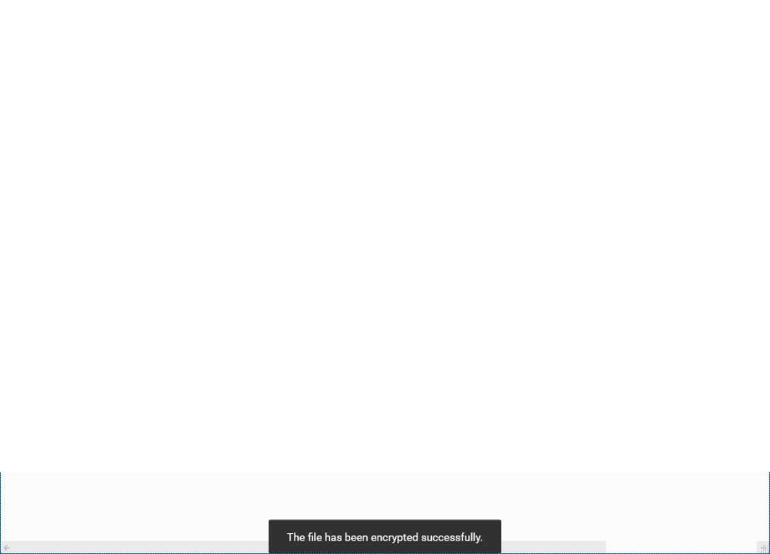ill appear:

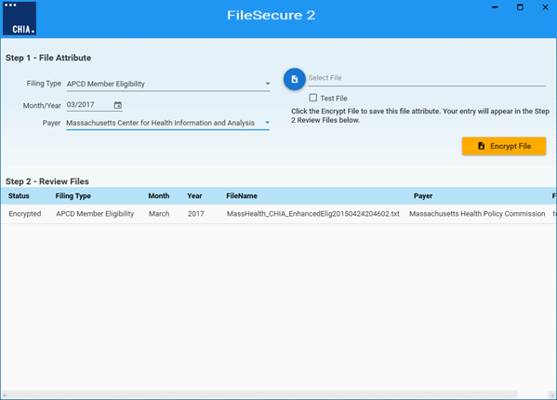
will need to be chosen. The list of encrypted files can be found by clicking on the CHIA icon and selecting “Browse
Encrypted Files”:

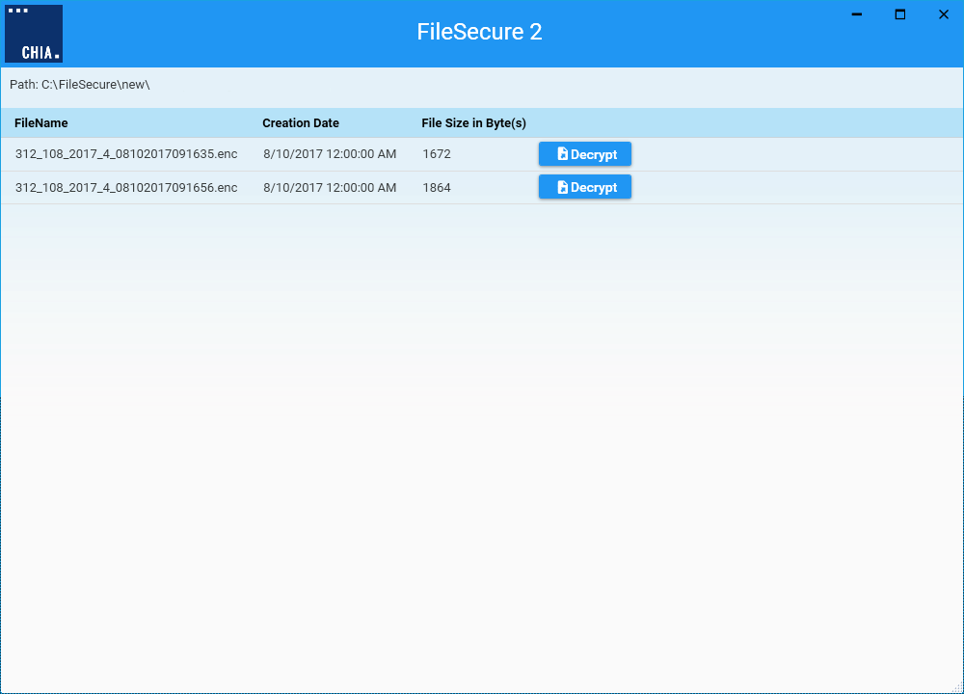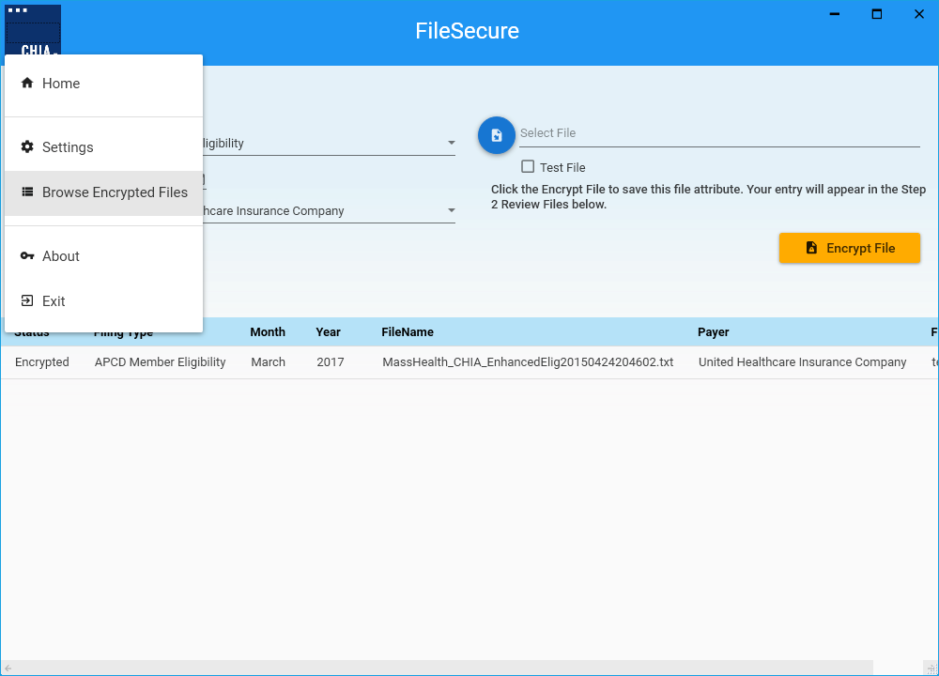

The list of encrypted files is dependent on the path that is established. Each file in the list can be decrypted by clicking on the ‘Decrypt’ button. Before the file can be decrypted, a location of the file is selected.

To change the default location, click on the CHIA icon and select Settings from the File menu.

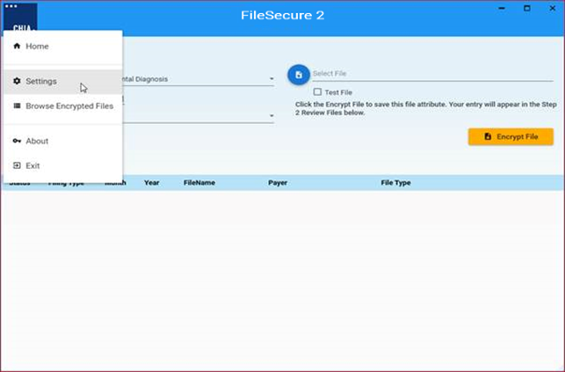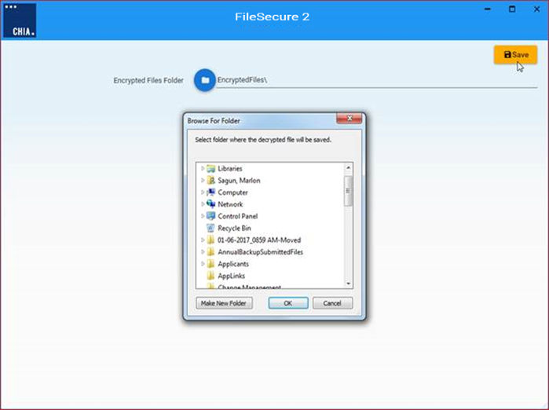Click on the folder icon to select the desired folder location. 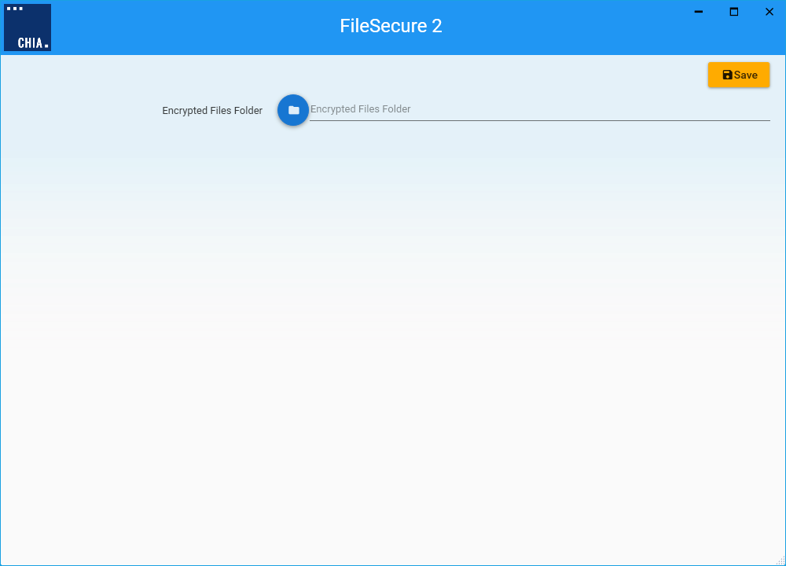 utton, click the Save button to save your

After setting the folder location on the dialog window and hitting the OK b settings.

Click the CHIA icon and select Home to go back to the main window.

Uploading the Encrypted Submission File from SFTP

After installing the SFTP client from Step 4 (page 7) AND after installing the File Secure application executable (page
8), you are ready to upload the encrypted CHIA submission file. You will log into the Connect.Chia.State.MA.US site. Upon successful login to the site, you’ll see something similar to the following. There will be a single folder that corresponds to your Org ID.

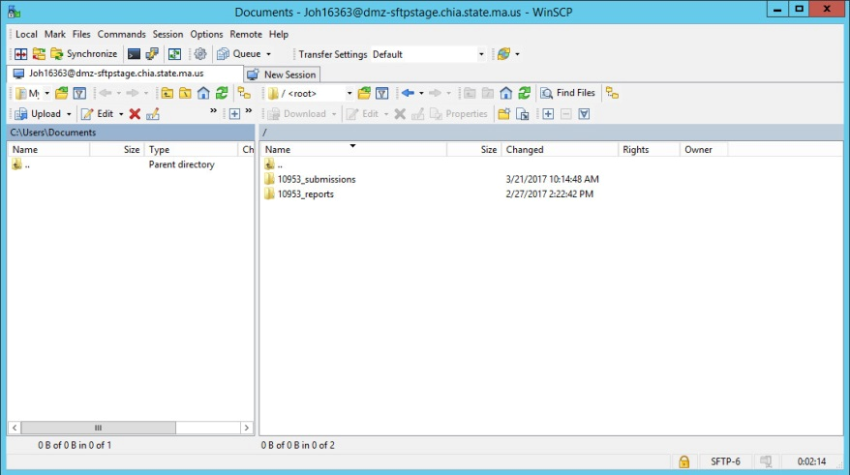

Note that the Org ID of 10953 is used for illustration purposes only.

You must select the Org ID folder before attempting to upload files.

For illustration purposes, we’ll use the 10953 directory. Progress of the file transfer and remaining estimated time of transfer will be shown in the status window as seen below:

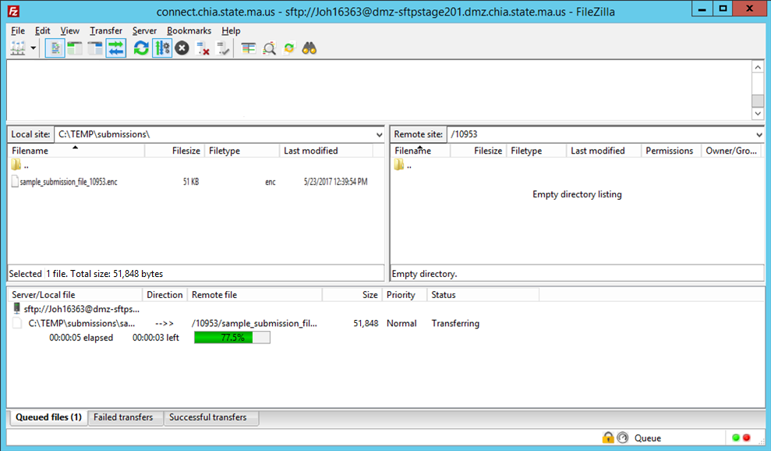

Once the file has been successfully transferred, you’ll see something like the following:

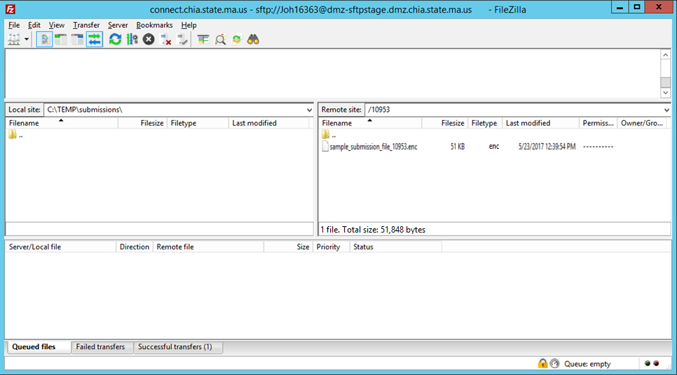

You may now safely disconnect from the site by either closing the SFTP application or manually disconnecting by going to Server->Disconnect. If you do not manually disconnect, you will be forcefully disconnected by the server after 5 minutes of inactivity has passed.

How to Retrieve Reports from File Secure

For each submission, each attempt per file, a report will be generated and placed into the ‘Report’ folder, found using the sFTP application.

This report, which is in PDF format, will act as the receipt of the file submitted. The naming convention for the file is reflected by the file type that was submitted:

“OrgID_File Type_Submission Identifier_Submission Year_Submission Month”

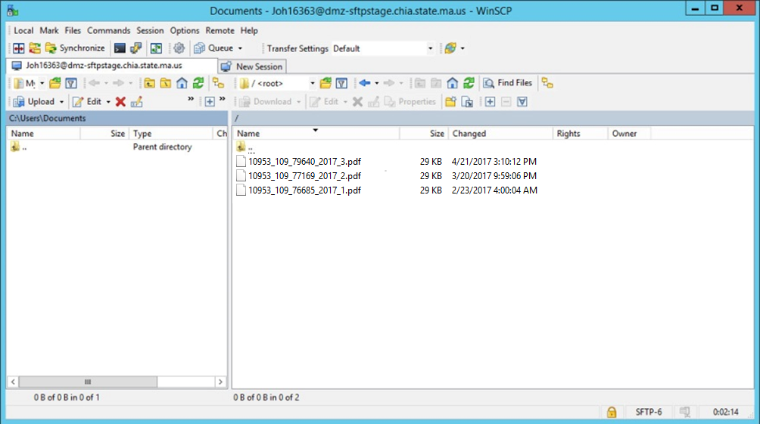

This report will include a summary and list of any errors that were identified during the submission process. When a file fails or is dropped, due to an error or issue during submission, a liasion will reach out to assist in correcting the issue for a re-file.

For more information, please contact:

CENTER FOR HEALTH INFORMATION AND ANALYSIS

501 Boylston Street www.chiamass.gov
Boston, MA 02116 @Mass_CHIA (617) 701-8100

