CENTER FOR HEALTH INFORMATION AND ANALYSIS

FREQUENTLY ASKED QUESTIONS (FAQS)

ON USING CHIA’S FILE SECURE PLATFORM AND SFTP
VERSION 2.0

NOVEMBER 2017

CHIA

Frequently Asked Questions (FAQs) on Using CHIA’s File
Secure Platform and SFTP

Table of Contents

Desktop Requirements ................................................................................................................. 2

Q. .......................................................................................................................................... 2

A............................................................................................................................................ 2

IP & Protocol Information .............................................................................................................. 2

Q. .......................................................................................................................................... 3

A............................................................................................................................................ 3

Port Mismatch/Active Refusal ....................................................................................................... 4

Q. .......................................................................................................................................... 4

A............................................................................................................................................ 4

A............................................................................................................................................ 5

Authentication Failures ................................................................................................................. 6

Q. .......................................................................................................................................... 6

A............................................................................................................................................ 7

Q. .......................................................................................................................................... 7

A............................................................................................................................................ 7

Software Incompatibility ................................................................................................................ 8

Q. .......................................................................................................................................... 8

A............................................................................................................................................ 8

Proxy Issues ................................................................................................................................. 9

Q. .......................................................................................................................................... 9

A............................................................................................................................................ 9

File Part Error ............................................................................................................................. 10

Q. ........................................................................................................................................ 10

A.......................................................................................................................................... 10

Submission Issue(s) ................................................................................................................... 12

Q. ........................................................................................................................................ 12

A.......................................................................................................................................... 12

Desktop Requirements

Q. What are the desktop requirements to run File Secure?

A. File Secure has been tested and certified to run under:

Windows 7 & 10 64 Bit Note: File Secure will NOT run under Windows XP)
The most recent Microsoft updates as of 7/2017 with .NET Framework 4.5.1 enabled.

Link to update .NET framework: URL https://www.microsoft.com/en- us/download/confirmation.aspx?id=53344.

IP & Protocol Information

If the user runs into firewall or network connectivity issues, they or their IT administrators will need to check the following:

Hostname

The hostname is connect.chia.state.ma.us. The hostname must be used when connecting. The IP address should not be used.

IP Address

If the user’s network has any firewalls or protections in place, the user’s IT administrators may need to whitelist the external IP of the CHIA SFTP server. This IP is 144.121.10.108. The port that will need to be whitelisted is 22.

Connection Refused

Q. Why am I getting a “Connection refused” or similar message? FileZilla

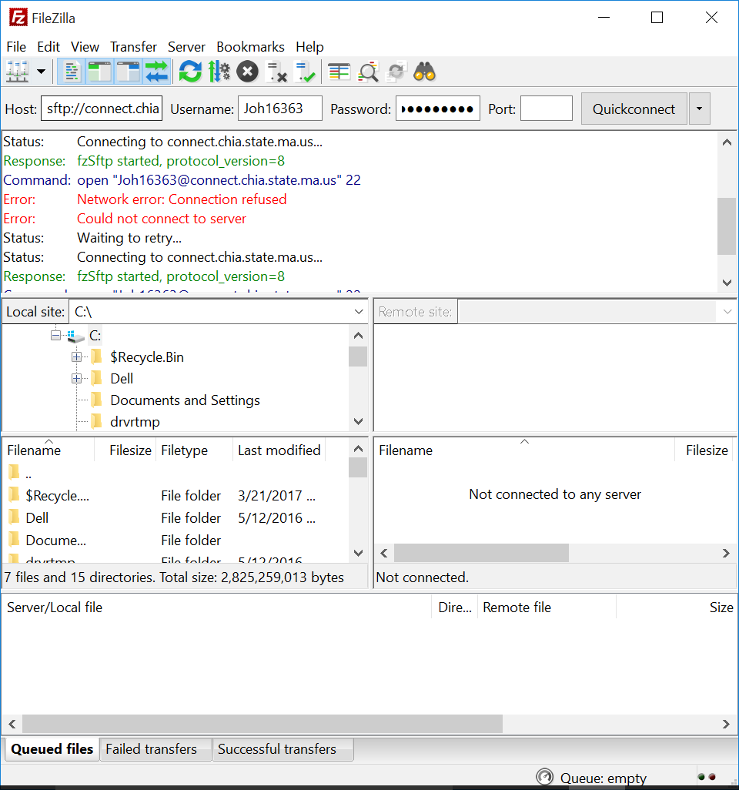

PSFTP

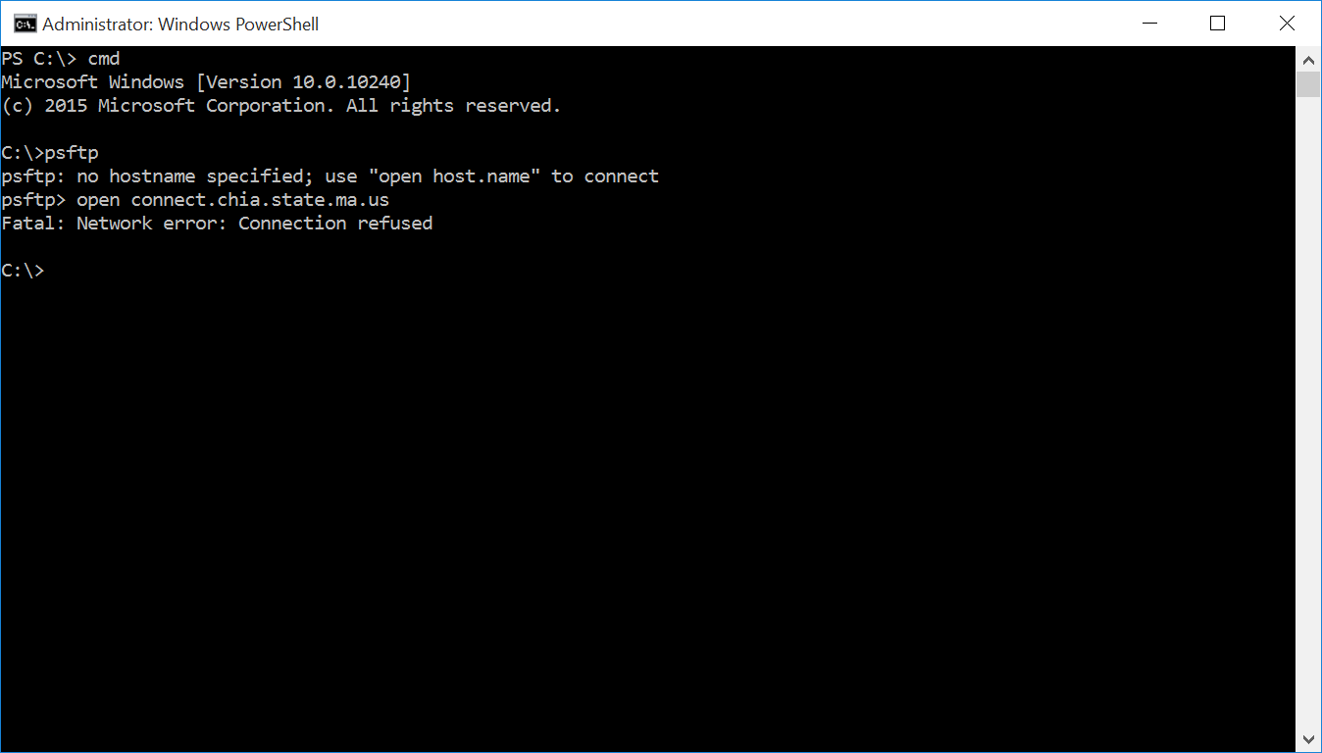

A. Using either FileZilla or PSFTP, there is some network connectivity issue preventing the user from connecting to CHIA’s SFTP environment. We recommend the user recommend you work with your local IT Security/Network team to resolve the connectivity issue.

Port Mismatch/Active Refusal

Q. Why am I getting an ECONNREFUSED or a “target machine actively refused” error? FileZilla

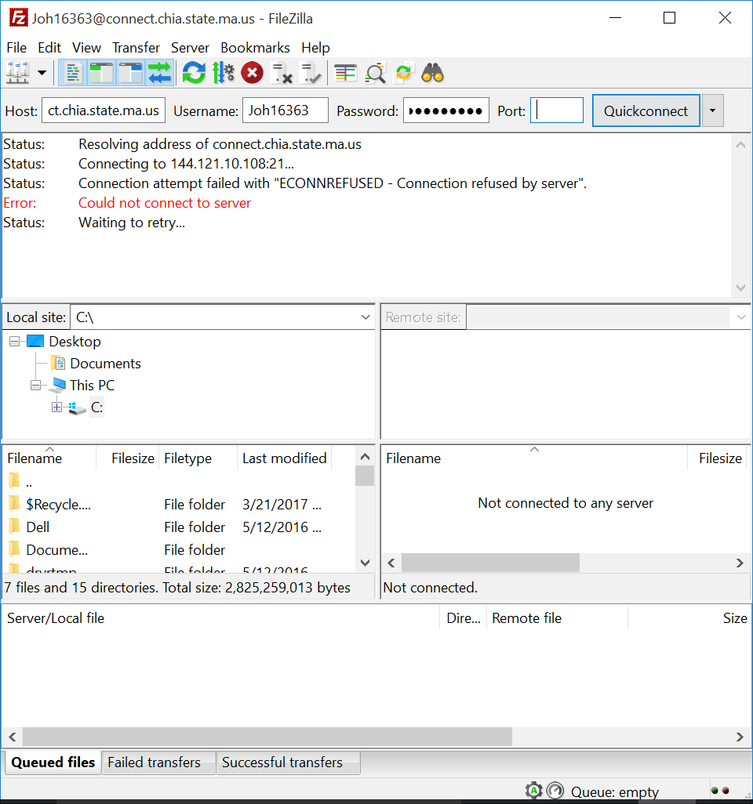

WinSCP

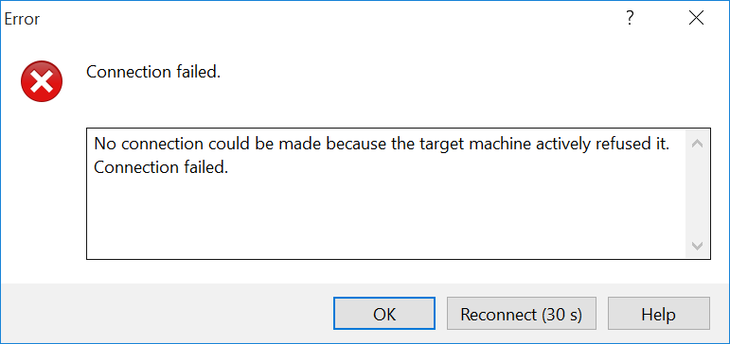

A. These errors reflect using the wrong port. In the SFTP client the user is using, s/he must be using port
22 and the SFTP protocol.

WinSCP

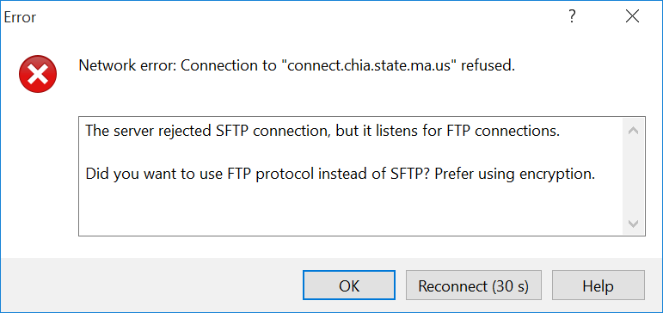

A. This error is usually generated when there is a firewall blocking traffic between the SFTP client and CHIA’s SFTP servers. The user will need to contact their IT or Firewall administrators and provide the following information to them in order to allow the traffic:

IP Address: 144.121.10.108 (connect.chia.state.ma.us is at this address)
Port: 22 (used by the SFTP traffic)

If users continue to see the same error, despite allowing this type of traffic to CHIA’s servers, then the problem should be elevated to IT.

Authentication Failures

Q. Why am I getting an authentication failure? FileZilla

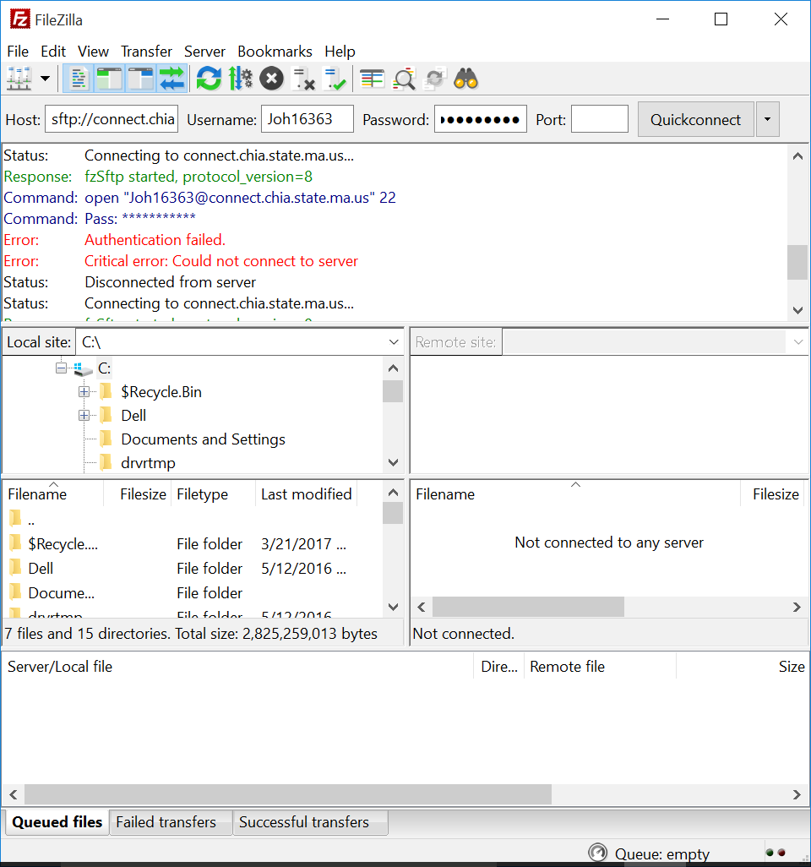

PSFTP

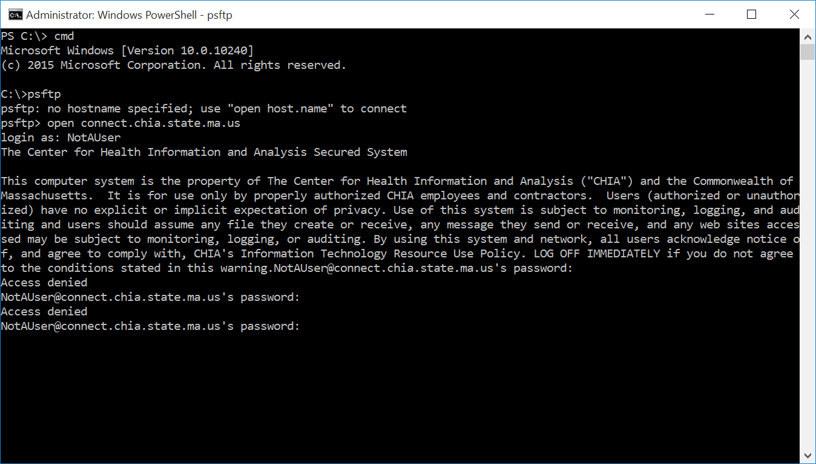

WinSCP

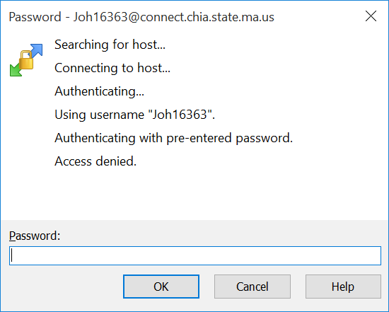

A. The likeliest answer is that the user is putting in the wrong credentials. The user should request a password reset via the CHIA Submissions site. However, if the new password (after running through the password reset process) still fails, then this problem should be escalated to CHIA IT.

Q. I am getting the following error message:

Permission denied. Error code: 3
Error message from server (en): Access is denied

A. The likeliest answer is that the user is putting in the wrong credentials. The user should request a password reset via the CHIA Submissions site.

Software Incompatibility

Q. I am getting the following message after downloading and unzipping (using 7-zip) the file secure zipped file. However, when I click on the executable file Chia.FileSecure.exe I get the following
error:

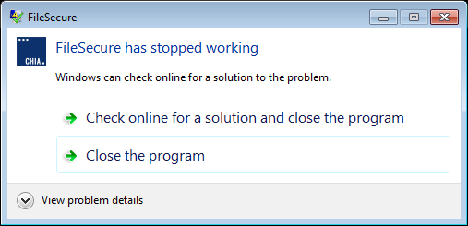

A. The likely cause is that there is an older version of the .Net framework installed on your PC because it may not have the most recent Microsoft updates. Download and install the latest .Net Framework version or through this URL: https://www.microsoft.com/en-us/download/confirmation.aspx?id=53344.

Proxy Issues

Q. Why am I getting proxy authentication errors? FileZilla

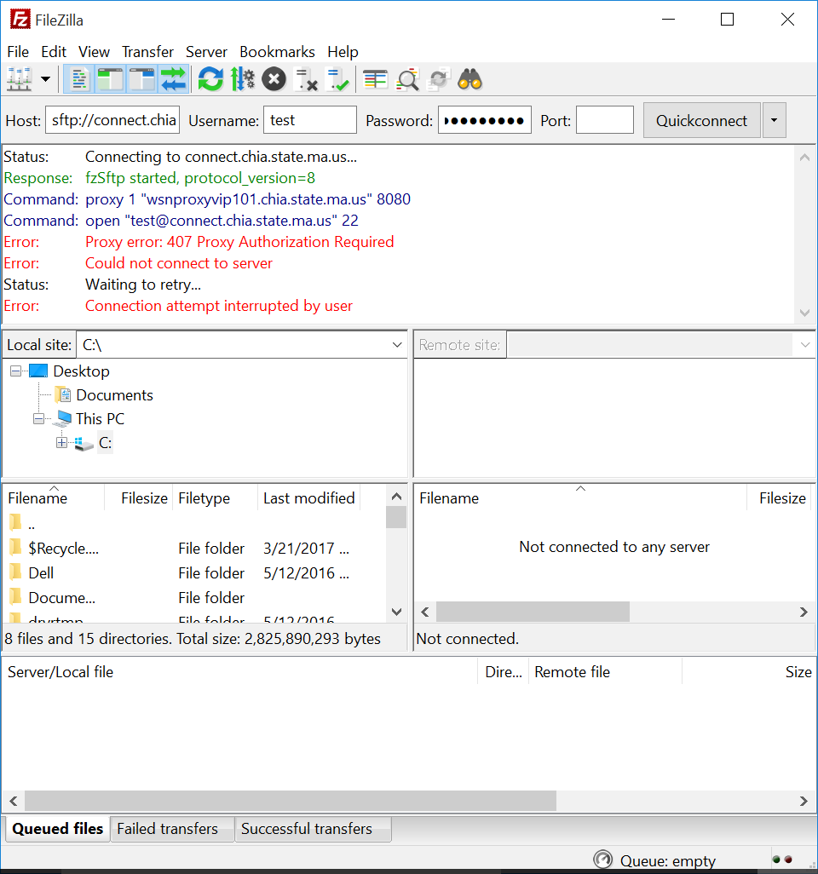

WinSCP

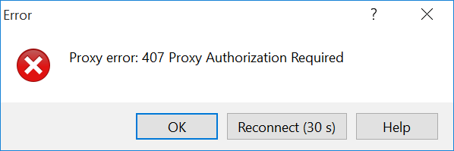

A. This problem usually is indicative that a user has a proxy in their organization’s environment. They will need to reach out to their IT organization to rectify the issue. But it is possible to do SFTP through a proxy.

File Part Error

Q. Why am I getting the following error?

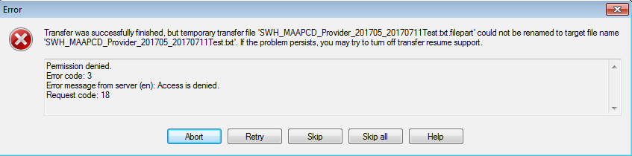
A. This error message appears when using WinSCP. The condition that creates is caused by some network interruption during the file transfer process. Below are instructions to disable the default conditions in WinSCP that could cause this error to appear during file transfer:

Procedure:
1) In WinSCP, go to Tools -> Preferences…

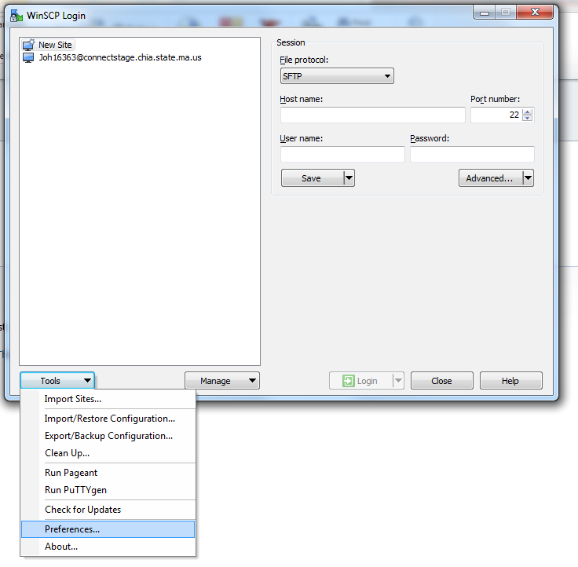November 2017 10

2) Go to Endurance
3) Under Enable transfer resume/transfer to temporary filename for…, select Disable.

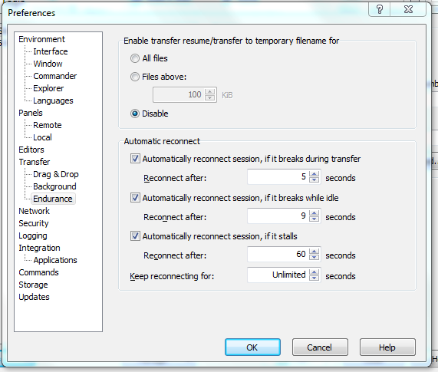

Submission Issue(s)

Q. Why am I getting the following error upon submission?

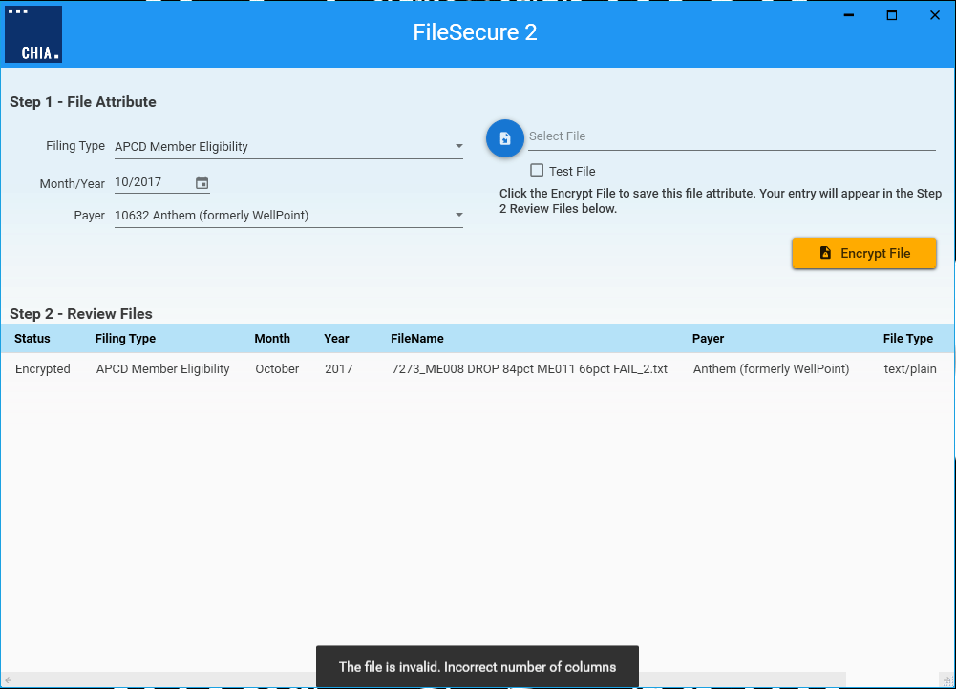
A. There is a new check for how many fields are on a line in a submission and will give a proper error message if it is incorrect (see above error highlighted). Please consult the most current Submission Guide for the correct format of the file you are submitting.

