Hospital Cost Report – Data Access Tool “QUICK GUIDE for USERS” May 23, 2018
- CHROME Brower is recommended and allow “Pop-Up Blockers” should they occur

- Web Address: https://chiasubmissions.chia.state.ma.us
(Please register for a User Name and Password to access this site)
About this Report: The basic hospital cost report contains standard cost centers (rows / columns). As each hospital is unique, each hospital has the ability to add and customize additional cost centers (rows / columns). These additional cost centers (rows / columns) must be considered querying the hospital data base. As such, there are two sections provided to assist with using the Hospital Cost Report – Data Access Tool.
Section 1: Standard Cost Centers
This section provides information on selecting the standard cost centers (rows / columns). For quick queries, instructions in this section will suffice for queries where one may be looking at total patient days versus patient days in a specific cost center. To know which hospital have customized or subscripted additional cost centers (rows / columns), see Section 2.
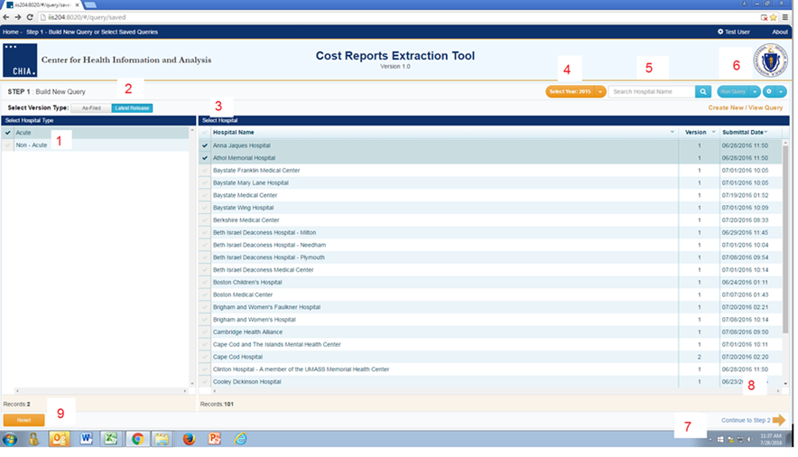
- Select Hospital Type
- Select “AS FILED” or “LATEST RELEASE” the default is the latest data
- Select Hospital by name
- Select Year
- Search by name or all by clicking next to Hospital Name
- (Internal Functionality – only)
- Continue to Step 2 to select data elements to extract
- Use “Page Down” function on your computer
- RESET selections
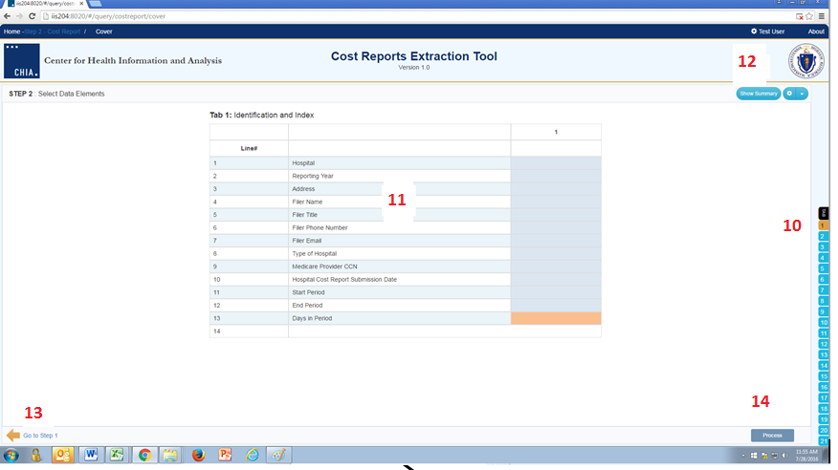

10 Select Tabs

11 Select specific data points or click on the column # / row # to select the entire column / row. The maximum limit is 1000 data cells.

12 View and edit selected data points

13 Return to prior screen

14 Process selections

Note: The orange cells are calculations while the blue are information provided by hospitals.

15 This is what the database returned

16 This can be exported to EXCEL by clicking this icon

17 And then clicking on EXCEL
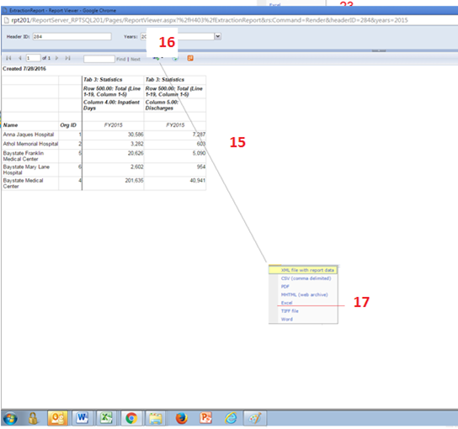

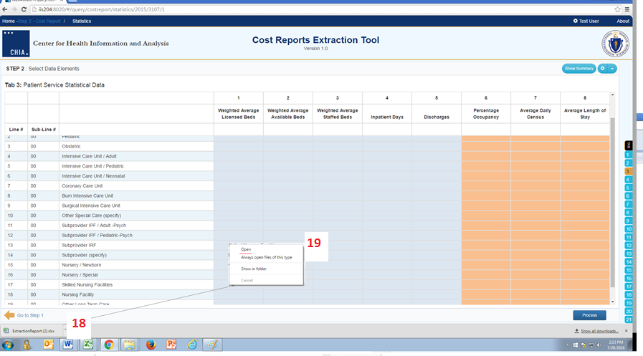

18 Clicks on Extraction Report

19 Choose “Open”

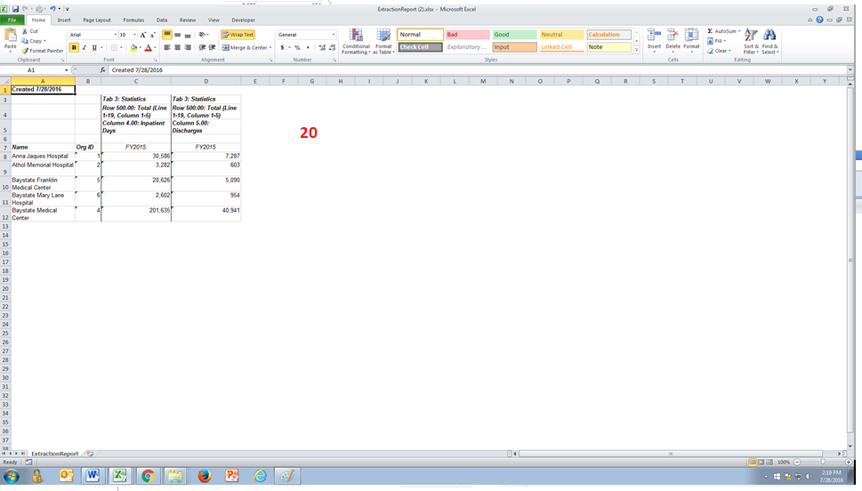

20 You are now in EXCEL and can use all its functionality!

Section 2: Customized or Subscripted Cost Centers
This section provides information on identifying and selecting the additional customized or subscripted cost centers (rows / columns).
Users will need to know which hospitals have elected to customize or subscript additional cost centers (rows / columns). CHIA has prepared a report which lists all the standard and subscripted additional cost centers (rows / columns) by hospital.
To access that report, which is titled the Subscripted and Specified Lines Report, open the RUN REPORT by clicking on the arrow (See A).
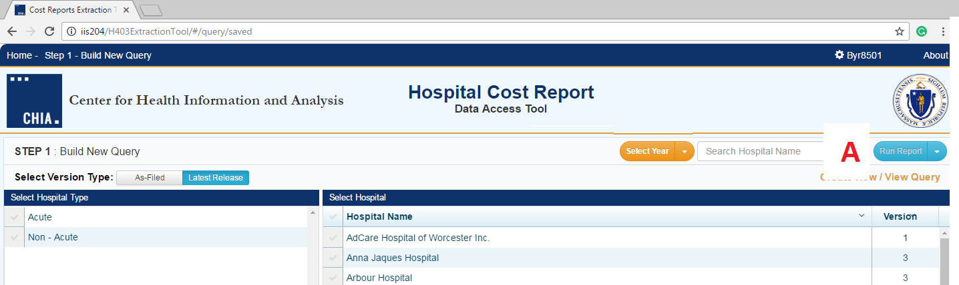
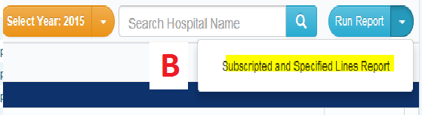
This will open the access to the Subscripted and Specified Lines Report (See B).
This report contains all standard and all subscripted cost centers, along with the descriptions provided by hospital. The standard cost center line number and description is intended for reference. Below is an example of how the report will look.
Example of the Subscripted and Specified Lines Report:
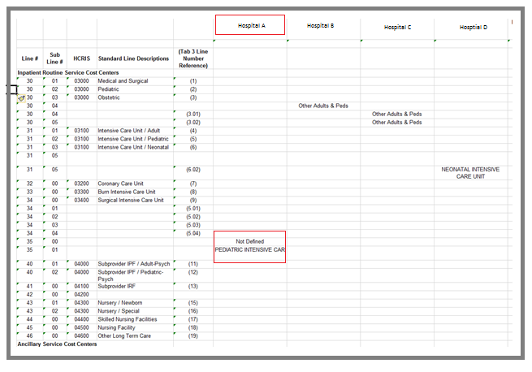
When all columns are populated, the data in the first three columns represents the standard cost center rows /columns for all tabs containing cost center data, excluding Tab 3. The corresponding Tab 3 cost center line reference is in Column 4.
Columns 5 and so forth contain the hospital names at the top. The hospital specific customized or subscripted cost centers are contained within the column.
For example (see chart above), Hospital A has customized lines 35 and 35.01. Line 35 is has information but not a label, and line 35.01 is described as Pediatric Intensive Care.
To select the customized or subscripted additional cost centers (rows / columns), click on the Show Summary (C).
The Selected Element box will open (See D). This is where the customized or subscripted additional cost centers (rows / columns) are identified (See F). The user will have to key in the tab, row and column. Once selected, the user can view the selection in the box. If a selection was made in error it can be deleted by clicking on the ‘X” (See E).
Note: Standard line items can also be selected using this method.

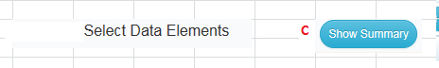
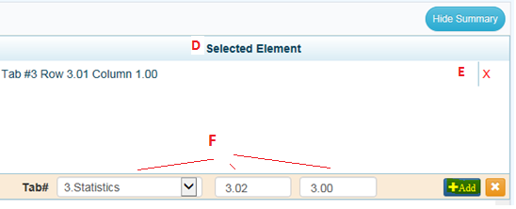

After all selections are complete, continue with the instructions in Section 1, step 14.

